# Table of Contents

Get started Get started Sign up Create a flow from a template Create a flow from scratch Create a team flow Overview of environments Frequently asked questions Build a flow Add an action Add a condition Run a flow on a schedule Trigger a flow with email Process a list of items Use data operations Filter and copy data Use expressions in conditions Create a flow with Dynamics 365 Add data to the Common Data Service Watch a flow Publish a template Troubleshoot a flow Create approval flows Single approvals Sequential approvals Parallel approvals Integrated approvals Use the mobile app Create a flow

Create a button flow Create a button flow with trigger tokens Create a button flow with user input Share a button Monitor flow activity Manage your flows Use physical devices Use a Flic Use a bttn Connections

[Available connections](https://go.microsoft.com/fwlink/)

Manage connections Manage gateways Understand gateways Develop: enterprise developers Microsoft Flow for enterprise developers Register and use custom connectors Describe a custom connector with Postman OpenAPI extensions for custom connectors Use Azure Active Directory with a custom connector Build a custom connector for a Web API Use a webhook to trigger a flow Develop: partners and ISVs Microsoft Flow for Microsoft partners and ISVs Overview of certifying API connectors Develop API connectors for certification Submit API connectors for certification FAQ for certifying API connectors Integrate with websites and other technologies Let customers test drive your flows Administration Flows in your organization Q&A

Pricing Introduction to the admin center Administer environments Set a policy to help prevent data loss Introduction to data groups Reference Regions overview Limits and configuration Release notes

# Get started with Microsoft Flow

11/3/2017 • 2 min to read • [Edit Online](https://github.com/MicrosoftDocs/flow-docs-pr/blob/live/flow-docs/getting-started.md)

Welcome! Microsoft Flow is a service that helps you create automated workflows between your favorite apps and services to synchronize files, get notifications, collect data, and more.

The first step is to sign up, or, if you already have an account with Microsoft Flow, [sign in](https://flow.microsoft.com/signin) on your tablet, desktop computer, or even your phone.

## Check out the start page

[On the start page](https://flow.microsoft.com/) for Microsoft Flow, you can [explore a diverse set of templates](https://flow.microsoft.com/templates) and learn about the key features for Microsoft Flow. You can get a quick sense of what's possible and how Microsoft Flow could help your business and your life.

With Microsoft Flow, you can:

Easily search for templates and services.

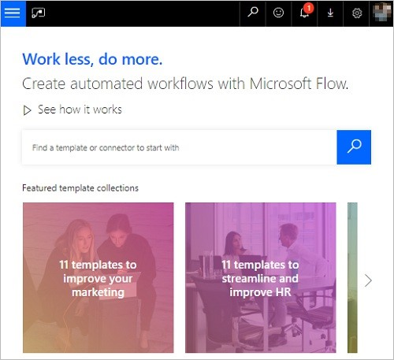

Choose from the most popular services.

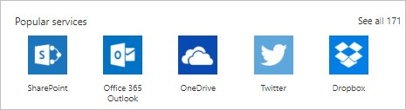

See an overview of each flow.

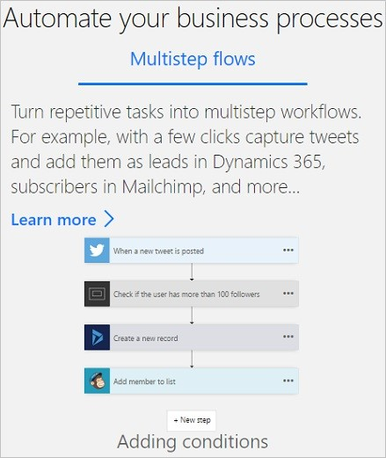

Each template is designed for a specific purpose. For example, there are templates for sending you a text message when your boss emails you, adding Twitter leads to Dynamics 365, or backing up your files. These templates are just the tip of the iceberg. They're intended to inspire you to create customized flows for the exact processes you need.

## Create your first flow

1. Select a template that's useful for you. A simple template is [**Get daily reminders in Email**](https://flow.microsoft.com/galleries/public/templates/45a3399aa29345308f08b6db0a9c85b9/):

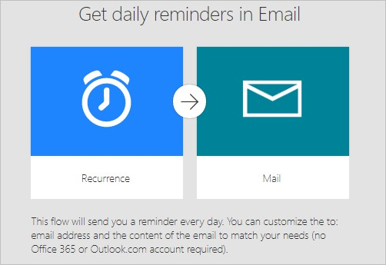

1. Select **Continue**.

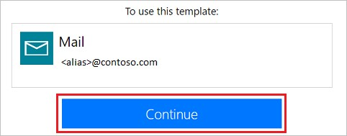

1. Enter the email addresses to which the daily reminder will be sent. Next, enter the reminder message. Finally, select **Create flow**, and then verify that your flow is running as expected.

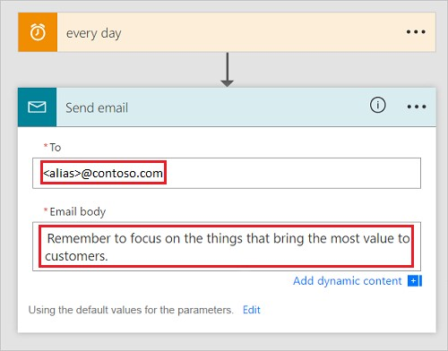

**NOTE**

You can explore the conditions that trigger the flow and the action that results from that event. Play around with the settings to make the flow your own. You can even add or delete actions.

1. Select **Done**.

Follow this tutorial to learn more about creating flows from templates.

## Get creative

Now that you've created your first flow from a template, use any of the more than [150 data sources](https://flow.microsoft.com/connectors/) that Microsoft Flow supports to create your own flows from scratch.

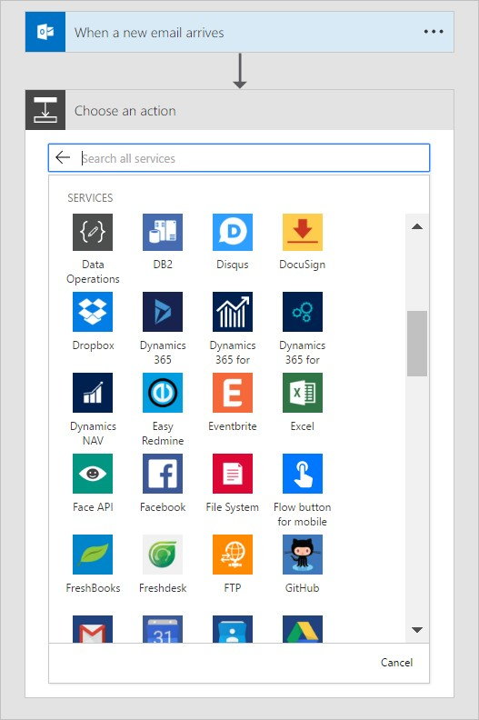

When you create a flow from scratch, you control the entire workflow. Here are a few ideas to get your started:

Flows with many steps.

Run tasks on a schedule.

[Create an approval flow](https://docs.microsoft.com/en-us/flow/wait-for-approvals).

Watch a flow in action. Publish a template.

## Use the mobile app

Download the Microsoft Flow mobile app for [Android](https://aka.ms/flowmobiledocsandroid), [iOS](https://aka.ms/flowmobiledocsios), or [Windows Phone](https://aka.ms/flowmobilewindows). With this app, you can monitor flow activity, manage your flows and create flows from templates.

## We're here to help

We're excited to see what you do with Microsoft Flow, and we want to ensure you have a great experience. Be sure [to check out our guided learning tutorials and join our community to ask questions and share your ideas. Contact support if you run into any issues.](http://go.microsoft.com/fwlink/?LinkID=787479)

# Sign up and sign in for Microsoft Flow

11/3/2017 • 3 min to read • [Edit Online](https://github.com/MicrosoftDocs/flow-docs-pr/blob/live/flow-docs/sign-up-sign-in.md)

Starting with Microsoft Flow, as an individual, is easy! Before you can create a flow, sign up by using any email address. If you've never used an online Microsoft product with that address, you'll need to take a few moments to register it.

## Sign up free

If you haven't used other online Microsoft products, you'll need to sign up.

1. In [flow.microsoft.com](https://flow.microsoft.com/), click or tap **Sign up free** in the upper-right corner.
2. Enter your email address.
3. Click or tap the right arrow.

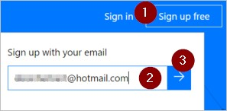

## Sign in

If you've used other Microsoft online products, either for work or yourself, all you need to do is sign in.

1. In [flow.microsoft.com](https://flow.microsoft.com/), click or tap **Sign in** in the upper-right corner.

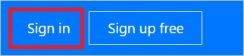

1. Enter your email address.
2. On the sign-in page, enter your email address and password.

## Using paid features

Anyone can sign up and get a free plan for Microsoft Flow. If your organization has purchased Office 365 or Dynamics 365 for you, you may have access to additional features for Microsoft Flow. You can also start a 90-day free trial or purchase Microsoft Flow Plan 1 or Plan 2 if you would like to use the paid features. Learn more about billing.

For administration information, see Flows in your organization Q&A.

## Troubleshooting

In many cases, you can register for Microsoft Flow by following the simple process described earlier in this topic. However, this table summarizes the most common reasons why you may not be able to sign up and describes available workarounds.

|  |  |
| --- | --- |
| **SYMPTOM / ERROR MESSAGE** | **CAUSE AND WORKAROUND** |
| **No Microsoft account created yet**  You receive a message after entering your email during signup:  *That Microsoft account doesn't exist. Enter a different account or get a new one.* | You signed up with an email that doesn't yet have a Microsoft account created for it. Select the **Sign up now** link on that page and you'll be able to create a new Microsoft account for your email. You can use your existing email to create a Microsoft account. |
| **.gov or .mil email addresses**  You receive a message like the following during signup:  *Microsoft Flow unavailable: Microsoft Flow is not available for users with .gov or .mil email addresses at this time. Use another work email address or check back later.* | You cannot currently sign up for Microsoft Flow with a .gov or .mil address. Instead, you can sign in with any Microsoft  Account email address such as a *@outlook.com* address. |
| **Self-service signup disabled**  You receive a message like the following during signup: *We can't finish signing you up. Your IT department has turned off signup for Microsoft Flow. Contact them to complete signup.*  or  *We can't finish signing you up. It looks like Microsoft Microsoft Flow isn't currently available for your work or school.* | You have selected **Sign up** instead of of **Sign in**. If you select **Sign in** in the top of the home page you will be able to access Microsoft Flow. |
| **Email address is not an Office 365 ID**  You receive a message like the following during signup: *We can't find you at contoso.com. Do you use a different ID at work or school? Try signing in with that, and if it doesn't work, contact your IT department.* | Your organization uses IDs to sign in to Office 365 and other Microsoft services, and those IDs differ from your email address. For example, your email address might be Nancy.Smith@contoso.com, but your ID might be nancys@contoso.com. To complete signup, use the ID that your organization has assigned to you for signing in to Office 365 or other Microsoft services. |

## Next steps

Start with a template, which is a pre-built flow that's set up for you.

Start from blank if you already have a process in mind and can't find a template for it.

# Create a flow from a template in Microsoft Flow

11/3/2017 • 1 min to read • [Edit Online](https://github.com/MicrosoftDocs/flow-docs-pr/blob/live/flow-docs/get-started-logic-template.md)

Create a flow from one of many built-in templates that can, for example, send you a Slack message when your manager sends you an email in Office 365.

**Note:** Create a flow from scratch if you already have a process in mind and can't find a template for it.

**Prerequisites**

An account on [flow.microsoft.com](https://flow.microsoft.com/)

A Slack account

Office 365 credentials

## Choose a template

1. In [flow.microsoft.com](https://flow.microsoft.com/), select **Templates** in the top navigation bar.
2. In the search bar, type **Slack**, and then select the search icon.
3. You'll see only templates related to Slack, so you can now select **Send a message on Slack when my manager emails me**.

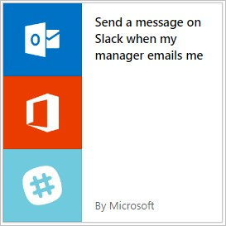

1. Confirm that this template will do what you want, and then select **Use this template**.
2. If you aren't signed into Office or Slack, select **Sign in** and then follow the prompts.

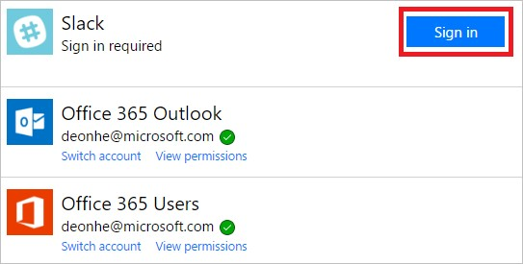

1. After you confirm your connections, select **Continue**.

Your flow appears, showing each action with an orange title bar.

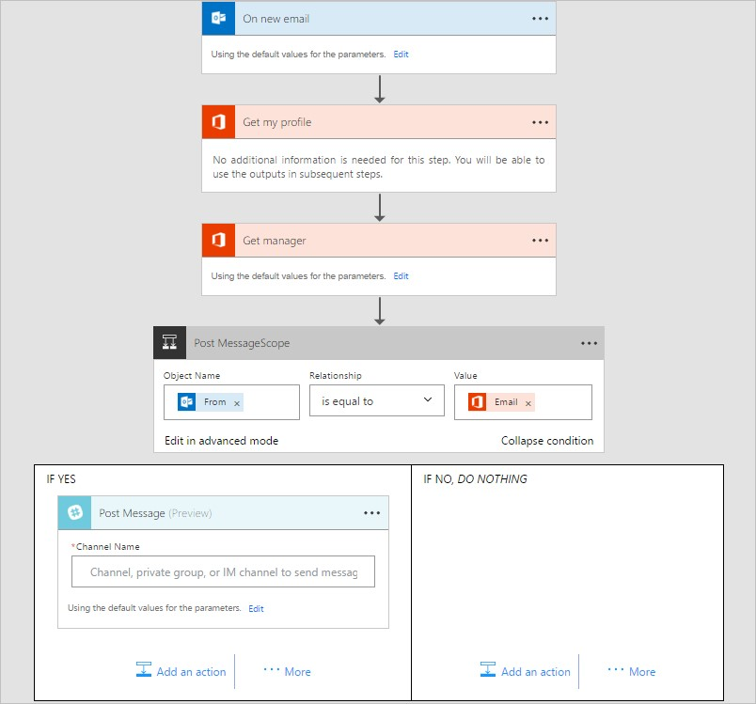

## Customize your flow

1. Select the title bar for an event to expand it, and then customize it (for example, by specifying a filter on the email that interests you).
2. Actions that require input from you will automatically be expanded.

For example, the **Post message** action is expanded because you need to enter a channel, such as your *@username*. You can also customize the message content. By default, the message will contain just the subject, but you can include other information.

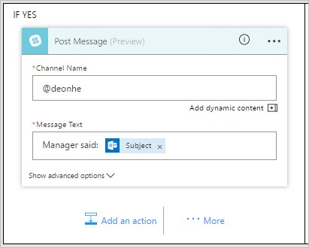

1. Near the top of the screen, specify a name for your flow, and then select **Create flow**.
2. Finally, if you're happy with your flow, select **Done**.

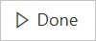

Now, when your manager sends you an email, you'll receive a Slack message that contains the information that you specified.

## Next steps

Watch your flow in action

Publish your own template

Use a template for the Common Data Service

Get started with team flows and invite others to collaborate with you to design flows.

# Create a flow in Microsoft Flow

11/3/2017 • 2 min to read • [Edit Online](https://github.com/MicrosoftDocs/flow-docs-pr/blob/live/flow-docs/get-started-logic-flow.md)

Create a flow that performs one or more tasks automatically after it's triggered by an event. For example, create a flow that notifies you by email when someone sends a tweet that contains a keyword you specify. In this example, sending a tweet is the event, and sending mail is the action.

## Prerequisites

An account on [flow.microsoft.com](https://flow.microsoft.com/)

A Twitter account

Office 365 credentials

## Specify an event to start the flow

First, you will need to select what event, or *trigger*, starts your flow.

1. In [flow.microsoft.com](https://flow.microsoft.com/), select **My flows** in the top navigation bar, and then select **Create from blank**.

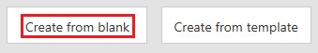

1. In the box that says **Search all connectors and triggers**, type or paste **Twitter**, and then select **Twitter When a new tweet is posted**.

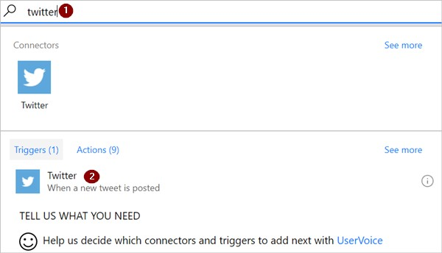

1. If you haven't already connected your Twitter account to Microsoft Flow, select **Sign in to Twitter**, and then provide your credentials.

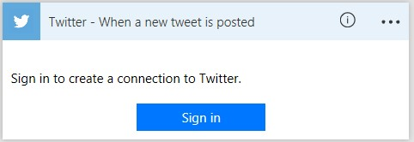

1. In the **Search text** box, type the keyword that you want to find.

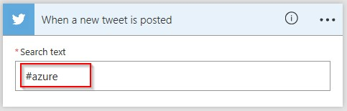

## Specify an action

1. Select **New step**, and then select **Add an action**.

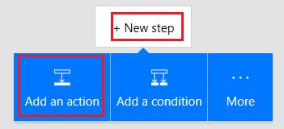

1. In the box that shows **Search all connectors and actions**, type or paste **send email**, and then select **Office 365 Outlook - Send an email**.

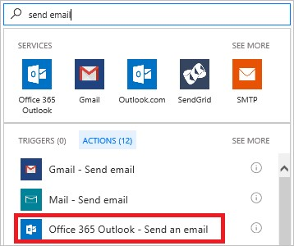

1. If prompted, select the sign-in button, and then provide your credentials.
2. In the form that appears, type or paste your email address in the **To** box then select your name from the list of contacts that appears.

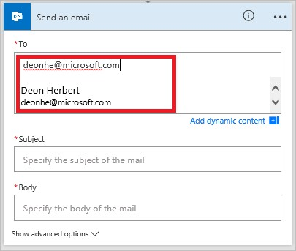

1. In the **Subject** box, type or paste **New tweet from:**, then type a space.

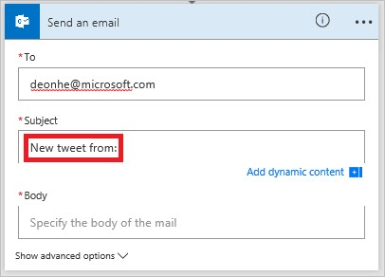

1. In the list of tokens, select the **Tweeted by** token to add a placeholder for it.

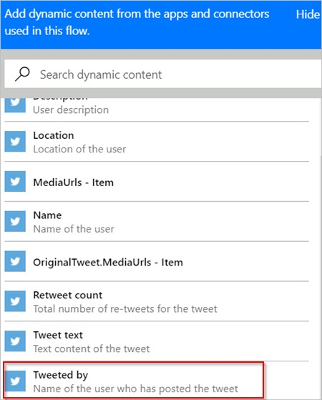

1. Click or tap in the **Body** box then click or tap the **Tweet text** token to add a placeholder for it.
2. (optional) Add more tokens, other content, or both to the body of the email.
3. Near the top of the screen, name your flow, and then select **Create flow**.

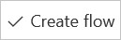

1. Select **Done** to update the list of your flows.



1. Send a tweet with the keyword that you indicated.

Within a minute, an email message notifies you of the new tweet.

## Manage a flow

1. In [flow.microsoft.com](https://flow.microsoft.com/), select **My flows** in the top navigation bar.
2. In the list of flows, do any of the following:

To pause a flow, set its toggle to **Off**.

To resume a flow, set its toggle to **On**.

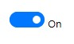

To edit a flow, select the pencil icon that coresponds to the flow you want to edit.

To view the run history of a flow, select the flow from the **My flows** page, and then view the history under the **RUN HISTORY** section of the page that opens.

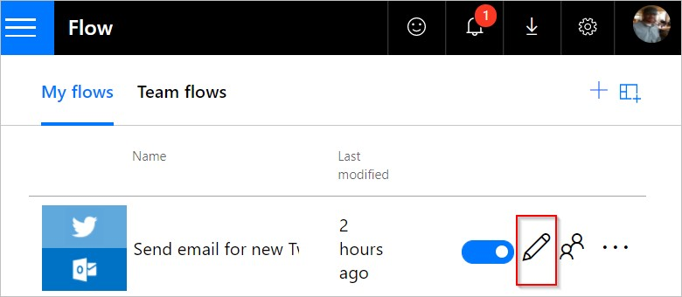

To delete a flow, select the

**...**

icon, select

**Delete**

, and then select

**Delete**

on the message box that

appears.

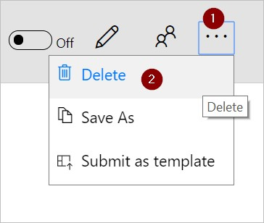

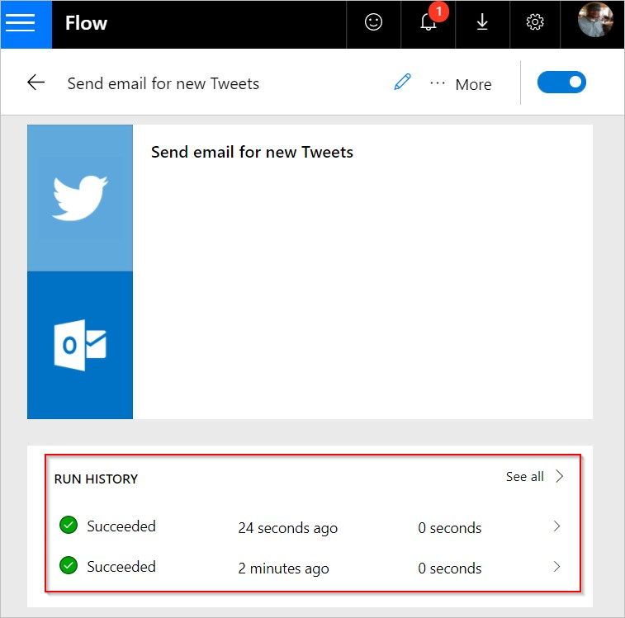

Select a flow run from the list of runs to see the inputs and outputs of each step.

**Note**: You can have up to 50 flows in your account. If you already have 50, delete one before you can create another.

## Next steps

Add steps, such as different ways to be notified, to your flow.

Run tasks on a schedule, when you want an action to occur daily, on a certain date, or after a certain number of minutes.

[Add a flow to an app](https://powerapps.microsoft.com/tutorials/using-logic-flows/) to allow your app to kick off logic in the cloud.

Get started with team flows and invite others to collaborate with you to design flows.

# Create team flows

11/3/2017 • 2 min to read • [Edit Online](https://github.com/MicrosoftDocs/flow-docs-pr/blob/live/flow-docs/create-team-flows.md)

Create a team flow by adding others in your organization as owners. All owners of a team flow can perform these actions:

View the flow's history (that is, each run).

Manage the properties of the flow (for example, start or stop the flow, add owners or update credentials for a connection).

Edit the definition of the flow (for example, add or remove an action or condition). Add and remove other owners (but not the flow's creator). Delete the flow.

If you're the creator or an owner of a team flow, you'll find it listed on the **Team flows** tab on [Microsoft Flow](https://flow.microsoft.com/).

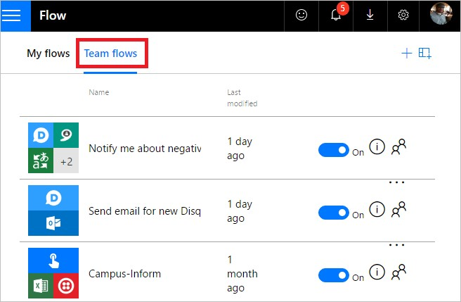

**NOTE**

Shared connections can be used **only** in the flow in which they were created.

Owners can use services in a flow but can't modify the credentials for a connection that another owner created.

## Prerequisites

You must have a [paid Microsoft Flow plan](https://flow.microsoft.com/pricing/) to create a team flow. Additionally, you must be the creator or owner to add/remove owners from a team flow.

## Create a team flow

Follow these steps to create a team flow or to add more owners to a team flow.

1. Sign into the [Microsoft Flow](https://flow.microsoft.com/), and then select **My flows**.
2. Select the people icon for the flow that you want to modify:

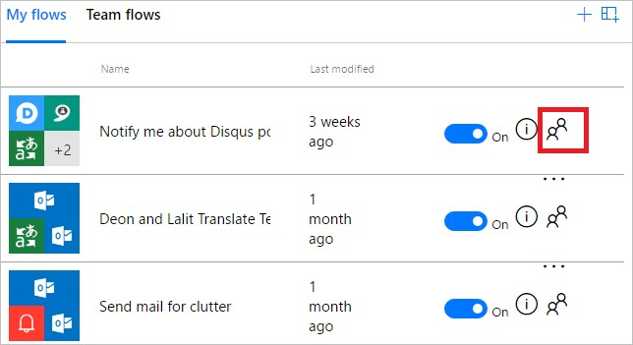

1. Enter the name, email address, or group name for the person or group that you want to add as an owner:

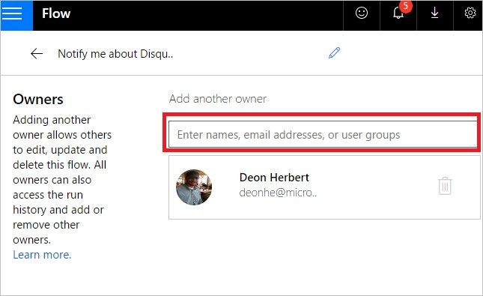

1. In the list that appears, select the user whom you want to make an owner:

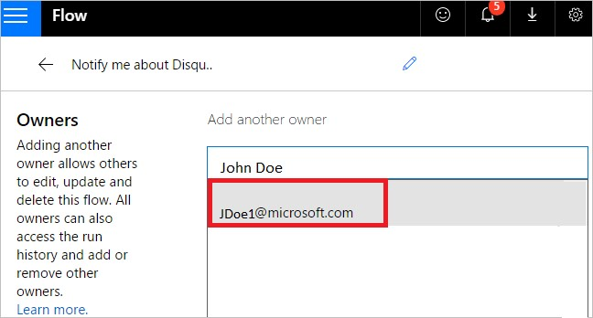

The user or group you've selected becomes an owner of the flow:

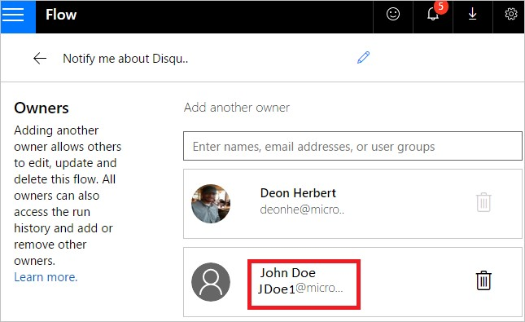

Congratulations — your team flow has been created!

## Remove an owner

**IMPORTANT**

When you remove an owner whose credentials are used to access Microsoft Flow services, you should update the credentials for those connections so that the flow continues to run properly.

1. Select the people icon for the flow that you want to modify:

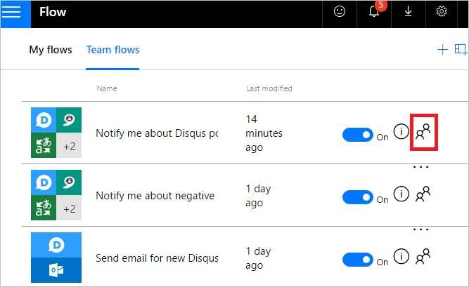

1. Select the **Delete** icon for the owner that you want to remove:

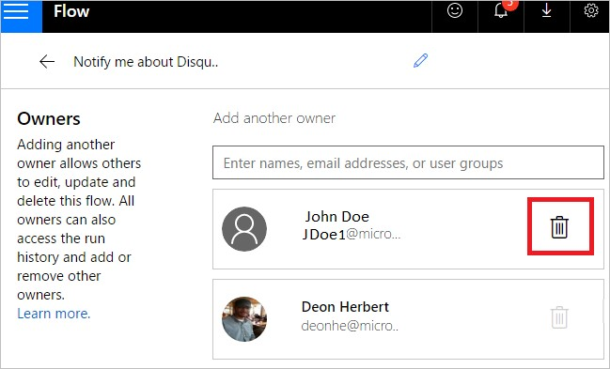

1. On the confirmation dialog box, select **Remove this owner**:

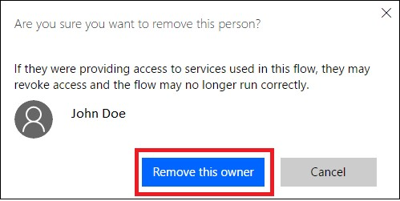

1. Congratulations — the user or group that you removed is no longer listed as an owner of the flow:

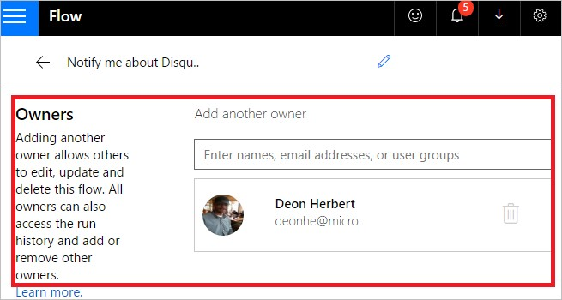

## Embedded and other connections

Connections used in a flow fall into two categories:

**Embedded** — These connections are used in the flow.

**Other** — These connections have been defined for a flow but aren't used in it.

If you stop using a connection in a flow, that connection appears in the **Other** connections list, where it remains until an owner includes it in the flow again.

The list of connections appears under the list of owners in a flow's properties:

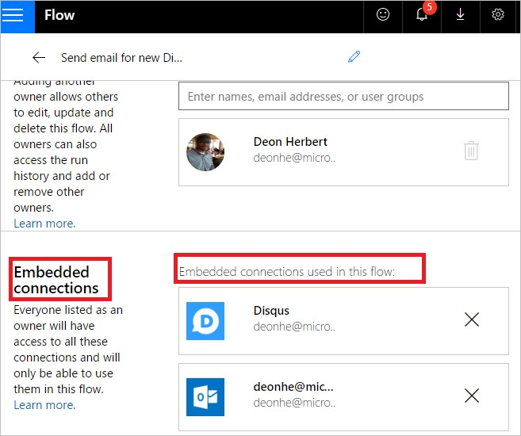

# Choosing an environment

11/30/2017 • 2 min to read • [Edit Online](https://github.com/MicrosoftDocs/flow-docs-pr/blob/live/flow-docs/environments-overview-maker.md)

This article introduces you to Microsoft Flow **environments** in which you can create, and securely isolate your flows, gateways, connections, and other resources.

You'll learn about:

The features that environments provide.

Switching between environments.

How to create a flow in the right environment.

## Environments overview

When you create a flow, you choose an environment to host the flow and the resources the flow uses. You can use separate environments for different scenarios.

## Here are a few scenarios for using environments

|  |  |
| --- | --- |
| **SCENARIO** | **RECOMMENDATION** |
| You want to create a flow that uses a connection to the Microsoft Common Data Service. | Place your flow and the Common Data Service into the same environment. This ensures all the data is isolated within that environment (isolation boundary). |
| You're creating a flow for your Human Resources department. You want to ensure that only users in your Human Resources department have access to the flow. | Create an environment and add only the HR users to it. Place the flow and any other resources the flow uses into this environment. |
| There are users in Europe who use a flow to show SharePoint data. | Create an environment in Europe, and then create your flow and the SharePoint connection in it. This Europe environment gives the European users the best performance, since all resources are local to Europe (data locality). |

To create environments, you must be a Microsoft Flow administrator. Administrators control who has access to environments. For details on how you can create and manage environments, see the administer environments topic.

## Switching environments

Microsoft Flow makes it easy to switch between environments. When you switch environments, you see only items that are created in that specific environment; you won't see or have access to items in any other environment.

Here's an example.

You’ve created a flow named *NewEmployee* in the *Human Resources* environment. In [Microsoft Flow](https://flow.microsoft.com/), you open the *Sales* environment. The *NewEmployee* flow isn’t listed. To see the *NewEmployee* flow, open the *Human Resources* environment. Remember, the same rules apply to any other items you created in the environment, including connections, gateways, flows, and more.

Follow these steps to switch environments:

1. Sign into [Microsoft Flow](https://flow.microsoft.com/).
2. In the top right corner, you see an image that represents your profile.



1. Select the image. A drop-down list displays all the environments available to you. The environment in which you're currently signed in is checked:

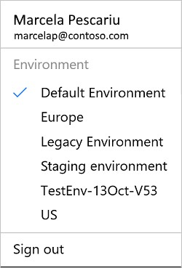

1. To switch to another environment, select that environment in the list:

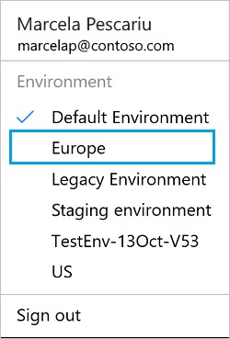

1. Microsoft Flow switches to the new environment.

## Create flows in the right environment

Before you create a flow, select the environment into which you'll add the flow and its resources.

**NOTE**

If you create a flow in the wrong environment, you'll have to delete it, and then create it in the correct environment.

Consider the following factors when choosing an environment to host your flows:

You can only create gateways in the default environment. So, if you want to use a gateway to connect your flow to on-premises data, you'll need to use the default environment.

Microsoft Common Data Service databases are tied to a specific environment. So, if you want to create a flow that uses the Common Data Service, you must create the flow in the environment that hosts the database.

You'll see all environments in which you can edit resources. However, you'll need to ask an administrator to add you as a maker to all environments in which you want to create flows.

**NOTE**

You'll always be able to create flows in the default environment.

## Next steps

Create a flow from a template

Create a flow

Environment overview for Administrators

# Frequently asked questions

11/3/2017 • 4 min to read • [Edit Online](https://github.com/MicrosoftDocs/flow-docs-pr/blob/live/flow-docs/frequently-asked-questions.md)

## Audience and strategy

**What is Microsoft Flow?**

Microsoft Flow is a cloud-based service that makes it practical and simple for line-of-business users to build workflows that automate time-consuming business tasks and processes across applications and services.

**Who is the intended audience for Microsoft Flow?** Microsoft Flow has two distinct audiences:

Line-of-business “Citizen Integrators” in enterprise organizations who partner with IT to move responsibility for business solutions closer to the business itself.

IT decision makers who want to empower line-of-business partners to create their own solutions so IT professionals and integration specialists can focus their expertise on more advanced integration tools, such as Azure Logic Apps.

**How do Microsoft Flow and Logic Apps relate to each other?**

Microsoft Flow provides features that help line-of-business users create automated workflows. Logic Apps is an

Azure service that provides the same great features of Microsoft Flow, plus features such as integration with Azure [Resource Manager and the Azure Portal, PowerShell and xPlat CLI, Visual Studio, and additional connectors. Learn more about Logic Apps.](https://azure.microsoft.com/services/app-service/logic/)

**How does Microsoft Flow fit in Microsoft’s overall business application platform strategy?**

Microsoft Flow is part of a powerful and adaptable business application platform that includes PowerApps, the

Common Data Service, Dynamics 365, and Office 365. This platform allows our customers, our partners, and our ISV partners to create purpose-built solutions for their own companies, their industry, for functional roles or even for specific geographies. Line-of-business users, who understand their business needs best, can now easily analyze, compose, and streamline data and processes. Professional developers can easily extend the automation, analytics and apps line-of-business to leverage Azure services like Functions, App Service, and Logic Apps. API connectors, gateways and the Microsoft Common Data Service make it possible to get more value out of services or data already in use, either in the cloud or on-premises.

## Functionality

**What do I need to use Microsoft Flow?**

To use Microsoft Flow, all you need is a web browser and an email address.

**What browsers does Microsoft Flow support?**

Microsoft Flow supports Microsoft Edge and the current versions of Chrome and Safari.

**Which email addresses are supported?**

Microsoft Flow supports email addresses that end with anything except .gov and .mil.

**Is Microsoft Flow available on-premises?**

Microsoft Flow is a public cloud service only. However, you can securely connect to your own on-premises services through the on-premises data gateway.

**What services can Microsoft Flow connect to?**

Microsoft Flow connects to more than 100 data sources out of the box, and we’re adding more all the time. Some examples of data sources and services include the following:

SharePoint

Dynamics 365

OneDrive

OneDrive for Business

Google Drive

Google Sheets

Trello

Twitter

Box

Facebook

SalesForce.com

Mailchimp

Customer APIs

You can find a full list of available connectors [here](https://go.microsoft.com/fwlink/?LinkId=832211).

You can access data sources in your own IT infrastructure through the on-premises data gateway.

**What are templates?**

Templates are pre-built flows for popular and common scenarios. Using a template only requires you to have access to the services in the template and to fill out any required settings.

**What data sources will I be able to connect to?**

You can connect to more than 100 standard services from Microsoft and third parties, such Office 365, Twitter, SharePoint, OneDrive, Dropbox, SQL Server, and more. You can also connect to premium services such as Salesforce and the Common Data Service for PowerApps.

**How do I connect to a REST API in my flow?**

You can connect to any REST API that uses JSON and supports at least one of more than 10 authentication methods by creating a custom connector.

**How do I connect to SQL Server and other on-premises data sources?**

You can connect to services on your local network using the on-premises data gateway.

**Can I share the flows I create?**

You can share flows in either of these ways:

You can add co-workers or groups in your organization as owners on your flows, so they can also edit and manage the flow.

For flows that can be run manually, you can also grant other people or groups in your organization permission to just run the flow.

**How many flows can I have?**

Microsoft Flow comes with up to 50 flows. If you need more, you can request them.

**Where do I get started with Microsoft Flow?** Get started with the following resources:

[Blog](https://flow.microsoft.com/)

[YouTube channel](https://youtube.com/playlist?list=PL8nfc9haGeb55I9wL9QnWyHp3ctU2_ThF)

Topic

[Community](https://powerusers.microsoft.com/)

**What operating systems does the mobile app for Microsoft Flow support?**

The Microsoft Flow mobile app is available on [Android](https://aka.ms/flowmobiledocsandroid), [iOS](https://aka.ms/flowmobiledocsios), or [Windows Phone](https://aka.ms/flowmobilewindows).

**What regions and languages does Microsoft Flow support?** Microsoft Flow is available in 42 languages and six regions.

**How does Microsoft Flow compare to SharePoint Designer 2013?**

Microsoft Flow is the successor to SharePoint Designer for many common business scenarios such as approvals, document review, and onboarding/offboarding. It will be the default tool for building business automation in SharePoint moving forward.

**How does Microsoft Flow ensure that corporate data isn't accidentally released to social media services?**

Administrators can create data loss prevention policies to ensure that only sanctioned services are used in Microsoft Flow.

## Licensing

**Will Microsoft Flow still have a free or trial option?**

Yes. You can use our free offering, which has limited user rights, or you can sign up for a free 90-day trial of Microsoft Flow. You can activate your subscription at any time during your trial.

**What pricing plans do you offer?**

Microsoft Flow offers both free and paid service levels. Learn more about pricing.

# Add multiple actions and advanced options to a flow

11/3/2017 • 2 min to read • [Edit Online](https://github.com/MicrosoftDocs/flow-docs-pr/blob/live/flow-docs/multi-step-logic-flow.md)

Customize a flow by adding one or more advanced options and multiple actions for the same trigger. For example, add an advanced option that sends an email message as high priority. In addition to sending mail when an item is added to a SharePoint list, create a file in Dropbox that contains the same information.

## Prerequisites

Create a flow

## Add another action

In this procedure, you'll add an action in the middle of the flow. This action will save a file in your Dropbox, archiving the item in the list.

1. In [flow.microsoft.com](https://flow.microsoft.com/), select **My flows** in the top navigation bar.
2. In the list of flows, select the flow that you want to edit.
3. Select **New step**, and then select **Add an action**.

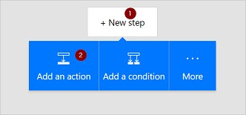

1. In the list of possible actions, search for **Create file**, and then select **Dropbox - Create file**.

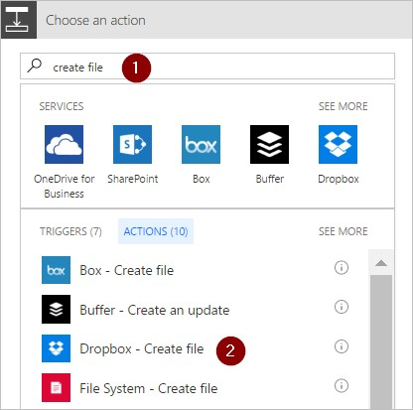

1. If prompted, provide your Dropbox credentials.
2. Select the folder icon on the right side of the **Folder path** box.
3. Find and then select the folder in which you want to place the new file.

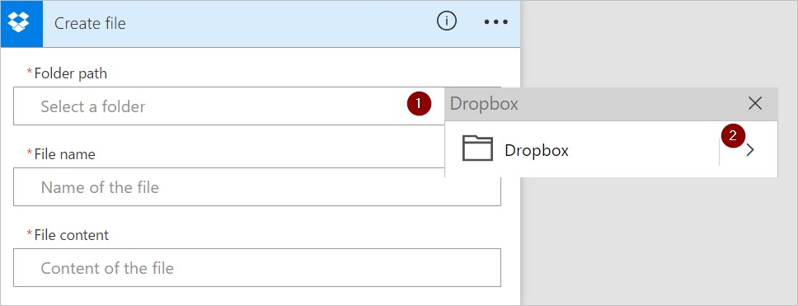

1. Enter the name of the new file into the **File name** box. Be sure to append an extension, such as ".txt", to the file name. Here, let's use the **TweetId** in the file's name to ensure uniqueness of the files. You may have to select **See more** to find the **TweetId** token.
2. Add the text that you want the file to contain by typing into the **File content** box. You can also add tokens into the **File content** box.

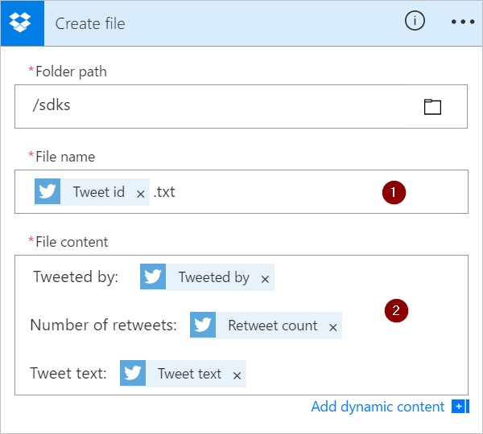

**IMPORTANT**

If you give the file a name that matches an existing file's name (in the selected folder), the existing file will be overwritten.

1. Select **Update flow**, which is located on the menu at the top of the screen.
2. Send a tweet that contains the keyword you specified.

Within a minute, a file is created in your Dropbox account.

## Reorder or delete an action

To receive email after the file is created in Dropbox, move the Dropbox action by dragging its title bar above the email action. Release the Dropbox action over the arrow between the trigger (**When a new tweet is posted**) and the email action. (The cursor indicates whether the action is positioned correctly.)

**NOTE**

You can't move a step before another if you're using any outputs from that step.

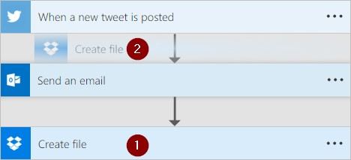

To delete an action, select the ellipsis (...) near the right edge of the title bar for the action you want to delete,

select

**Delete**

, and then select

**OK**

.

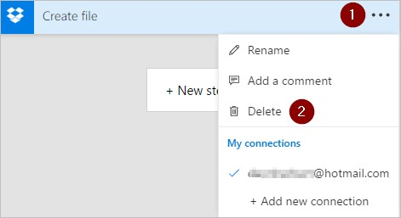

**Note:** You can't delete an action if you're using any outputs from it anywhere in the flow. First, remove those outputs from the fields, and then you can delete the action.

## Add advanced options

Start with a flow that has a **Send an email** action.

1. Select **Show advanced options**, which is located at the bottom of the **Send an email** card.

You'll then see the advanced options for sending an email.

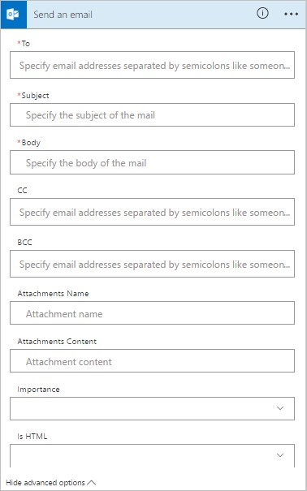

1. Select **High** from the **Importance** list, and then select **Hide advanced options** to hide the advanced options.
2. Select **Update flow**, which is located on the menu at the top of the screen.

This step saves your changes.

# Add a condition to a flow

11/3/2017 • 1 min to read • [Edit Online](https://github.com/MicrosoftDocs/flow-docs-pr/blob/live/flow-docs/add-condition.md)

Specify that a flow performs one or more tasks only if a condition is true. For example, specify that you'll get an email only if a tweet that contains a keyword is retweeted at least 10 times.

## Prerequisites

Create a flow from a template - this tutorial [uses this template](https://flow.microsoft.com/galleries/public/templates/e78571e5c70e4806a18eeacba5a897c8/) as the example

## Add a condition

1. In [Microsoft Flow](https://flow.microsoft.com/), select **My flows** in the top navigation bar.

You might need to sign in if you're not already signed in.

1. In the list of flows, select one of the flows that you've created.

This tutorial uses an example with a Twitter trigger and a SharePoint action.

1. Select **Edit flow**.
2. Under the last action, select **New step**.
3. Select **Add a condition**.

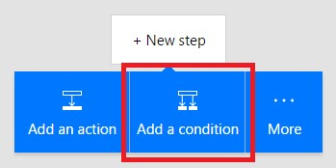

1. On the **Condition** card, select an empty area in box on the left.

The **Dynamic content** list opens.

1. Select the **Retweet count** parameter to add it to the box.
2. In the box in the middle of the **Condition** card, select **is greater than or equal to**.
3. In the box on the right, enter **10**.

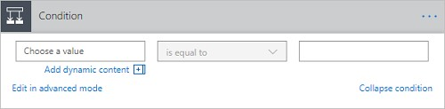

1. Select the header of the action you want to use inside the condition (such as **Create item**) and drag it underneath the text that reads **If yes**.

When you release the cursor, the action moves into that box.

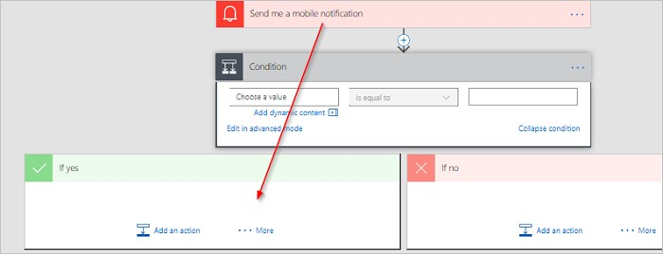

1. Configure the action as necessary.
2. Save the flow.

## Edit in advanced mode

You can also select **Edit in advanced mode** to write more advanced conditions. You can use any expression from the *Workflow definition language* in advanced mode. Learn about all available [expressions](https://msdn.microsoft.com/library/azure/mt643789.aspx).

Next steps

Learn how to use expressions in conditions in advanced mode.

# Run flows on a schedule

11/3/2017 • 1 min to read • [Edit Online](https://github.com/MicrosoftDocs/flow-docs-pr/blob/live/flow-docs/run-scheduled-tasks.md)

Create a flow that performs one or more tasks (such as sending a report in email):

once a day, an hour, or a minute on a date that you specify

after a number of days, hours, or minutes that you specify

## Create a recurring flow

1. Sign in to [Microsoft Flow](https://flow.microsoft.com/), and then select **My flows** in the top navigation bar.



1. Select **Create from blank**.

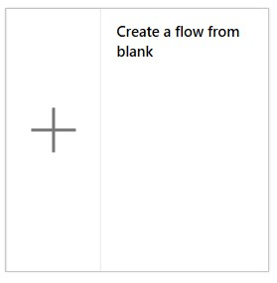

1. In the **Search all connectors and triggers** box, type **Recurrence**, and then select **Schedule - Recurrence**.

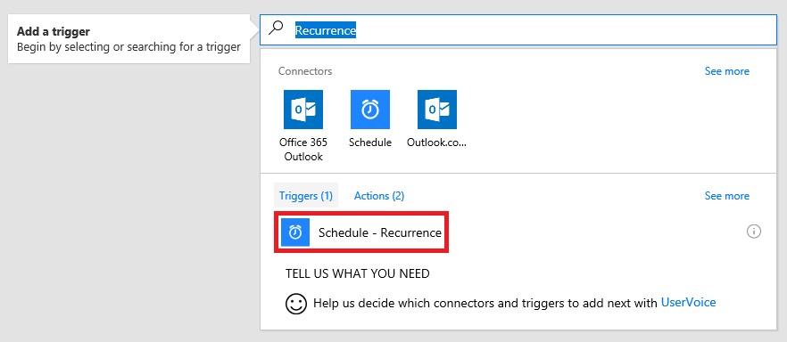

1. In the **Recurrence** dialog box, specify how often you want the flow to run.

For example, specify **2** under **Interval** and **Week** under **Frequency** if you want the flow to run every two weeks.

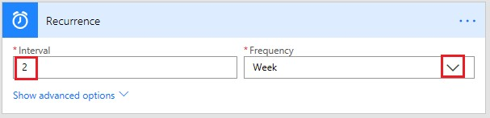

## Specify advanced options

1. Follow the steps in the previous section, and then select **Show advanced options**.

**Note**: These options change based on the values to which **Interval** and **Frequency** are set. If your screen doesn't match the graphic below, make sure that **Interval** and **Frequency** are set to the same values that the graphic shows.

1. Select a **Time zone** to specify whether the **Start time** reflects a local time zone, Universal Coordinated Time (UTC), etc.
2. Specify a **Start time** in this format:

YYYY-MM-DDTHH:MM:SSZ

1. If you specified **Day** under **Frequency**, specify the time of day when the flow should run.
2. If you specified **Week** under **Frequency**, specify the day or days of the week on which the flow should run and the time or times of day when the flow should run.

For example, configure the options as shown to start a flow no sooner than noon (Pacific time) on Monday, January 1, 2018, and run it every two weeks on Tuesdays at 5:30p (Pacific time).

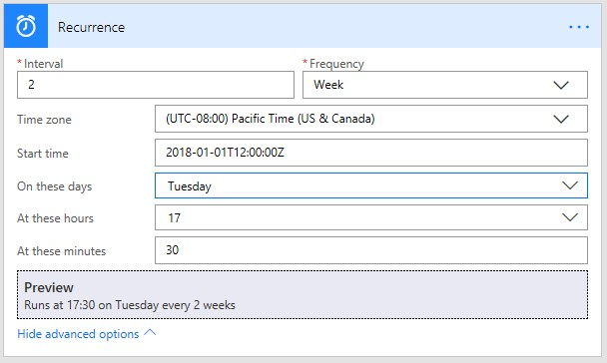

1. Add the action or actions that you want the flow to take, as Create a flow from scratch describes.

## Delay a flow

1. Sign in to [Microsoft Flow](https://flow.microsoft.com/), and then select **My flows** in the top navigation bar.



1. Select **Create from blank**.



1. Specify an event as Create a flow from scratch describes.
2. Select **New step**, and then select **Add an action**.

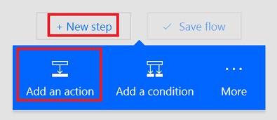

1. In the list of actions, do either of the following:

Select

**Delay**

, specify a

**Count**

, and specify a

**Unit**

of time such as second, minute, or hour.

Select

**Delay until**

, and then specify a date in this format.

YYYY-MM-DDTHH:MM:SSZ

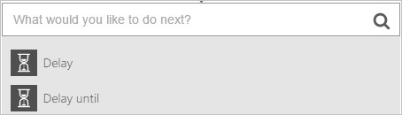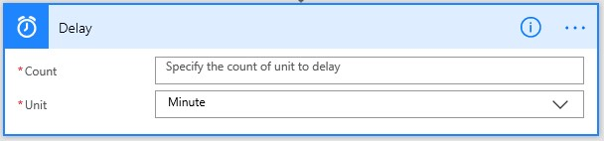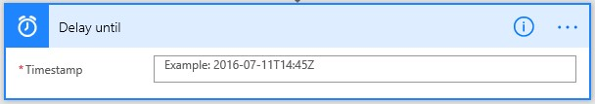

# Trigger a flow based on email properties

11/3/2017 • 6 min to read • [Edit Online](https://github.com/MicrosoftDocs/flow-docs-pr/blob/live/flow-docs/email-triggers.md)

Use the **When a new email arrives** trigger to create a flow that runs when one or more of these email properties match criteria you provide:

|  |  |
| --- | --- |
| **PROPERTY** | **WHEN TO USE** |
| Folder | Trigger a flow whenever emails arrive into a specific folder. This property can be useful if you have rules that route emails to different folders. |
| To | Trigger a flow based on the address to which an email was sent. This property can be useful if you receive email that was sent to different email addresses in the same inbox. |
| From | Trigger a flow based on the sender's email address. |
| Importance | Trigger a flow based on the importance with which emails were sent. Email can be sent with high, normal, or low importance. |
| Has Attachment | Trigger a flow based on the presence of attachments on incoming emails. |
| Subject Filter | Search for the presence of specific words in the subject of an email. Your flow then runs *actions* based on the results of your search. |

**IMPORTANT**

Each [Microsoft Flow plan](https://flow.microsoft.com/pricing/) includes a run quota. Always check properties in the flow's trigger when possible, doing so avoids using your run quota unnecessarily. If you check a property in a condition, each run counts against your plan's run quota, even if the filter condition you defined isn't met. For example, if you check an email's *from* address in a condition, each run counts against your plan's run quota, even if it's not *from* the address that interests you.

In the walk-throughs below, we check all properties in the **When a new email arrives** trigger. You can learn more by visiting the frequently asked billing questions and the [pricing](https://ms.flow.microsoft.com/pricing/) page.

## Prerequisites

An account with access to [Microsoft Flow](https://flow.microsoft.com/).

An Office 365 Outlook account.

The Microsoft Flow mobile app for [Android](https://aka.ms/flowmobiledocsandroid), [iOS](https://aka.ms/flowmobiledocsios), or [Windows Phone](https://aka.ms/flowmobilewindows). Connections to Office 365 Outlook and the push notification service.

## Trigger a flow based on an email's subject

In this walkthrough, we create a flow that sends a push notification to your mobile phone if the subject of any new email has the word "lottery" in it. Your flow then marks any such email as *read*.

Note: While this walkthrough sends a push notification, you're free to use any other action that suits your workflow needs. For example, you could store the email contents in another repository such as Google Sheets or a Microsoft Excel file stored on Dropbox.

Ok, let's get started:

1. Sign into [Microsoft Flow](https://flow.microsoft.com/), and then select the **My flows** tab.
2. Select **Create from blank**.

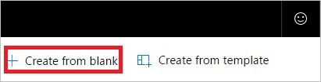

1. Search for "email", and then select **Office 365 Outlook - When a new email arrives** from the list of triggers. This trigger runs each time an email arrives.

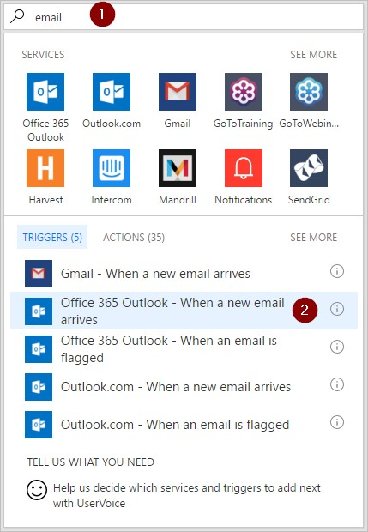

1. Select the folder that you'd like the flow to monitor for incoming emails, and then select **Show advanced options**.

Note: To display all your email folders, select the **Show Picker** icon, which is located on the right side of the **Folder** box on the **When a new email arrives** card.

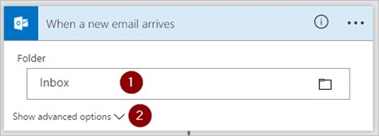

1. In the **Subject Filter** box, enter the text that your flow uses to filter incoming emails.

In this example I'm interested in any email that has the word "lottery" in the subject.

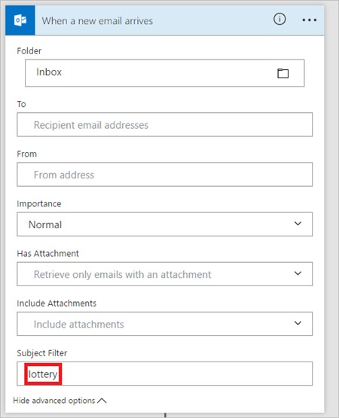

1. Select **New step** > **Add an action**.
2. Search for "notification", and then select **Notifications - Send me a mobile notification** from the list of actions.

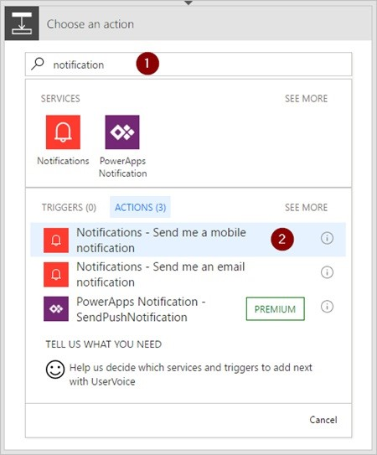

1. Enter the details for the mobile notification you'd like to receive when an email that matches the **Subject Filter** you specified earlier arrives.

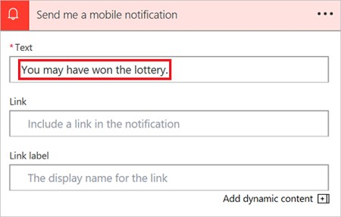

1. Select **New step** > **Add an action**.
2. Search for "read", and then select **Office 365 Outlook - Mark as read** from the list of actions.

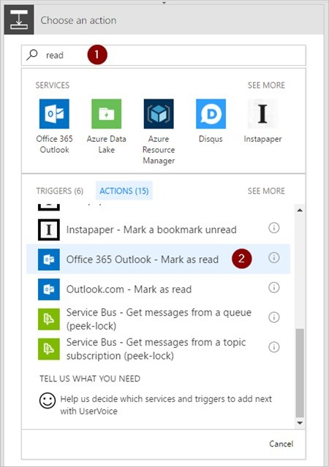

1. Add the **MessageId** token into the **Message Id** box on the **Mark as read** card.

If the **Message Id** token isn't visible, search for it by entering **Message Id** in the search box.

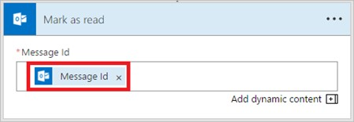

1. Give your flow a name, and then save it by selecting **Create flow** at the top of the page.



Congratulations, you receive a push notification each time you receive an email that contains the word "lottery" in the subject.

## Trigger a flow based on an email's sender

In this walkthrough, we create a flow that sends a push notification to your mobile phone if any new email arrives from a specific sender (email address). The flow also marks any such email as *read*.

1. Sign into [Microsoft Flow](https://flow.microsoft.com/), and then select the **My flows** tab.
2. Select **Create from blank**.



1. Search for "email", and then select **Office 365 Outlook - When a new email arrives** from the list of triggers. This trigger runs each time an email arrives.



1. Select the folder that you'd like the flow to monitor for incoming emails, and then select **Show advanced options**.

Note: To display all your email folders, select the **Show Picker** icon, which is located on the right side of the **Folder** box on the **When a new email arrives** card.



1. Enter the email address of the sender into **From**.

Your flow takes action on any emails sent from this address.

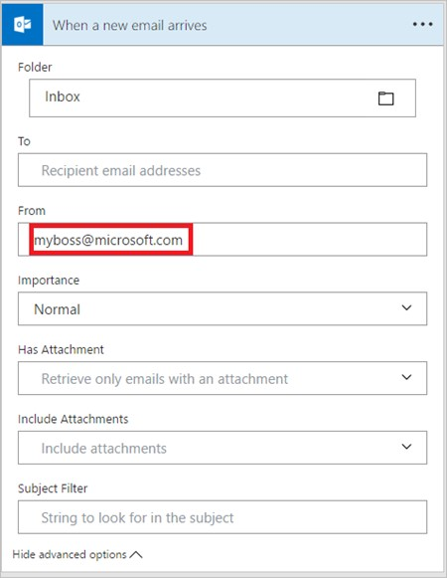

1. Select **New step** > **Add an action**.
2. Search for "notification", and then select **Notifications - Send me a mobile notification** from the list of actions.



1. Enter the details for the mobile notification you'd like to receive whenever a message arrives from the email address you entered earlier.

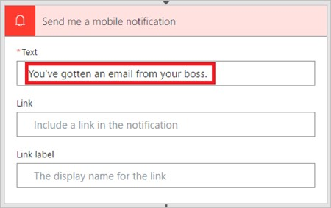

1. Select **New step** > **Add an action**.
2. Search for "read", and then select **Office 365 Outlook - Mark as read** from the list of actions.



1. Add the **MessageId** token into the **Message Id** box on the **Mark as read** card.

If the **Message Id** token isn't visible, search for it by entering **Message Id** in the search box.



1. Give your flow a name, and then save it by selecting **Create flow** at the top of the page.



## Trigger a flow when emails arrive in a specific folder

If you have rules that route email to different folders based on certain properties, such as the address, you may want this type of flow.

Let's get started:

**NOTE**

If you don't already have a rule that routes email to a folder other than your inbox, create such a rule and confirm it works by sending a test email.

1. Sign into [Microsoft Flow](https://flow.microsoft.com/), and then select the **My flows** tab.
2. Select **Create from blank**.



1. Search for "email", and then select **Office 365 Outlook - When a new email arrives** from the list of triggers. This trigger runs each time an email arrives.



1. Select the folder to which you've created the rule to route specific emails. To display all email folders, first select the **Show Picker** icon, which is located on the right side of the **Folder** box on the **When a new email arrives** card.

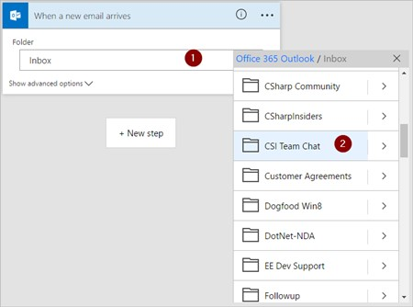

1. Select **New step** > **Add an action**.
2. Search for "notification", and then select **Notifications - Send me a mobile notification** from the list of actions.



1. Enter the details for the mobile notification you'd like to receive when an email arrives into the folder you've selected earlier. If you haven't already, enter the credentials for the notifications service.

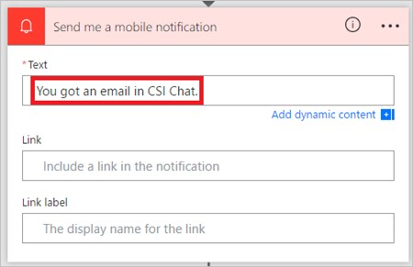

1. Select **New step** > **Add an action**.
2. Search for "read", and then select **Office 365 Outlook - Mark as read** from the list of actions.



1. Add the **MessageId** token into the **Message Id** box on the **Mark as read** card.

If the **Message Id** token isn't visible, search for it by entering **Message Id** in the search box.



1. Give your flow a name, and then save it by selecting **Create flow** at the top of the page.



Test the flow by sending an email that gets routed to the folder you selected earlier in this walkthrough.

# Use the apply to each action in Microsoft Flow to process a list of items periodically

11/3/2017 • 5 min to read • [Edit Online](https://github.com/MicrosoftDocs/flow-docs-pr/blob/live/flow-docs/apply-to-each.md)

Many triggers can immediately start a flow based on an event such as when a new email arrives in your inbox. These triggers are great, but sometimes you want to run a flow that queries a data source on a predefined schedule, taking certain actions based on the properties of the items in the data source. To do this, your flow can be started on a schedule (such as once per day) and use a loop action such as **Apply to each** to process a list of items. For example, you could use **Apply to each** to update records from a database or list of items from Microsoft SharePoint.

In this walk-through, we'll create a flow that runs every 15 minutes and does the following:

1. Gets the last 10 unread messages in your Office 365 Outlook Inbox.
2. Checks each of the 10 messages to confirm if any has **meet now** in the subject.
3. Checks if the email is from your boss or was sent with high importance.
4. Sends a push notification and marks as read any email that has **meet now** in the subject and is either from your boss or was sent with high importance.

This diagram shows the details of the flow we'll create in this walk-through:

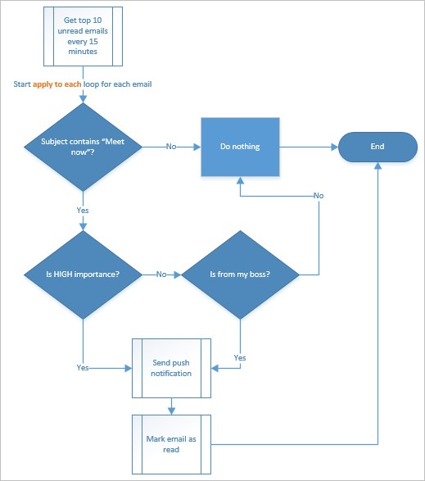

## Prerequisites

Here are the requirements for successfully performing the steps in this walk-through:

An account that's registered to use [Microsoft Flow](https://flow.microsoft.com/).

An Office 365 Outlook account.

The Microsoft Flow mobile app for [Android](https://aka.ms/flowmobiledocsandroid), [iOS](https://aka.ms/flowmobiledocsios), or [Windows Phone](https://aka.ms/flowmobilewindows). Connections to Office 365 Outlook and the push notification service.

## Create a flow

1. Sign into [Microsoft Flow](https://flow.microsoft.com/):
2. Select the **My flows** tab, and then create a flow from a blank:

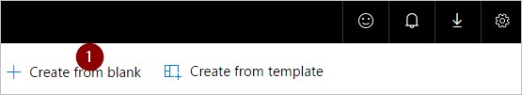

1. Enter "schedule" into the search box to search for all services and triggers that are related to scheduling.
2. Select the **Schedule - Recurrence** trigger to indicate that your flow will run on a schedule that you'll provide next:

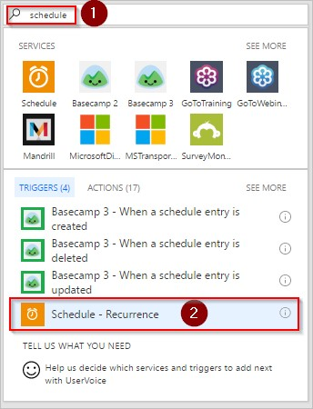

1. Set the schedule to run every 15 minutes:

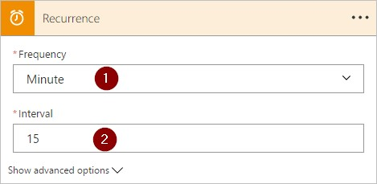

1. Select **+ New step**, **Add an action**, and then type **outlook** into the search box to search for all actions related to Microsoft Outlook.
2. Select the **Office 365 Outlook - Get emails** action:

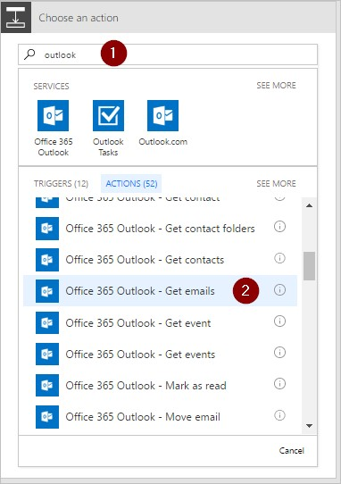

1. This will open the **Get emails** card. Configure the **Get emails** card to select the top 10 unread emails from the Inbox folder. Don't include attachments because they won't be used in the flow:

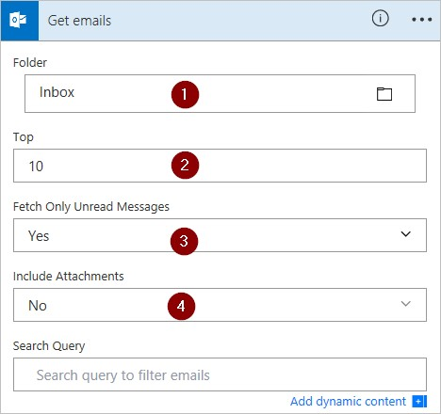

**NOTE**

So far, you've created a simple flow that gets some emails from your inbox. These emails will be returned in an array; the **Apply to each** action requires an array, so this is exactly what's needed.

## Add actions and conditions

1. Select **+ New step**, **More**, and then **Add an apply to each** action:

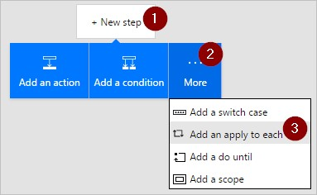

1. Insert the **Body** token into the **Select an output from previous steps** box on the **Apply to each** card. This pulls in the body of the emails to be used in the **Apply to each** action:

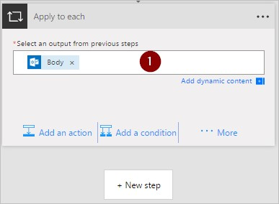

1. Select **Add a condition**:

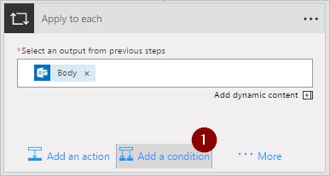

1. Configure the **Condition** card to search the subject of each email for the words "meet now":

Insert the **Subject** token into the **Object Name** box.

Select

**contains**

in the

**Relationship**

list.

Enter

**meet now**

into the

**Value**

box.

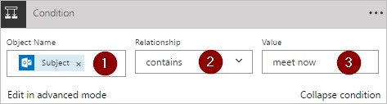

1. Select **More**, and then select **Add a condition** from the **IF YES, DO NOTHING** branch. This opens the **Condition 2** card; configure that card like this:

Insert the **Importance** token into the **Object Name** box.

Select **is equal to** in the **Relationship** list.

Enter

**High**

into the

**Value**

box.

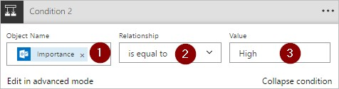

1. Select **Add an action** under the **IF YES, DO NOTHING** section. This will open the **Choose an action** card, where you'll define what should happen if the search condition (the **meet now** email was sent with high importance) is true:

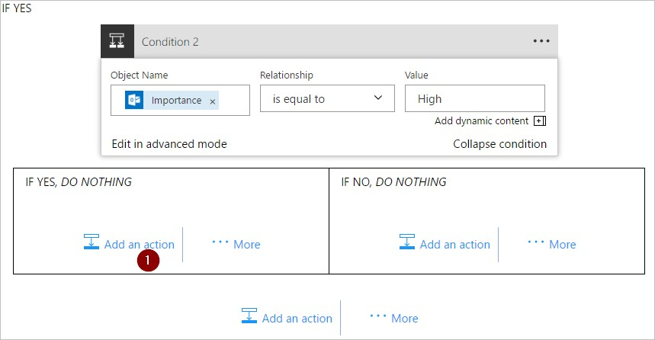

1. Search for **notification**, and then select the **Notifications - Send me a mobile notification** action:

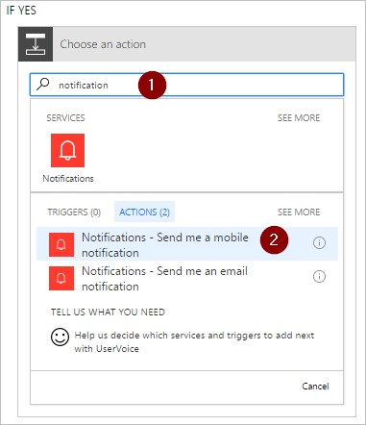

1. On the **Send me a mobile notification** card, provide the details for the push notification that will be sent if the subject of an email contains "meet now", and then select **Add an action**:

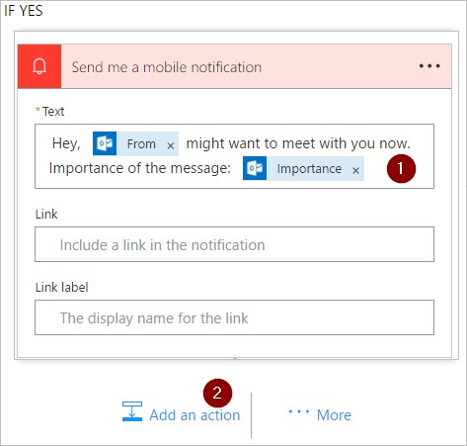

1. Enter **read** as the search term, and then select the **Office 365 Outlook - Mark as read** action. This will mark each email as read after the push notification is sent:

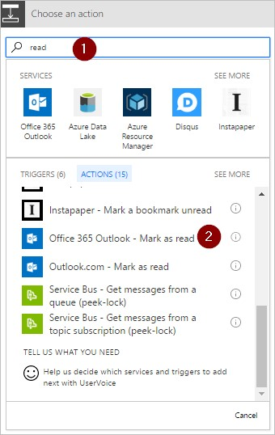

1. Add the **Message Id** token to the **Message Id** box of the **Mark as read** card. You may need to select **See more** to find the **Message Id** token. This indicates the Id of the message that will be marked as read:

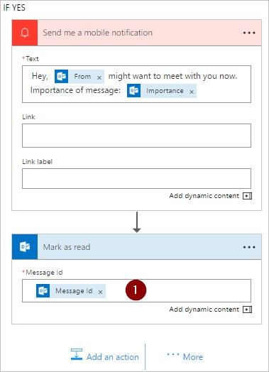

11

.

Going back to the

**Condition 2**

card, on the

**IF NO, DO NOTHING**

branch:

Select

**Add an action**

, and then type

**get manager**

into the search box.

Select the

**Office 365 Users - Get manager**

action from the search results list.

Enter your

*full*

email address into the

**User**

box of the

**Get Manager**

card.

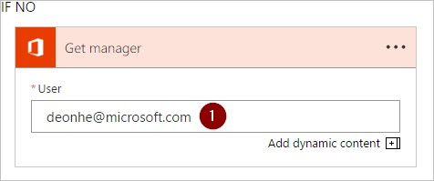

1. Select **More**, and then select **Add a condition** from the **IF NO** branch. This opens the **Condition 3** card; configure the card to check if the email sender's email address (the From token) is the same as your boss'

email address (the Email token):

Insert the

**From**

token into the

**Object Name**

box.

Select

**contains**

in the

**Relationship**

list.

Enter

**Email**

token into the

**Value**

box.

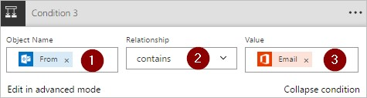

1. Select **Add an action** under the **IF YES, DO NOTHING** section of the **Condition 3** card. This will open the **IF YES** card, where you'll define what should happen if the search condition (the email was sent from your boss) is true:

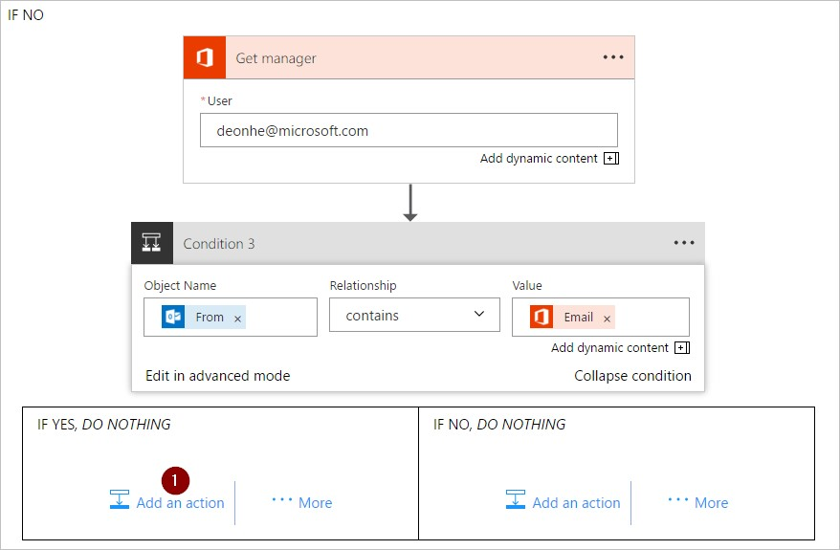

1. Search for **notification**, and then select the **Notifications - Send me a mobile notification** action:



1. On the **Send me a mobile notification 2** card, provide the details for the push notification that will be sent if the email is from your boss, and then select **Add an action**:

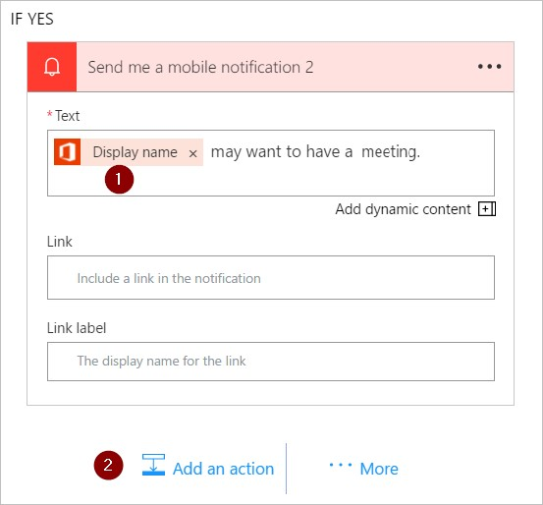

1. Add the **Office 365 Outlook - Mark as read** action. This will mark each email as read after the push notification is sent:



1. Add the **Message Id** token to the **Mark as read 2** card. You may need to select **See more** to find the **Message Id** token. This indicates the Id of the message that will be marked as read:

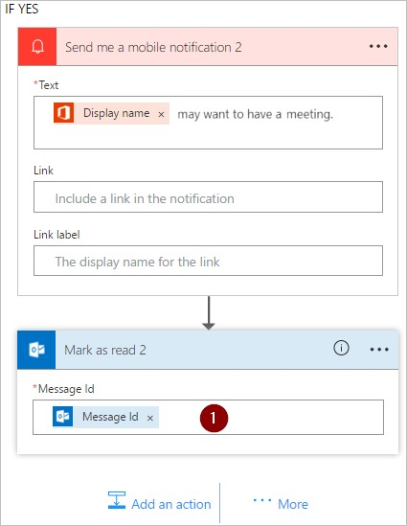

1. Name your flow, and then create it:



If you followed along, your flow should look similar to this diagram:

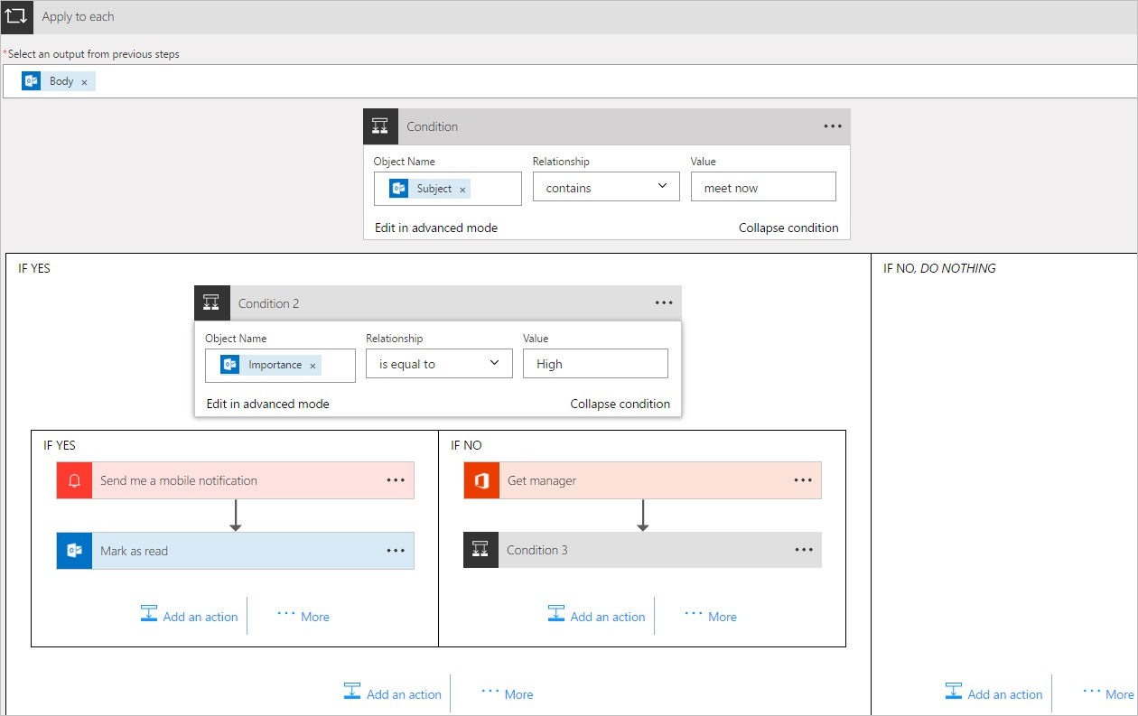

## Run the flow

1. Send yourself a high-importance email that includes **meet now** in the subject (or have someone in your organization send you such an email).
2. Confirm the email is in your inbox and it's unread.
3. Sign into Microsoft Flow, select **My flows**, and then select **Run now**:

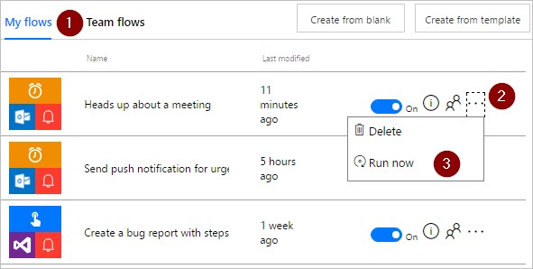

1. Select **Run flow** to confirm you really want to run the flow:

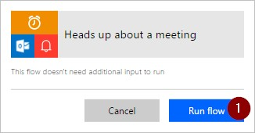

1. After a few moments you should see the results of the successful run:

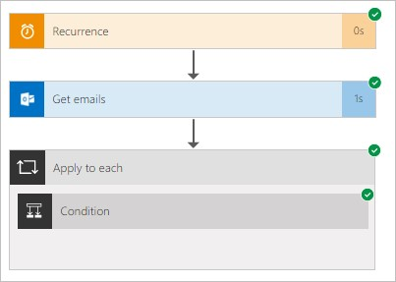

## View results of the run

Now that you've run the flow successfully, you should receive the push notification on your mobile device.

1. Open the Microsoft Flow app on your mobile device, and then select the **Activity** tab. You'll see the push notification about the meeting:

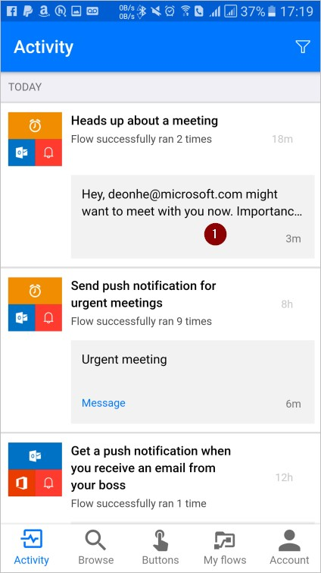

1. To see the full contents of the notification, you may have to select the notification. You'll see the full notification, similar to this:

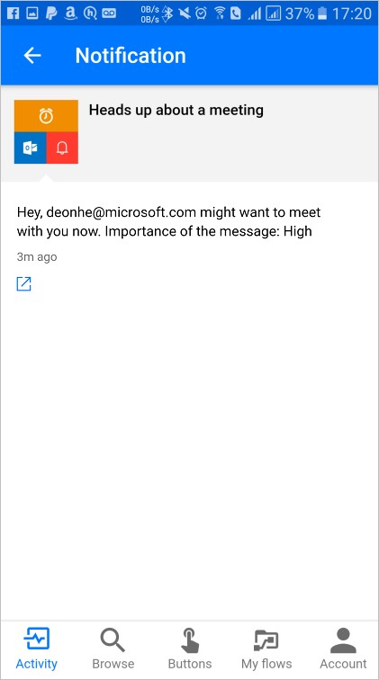

**NOTE**

If you don't receive the push notification, confirm that your mobile device has a working data connection.

# Use data operations with Microsoft Flow

11/3/2017 • 5 min to read • [Edit Online](https://github.com/MicrosoftDocs/flow-docs-pr/blob/live/flow-docs/data-operations.md)

In this walkthrough, you learn about some of the Microsoft Flow’s popular data operations, such as compose, join, select, filter array, create table, and parse JSON that are available to manipulate data when you create flows.

## Prerequisites

Access to Microsoft Flow.

A tool such as [PostMan](https://www.getpostman.com/postman) to send HTTP POST requests with a JSON array to your flow.

## Use the compose action

Use the **Data Operations - Compose** (compose) action to save yourself from entering identical data multiple times when you’re designing a flow. For example, if you need to enter an array of digits: [0,1,2,3,4,5,6,7,8,9] several times while you design your flow, you could use the compose action to save the array like this:

1. Search for **Compose**, and then select the **Data Operations - Compose** (compose) action.

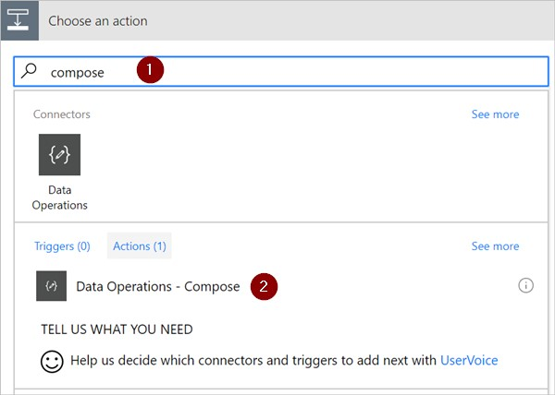

1. Enter the array into the **Inputs** box you want to reference later:

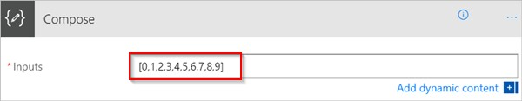

**TIP**

For easier reference later, rename the **Compose** card by clicking on the text "Compose" on the title bar of the **Compose** card.

When you need to access the contents of the compose action, do so via the **Output** token on the **Add dynamic content from the apps and connectors used in this flow** list by following these steps:

1. Add an action such as **Data Operations – Join**.
2. Select the control to which you’d like to add the contents you saved in the compose action.

The **Add dynamic content from the apps and connectors used in this flow** opens.

1. On the **Add dynamic content from the apps and connectors used in this flow**, select the **Output** token that’s under the **Compose** category of the **Dynamic content** tab.

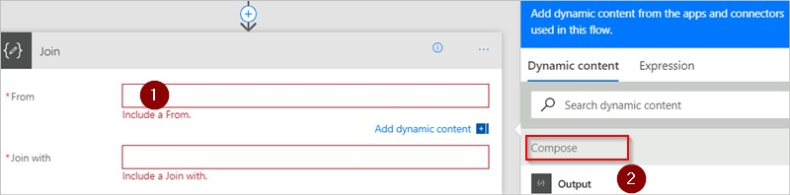

## Use the join action

Use the **Data Operations - Join** action (Join) to delimit an array with a separator of your choice. For example, assume your flow receives a web request that includes the following array of email addresses:

|  |
| --- |
| ["d@example.com", "k@example.com", "dal@example.com"] |

. However, your email program requires addresses to be a

single string that's separated with semicolons. To do this, use the **Data Operations - Join** (join) action to change the comma delimiter to a semicolon “;“ by following these steps:

1. Add a new action, search for **Join**, and then select **Data Operations - Join** (join).

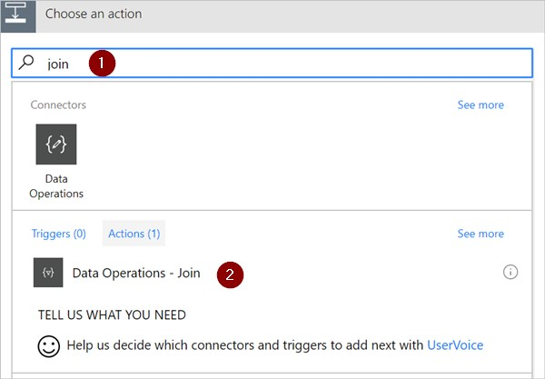

1. Enter the array into the **From** box, and then enter the new delimiter that you want to use into the **Join with** box.

Here, I’ve used the semicolon (;) as the new delimiter.

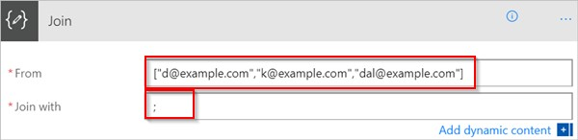

1. Save your flow, and then run it.
2. After your flow runs, the output of the **Data Operations – Join** action will be:

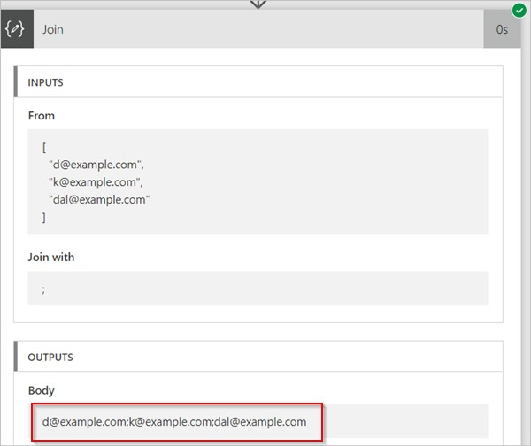

## Use the select action

Use the **Data Operations – Select** (select) to transform the shape of the objects in an array. For example, you may add, remove, or rename elements in each object in an array.

**NOTE**

While you can add or remove elements using the select action, you cannot change the number of objects in the array.

For example, you can use the select action if data enters your flow via a web request in this format:

[ { "first": "Deon", "last": "Herb" }, { "first": "K", "last": "Herb" } ]

and you’d like to reshape the incoming data by renaming "first" to "FirstName", "last" to "LastName" and adding a new member named "FamilyName" that combines "first" and "last" (separated with a space):

[ { "FirstName": "Deon", "FamilyName": "Herb", "FullName": "Deon Herb" }, { "FirstName": "K", "FamilyName": "Herb", "FullName": "K Herb" } ]

.

To do this:

1. Add the **Request / Response – Response** (request) action to your flow.
2. Select the **Use sample payload to generate schema** from the **Request** card.
3. In the box that displays, paste a sample of your source data array, and then select the **Done** button.
4. Add the **Data Operations – Select** (select) action, and then configure it like the following image.

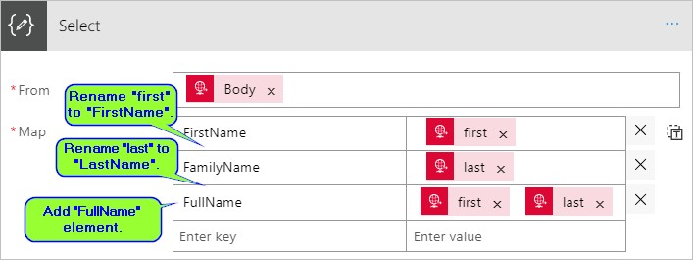

**TIP**

The output from the select action is an array that contains the newly shaped objects. You can then use this array in any other action, such as **Compose**, discussed earlier.

## Use the filter array action

Use **Data Operations - Filter array** (filter array) to reduce the number of objects in an array to a subset that matches the criteria you provide.

**NOTE**

Filter array cannot be used to change the shape of the objects in an array. Also, the text on which you filter is case sensitive.

For example, you can use filter array on this array:

[ { "first": "Deon", "last": "Herb" }, { "first": "K", "last": "Herb" } ]

to create a new array that contains only objects in which *first* is set to “Deon”.

Let's do this.

1. Find, and then add the **Data Operations - Filter array** (filter array) action to your flow.
2. Configure the filter array action like the following image.

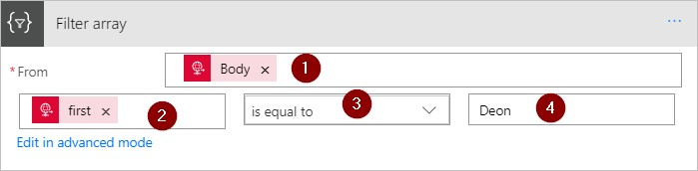

1. Save, and then run your flow.

You can use [PostMan](https://www.getpostman.com/postman) to generate a web request that sends a JSON array to your flow.

1. When your flow runs, assuming the JSON input looks like this array:

|  |
| --- |
| [ { "first": "Deon", "last": "Herb" }, { "first": "K", "last": "Herb" } ] |

,

the output looks like this array (notice that only objects in which *first* is set to “Deon” are included in the output of the action):

[ { "first": "Deon", "last": "Herb" } ]

## Use the create csv table action

Use the **Data Operations - Create CSV table** (create csv table) to change a JSON array input into a comma separated value (CSV) table. Optionally, you can keep the headers visible in the CSV output. For example, you can convert the following array into a CSV table by using the **Create CSV table** action:

[ { "first": "Deon", "last": "Herb" }, { "first": "K", "last": "Herb" } ]

1. Find, add, and then configure the **Data Operations - Create CSV table** action to resemble the following image.

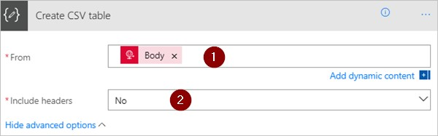

Note: The **Body** token in this image comes from a **Request / Response – Response** action, however, you could get the input for the **Create CSV table** action from the output of any previous action in your flow, or you can enter it directly into the **From** box.

1. Save, and then run your flow.

When your flow runs, the **Create CSV table** output looks like this image:

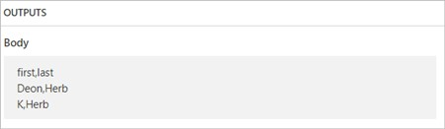

## Use the create html table action

Use **Data Operations - Create HTML table** to change a JSON array input into an HTML table. Optionally, you can keep the headers visible in the HTML output.

To do this, follow the steps in the create csv table section for a detailed example. Be sure to use the **Data Operations - Create HTML table** action, instead of the **Data Operations - Create CSV table** action.

**TIP**

If you plan to send the HTML table via email, remember to select "IsHtml" in the email action.

# Filter and copy data with Microsoft Flow

11/3/2017 • 5 min to read • [Edit Online](https://github.com/MicrosoftDocs/flow-docs-pr/blob/live/flow-docs/odata-filters.md)

This walkthrough shows you how to create a flow that monitors a source for new or changed items and then copies those changes to a destination. You may create a flow like this one if your users enter data in one location, but your team needs it in a different location or format.

While this walkthrough copies data from a Microsoft SharePoint [list](https://support.office.com/en-us/article/SharePoint-lists-I-An-introduction-f11cd5fe-bc87-4f9e-9bfe-bbd87a22a194) (the source) to an [Azure SQL Database](https://docs.microsoft.com/azure/sql-database/sql-database-technical-overview) table (the destination), you can copy data among any of the more than [150 services](https://flow.microsoft.com/connectors/) that Microsoft Flow supports.

**IMPORTANT**

Changes you make in the destination aren't copied to the source because two-way syncs aren't supported. If you attempt to set up a two-way sync, you'll create an infinite loop where changes are sent endlessly between the source and destination.

## Prerequisites

Access to a data source and a destination. This walkthrough doesn’t include steps to create the source and destination.

Access to [Microsoft Flow](https://flow.microsoft.com/).

A basic understanding of how your data is stored.

Familiarity with the basics of creating flows. You can review how to add actions, triggers, and conditions. The following steps assume that you know how to perform these actions.

**TIP**

Every column name in the source and destination don't need to match, but you must provide data for all *required* columns when you insert or update an item. Microsoft Flow identifies the required fields for you.

## Quick overview of the steps

If you're comfortable with Microsoft Flow, use these quick steps to copy data from one data source to another:

1. Identify the source you'll monitor and the destination to which you'll copy changed data. Confirm you've access to both.
2. Identify at least one column that uniquely identifies items in the source and destination. In the example that follows, we use the **Title** column, but you could use any column(s) you want.
3. Set up a trigger that monitors the source for changes.
4. Search the destination to determine if the changed item exists.
5. Use a **Condition** like this:

If the new or changed item doesn't exist in the destination, create it. If the new or changed item exists in the destination, update it.

1. Trigger your flow, and then confirm that new or changed items are being copied from the source to the destination.

**NOTE**

If you haven't created a connection to SharePoint or Azure SQL Database previously, follow the instructions when you're prompted to sign in.

Here are the detailed steps to create the flow.

## Monitor the source for changes

1. Sign into [Microsoft Flow](https://flow.microsoft.com/), select **My flows** > **Create from blank**.
2. Search for **SharePoint** > select the **SharePoint - When an item is created or modified** trigger from the list of triggers.
3. Enter the **Site Address** and then select the **List Name** on the **When an item is created or modified** card.

Provide the **Site Address** and **List Name** for the SharePoint list your flow monitors for new or updated items.

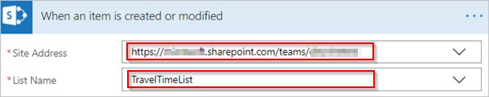

## Search the destination for the new or changed item

We use the **SQL Server - Get rows** action to search the destination for the new or changed item.

1. Select **New step** > **Add an action**.
2. Search for **Get rows**, select **SQL Server - Get rows**, and then select the table you want to monitor from the **Table name** list.
3. Select **Show advanced options**.
4. In the **Filter Query** box, enter **Title eq '**, select the **Title** token from the dynamic content list, and then enter

**'**.

The previous step assumes you're matching the Titles of the rows in the source and the destination.

The **Get rows** card should now look like this image:

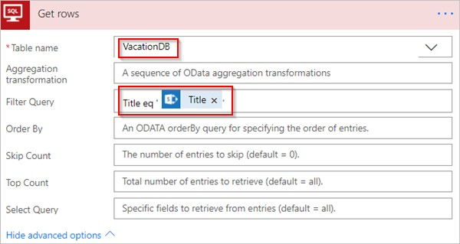

## Check if the new or changed item was found

Select **New step** > **Add a condition** to open the **Condition** card.

On the condition card:

1. Select the box on the left.

The **Add dynamic content from the apps and connectors used in this flow** list opens.

1. Select **value** from the **Get rows** category.

**TIP**

Confirm you've selected **value** from the **Get rows** category. Don't select **value** from the **When an item is created or modified** category.

1. Select **is equal to** from the list in the center box.
2. Enter **0** (zero) in the box on the right side.

The **Condition** card now resembles this image:

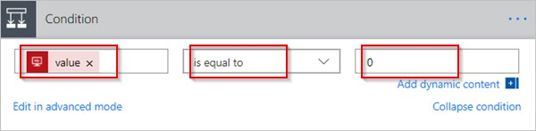

1. Select **Edit in advanced mode**.

When advanced mode opens, you see **@equals(body('Get_rows')?['value'], 0)** expression in the box. Edit this expression by adding **length()** around the **body('Get_items')?['value']** function. The entire expression now appears like this: **@equals(length(body('Get_rows')?['value']), 0)** The **Condition** card now resembles this image:

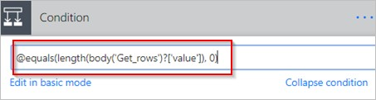

**TIP**

Adding the **length()** function allows the flow to check the **value** list and determine if it contains any items.

When your flow "gets" items from the destination, there're two possible outcomes.

|  |  |
| --- | --- |
| **OUTCOME** | **NEXT STEP** |
| The item exists | Update the item |
| The item doesn't exist | Create a new item |

**NOTE**

The images of the **Insert row** and **Update row** cards shown next may differ from yours because these cards show the names of the columns in the Azure SQL Database table that's being used in the flow.

## Create the item in the destination

If the item doesn't exist in the destination, create it using the **SQL Server - Insert row** action.

On the **If yes** branch of the **Condition**:

1. Select **Add an action**, search for **insert row**, and then select **SQL Server - Insert row**.

The **Insert row** card opens.

1. From the **Table name** list, select the table into which the new item will be inserted.

The **Insert row** card expands and displays all fields in the selected table. Fields with an asterisk (*) are required and must be populated for the row to be valid.

1. Select each field that you want to populate and enter the data.

You may enter the data manually, select one or more tokens from the **Dynamic content**, or enter any combination of text and tokens into the fields.

The **Insert row** card now resembles this image:

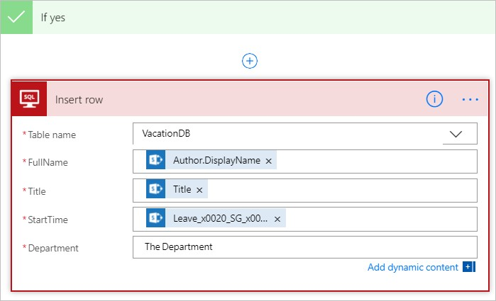

## Update the item in the destination

If the item exists in the destination, update it with the changes.

1. Add the **SQL Server - Update row** action to the **If no** branch of the **Condition**.
2. Follow the steps in the create the item section of this document to populate the fields of the table.

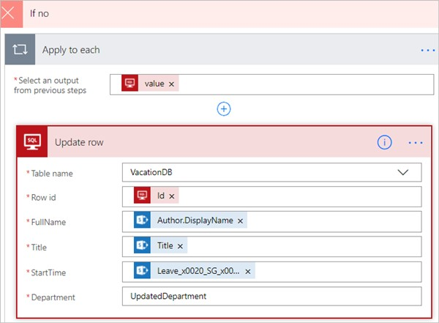

1. At the top of the page, enter a name for your flow in the **Flow name** box, and then select **Create flow** to save it.

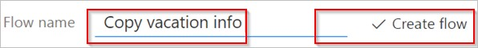

Now, whenever an item in your SharePoint list (source) changes, your flow triggers and either inserts a new item or updates an existing item in your Azure SQL Database (destination).

**NOTE**

Your flow isn't triggered when an item is deleted from the source. If this is an important scenario, consider adding a separate column that indicates when an item is no longer needed.

Learn more

Use data operations in your flows.

# Use expressions in conditions to check multiple values

11/3/2017 • 7 min to read • [Edit Online](https://github.com/MicrosoftDocs/flow-docs-pr/blob/live/flow-docs/use-expressions-in-conditions.md)

In this walkthrough, you'll learn to use expressions and **Conditions** to compare multiple values in **Advanced mode**.

When you create a flow, you can use the **Condition** card in basic mode to quickly compare a single value with another value. However, there're times when you need to compare multiple values. For example, you may want to check the value of a few columns in a spreadsheet or database table.

You can use any combination of the following logical expressions in your conditions.

|  |  |  |
| --- | --- | --- |
| **EXPRESSION** | **DESCRIPTION** | **EXAMPLE** |
| and | Takes two arguments and returns true if both values are true.  **Note**: Both arguments must be Booleans. | This expression returns false: and(greater(1,10),equals(0,0)) |
| or | Takes two arguments and returns true if either argument is true. **Note**: Both arguments must be Booleans. | This expression returns true: or(greater(1,10),equals(0,0)) |
| equals | Returns true if two values are equal. | For example, if parameter1 is someValue, this expression returns true: equals(parameters('parameter1'),  'someValue') |
| less | Takes two arguments and returns true if the first argument is less than the second argument.  **Note**: The supported types are integer, float, and string. | This expression returns true:  less(10,100) |
| lessOrEquals | Takes two arguments and returns true if the first argument is less than or equal to the second argument.  **Note**: The supported types are integer, float, and string. | This expression returns true:  lessOrEquals(10,10) |
| greater | Takes two arguments and returns true if the first argument is greater than the second argument.  **Note**: The supported types are integer, float, and string. | This expression returns false:  greater(10,10) |
| greaterOrEquals | Takes two arguments and returns true if the first argument is greater than or equal to the second argument.  **Note**: The supported types are integer, float, and string. | This expression returns false:  greaterOrEquals(10,100) |
| **EXPRESSION** | **DESCRIPTION** | **EXAMPLE** |
| empty | Returns true if the object, array, or string is empty. | This expression returns true:  empty('') |
| not | Takes two arguments and returns true if the arguments are false. **Note**: Both arguments must be Booleans. | This expression returns true:  not(contains('200 Success','Fail')) |
| if | Returns a specific value if the expression results in true or false. | This expression returns "yes":  if(equals(1, 1), 'yes', 'no') |

## Prerequisites

Access to Microsoft Flow.

A spreadsheet with the tables described later in this walkthrough. Be sure to save your spreadsheet in a location such as Dropbox or Microsoft OneDrive so that Microsoft Flow can access it.

Microsoft Office 365 Outlook (While we use Office 365 Outlook, you can use any supported email service in your flows.)

## Use the or expression

Sometimes your workflow needs to take an action if the value of an item is valueA **or** valueB. For example, you may be tracking the status of tasks in a spreadsheet table. Assume that the table has a column named *Status* and the possible values in the *Status* column are: **completed blocked unnecessary not started**

Here's an example of what the spreadsheet might look like:

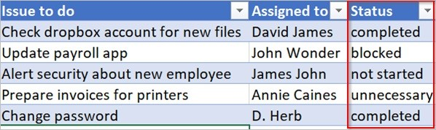

Given the preceding spreadsheet, you want to use Microsoft Flow to remove all rows with a *Status* column that's set to *completed* or *unnecessary*.

Let's create the flow.

**Start with a blank flow** 1. Sign into [Microsoft Flow](https://flow.microsoft.com/).

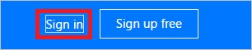

1. Select the **My flows** tab.

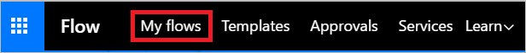

1. Select **Create from blank**.

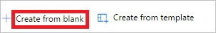

### Add a trigger to your flow

1. Search for **Schedule**, and then select the **Schedule - Recurrence** trigger

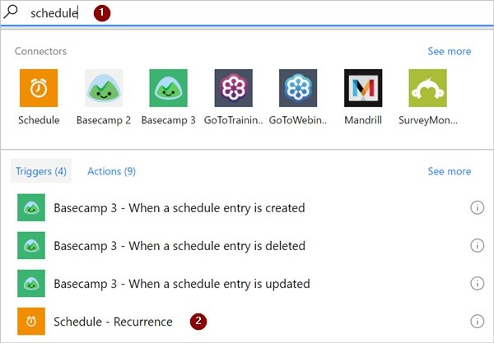

1. Set the schedule to run once daily.

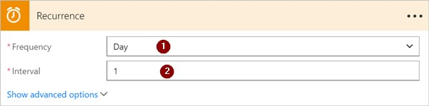

### Select the spreadsheet and get all rows

1. Select **New step** > **Add an action**.

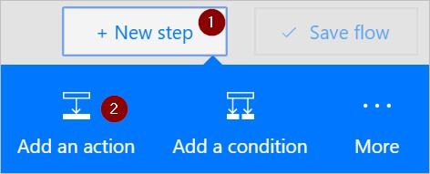

1. Search for **rows**, and then select **Excel - Get rows**.

Note: Select the "get rows" action that corresponds to the spreadsheet that you're using. For example, if you're using Google Sheets, select **Google Sheets - Get rows**.

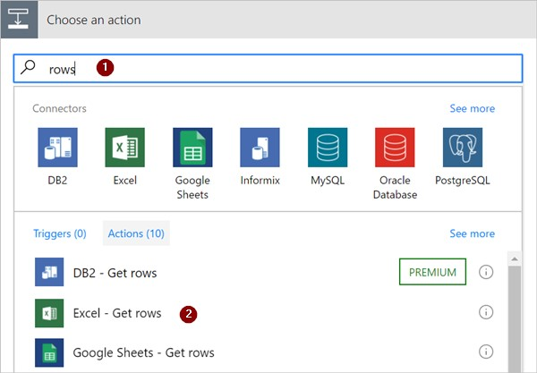

1. Select the folder icon in the **File name** box, browse to, and then select the spreadsheet that contains your data.

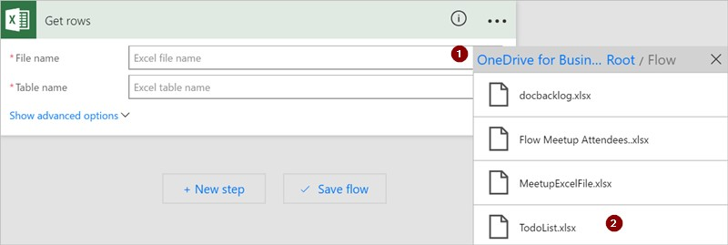

1. Select the table that contains your data from the **Table name** list.

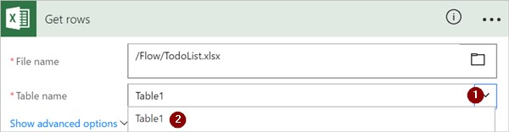

### Check the status column of each row

1. Select **New step** > **More** > **Add an apply to each**.

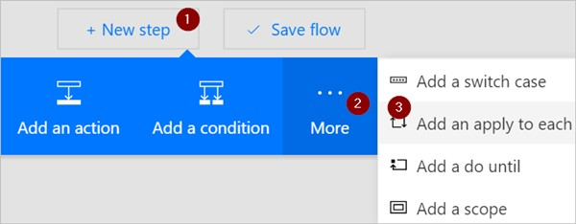

1. Add the **Value** token to the **Select an output from previous steps** box.

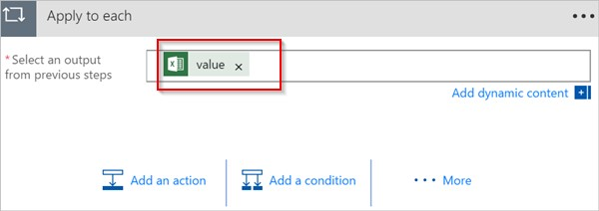

1. Select **Add a condition** > **Edit in advanced mode**.
2. Add the following **or** expression. This **or** expression checks the value of each row in the table (a row is known as an item when accessed in a expression). If the value of the **status** column is *completed* **or** *unnecessary*, the **or** expression evaluates to "true".

The **or** expression appears as shown here:

@or(equals(item()?['status'], 'unnecessary'), equals(item()?['status'], 'completed'))

Your **Condition** card resembles this image:

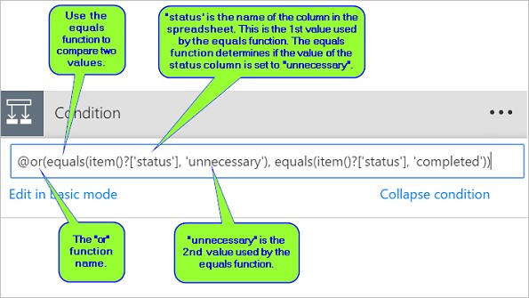

### Delete matching rows from the spreadsheet

1. Select **Add an action** on the **IF YES, DO NOTHING** branch of the condition.
2. Search for **Delete row**, and then select **Excel - Delete row**.

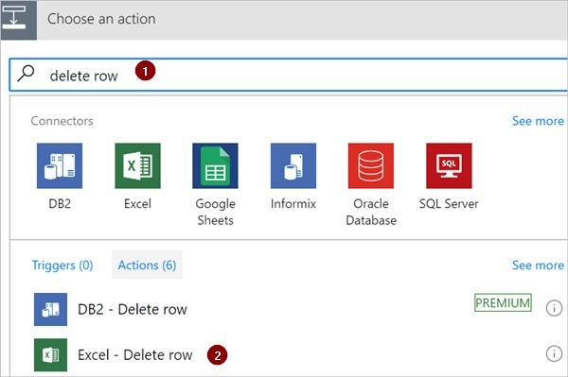

1. In the **File name** box, search for, and select the spreadsheet file that contains the data you want to delete.
2. In the **Table name** list, select the table that contains your data.
3. Place the **Row id** token in the **Row id** box.

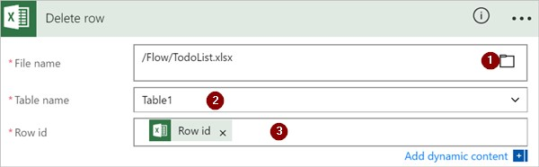

### Name the flow and save it

1. Give your flow a name and then select the **Create flow** button.



### Run the flow with the or expression

The flow runs after you save it. If you created the spreadsheet shown earlier in this walkthrough, here's what the it looks like after the run completes:

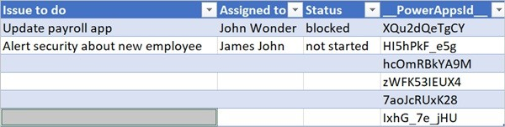

Notice all data from rows that had "completed" or "unnecessary" in the Status column were deleted.

## Use the and expression

Assume you have a spreadsheet table with two columns. The column names are Status and Assigned. Assume also that you want to delete all rows if the Status column's value is "blocked" and the Assigned column's value is "John

Wonder". To accomplish this task, follow all steps earlier in this walkthrough, however, when you edit the **Condition** card in advanced mode, use the **and** expression shown here:

@and(equals(item()?['Status'], 'blocked'), equals(item()?['Assigned'], 'John Wonder'))

Your **Condition** card resembles this image:

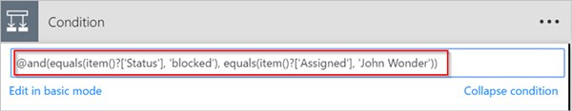

### Run the flow with the and expression

If you followed along, your spreadsheet resembles this image:

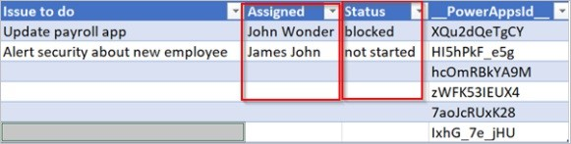

After your flow runs, your spreadsheet resembles this image:

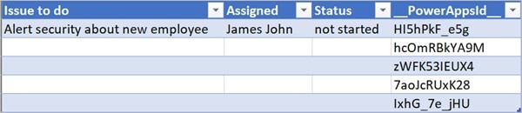

## Use the empty expression

Notice that there are several empty rows in the spreadsheet now. To remove them, use the **empty** expression to identify all rows that don't have any text in the Assigned and Status columns.

To accomplish this task, follow all steps listed in **Use the and expression** section earlier in this walkthrough, however, when you edit the **Condition** card in advanced mode, use the empty expression this way:

@and(empty(item()?['Status']), empty(item()?['Assigned']))

Your **Condition** card resembles this image:

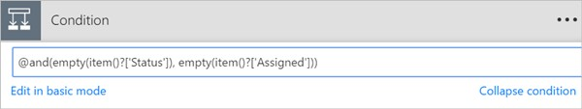

After your flow runs, the spreadsheet resembles this image:

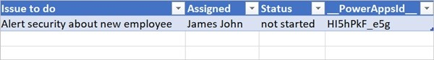

Notice extra lines are removed from the table.

## Use the greater expression

Imagine you've bought baseball tickets for your coworkers and you're using a spreadsheet to ensure you're reimbursed by each person. You can quickly create a flow that sends a daily email to each person who hasn't paid the full amount.

Use the **greater** expression to identify the employees who haven't paid the full amount. You can then automatically send a friendly reminder email to those who haven't paid in full.

Here's a view of the spreadsheet:

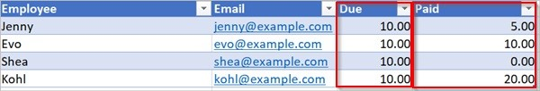

Here's the implementation of the **greater** expression that identifies all persons who have paid less than the amount due from them:

@greater(item()?['Due'], item()?['Paid'])

## Use the less expression

Imagine you've bought baseball tickets for your coworkers, and you're using a spreadsheet to ensure you're reimbursed by each person by the date to which everyone agreed. You can create a flow that sends a reminder email to each person who hasn't paid the full amount if the current date is less than one day before the due date.

Use the **and** expression along with the **less** expression since there are two conditions being validated:

|  |  |  |
| --- | --- | --- |
| **CONDITION TO VALIDATE** | **EXPRESSION TO USE** | **EXAMPLE** |
| Has the full amount due been paid? | greater | @greater(item()?['Due'], item()?['Paid']) |
| Is the due date less than one day away? | less | @less(item()?['DueDate'], addDays(utcNow(),1)) |

## Combine the greater and less expressions in an and expression

Use the **greater** expression to identify the employees who have paid less than the full amount due and use the **less** expression to determine if the payment due date is less than one day away from the current date. You can then the **Send an email** action to send friendly reminder email to those who haven't paid in full and the due date is less than one day away.

Here's a view of the spreadsheet table:

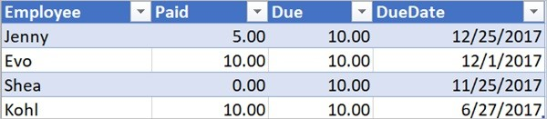

Here's the implementation of the **and** expression that identifies all persons who have paid less than the amount due from them and the due date is less than one day away from the current date:

@and(greater(item()?['Due'], item()?['Paid']), less(item()?['dueDate'], addDays(utcNow(),1)))

Learn more

Learn about other [expressions](https://docs.microsoft.com/azure/logic-apps/logic-apps-workflow-definition-language#functions)

# Create a flow by using Dynamics 365 (online)

11/3/2017 • 6 min to read • [Edit Online](https://github.com/MicrosoftDocs/flow-docs-pr/blob/live/flow-docs/connection-dynamics365.md)

By using a Dynamics 365 connector, you can create flows that initiate when an event occurs in Dynamics 365, or some other service, which then performs an action in Dynamics 365, or some other service.

In Microsoft Flow, you can set up automated workflows between your favorite apps and services to synchronize files, get notifications, collect data, and more. For more information, see Get started with Microsoft Flow.

## Create a flow from a template

You can create a flow using one of the many templates available, such as these examples:

When an object is created in Dynamics 365, create a list item in SharePoint.

Create Dynamics 365 lead records from an Excel table.

Copy Dynamics 365 accounts to customers in Dynamics 365 for Operations.

To create a flow from a template, follow these steps.

1. Sign in to the [Microsoft Flow website](https://flow.microsoft.com/).
2. Click or tap **Services**, and then click or tap **Dynamics 365**.
3. Several templates are available. To get started, select the template that you want.

## Create a task from a lead

If a template isn’t available for what you need, create a flow from scratch. This walkthrough shows you how to create a task in Dynamics 365 whenever a lead is created in Dynamics 365.

1. Sign in to the [Microsoft Flow website](https://flow.microsoft.com/).
2. Click or tap **My flows**, and then click or tap **Create from blank**.
3. In the list of flow triggers, click or tap **Dynamics 365 - When a record is created**.
4. If prompted, sign in to Dynamics 365.
5. Under **Organization Name**, select the Dynamics 365 instance where you want the flow to listen.
6. Under **Entity Name**, select the entity that you want to listen to, which will act as a trigger initiating the flow.

For this walkthrough, select **Leads**.

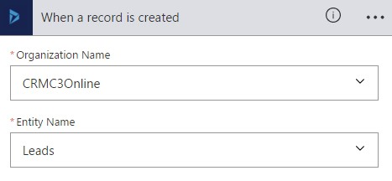

1. Click or tap **New step**, and then click or tap **Add an action**.
2. Click or tap **Dynamics 365 – Create a new record**.
3. Under **Organization Name**, select the Dynamics 365 instance where you want the flow to create the record.

Notice that it doesn’t have to be the same instance where the event is triggered from.

1. Under **Entity Name**, select the entity that will create a record when the event occurs.

For this walkthrough, select **Tasks**.

1. A **Subject** box appears. When you click or tap it, a dynamic content pane appears where you can select either of these fields.

**Last Name**. If you select this field, the last name of the lead will be inserted in the **Subject** field of the task when it's created.

**Topic**. If you select this field, the **Topic** field for the lead will be inserted in the **Subject** field of the task when it's created.

12

.

Click or tap

**Create flow**

.

For this walkthrough, select

**Topic**

.

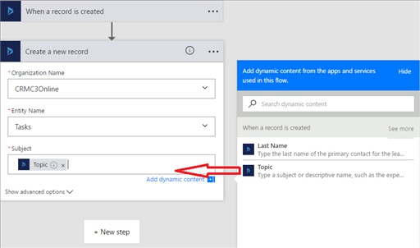

**Tip:**

On the dynamic content pane, click or tap

**See more**

to display more fields that are associated with

the entity. For example, you can also populate the

**Subject**

field of the task with the

**Company Name**

,

**Customer**

,

**Description**

, or

**Email**

field of the lead.

## Create a Wunderlist task from a Dynamics 365 task

This walkthrough shows you how to create a task in [Wunderlist](https://www.wunderlist.com/) whenever a task is created in Dynamics 365.

Wunderlist is an Internet-based service that you can use to create to-do lists, add reminders, or track errands.

1. Sign in to the [Microsoft Flow website](https://flow.microsoft.com/).
2. Click or tap **My flows**, and then click or tap **Create from blank**.
3. In the list of flow triggers, click or tap **Dynamics 365 - When a record is created**.
4. Under **Organization Name**, select the Dynamics 365 instance where you want the flow to listen.
5. Under **Entity Name**, select the entity that you want to listen to, which will act as a trigger to initiate the flow.

For this walkthrough, select **Tasks**.

1. Click or tap **New step**, and then click or tap **Add an action**.
2. Type *create a task*, and then click or tap **Wunderlist – Create a task**.
3. Under **List ID**, select **inbox**.
4. Under **Title**, select **Subject** in the dynamic content pane.
5. Click or tap **Create flow**.

## Specify advanced options

When you add a step to a flow, you can click or tap **Show advanced options** to add a filter or order by query that controls how the data is filtered in the flow.

For example, you can use a filter query to retrieve only active contacts, and you can order them by last name. To do this, enter the OData filter query **statuscode eq 1** and select **Last Name** from the dynamic content pane. For more information about filter and order by queries, see [MSDN: $filter](https://msdn.microsoft.com/library/gg309461.aspx#Anchor_1) and [MSDN: $orderby](https://msdn.microsoft.com/library/gg309461.aspx#Anchor_2).

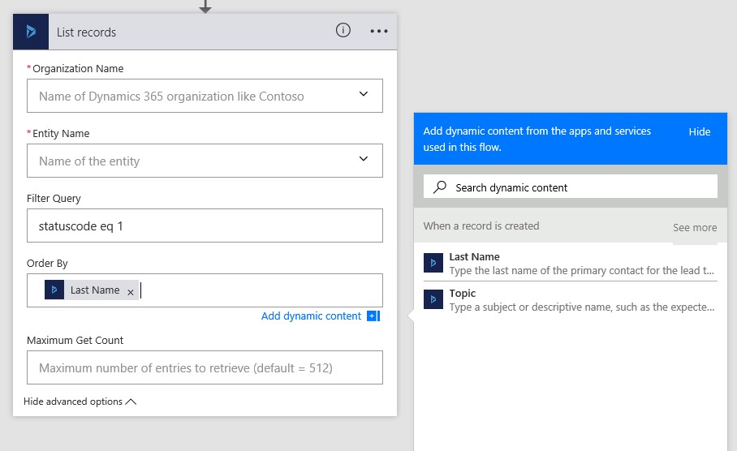

### Best practices when using advanced options

When you add a value to a field, you must match the field type whether you type a value or select one from the dynamic content pane.

|  |  |  |  |  |
| --- | --- | --- | --- | --- |
| **FIELD TYPE** | **HOW TO USE** | **WHERE TO FIND** | **NAME** | **DATA TYPE** |
| Text fields | Text fields require a single line of text or dynamic content that is a text type field. Examples include the **Category** and **SubCategory** fields. | **Settings** >  **Customizations** >  **Customize the**  **System** > **Entities** >  **Task** > **Fields** | **category** | **Single Line of Text** |
| Integer fields | Some fields require integer or dynamic content that is an integer type field. Examples include **Percent Complete** and **Duration**. | **Settings** >  **Customizations** >  **Customize the**  **System** > **Entities** >  **Task** > **Fields** | **percentcomplete** | **Whole Number** |
| **FIELD TYPE** | **HOW TO USE** | **WHERE TO FIND** | **NAME** | **DATA TYPE** |
| Date fields | Some fields require a date entered in mm/dd/yyyy format or dynamic content that is a date type field. Examples include **Created On**, **Start**  **Date**, **Actual Start**,  **Last on Hold Time**, **Actual End**, and **Due**  **Date**. | **Settings** >  **Customizations** >  **Customize the**  **System** > **Entities** >  **Task** > **Fields** | **createdon** | **Date and Time** |
| Fields that require both a record ID and lookup type | Some fields that reference another entity record require both the record ID and the lookup type. | **Settings** >  **Customizations** >  **Customize the**  **System** > **Entities** > **Account** > **Fields** | **accountid** | **Primary Key** |

### More examples of fields that require both a record ID and lookup type

Expanding on the previous table, here are more examples of fields that don't work with values selected from the dynamic content list. Instead, these fields require both a record ID and lookup type entered into the fields in PowerApps.

**Owner** and **Owner Type**.

The **Owner** field must be a valid user or team record ID.

The **Owner Type** must be either **systemusers** or **teams**. **Customer** and **Customer Type**.

The **Customer** field must be a valid account or contact record ID.

The **Customer Type** must be either **accounts** or **contacts**. **Regarding** and **Regarding Type**.

The **Regarding** field must be a valid record ID, such as an account or contact record ID.

The **Regarding Type** must be the lookup type for the record, such as **accounts** or **contacts**.

This example adds an account record that corresponds to the record ID, adding it to the **Regarding** field of the task.

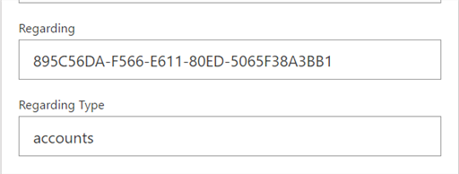

This example also assigns the task to a specific user based on the user's record ID.

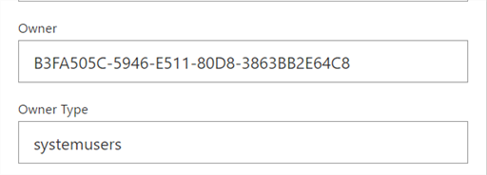

To find a record's ID, see Find the record ID later in this topic.

**Important:** Fields shouldn't contain a value if they have a description of "For internal use only." These fields include **Traversed path**, **Additional Parameters**, and **Time Zone Rule Version Number.**

## Find the record's ID

1. In the Dynamics 365 web application, open a record, such as an account record.
2. On the actions toolbar, click or tap **Pop Out**  (or click or tap **EMAIL A LINK** to copy the full URL to your default email program).

In the address bar of the web browser, the URL contains the record ID between the %7b and %7d encoding characters.



## Related topics

Troubleshooting a flow

Flow in your organization Q&A Frequently asked questions

# Create a flow that uses the Common Data Service

11/3/2017 • 2 min to read • [Edit Online](https://github.com/MicrosoftDocs/flow-docs-pr/blob/live/flow-docs/common-data-model-intro.md)

[Improve operational efficiency with a unified view of business data by creating flow that uses the Common Data](https://powerapps.microsoft.com/tutorials/data-platform-intro/)

[Service. Deploy this secure business database that comprises well-formed standard business entities (such as](https://powerapps.microsoft.com/tutorials/data-platform-intro/) Sales, Purchase, Customer Service, and Productivity) in your organization. Store organizational data in one or more [custom entities](https://powerapps.microsoft.com/tutorials/data-platform-create-entity/), which offer several benefits over external data sources such as Microsoft Excel and Salesforce.

For example, leverage the Common Data Service within Microsoft Flow in these key ways:

Create a flow to import data, export data, or take action on top of data (such as sending a notification). Note that this approach isn't a full synchronization service; it simply allows you to move data in or out on a perentity basis.

For detailed steps, see the procedures later in this topic.

Instead of [creating an approval loop through email](https://docs.microsoft.com/en-us/flow/wait-for-approvals), create a flow that stores approval state in an entity, and build a custom app in which users can approve or reject items.

For detailed steps, see Build an approval loop with the Common Data Service.

**Prerequisites**

Sign up for [Microsoft Flow](https://flow.microsoft.com/) and [PowerApps](https://web.powerapps.com/).

If you have trouble, verify whether Microsoft Flow and [PowerApps](https://powerapps.microsoft.com/en-us/tutorials/signup-for-powerapps/) supports the type of account that you have and your organization hasn't blocked signup.

If you haven't used the Common Data Service before, open the **Entities** tab of [powerapps.com](https://web.powerapps.com/#/entities), and then click or tap **Create my database**.

## Sign in to your Environment

1. Open the [Microsoft Flow portal](https://flow.microsoft.com/), and then click or tap **Sign in** in the upper-right corner.

**Note**: you might need to open the top-left menu to show the **Sign in** button.

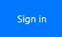

1. In the top right menu you select the environment that you created the database in powerapps.com.

**Note**: if you do not select the same environment then you will not see your entities.

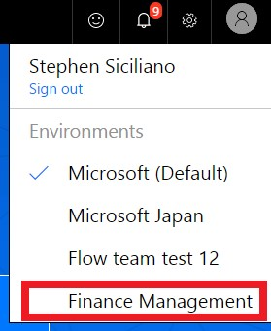

## Open a template

1. In the **Search templates** box at the top of the screen, type or paste **common**, and then press Enter.

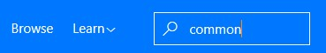

1. In the list of templates, click or tap the template that imports data from the source you want into the entity (or *object*) that you want.

For example, click or tap the template that copies contact information from Dynamics 365 into the Common Data Service.

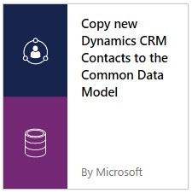

1. Click or tap **Use this template**.

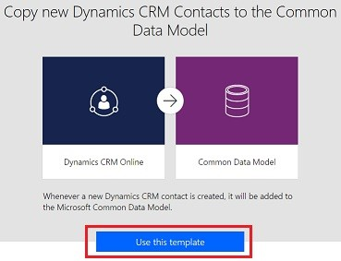

1. If you haven't already created a connection from Microsoft Flow to Dynamics 365, click or tap **Sign in**, and then provide your credentials if prompted.

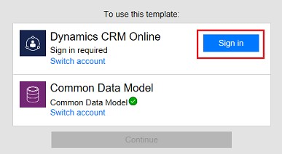

1. Click or tap **Continue**.

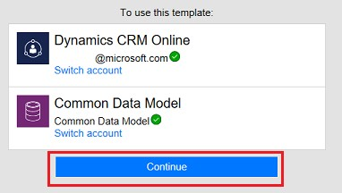

## Build your flow

1. In the first card, specify the event that will trigger the flow.

For example, you're building a flow that will copy new contacts from an instance of Dynamics 365 to the Common Data Service. Under **When a record is created**, specify the instance by clicking or tapping the down arrow and then clicking or tapping an option in the list that appears.

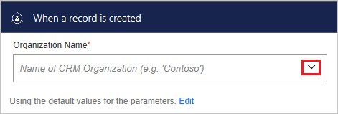

1. (optional) Near the top of the screen, specify a different name for the flow that you're creating.

**Note**: If your browser window isn't maximized, the UI might look slightly different.



1. Click or tap **Create flow**.

**Note**: If your browser window isn't maximized, only the checkmark may appear.

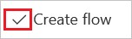

Now, whenever that object is created in the source system, it will be imported into the Common Data Service. If you can't find a template that does what you need, you can build a flow from scratch that operates on top of the Common Data Service.

You can take actions on changes in the database. For example, you can send notification mail whenever data changes.

# Watch your flows in action

11/30/2017 • 1 min to read • [Edit Online](https://github.com/MicrosoftDocs/flow-docs-pr/blob/live/flow-docs/see-a-flow-run.md)

To ensure that your flows run as you expect, perform the trigger, and then review the inputs and outputs that each step in your flow generates.

1. Create or update a flow, and then leave the designer open after you select **Create flow** or **Update flow**.

For example, create a flow that sends mail whenever someone tweets using the **#azure** hashtag.

1. Perform the starting action for your flow.

For example, send a tweet that contains the **#azure** hashtag.

The starting action and each subsequent step indicates whether it succeeded and how long it took

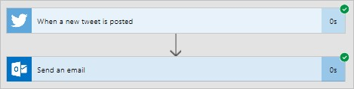

1. Select an individual trigger or action to see its inputs and outputs.

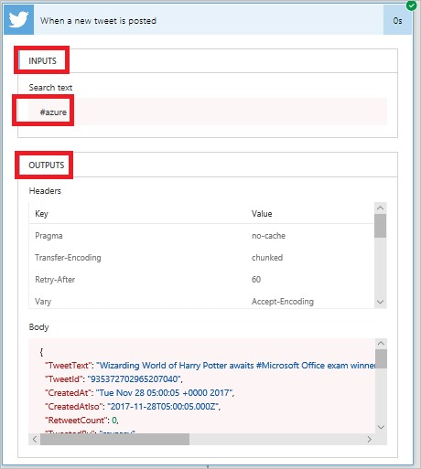

1. Select **Edit flow** to make more changes or select **Done** if the flow works as you expect.

# Submit a template to the Microsoft Flow gallery

11/3/2017 • 1 min to read • [Edit Online](https://github.com/MicrosoftDocs/flow-docs-pr/blob/live/flow-docs/publish-a-template.md)

Submit a flow template to the gallery of templates for Microsoft Flow. Templates help people not only to create flows more easily but also to imagine additional scenarios that would benefit from a flow.

1. On the **My Flows** page, select the ellipsis (...) for a flow.

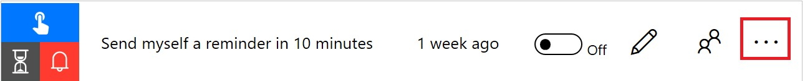

1. In the menu that appears, select **Submit as a template**.

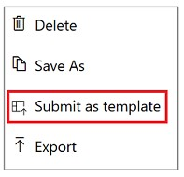

1. Specify a meaningful title, a clear description of the scenario that your template will help automate, and the categories that apply for the template.

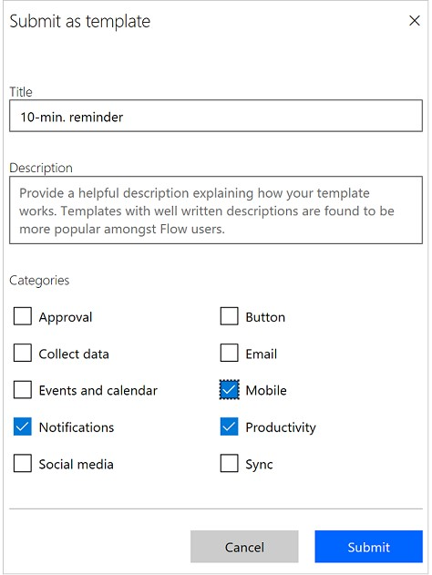

1. Select **Submit**.

The Microsoft Flow team will verify and *possibly modify* your template. If the team approves your template, it will appear in the gallery of templates for Microsoft Flow.

# Troubleshooting a flow

11/3/2017 • 1 min to read • [Edit Online](https://github.com/MicrosoftDocs/flow-docs-pr/blob/live/flow-docs/fix-flow-failures.md)

## Identify the error

Before you can fix a flow, you must identify why it failed. Click or tap the notifications icon at the top of the web portal (or open the **Activity** tab in the mobile app), and then click or tap your flow in the list that appears.

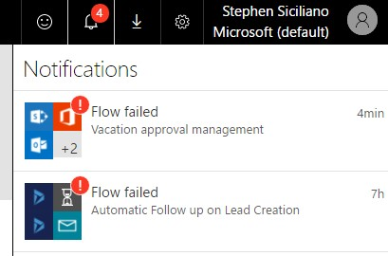

Details about the flow appear, and at least one step shows a red exclamation icon. Open that step, and review the error message.

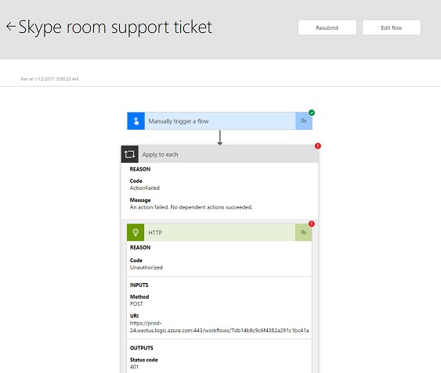

## Authentication failures

In many cases, flows fail because of an authentication error. If you have this type of error, the error message contains **Unauthorized** or an error code of **401** or **403** appears. You can usually fix an authentication error by updating the connection:

1. At the top of the web portal, click or tap the gear icon to open the **Settings** menu, and then click or tap **Connections**.
2. Scroll to the connection for which you saw the **Unauthorized** error message.
3. Next to the connection, click or tap the **Verify password** link in the message about the connection not being authenticated.
4. Verify your credentials by following the instructions that appear, return to your flow-run failure, and then click or tap **Resubmit**.

The flow should now run as expected.

## Action configuration

Flows also fail if a setting in an action of the flow doesn't function as expected. In this case, the error message contains **Bad request** or **Not found**, or an error code of **400** or **404** appears.

The error message should specify how to correct the failure. You'll need to click or tap the **Edit** button and then correct the problem inside the flow definition. Save the updated flow, and then click or tap **Resubmit** to try the run again with the updated configuration.

## Other failures

If the error code **500** or **502** appears, the failure is temporary or transient. Click or tap **Resubmit** to try the flow again.

If you encounter some other problem, [please ask our community](https://go.microsoft.com/fwlink/?LinkID=787467) because others may have encountered a similar problem.

# Create and test an approval workflow with Microsoft Flow

11/3/2017 • 4 min to read • [Edit Online](https://github.com/MicrosoftDocs/flow-docs-pr/blob/live/flow-docs/modern-approvals.md)

With Microsoft Flow, you can manage the approval of documents or processes accross several services, including SharePoint, Dynamics CRM, Salesforce, OneDrive for Business, Zendesk, or WordPress.

To create an approval workflow, add the **Approvals - Start an approval** action to any flow. After you add this action, your flow can manage the approval of documents or processes. For example, you can create document approval flows that approve invoices, work orders, or sales quotations. You can also create process approval flows that approve vacation requests, overtime work, or travel plans.

Approvers manage requests from their email inbox, [the approvals center](https://flow.microsoft.com/manage/approvals/received/) on the Microsoft Flow website, or the Microsoft Flow app.

## Create an approval flow

Here's an overview of the flow we'll create and test:

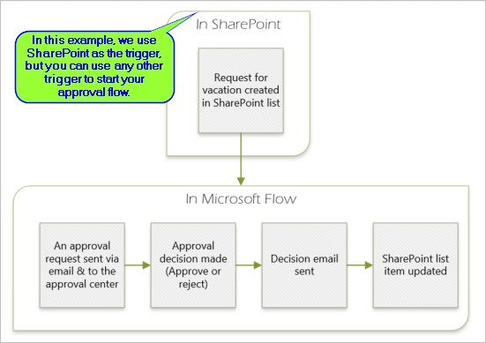

The flow performs the following steps:

1. Starts when someone creates a vacation request in a SharePoint Online list.
2. Adds the vacation request to the approval center, and then emails it to the approver.
3. Sends an email with the approver's decision to the person who requested vacation.
4. Updates the SharePoint Online list with the approver's decision comments.

## Prerequisites

To complete this walkthrough, you must have access to:

[Microsoft Flow](https://flow.microsoft.com/).

A SharePoint Online list.

Office 365 Outlook and Office 365 Users account.

**NOTE**

While we use SharePoint Online and Office 365 Outlook in this walk-through, you can use other services such as Zendesk, Salesforce, or Gmail.

Before you create the flow, create a [SharePoint Online list](https://support.office.com/article/Training-Create-and-set-up-a-list-1DDC1F5A-A908-478B-BB6D-608F34B71F94); later, we'll use this list to request approval for vacations. Create these columns in your SharePoint Online list:

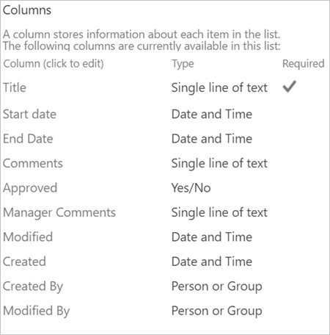

Make note of the name and URL of the SharePoint Online list. You'll need these items later when you configure the **SharePoint - When a new item is created** trigger.

## Create your flow from the blank template

1. Sign into [Microsoft Flow](https://flow.microsoft.com/).



1. Select the **My flows** tab.



1. Select **Create from blank**.



## Add a trigger

1. Enter **SharePoint** into the search box.

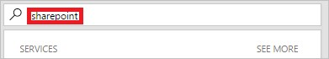

1. Find, and then select the **SharePoint - When a new item is created** trigger.

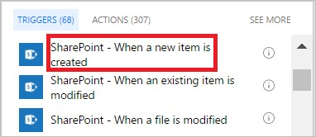

1. Select the **Site Address** and the **List Name** for the SharePoint list that your flow monitors for new items.

The **Site Address** and the **List Name** are the items you noted earlier in this walkthrough.

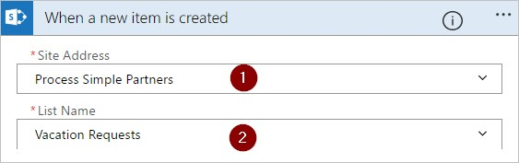

## Add a profile action

1. Select **New step**, and then select **Add an action**.

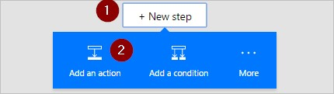

1. Enter **profile** into the **Choose an action** search box.

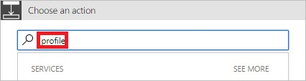

1. Find, and then select the **Office 365 Users - Get my profile** action.

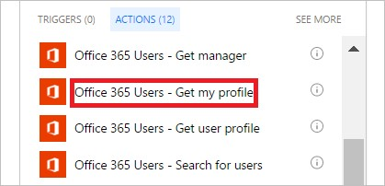

1. Provide a name for your flow, and then select **Create flow** to save the work we've done so far.

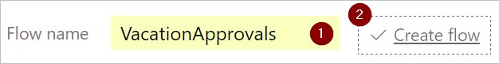

## Add an approval action

1. Select **Edit flow**.

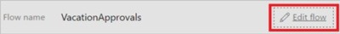

1. Select **New step**, and then select **Add an action**.



1. Enter **approval** into the **Choose an action** search box.

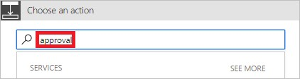

1. Select the **Approvals - Start an approval** action.

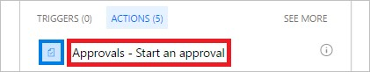

1. Configure the **Start an approval** card to suit your needs.

Note: **Title** and **Assigned To** are required.

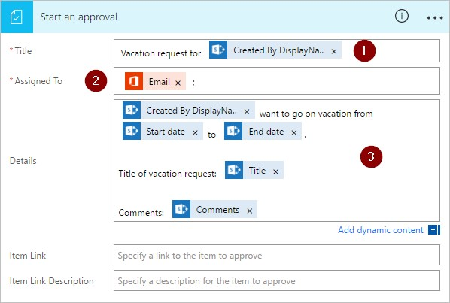

Note: This action sends the approval request to the email address in the **Assigned To** box.

## Add a condition

1. Select **New step**, and then select **Add a condition**.

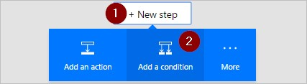

1. Select the **Object Name** box, and then enter **response** into the search box on the **Add dynamic content from the apps and services used in this flow** card.
2. Select the **Response** token.

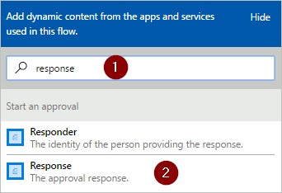

1. Select the **Value** box, and then enter **Approve** into the box.

**NOTE**

The valid responses to the **Approvals - Start an approval** action are "Approve" and "Reject". These responses are case-sensitive.

1. Your **Condition** card should now resemble this image:

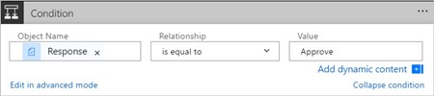

## Add an email action for approvals

Follow these steps to send an email if the vacation request is approved:

1. Select **Add an action** on the **IF YES, DO NOTHING** branch of the condition.

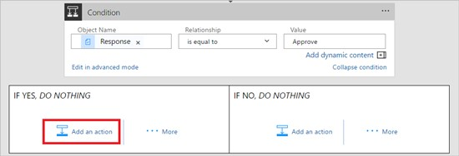

1. Enter **send email** into the search box on the **Choose an action** card.

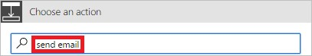

1. Select the **Office 365 Outlook - Send an email** action.

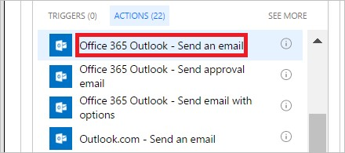

1. Configure the email card to suit your needs.

Note: **To**, **Subject**, and **Body** are required.

This card is a template for the email that is sent when the status of the vacation request changes.

Note: In the **Body** box on the **Send an email** card, use the **Comments** token from the **Approvals - Start an approval** action.

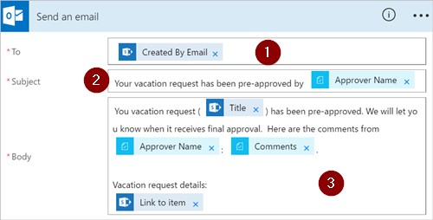

## Add an update action for approved requests

1. Select **Add an action** from the **IF YES** branch.
2. Enter **update** into the search box on the **Choose an action** card.

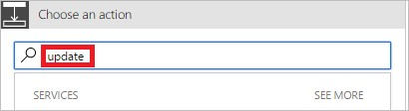

1. Select the **SharePoint - Update item** action.

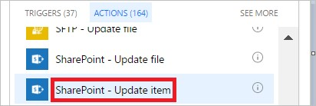

1. Configure the **Update item** card to suit your needs.

Note: **Site Address**, **List Name**, **Id**, and **Title** are required.

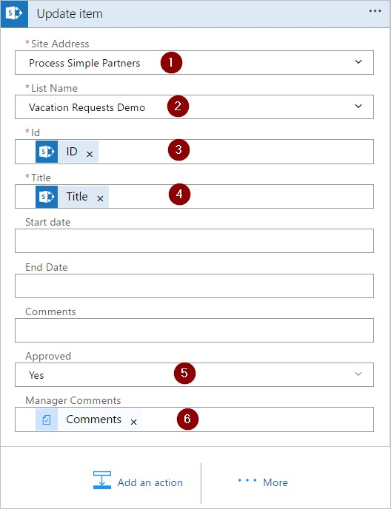

## Add an email action for rejections

1. Select **Add an action** on the **IF NO, DO NOTHING** branch.
2. Enter **Send email** into the search box of the **Choose an action** card.

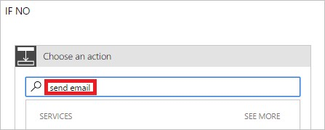

1. Select the **Office 365 Outlook - Send an email** action.

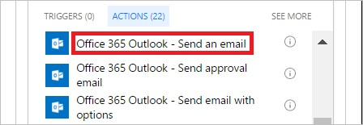

1. Configure the email card to suit your needs.

This card represents the template for the email that's sent when the status of vacation requests change.

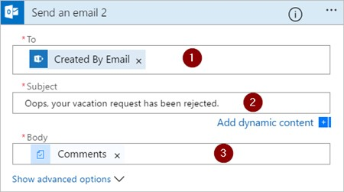

## Add update action for rejected requests

1. Select **Add an action**.

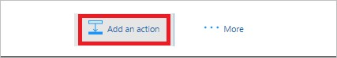

1. Enter **update item** into the search box on the **Choose an action** card.

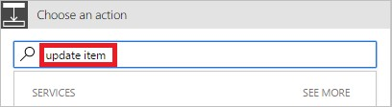

1. Select the **SharePoint - Update item** action.

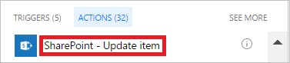

1. Configure the card to suit your needs.

Note: **Site Address**, **List Name**, **Id**, and **Title** are required.

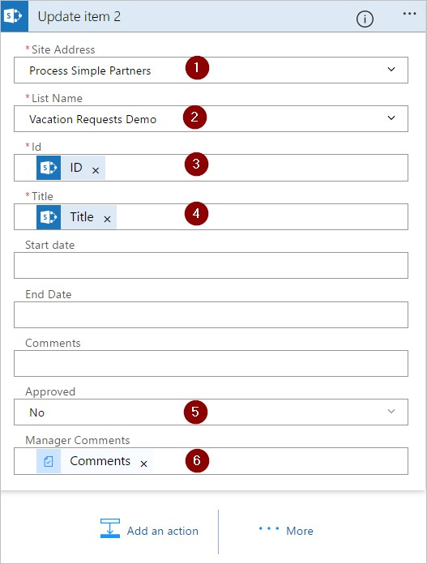

1. Select **Update flow** to save the work we've done.

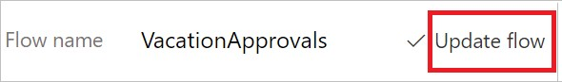

If you've followed along, your flow should resemble this screenshot:

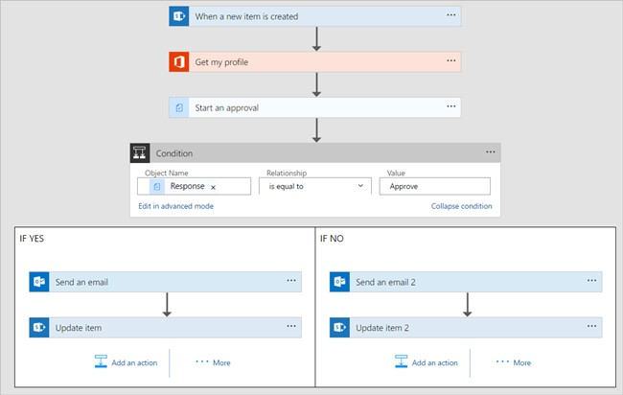

Now that we've created the flow, it's time to test it!

## Request an approval

Create a vacation request in the SharePoint Online list you created earlier.

After you save this request, the flow triggers, and then:

1. Creates a request in the approvals center.
2. Sends an approval request email to the approvers.

Now that you've created and tested your flow, be sure to let others know how to use it.

## Learn more

View and manage [pending approval requests](https://docs.microsoft.com/en-us/flow/approve-reject-requests) Create sequential approval flows.

Create parallel approval flows.

Install the Microsoft Flow mobile app for [Android](https://aka.ms/flowmobiledocsandroid), [iOS](https://aka.ms/flowmobiledocsios), or [Windows Phone](https://aka.ms/flowmobilewindows).

# Manage sequential approvals with Microsoft Flow

11/3/2017 • 8 min to read • [Edit Online](https://github.com/MicrosoftDocs/flow-docs-pr/blob/live/flow-docs/sequential-modern-approvals.md)

Some workflows require pre-approval before the final approver is required to sign off. For example, a company may have a sequential approval policy that requires pre-approval for invoices over $1000.00 before they're approved by the Finance department.

In this walkthrough, we create a sequential approval flow that manages employee vacation requests.

## Detailed steps in the flow

The flow:

1. Starts when an employee creates vacation request in a [SharePoint Online list](https://support.office.com/article/Introduction-to-lists-0a1c3ace-def0-44af-b225-cfa8d92c52d7).
2. Adds the vacation request to the approval center and then emails the request to the pre-approver.
3. Emails the pre-approval decision to the employee.
4. Updates the SharePoint Online list with the pre-approver's decision and comments.

Note: If the request is pre-approved, the flow continues with these steps:

1. Sends the request to the final approver.
2. Emails the final decision to the employee.
3. Updates the SharePoint list with the final decision.

This image summarizes the preceding steps:

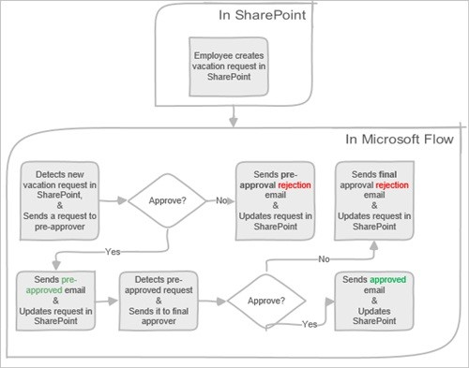

## Prerequisites

[Microsoft Flow](https://flow.microsoft.com/).

A SharePoint Online list.

Office 365 Outlook and Office 365 Users account.

**NOTE**

While we use SharePoint Online and Office 365 Outlook in this walk-through, you can use other services such as Zendesk, Salesforce, or Gmail.

Before you create the flow, create a [SharePoint Online list](https://support.office.com/article/Training-Create-and-set-up-a-list-1DDC1F5A-A908-478B-BB6D-608F34B71F94); later, we'll use this list to request approval for vacations.

The SharePoint Online list that you create must include the following columns:

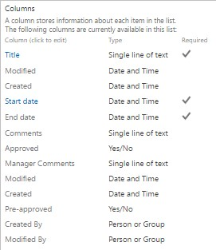

Make note of the name and URL of the SharePoint Online list. We use these items later when you configure the **SharePoint - When a new item is created** trigger.

## Create your flow from the blank template

1. Sign into [Microsoft Flow](https://flow.microsoft.com/).



1. Select the **My flows** tab.



1. Select **Create from blank**.



## Add a trigger

1. Enter **SharePoint** into the search box.



1. Find, and then select the **SharePoint - When a new item is created** trigger.



1. Select the **Site Address** and the **List Name** for the SharePoint list that your flow monitors for new items.

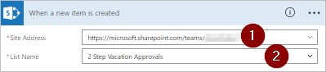

## Get the manager for the person who created the vacation request

1. Select **New step**, and then select **Add an action**.



1. Enter **get manager** into the **Choose an action** search box.
2. Find, and then select the **Office 365 Users - Get manager** action.

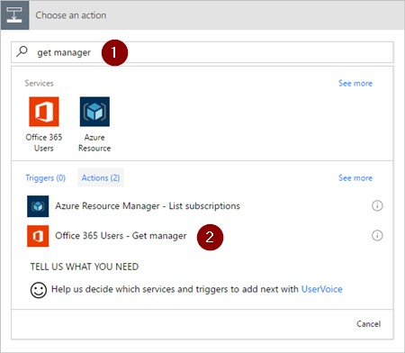

1. Insert the **Created By Email** token into the **User** box on the **Get manager** card.

This action gets the manager for the person who created the vacation request in SharePoint.

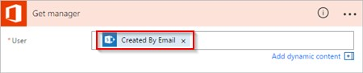

1. Provide a name for your flow, and then select **Create flow** to save the work we've done so far.

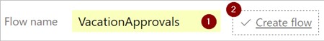

**NOTE**

Select **Update flow** from the top of the screen periodically to save the changes to your flow.

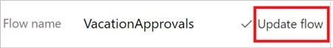

After each save operation, select **Edit flow** from the top of the screen, and then continue making changes.

## Add an approval action for pre-approvals

1. Select **Edit flow**.



1. Select **New step**, and then select **Add an action**.



1. Enter **approval** into the **Choose an action** search box.



1. Select the **Approvals - Start an approval** action.



1. Configure the **Start an approval** card to suit your needs.

Note: **Title** and **Assigned To** are required.



Note: This action sends the pre-approval request to the email address in the **Assigned To** box.

## Add a condition

1. Select **New step**, and then select **Add a condition**.



1. Select the **Object Name** box, and then enter **response** into the search box on the **Add dynamic content from the apps and services used in this flow** card.
2. Select the **Response** token.



1. Select the **Value** box, and then enter **Approve** into the box.

**NOTE**

The valid responses to the **Approvals - Start an approval** action are "Approve" and "Reject". These responses are case-sensitive.

1. Your **Condition** card should now resemble this image:



**NOTE**

This condition checks the response from the **Start an approval** action.

## Add an email action for pre-approvals

1. Select **Add an action** on the **IF YES, DO NOTHING** branch of the condition.



1. Enter **send email** into the search box on the **Choose an action** card.



1. Select the **Office 365 Outlook - Send an email** action.



1. Configure the email card to suit your needs.

Note: **To**, **Subject**, and **Body** are required.

This card is a template for the email that is sent when the status of the vacation request changes.

Note: In the **Body** box on the **Send an email** card, use the **Comments** token from the **Approvals - Start an approval** action.



## Add an update action for pre-approved requests

1. Select **Add an action** from the **IF YES** branch.
2. Enter **update** into the search box on the **Choose an action** card.



1. Select the **SharePoint - Update item** action.



1. Configure the **Update item** card to suit your needs.

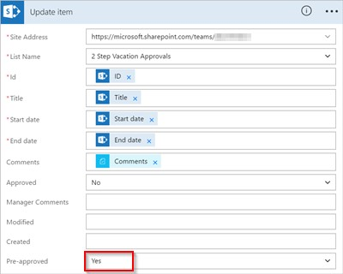

## Get the pre-approver's manager

1. Use the Get the manager for the person who created the vacation request steps we did earlier to add, and then configure another **Get manager** action. This time we get the pre-approver's manager.
2. The **Get manager 2** card should resemble this image when you're finished. Be sure to use the **Email** token from the **Get manager** category on the **Add dynamic content from the apps and services used in this flow** card.

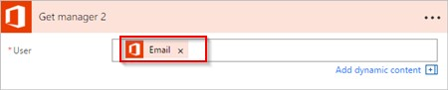

## Add the final approval action

1. Use the add an approval action for pre-approvals steps we did earlier to add, and then configure another **Start an approval** action. This action sends an email request for final approval.
2. When you're done, the card should resemble this image:

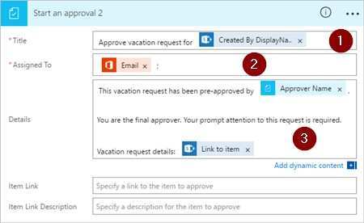

## Add the final approval condition

1. Repeat the steps from add a condition to add, and then configure a **Condition** that checks the final approver's decision.

## Send email with final approval

1. Use the steps from Add an email action for pre-approvals to add, and then configure an action that sends an email when vacation requests are approved.
2. When you're finished, your card should resemble this image:

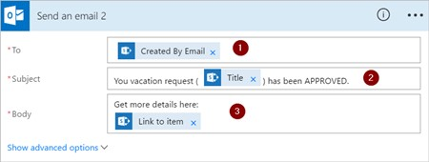

## Update SharePoint with approval

1. Use the steps from Add an update action for pre-approved requests to add, and then configure an action that updates SharePoint when the vacation request is approved.
2. When you're finished, the card should resemble this image:

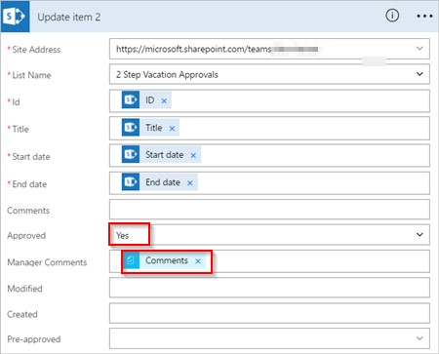

## Send email with pre-approval rejection

1. Select **Add an action** on the **IF NO, DO NOTHING** branch.
2. Enter **Send email** into the search box of the **Choose an action** card.



1. Select the **Office 365 Outlook - Send an email** action.



1. Configure the email card to suit your needs.

This card represents the template for the email that's sent when the status of vacation requests change.

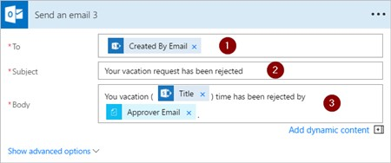

Note: This action must be added to the **IF NO, DO NOTHING** branch below the **Condition** card.

## Update SharePoint with pre-approval rejection

1. Select **Add an action**.



1. Enter **update item** into the search box on the **Choose an action** card.



1. Select the **SharePoint - Update item** action.



1. Configure the card to suit your needs.

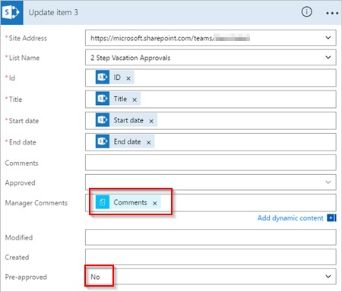

## Send email with final rejection

1. Use the steps from Send email with pre-approval rejection to add, and then configure an action that sends an email when the vacation request is rejected by the final approver.

Note: This action must be added to the **IF NO, DO NOTHING** branch below the **Condition 2** card.

1. When you're finished, the card should resemble this image:

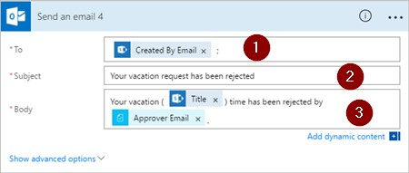

## Update SharePoint with final rejection

1. Use the steps from Update SharePoint with pre-approval rejection to add, and then configure an action that updates SharePoint if the final approver rejects the vacation request.
2. When you're finished, the card should resemble this image:

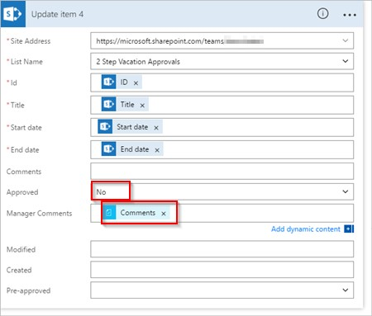

1. Select **Update flow** to save the work we've done.



If you've followed along, your flow should resemble this image:

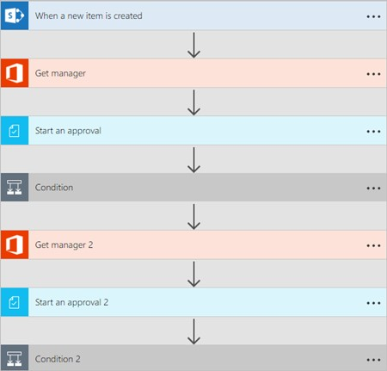

Now that we've created the flow, let's see it in action.

## Request an approval

Create a vacation request in the SharePoint Online list you created earlier.

After you save this request, the flow triggers, and then:

1. Creates a request in the approvals center.
2. Sends an approval request email to the approvers.

Your request should resemble this image:

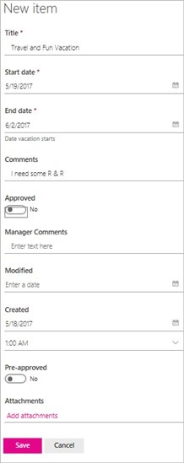

## View pending approval requests

View all pending approval requests by following these steps:

1. Sign into [Microsoft Flow](https://flow.microsoft.com/).



1. Select the **Approvals** tab.

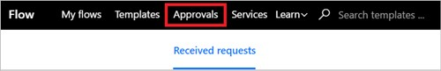

1. Find all pending approval requests under **Received requests**.

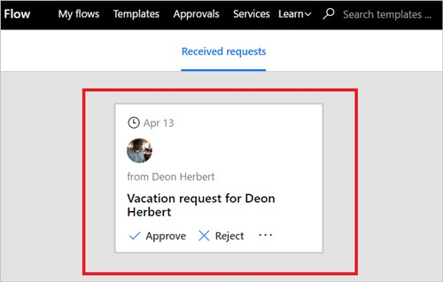

## Pre-approve a request

If you're an approver in an approval flow, you receive an email whenever someone creates a request. The approval request is also sent to the approvals center. You can then approve or reject requests from the email, the approvals center, or the Microsoft Flow app.

To approve a request:

### From email

1. Select **Approve** from the email you receive when an item is added to the SharePoint Online list.

Note: If you're using a mobile device with the Microsoft Flow app installed, the Microsoft Flow app launches, otherwise, the approvals center opens in your browser.

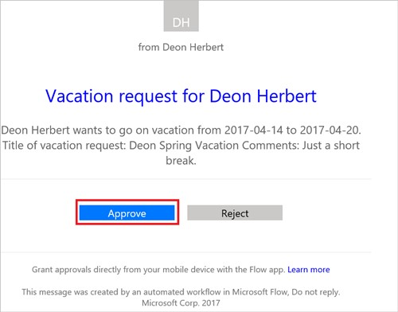

1. Enter a comment, and then select the **Confirm** button.

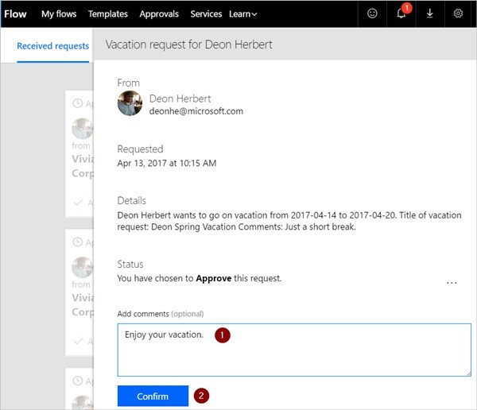

### From the approvals center

1. Sign into [Microsoft Flow](https://flow.microsoft.com/).



1. Select the **Approvals** tab.



1. Select **Approve** on the request you want to approve.

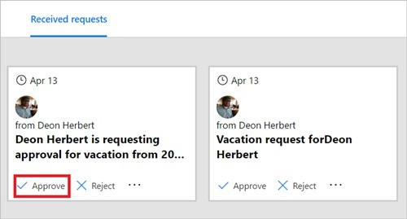

1. Add a note, and then select the **Confirm** button.

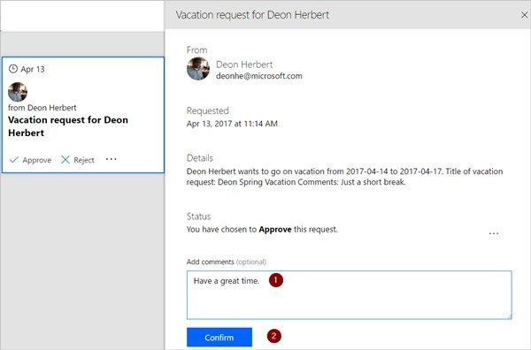

### From the Microsoft Flow app

1. On your mobile phone with the Microsoft Flow app installed, select **Approve** from the request approval email.
2. Select **Confirm** in the upper right corner of the screen.

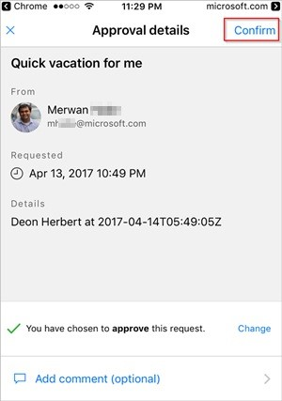

1. The success page shows, indicating that your approval has been recorded.

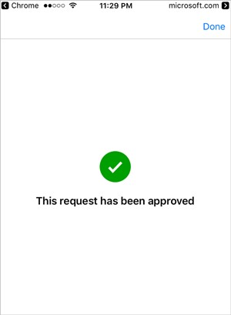

Note: The screens on Android, iOS and Windows Phone may differ slightly, however, the functionality is the same on all devices.

## Approve the request

The steps to approve a request are identical to the steps to pre-approve a request

Note: The final approver gets the vacation request only after the request has been pre-approved.

## Reject a request

You can reject a request via email, the approvals center, or the Microsoft Flow app. To reject a request, follow the steps for approving a request, but select **Reject**, instead of **Approve**.

After you confirm your decision (rejection of the request), the flow runs the following steps:

1. Sends an email to the person who requested vacation.
2. Updates the SharePoint Online list with the decision, and the comments from the approver.

More information

Single approver modern approvals walkthrough

# Create parallel approval workflows with Microsoft Flow

11/3/2017 • 6 min to read • [Edit Online](https://github.com/MicrosoftDocs/flow-docs-pr/blob/live/flow-docs/parallel-modern-approvals.md)

In a parallel approval workflow, multiple persons are required to approve items including invoices, purchase orders, vacation requests, etc. Each person's approval is independent of all other approvers.

In this walkthrough, we use Microsoft Flow to create a flow that automates a parallel approval workflow. This flow automates an employee vacation request process that requires approval from all persons (or teams) that the employee supports regularly. Employees use a [SharePoint list](https://support.office.com/article/Introduction-to-lists-0a1c3ace-def0-44af-b225-cfa8d92c52d7) to request vacation. Vacation approvals are required from the employee's direct manager, the Sales team, and the Human Resources team. Each vacation request is routed to each approver for a decision. The flow sends email with status changes and then updates SharePoint with the decisions.

## Prerequisites

[Microsoft Flow](https://flow.microsoft.com/).

A SharePoint Online list.

Office 365 Outlook and Office 365 Users account.

**NOTE**

While we use SharePoint Online and Office 365 Outlook in this walk-through, you can use other services such as Zendesk, Salesforce, or Gmail.

Before you create the flow, create a [SharePoint Online list](https://support.office.com/article/Training-Create-and-set-up-a-list-1DDC1F5A-A908-478B-BB6D-608F34B71F94); later, we'll use this list to request approval for vacations.

The SharePoint Online list you create must include the following columns:

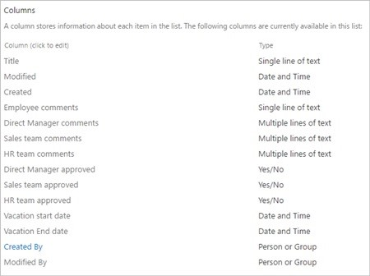

Make note of the name and URL of the SharePoint Online list. We use these items later to configure the **SharePoint - When a new item is created** trigger.

## Create your flow from the blank template

1. Sign into [Microsoft Flow](https://flow.microsoft.com/).



1. Select the **My flows** tab.



1. Select **Create from blank**.



## Add a trigger

1. Enter **SharePoint** into the search box.



1. Find, and then select the **SharePoint - When a new item is created** trigger.



1. Select the **Site Address** and the **List Name** for the SharePoint list that your flow monitors for new items.

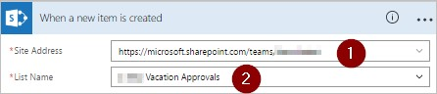

## Get the manager for the person who created the vacation request

1. Select **New step**, and then select **Add an action**.



1. Enter **get manager** into the **Choose an action** search box.
2. Find, and then select the **Office 365 Users - Get manager** action.



1. Insert the **Created By Email** token into the **User** box on the **Get manager** card.

This action gets the manager for the person who created the vacation request in SharePoint.



## Name and save your flow

1. Provide a name for your flow, and then select **Create flow** to save the work we've done so far.



**NOTE**

Select **Update flow** from the top of the screen periodically to save the changes to your flow.



To continue making changes after you save or update your flow, select **Edit flow** from the top of the screen, and then continue making changes.

## Add an approval action for immediate manager

1. Select **Edit flow**.



1. Select **New step**, and then select **Add an action**.



1. Enter **approval** into the **Choose an action** search box.



1. Select the **Approvals - Start an approval** action.



1. Configure the **Start an approval** card to suit your needs.

Note: **Title** and **Assigned To** are required.



**IMPORTANT**

This action sends the vacation request to the email address in the **Assigned To** box, so insert the **Email** token from the **Get manager** list.

## Insert a parallel branch approval action for the sales team

1. Select the down arrow that's located between the **Get manager** card and the **Start an approval** card.
2. Select the plus sign that shows up on the down arrow after you select it.
3. Select **Add a parallel branch**.
4. Select **Add an action**.

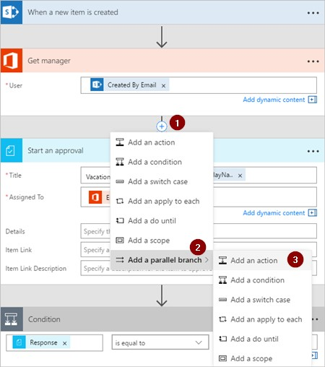

1. Search for, select, and then configure a **Start an approval** action that sends the vacation request to the sales team. See the steps used to Add an approval action for immediate manager if you're not sure how to add the **Start an approval** action.

**IMPORTANT**

Use the sales team's email address in the **Assigned To** box of the **Start an approval** action.

## Insert a parallel branch approval action for the human resources team

1. Repeat the steps to insert a parallel branch for the sales team to add, and then configure a **Start an approval** action to send vacation requests to human resources.

**IMPORTANT**

Use the human resources team's email address in the **Assigned To** box of the **Start an approval** action.

If you've followed along, your flow should resemble this example:

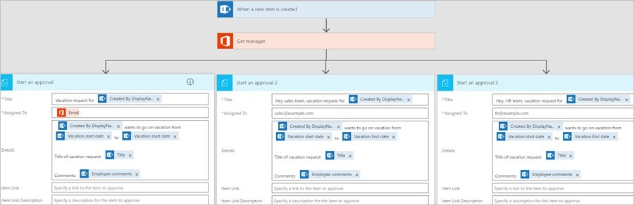

## Options after adding parallel branches

After you've added actions to parallel branches, you have two options for adding more steps to your flow:

Use the small **Insert a new step** button (the circular plus button that appears when you select any white space on a branch or the area immediately below a branch). This button adds a step to that **specific branch**. Steps you add with this button run after this specific branch completes.

Use the larger **New step** button at the bottom of the entire workflow. This button adds an action that runs after **all branches** complete. Steps you add with this button run after all branches complete.

In the following sections, we use the small **Insert a new step** button to perform the following steps on each branch:

Add a condition that checks if the vacation request was approved or rejected.

Send an email that informs the employee of the decision.

Update the vacation request in SharePoint with the approval decision.

Then, we use the larger **New step** button to send an email that summarizes all decisions made on the vacation request.

Let's continue:

## Add a condition to each branch

1. Select any white space on the **Start an approval** branch.
2. Select the small **Insert a new step** button (the circular plus button that appears after you select the white space in the previous step).
3. Select **Add a condition** from the menu that appears.
4. Select the first box on the **Condition** card, and then select the **Response** token from the **Start an approval** category in the dynamic content list.

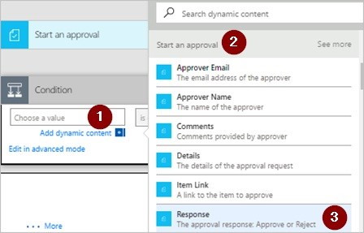

1. Confirm the list (in the middle of the **Condition card**) is set to **is equal to**.
2. Enter **Approve** (this text is case-sensitive) into the last box.
3. Your condition card should now resemble this example:

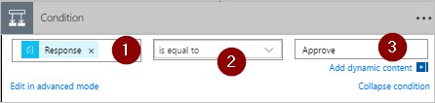

**NOTE**

This condition checks the response from the **Start an approval** action that goes to the employee's manager.

1. Repeat the preceding steps on the **Start an approval 2** (the approval request to sales) and **Start an approval 3** (the approval request to human resources) branches.

## Add email actions to each branch

Perform the following steps on the **IF YES, DO NOTHING** side of the **Condition** branch.

Note: Your flow uses these steps to send an email when the request is approved:

1. Select **Add an action** on the **IF YES, DO NOTHING** branch of the condition.



1. Enter **send email** into the search box on the **Choose an action** card.



1. Select the **Office 365 Outlook - Send an email** action.



1. Configure the email card to suit your needs.

Note: **To**, **Subject**, and **Body** are required.

This card is a template for the email that is sent when the status of the vacation request changes.

Note: In the **Body** box on the **Send an email** card, use the **Comments** token from the **Approvals - Start an approval** action.

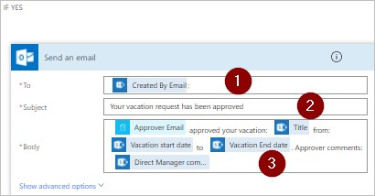

To send an email when a request is rejected, use the **IF NO, DO NOTHING** side of the **Condition** branch, and then repeat the preceding steps to add a template for the rejection email.

Repeat the preceding steps on the **Start an approval 2** (the approval request to sales) and **Start an approval 3** (the approval request to human resources) branches.

## Update the vacation request with the decision

Perform the following steps to update SharePoint when decisions are made.

Note: Be sure perform these steps on both the **IF YES** and the **IF NO** sides of the branch.

1. Select **Add an action** from the **IF YES** branch.
2. Enter **update** into the search box on the **Choose an action** card.



1. Select the **SharePoint - Update item** action.



1. Configure the **Update item** card to suit your needs.

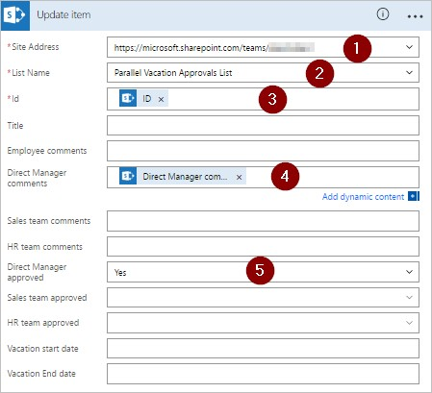

Repeat the preceding steps on the **Start an approval 2** and **Start an approval 3** branches.

## Complete the flow

1. Select **New step** > **Add an action**

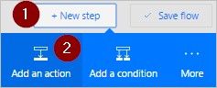

1. Use the steps provided previously to send an email that summarizes the results of each approval. Send this email to the employee who requested vacation. Your card may resemble this example:

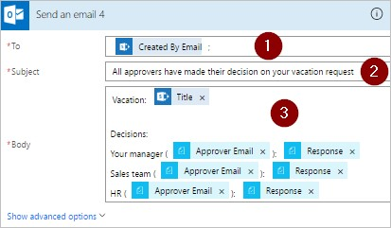

Learn more about modern approvals

Introduction to modern approvals

# Build an approval loop by using Microsoft Flow and the Microsoft Common Data Service

11/3/2017 • 9 min to read • [Edit Online](https://github.com/MicrosoftDocs/flow-docs-pr/blob/live/flow-docs/common-data-model-approve.md)

The Common Data Service can give you a way to build flows that have information stored in a database independent of a flow. The best example of this is with approvals. If you store the status of the approval in an entity, your flow can work on top of it.

In this example, you'll create an approval process that starts when a user adds a file to Dropbox. When the file is added, information about it appears in an app, where a reviewer can approve or reject the change. When the reviewer approves or rejects the change, notification mail is sent, and rejected files are deleted from Dropbox.

By following the steps in this section, you'll build:

a **custom entity** that will contain information about each file added to Dropbox and whether the file's status is approved, rejected, or pending.

a **flow** that adds information to the custom entity when a file is added to Dropbox, sends mail when the file is approved or rejected, and deletes rejected files. These steps demonstrate how to build such a flow from scratch, but you can create a similar flow from a template.

an **app** in which a reviewer can approve or reject files added to Dropbox. You'll use PowerApps to generate this app automatically based on the fields in the custom entity.

**Prerequisites**

Sign up for Microsoft Flow and [PowerApps](https://powerapps.microsoft.com/en-us/tutorials/signup-for-powerapps/).

Create connections to Dropbox and Office 365 Outlook, as [Manage your connections](https://powerapps.microsoft.com/tutorials/add-manage-connections/) describes.

## Build the entity

1. Sign in to [powerapps.com](https://web.powerapps.com/).
2. If the left navigation bar doesn't appear by default, click or tap the icon with three horizontal lines in the upper-left corner.



1. In the left navigation bar, click or tap **Manage**, and then click or tap **Entities**.

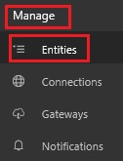

1. If prompted, click or tap **Create my database**.

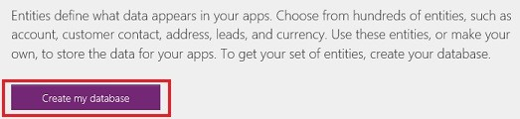

1. Near the upper-right corner, click or tap **New entity**.

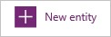

If your browser window isn't maximized, this button might appear in a different place.

1. Under **Entity name**, specify a name that doesn't contain spaces and that no other entity in your database has.

To follow this example exactly, specify **ReviewDropboxFiles**.

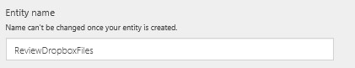

1. Under **Display name**, specify a friendly name.

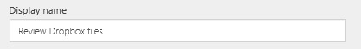

1. Click or tap **Next**.

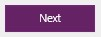

## Add fields to the entity

1. Near the upper-right corner, click or tap **Add field**.

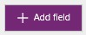

1. In the blank row that appears at the bottom of the list of fields, set the properties of an **Approver** field. (As you set these properties, you can switch to the next column by pressing Tab.)

In the

**Display Name**

column, type

**Approver**

.

In the

**Name**

column, type

**ApproverEmail**

.

In the

**Type**

column, click or tap the

**Email**

option.

In the

**Required**

column, select the checkbox.

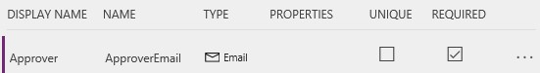

3

.

In the next row, set the properties of a

**Status**

field:

In the **Display Name** column, type **Status**.

In the **Name** column, type **Status**.

In the **Type** column, click or tap the **Text** option.

In the **Properties** column, leave the default value.

In the **Required** column, select the checkbox.

In the **Required** column, select the checkbox.

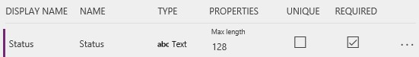

4

.

In the next row, set the properties of a

**FileID**

field:

In the

**Display Name**

column, type

**File identifier**

.

In the

**Name**

column, type

**FileID**

.

In the

**Type**

column, click or tap the

**Text**

option.

In the

**Properties**

column, leave the default value.

In the

**Unique**

column, select the checkbox.

In the

**Required**

column, select the checkbox.

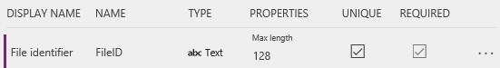

1. Near the right edge, click or tap the ellipsis (...) for the **FileID** field, and then click or tap **Set as Title field**.

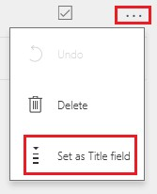

1. Near the lower-left corner, click or tap **Create**.

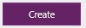

1. (optional) When the list of entities reappears, maximize your browser window if it isn't already maximized, and then click or tap the **Type** column header. The list is sorted with the custom entities, such as the one you just created, appearing at the top.

## Sign in and create a flow

1. Open the [Microsoft Flow portal](https://flow.microsoft.com/).
2. Maximize your browser window if it isn't already maximized, and then click or tap **Sign in** near the upperright corner.



1. In the top right menu you select the environment that you created the database in powerapps.com.

**Note**: if you do not select the same environment then you will not see your entity.

1. Near the upper-left corner, click or tap **My flows**.

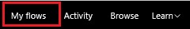

1. Near the upper-right corner, click or tap **Create new flow**.

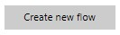

## Start when a file is added

1. In the box that contains **Search for more triggers**, type or paste **Dropbox**, and then click or tap **Dropbox when a file is created**.

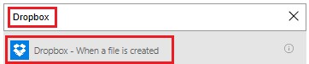

1. Under **Folder**, click or tap the folder icon, and then browse to the folder where files will be added.

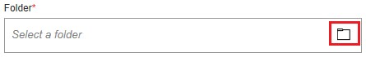

## Add data to the entity

1. Click or tap **New step**, and then click or tap **Add an action**.

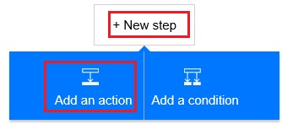

1. In the box that contains **Search for more actions**, type or paste **Common Data Service**, and then click or tap **Common Data Service - Create object**.

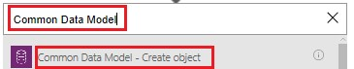

1. Under **The entity**, type or paste **Review**, and then click or tap **Review Dropbox files**.

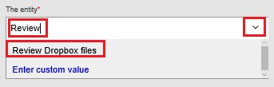

1. Under **Title**, click or tap in the box, and then click or tap **File name** in the list of parameter tokens to add that token to the field.

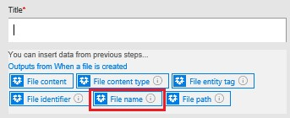

1. Under **Approver**, type or paste the email address of the person who will review the files.

**Note**: To make testing the flow easier, specify your own address. You can change it later, when the flow is ready for actual use.

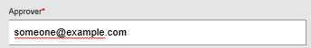

1. Under **Status**, type or paste **Pending**.

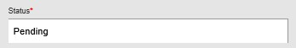

1. Under **File Identifier**, click or tap in the box, and then click or tap **File identifier** in the list of parameter tokens to add that token to the field.

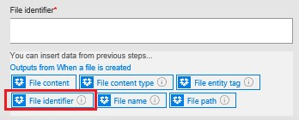

## Check whether the file has been reviewed

1. Under the **Create object** action, click or tap **New step**, click or tap **More**, and then click or tap **Add a do until**.

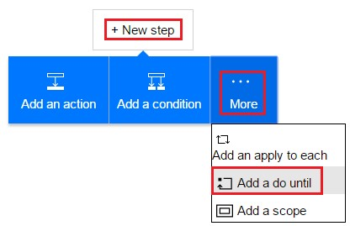

1. In the upper-left corner of the **Do until** action, click or tap in the box that contains **Choose a value**.

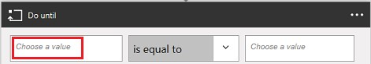

**Note**: If your browser window isn't maximized, click or tap in the upper box that contains **Choose a value**.

1. Under **Outputs from Create object**, click or tap **Status** to add that parameter token to the field.

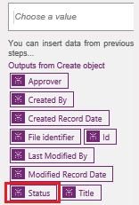

1. Open the list near the center of the **Do until** action, and then click or tap **is not equal to**.

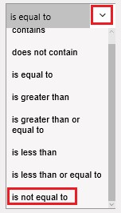

1. In the upper-right corner of the **Do until** action, type or paste **Pending** in the box that contains **Choose a value**.

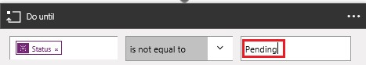

**Note**: If your browser window isn't maximized, click or tap in the lower box that contains **Choose a value**.

1. Near the bottom of the **Do until** action, click or tap **Add an action**.

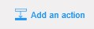

1. In the box that contains **Search for more actions**, type **Common**, and then click or tap **Common Data Service - Get object**.

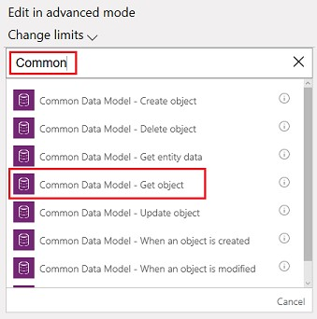

1. Under **The namespace**, click or tap your database.
2. Under **The entity**, type or paste **Review**, and then click or tap **Review Dropbox files**.



1. Under **Object id**, click or tap in the box, and then click or tap the **File identifier** parameter token to add it to the field.

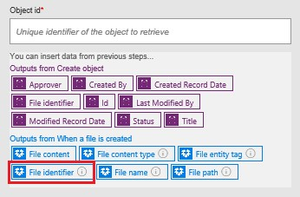

## Check whether the item has been approved

1. Under the **Do-Until** action, click or tap **New step**, and then click or tap **Add a condition**.

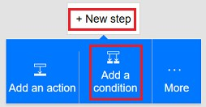

1. In the upper-left corner of the condition, click or tap in the box that contains **Choose a value**.

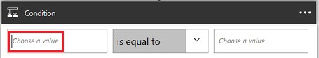

**Note**: If your browser window isn't maximized, click or tap in the upper box that contains **Choose a value**.

1. Under **Outputs from Get object**, click or tap the **Status** parameter token to add it to the field.

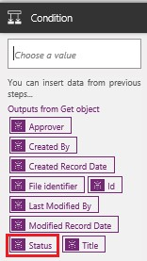

1. In the upper-right corner of the condition, type or paste **Approved** in the box that contains **Choose a value**.

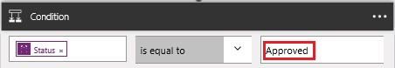

**Note**: If your browser window isn't maximized, type or paste **Approved** in the lower box that contains **Choose a value**.

## Send notification mail

1. Under **If yes, do nothing**, click or tap **Add an action**.

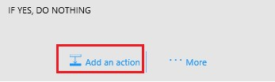

1. In the box that contains **Search for more actions**, type or paste **send mail**, and then click or tap **Office 365 Outlook - Send an email**.

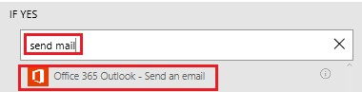

1. Under **To**, type or paste the address of the person whom you want to notify when an item is accepted.

**Note**: To make testing the flow easier, specify your own address. You can change it when the flow is ready for actual use.

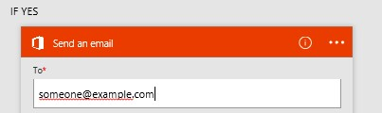

1. Under **Subject**, click or tap in the box, and then click or tap the **File name** parameter token to add it to the field.

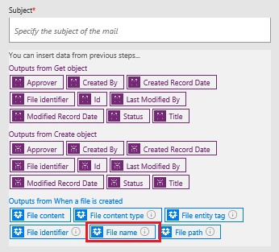

1. Under **Body**, type or paste **The item has been approved.**

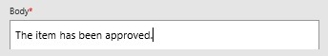

1. Under **If no, do nothing**, repeat steps 1-5 in this procedure except specify the body of the email message as **The item has been rejected.**

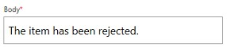

## Delete rejected files

1. Under the fields for the rejection mail, click or tap **Add an action**.

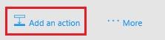

1. In the box that contains **Search for more actions**, type or paste **Dropbox**, and then click or tap **Dropbox Delete file**.

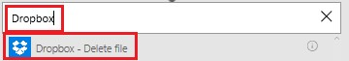

1. Under **File**, click or tap in the box, and then click or tap the **File identifier** token parameter to add it to the field.

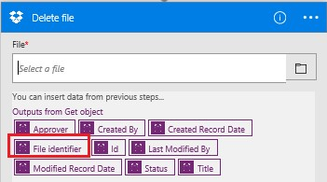

## Save the flow

1. At the top of the screen, type or paste a name for the flow that you're creating, and then click or tap **Create Flow**.



1. Click or tap **Close** and then click or tap **Done**.
2. In Dropbox, add at least two files to the folder that you specified: one to test approval and one to test rejection.

## Build the app

1. Sign in to [powerapps.com](https://web.powerapps.com/), and then click or tap **New app** near the bottom of the left navigation bar.

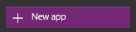

1. In the dialog box that appears, click or tap the option to open either PowerApps Studio for Windows or PowerApps Studio for the web.
2. If you opened PowerApps Studio for Windows, click or tap **New** in the left navigation bar.
3. Under **Create an app from your data**, click or tap **Phone layout** in the **Common Data Service** tile.

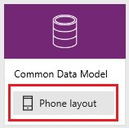

1. In the **Search** box, type or paste **Review**.

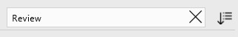

6 Under **Choose an entity**, click or tap **Review Dropbox Files**.

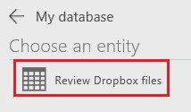

1. Near the lower-right corner, click or tap **Connect**.

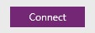

1. If the opening screen of intro tour appears, take the tour to get familiar with PowerApps (or click or tap **Skip**).

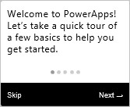

You can always take the tour later by clicking or tapping the question-mark icon near the upper-left corner and then clicking or tapping **Take the intro tour**.

1. (optional) Near the bottom of the screen, drag the slider to increase the zoom so the app is easier to see.

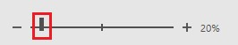

## Customize the app

1. In the right navigation bar, click or tap the layout that includes a header and a description.

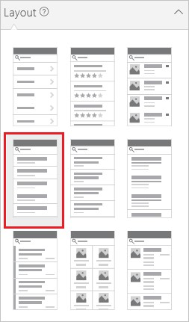

1. On the **BrowseScreen**, click or tap just under the search bar to select the larger text-box control.

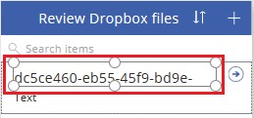

1. In the right-hand pane, open the lower list by clicking or tapping its down arrow.

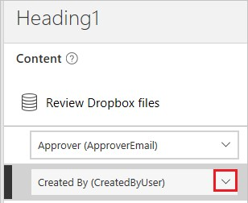

1. In the lower list, click or tap **Title** so show the file name of the added files.

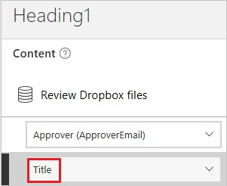

1. In the right-hand pane, open the upper list, and then click or tap **Status** to show the status of each file.

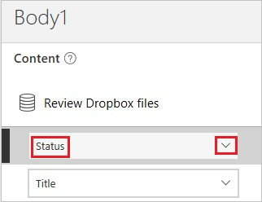

## Test the overall solution

1. In PowerApps, open Preview mode by clicking or tapping the play button near the upper-left corner.



1. For the first file in the list, click or tap the arrow to show details about that file.



3 In the upper-right corner, click or tap the pencil icon to change details about the file.



1. In the **Status** box, type or paste **Approved**.

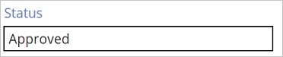

1. In the upper-right corner, click or tap the checkmark icon to save your changes and return to the details screen.



In a few minutes, you'll receive email stating that the file was approved.

1. In the upper-right corner, click or tap the back button to return to the browse screen.



1. For the other file in the list, click or tap the arrow to show details about that file.



1. In the upper-right corner, click or tap the pencil icon to change details about the file.



1. In the **Status** box, type or paste **Rejected** (or anything except **Approved**, including **Aproved** or **Approoved**).

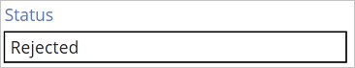

1. In the upper-right corner, click or tap the checkmark icon to save your changes and return to the details screen.



In a few minutes, you'll receive email stating that the file was rejected, and the file will be deleted from Dropbox.

# Create a flow from your phone by using Microsoft Flow

11/3/2017 • 2 min to read • [Edit Online](https://github.com/MicrosoftDocs/flow-docs-pr/blob/live/flow-docs/mobile-create-flow.md)

Create a flow from your phone by using a template, which you can find by searching through a list of services, browsing categories, or specifying keywords. Follow the steps in this topic to create a flow that sends a push notification to your phone when you get mail from your manager.

If you're unfamiliar with Microsoft Flow, get an overview.

## Prerequisites

An account for Microsoft Flow.

The Microsoft Flow mobile app for [Android](https://aka.ms/flowmobiledocsandroid), [iOS](https://aka.ms/flowmobiledocsios), or [Windows Phone](https://aka.ms/flowmobilewindows) on a supported device. The graphics in this topic reflect the iPhone version of the app, but the interface on an Android device or Windows Phone is similar.

To use the template demonstrated in this topic, you'll also need:

Office 365 credentials.

Push notifications enabled on your phone.

## Find a template

1. Open the mobile app, and then tap **Browse** at the bottom of the screen.



You can find a template in any of these ways:

Specify a keyword in the search box at the top of the screen.

Tap an option in the list of services.

Scroll down to show a variety of categories, and then tap a template in any category.

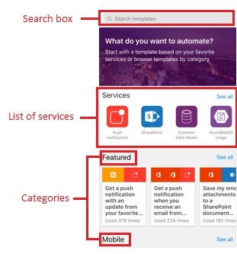

For this tutorial, you'll open the template that sends a push notification when you get mail from your manager.

2 In the list of services, tap **See all**.

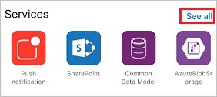

1. Tap the icon for **Push notification**.

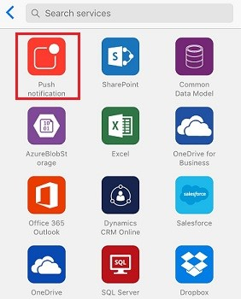

1. In the search bar, type **email**, and then tap the template to send a push notification when you receive a message from your manager.

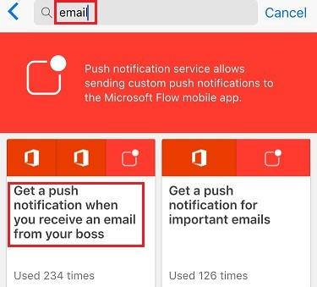

1. In the screen that gives details about the template that you've selected, tap **Use this template**.

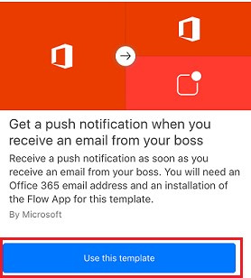

## Finish the flow

1. If prompted, tap **Sign in**, and provide your credentials for Office 365 Outlook, Office 365 Users, or both.

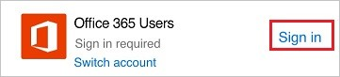

You can use the same connections when you create other flows.

1. In the upper-right corner, tap **Next**.

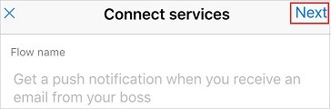

The next screen shows the trigger event and all of the resulting actions.

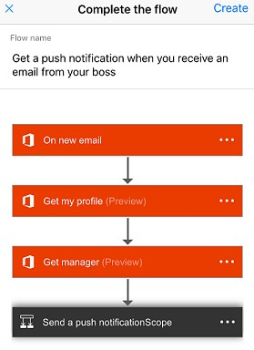

For this template, new mail triggers the flow, which retrieves your information (including your manager's address) and sends you a push notification when you get mail from that address. Some templates require some customization to work properly, but this template doesn't.

1. (optional) Near the top of the screen, type a different name for the flow.

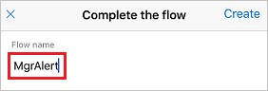

1. In the upper-right corner, tap **Create**.



Your flow is created and will check for mail from your manager until you pause or delete the flow.

## Next steps

Monitor your flow activity.

Manage your flows.

# Introducing button flows

11/3/2017 • 5 min to read • [Edit Online](https://github.com/MicrosoftDocs/flow-docs-pr/blob/live/flow-docs/introduction-to-button-flows.md)

What are button flows?

There are many repetitive tasks that we all wish we could run with just a tap of a button. For example, you may need to quickly email your team to remind them to join the daily team sync, or you may want to start a new Visual Studio Online build of your code base after you've been notified that there are no more checkins planned for the day. Button flows allow you to accomplish these and many other tasks simply by tapping a button on your mobile device.

**Note** You can create button flows either from your mobile device or from the Flow portal.

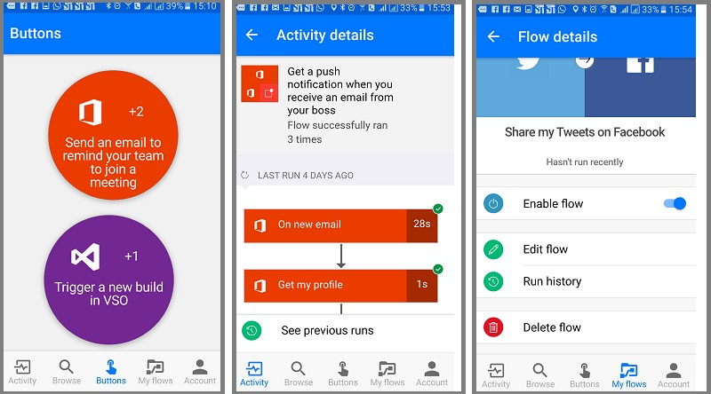

Why create buttons?

Create buttons so that you can easily run repetitive tasks from anyplace, at anytime via your mobile device. Executing buttons saves you time and, since the tasks they perform are automated, there will be less errors than if you manually did them.

## Create a button

### Prerequisites

Access to Flow. Your administrator can provide you with access.

An account with permissions to use the connectors to create your button. For example, you will need a Dropbox account in order to create a button that accesses Dropbox.

### From the portal

In this walk-through, let's create a button that starts a Visual Studio Online (VSO) build and sends notifications to let you know when the build starts:

1. Select the **Showing** drop down list and choose the **Button** category. This filters the list of templates to only those that can be used in button flows.



1. Select the **Trigger a new build in VSO** template from the list of templates.

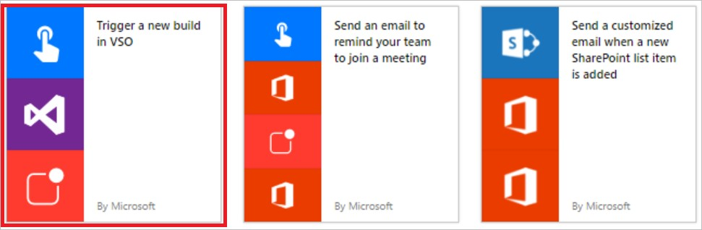

1. Select the **Use this template** button on the **Trigger a new build in VSO** page.

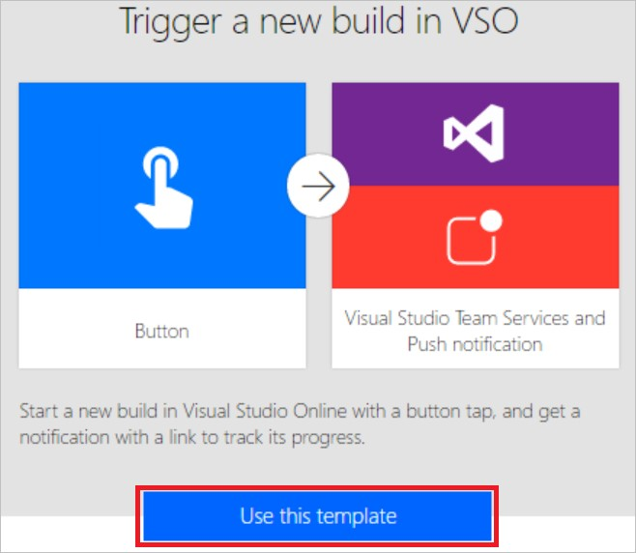

1. If you aren't signed in, you'll be prompted to do so at this point:

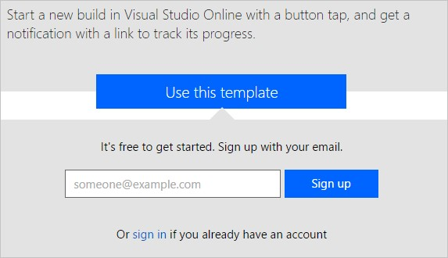

1. After you've signed into Flow, you'll be prompted to sign into the connectors used in the template you've selected. In this example, in step 2 above we selected the **Trigger a new build in VSO** template, so we have to sign into VSO (and any other connectors you are working with), if you're not already signed in:

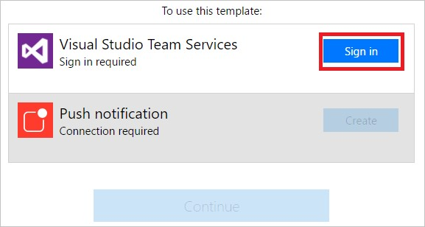

1. Select the **Accept** button if you agree to authorize Flow to access your VSO account.

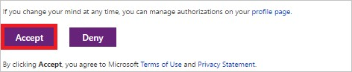

**Note** You'll need to authorize each connector similarly. The designer should appear like this when you are ready to move on to the next step. Select the **Continue** button to move on:

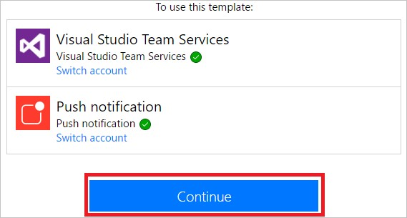

1. You are now ready to configure the properties for the build you wish to start:

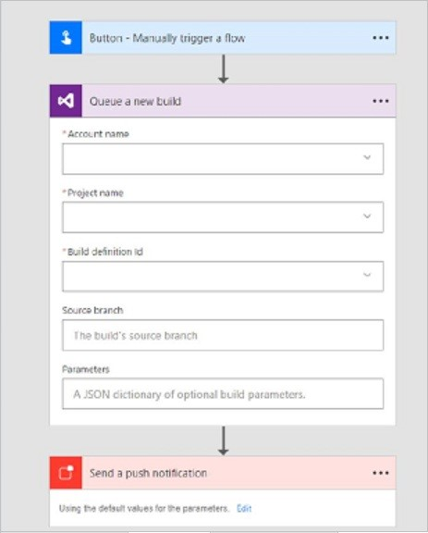

1. Select or enter the **Account name**, **Project name**, **Build definition Id**, **Source branch** and optionally, **Parameters**, in the **Queue a new build** card:

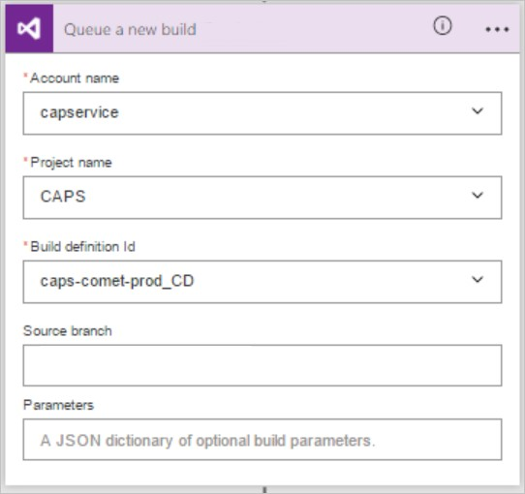

1. Next, configure the properties of the push notification on the **Send a push notification** card. By default, this push notification is configured to send an HTML link to a Web page that displays the status of the build:

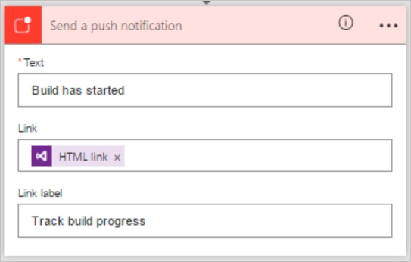

1. Select the **Create flow** button to save your button flow:



1. You should see this success message within a few moments:



Congratulations, you've created a button flow! You can now run this button flow anytime, anyplace, from the **Buttons** tab in the Flow app. Simply press the "button" and it will run! The Microsoft Flow mobile app is available for [Android](https://aka.ms/flowmobiledocsandroid), [iOS](https://aka.ms/flowmobiledocsios), or [Windows Phone](https://aka.ms/flowmobilewindows).

### From your mobile device

**Note**: While this walk-through displays screens from an Android device, the screens and experience on an iOS device are similar.

In the Flow app:

1. Select the **Browse** tab and scroll to the **Button** category.

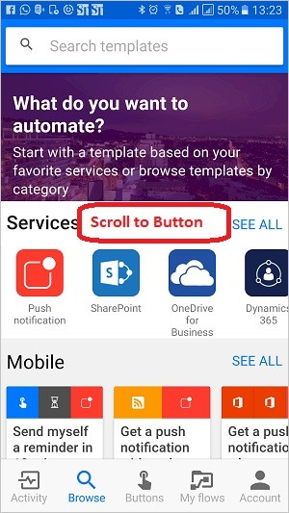

1. Select the **See all** link. This displays all ready-to-go button templates.

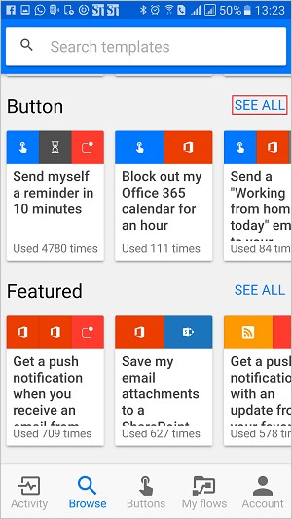

1. Select the **Send an email to remind your team to join a meeting** template

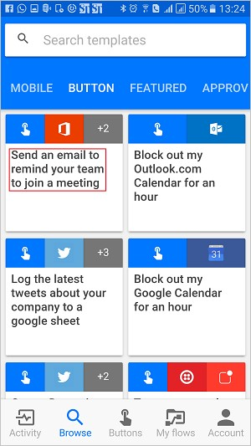

1. Select the **USE THIS TEMPLATE** link, at the bottom of the page.

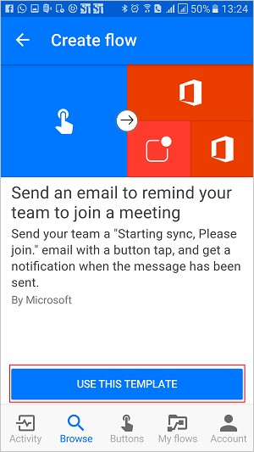

1. You'll need to sign into all services that this template uses:

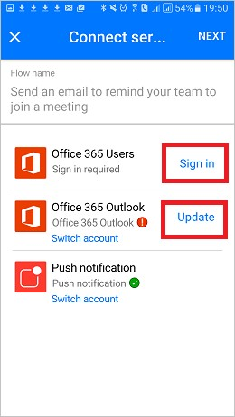

1. Select the **Next** link after you've signed in to all services.

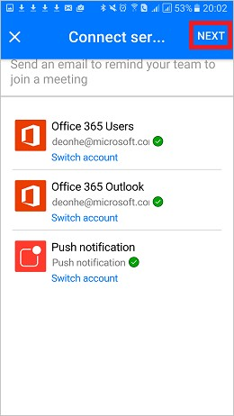

1. Select the **Create** link. Here you can also review the flow and make any changes you require to personalize the email, for example.

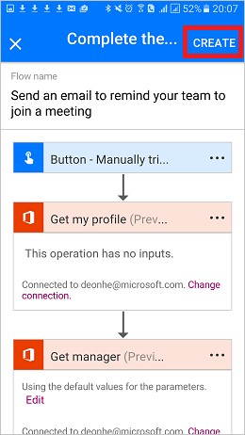

1. After a few moments, the button flow is created. Select **SEE MY FLOW**:

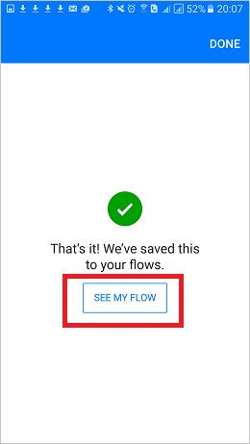

1. View all your flows on the **My flows** tab

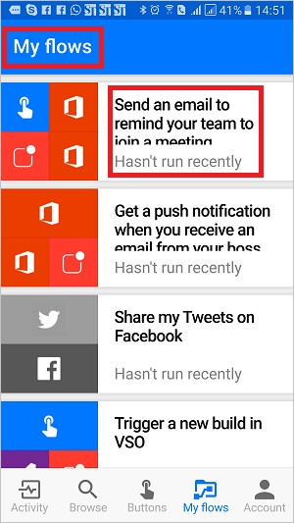

Congratulations, you've created a button flow! You can now run this button flow anytime, anyplace, from the **Buttons** tab in the Flow app. Simply press the "button" and it will run! The Flow app is currently available on Android and iOS mobile devices.

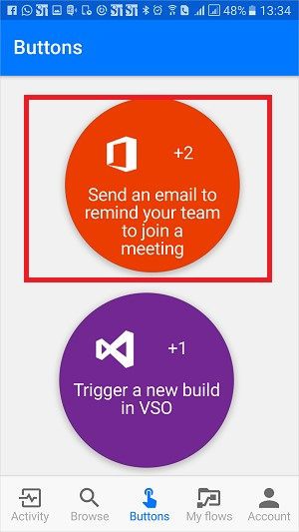

## Trigger a button flow

Now that you've created a button flow, it's time to run it. Since you can only run button flows from the Flow app, be sure you've installed Flow on your Android or iOS mobile device.

1. Now, launch the flow app, tap the **Buttons** tab that's located at the bottom of the page, and tap the *button* that represents the button flow you wish to trigger:

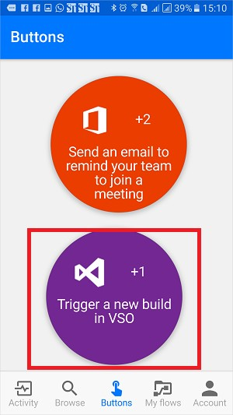

1. See the progress while the flow runs:

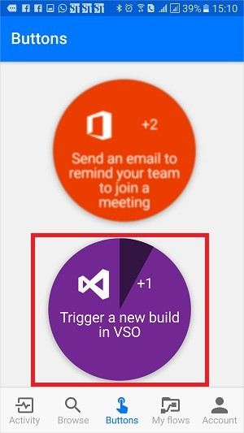

1. Finally, the page updates, indicating that the button flow has completed:

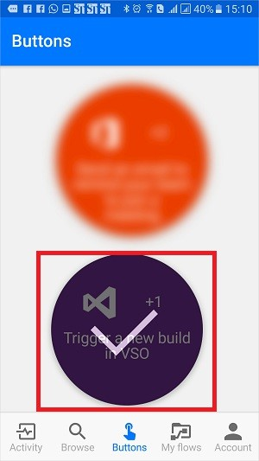

That's all there is to running a flow.

You should now receive the push notification, indicating that the email has been sent.

## Monitor your button flow runs

You can monitor button flows from the **Activity** tab of the flow app:

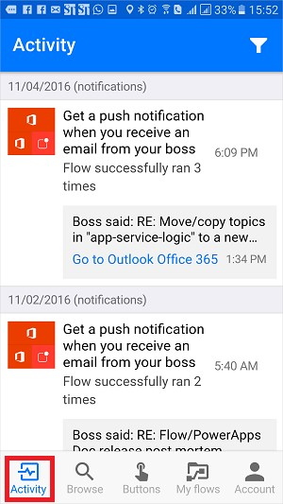

**Note**: Tap any activity to drill into the results of the run to learn about the run.

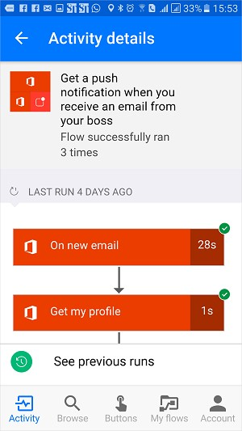

## Manage button flows

You have full control of your button flows so you can enable/disable, edit or delete a button anytime, anyplace. From the mobile app or from the flow portal, select **My flows** to get started managing your flows.

On the **My flows** tab of the Flow app:

1. Select the flow you wish to manage:

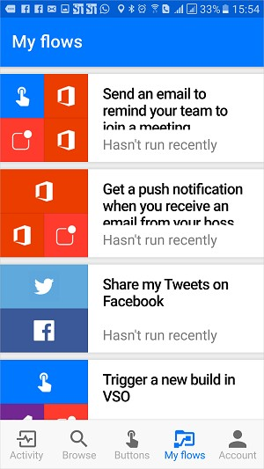

1. You can tap any of these options, based on what you'd like to accomplish:

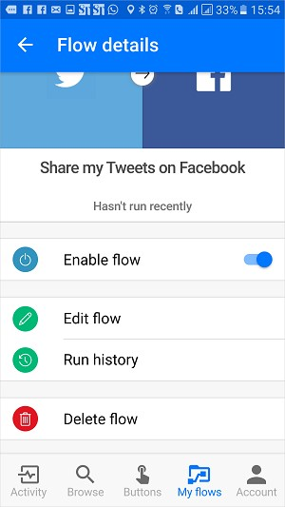

1. Tap **Delete flow** to delete a flow.

**Note** All run history is deleted when you delete a flow:

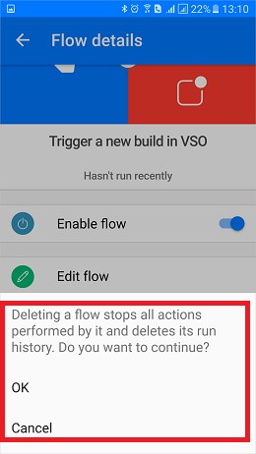

1. Tap **Update** after you are done editing a button flow, to save your changes:

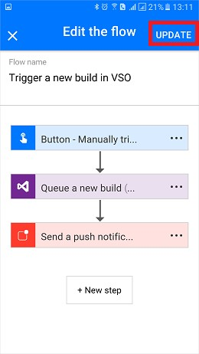

1. Tap **Run history** to see the results of all runs of a particular button flow:

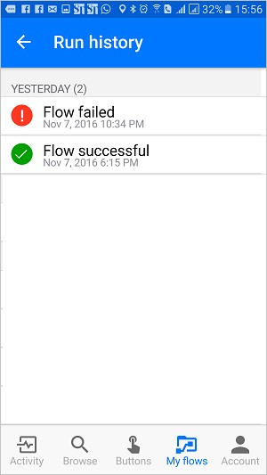

1. If you disable a flow, it will no longer be available on the **Buttons** tab:

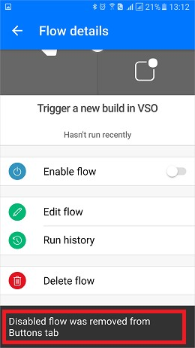

## Next steps

Share button flows.

Learn to use button trigger tokens to send real-time data when your button flows are run.

Install the Microsoft Flow mobile app for [Android](https://aka.ms/flowmobiledocsandroid), [iOS](https://aka.ms/flowmobiledocsios), or [Windows Phone](https://aka.ms/flowmobilewindows).

# Get started with button trigger tokens

11/3/2017 • 3 min to read • [Edit Online](https://github.com/MicrosoftDocs/flow-docs-pr/blob/live/flow-docs/introduction-to-button-trigger-tokens.md)

What are button trigger tokens?

Button trigger tokens are data points that are known and available to the device on which a button flow is running. These tokens change based on factors such as the current time or the geographic location of the device at a given moment.

For example, if you are running a button flow on a smart phone, it is likely that the **phone knows the time** at your current location as well as the date and your current address. In this context, the time, date and address where the phone is located are all determined at the time the button flow runs. They are automatically available for use in any button flows that are executed on the device. You can use these trigger tokens to build useful flows that will minimize repetitive tasks such as providing your location to someone or tracking how much time you spent on a particular job/service call.

## **List of button trigger tokens**

Here's the list of the button trigger tokens that are available for you to use when creating your button flows.

|  |  |
| --- | --- |
| **PARAMETER** | **DESCRIPTION** |
| City | The city in which the device that's running the flow is located. |
| Country/Region | The country/region in which the device that's running the flow is located. |
| Full address | The full address where the device that's running the flow is located. |
| Latitude | The latitude in which the device that's running the flow is located. |
| Longitude | The longitude in which the device that's running the flow is located. |
| PostalCode | The postal code in which the device that's running the flow is located. |
| State | The state in which the device that's running the flow is located. |
| Street | The street on which the device that's running the flow is located. |
| Timestamp | The time in the area where the device that's running the flow is located. |
| Date | The date in the area where the device that's running the flow is located. |
| **PARAMETER** | **DESCRIPTION** |
| User name | The user name of the person signed into the device that's running the flow. |
| User email | The email address of the person signed into the device that's running the flow. |

## Create a button flow that uses trigger tokens

When you create a button, you can use trigger tokens to add rich functionality to your button.

In this walk-through, we will create a button flow on an Android device. The button flow will use trigger tokens to send the date and your full address in a "**Working from home**" email to your boss.

In this walk-through, you will see screen-shots from an Android device, however, the experience is similar on iOS and Windows Phone devices as well.

### Prerequisites

A work or school email address or a [Microsoft Account](https://account.microsoft.com/about?refd=www.microsoft.com) with access to Microsoft Flow. The Microsoft Flow mobile app for [Android](https://aka.ms/flowmobiledocsandroid), [iOS](https://aka.ms/flowmobiledocsios), or [Windows Phone](https://aka.ms/flowmobilewindows).

Let's get started:

1. Launch Flow and select **Browse**

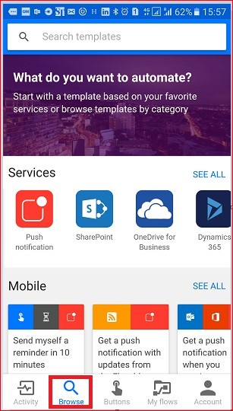

1. Select the **Send a 'Working from home today' email to your manager** service under the **Button** category
2. 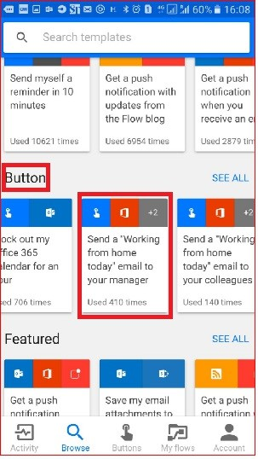Select **USE THIS TEMPLATE**

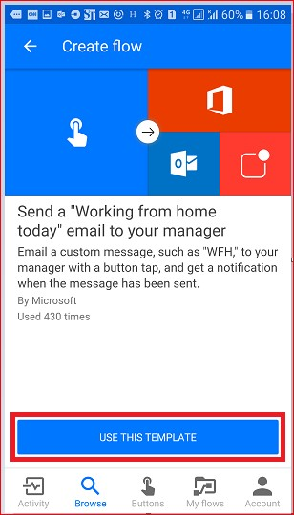

4 Select **Edit** on the **Send an email** card

1. 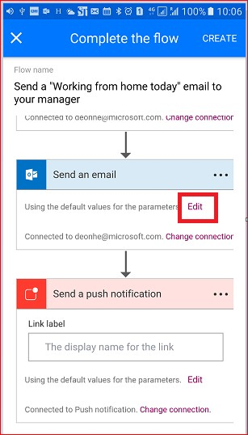Tap the **Subject** text box and enter: " **today -** " into the text box after the "WFH" text. Notice that when you tapped on the text box, a list of parameters/tokens also opened up. We'll use one of these tokens in the next step to add the date to the subject of the email.

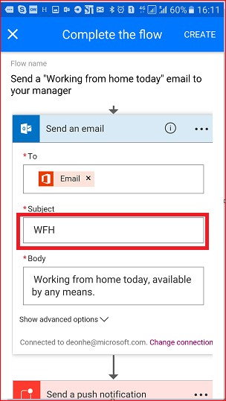

1. With the cursor still in the subject text box, scroll to the **manual** list of parameters and tap **Date**. Notice the date parameter is now in the **Subject** text box:
2. 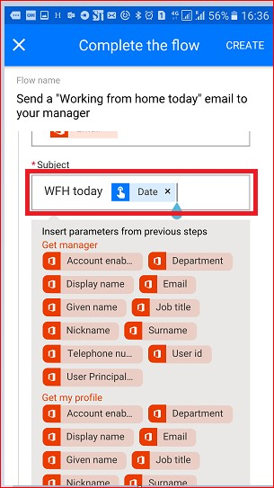Scroll to the **Body** text box and tap after the default message so that additional tokens can be included there.

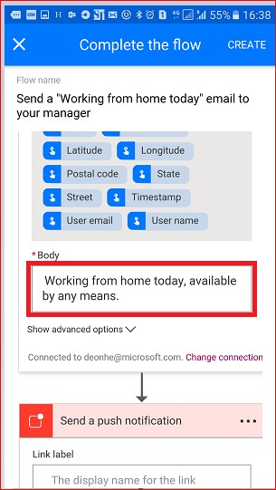

8 Tap the **Full address** parameter, then tap **Create**

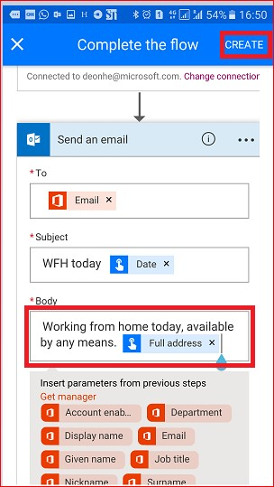9. Tap **Done**. Your button flow is now created.

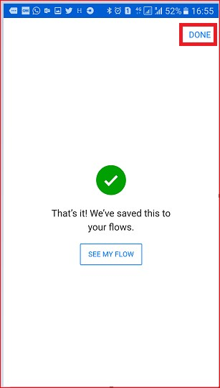

## Run the button flow

**NOTE**: This button flow will send your current location via email.

1. Tap the **Buttons** category at the bottom of the screen. You will see a list of the buttons that you have permissions to use. Tap the button that represents the button flow you just created:
2. 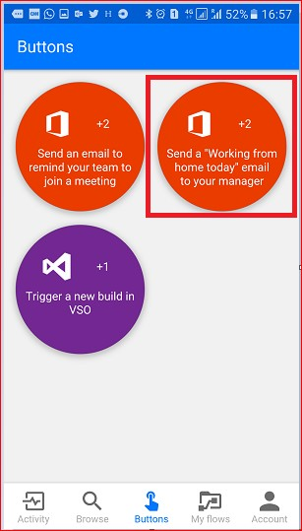Tap **ALLOW** to indicate that it's OK for the button flow to access your device's location information:

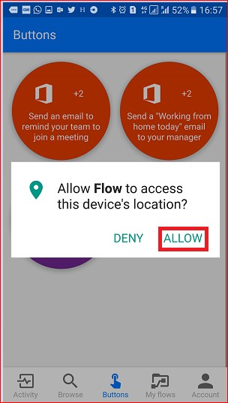

3 Within a few moments, notice that the email was sent to your boss:

Congratulations, you've just created a button flow that uses both the date and full address trigger tokens.

## Next steps

Share button flows

Learn about button flows

Learn about flows

# Introducing button flows with user input

11/3/2017 • 3 min to read • [Edit Online](https://github.com/MicrosoftDocs/flow-docs-pr/blob/live/flow-docs/button-flow-with-user-input-tokens.md)

Create a button flow to run routine tasks by simply tapping a button. Customize your flow by allowing the user to provide specific details that will be used when the flow runs. This topic walks you through creating a button flow that takes input from the user and then running the button flow, highlighting how to provide the user input.

You can create a button flow in the Microsoft Flow website or the mobile app for Microsoft Flow. For this topic, you'll use the website.

## **Prerequisites**

An account on the Microsoft Flow website.

## Open the template

1. Sign in to the [Microsoft Flow website](https://flow.microsoft.com/), enter **Visual Studio** in the search box, and then click or tap the search icon to find all templates that relate to Visual Studio:

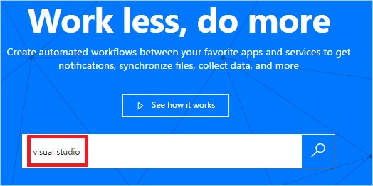

1. Select the **Open a Priority 2 Bug in Visual Studio** template:

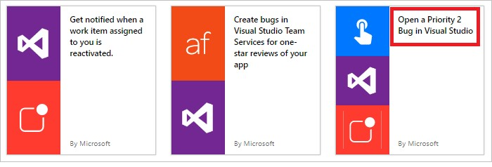

1. Select **Use this template** button:

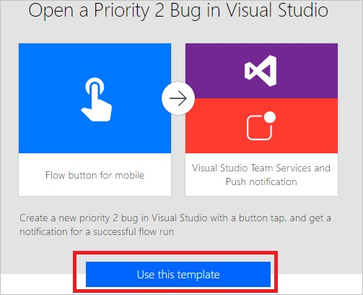

This template uses the Visual Studio Team Services (VSTS) and the Push notification services. You'll need to sign into these services if you don't have a connection to either of them. The **Sign in** button will appear only if you need to sign into a service.

1. After you sign into all required services, select the **Continue** button:

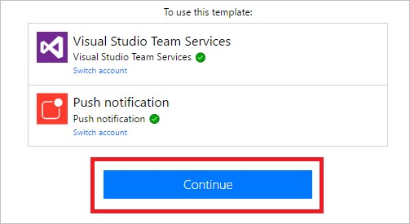

1. (optional) Change the name of the flow by typing a name of your choice into the box at the top of the portal:



## Customize the user input

1. In the trigger card, select **Edit**:

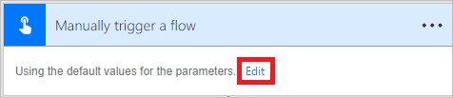

1. Select the **+** icon to expand the page so that you can add custom input fields:

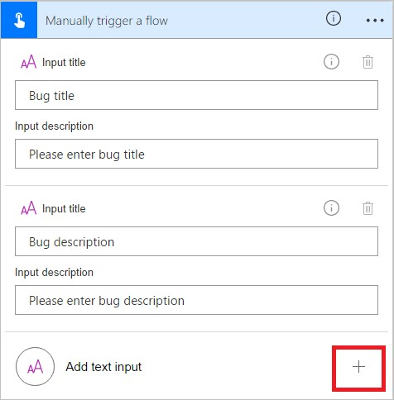

1. Enter the **Input title** and **Input description** for each custom field that you want to make available when someone runs your flow.

In this example, you'll create two custom input fields (**Bug repro steps** and **Bug severity**) so that anyone who uses this flow can enter the steps to reproduce the bug and rate the bug's severity:

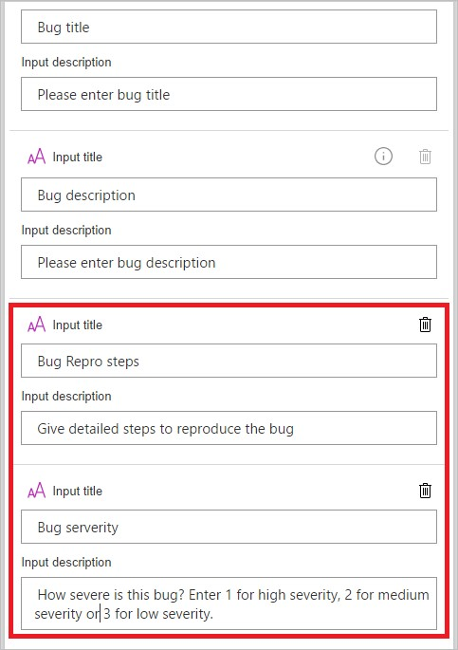

## Customize the bug

1. Tap the **Create a new work item** card's title bar:

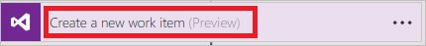

1. Make the selections that are appropriate for your VSTS environment, and then select **Edit**:

For example, connect to myinstance.visualstudio.com by typing **myinstance**.

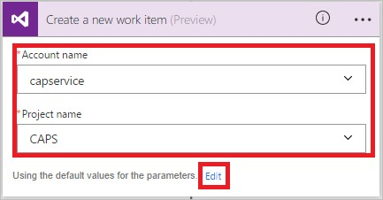

1. Select **Show advanced options** to reveal the other fields for this card:

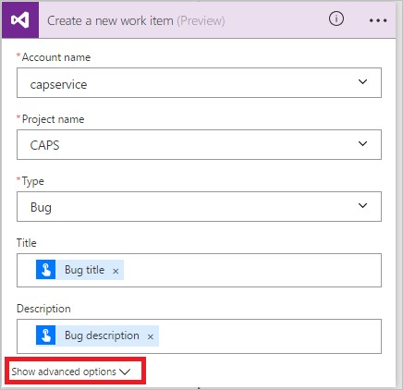

1. Place the cursor before the **Bug title** token, and then enter "Severity: " into the **Title** text field.
2. With the cursor still in the title text field, select the **Bug severity** token, and then enter " -- ".
3. In the **Description** text field, place your cursor just after the **Bug description** token, and then press Enter to start a new line.
4. Place your cursor on the new line, and then select the **Bug Repro steps** token:

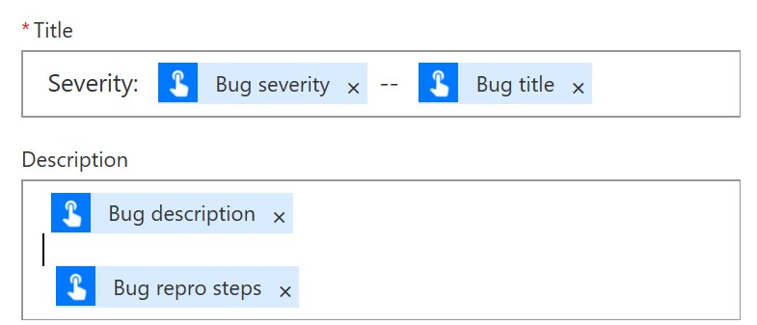

## Customize the push notification

1. Tap the title bar on the **Send a push notification** card to expand it.
2. In the list of dynamic content tokens, select **See more**, and then add the **URL** token in the **Link** text field.
3. In the **Link label** text field, add the **Id** token:

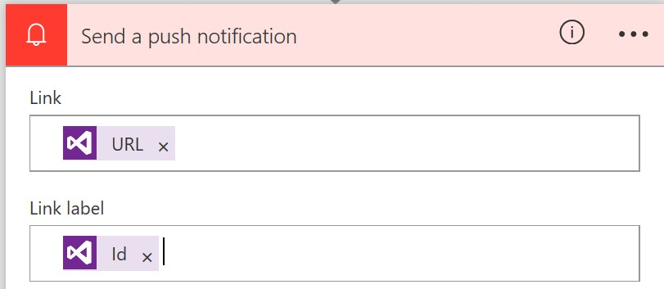

1. Tap **Create flow** on the menu to create your flow:



## Run your flow

In this walk-through, you'll use the mobile app for Microsoft Flow to run the button flow you just created. You'll provide all the user input that's needed to create a bug with a title, a description, repro steps, and a severity level.

1. In the mobile app for Microsoft Flow, tap the **Buttons** tab, and then tap the **Create bug report with steps** button.

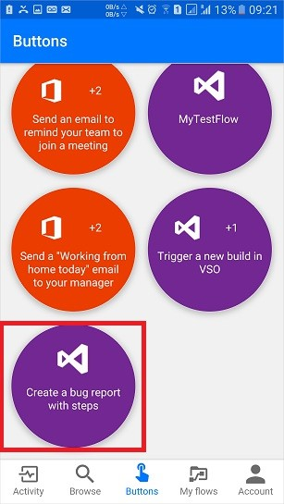

1. Enter the title for the bug you are reporting, and then tap **Next**. For example:

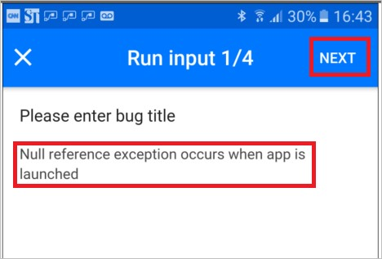

1. Enter the description of the bug you are reporting, and then tap **Next**. For example:

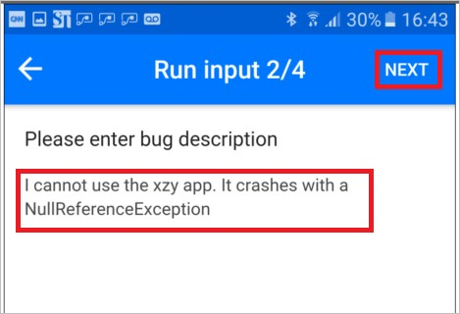

1. Enter the steps to reproduce the bug you are reporting, and then tap **Next**. For example:

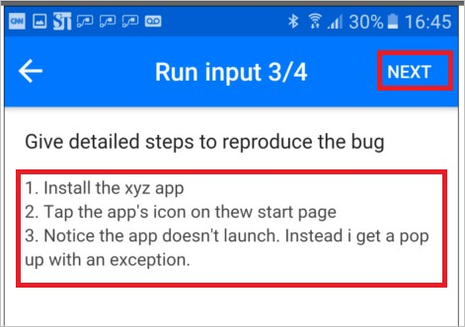

1. Enter the severity of the bug you are reporting, and then tap **Done**:

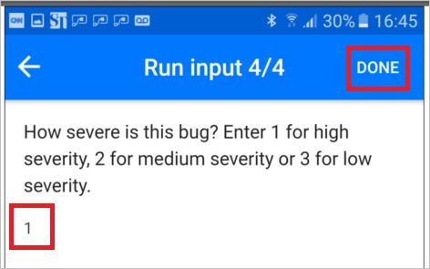

The flow runs.

1. (optional) Tap the **Activity** tab to show the results.

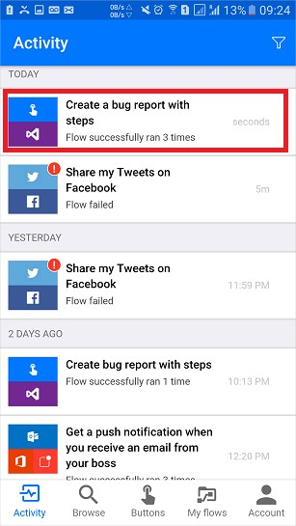

1. (optional) Show the detailed results of the flow's run by tapping the **Create a new work item** step.

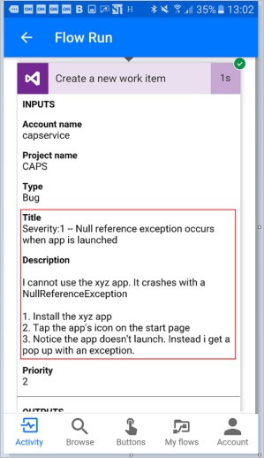

## Next steps

Share button flows

Learn about flows

Learn about button flows

Learn about button flows with trigger tokens

# Share button flows in Microsoft Flow

11/3/2017 • 3 min to read • [Edit Online](https://github.com/MicrosoftDocs/flow-docs-pr/blob/live/flow-docs/share-buttons.md)

In the Microsoft Flow mobile app, you can share button flows (buttons) with other users or groups within your organization. When you share a button, the person or group with whom you share can run your button, the same way they run their own buttons. You can also share a link to buttons that another person shared with you. You can stop sharing your buttons at any time.

The screenshots used in this document were taken from an Android device. If you're using an iPhone, the images may appear differently, but the functionality is the same.

Follow these steps to use a button that someone shared with you.

## Prerequisites

To share buttons, you need:

An account with access to [Microsoft Flow](https://flow.microsoft.com/).

A flow to share.

A mobile device with the Microsoft Flow mobile app for [Android](https://aka.ms/flowmobiledocsandroid), [iOS](https://aka.ms/flowmobiledocsios), or [Windows Phone](https://aka.ms/flowmobilewindows). A group or user within your organization with whom to share your button.

## Share a button

You can share a button from the **Buttons** tab of the Microsoft Flow mobile app.

1. Tap the small icon next to the button you want to share.

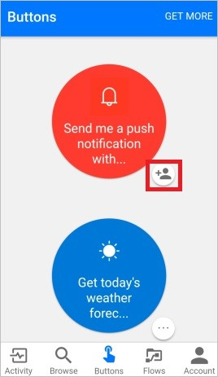

1. Tap **Invite others** from the **Button users** page.

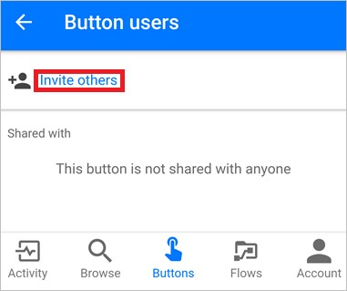

1. Search for, and then select the group or person with whom you'd like to share the button.

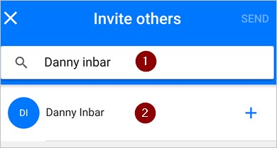

1. Tap **SEND** on the **Invite others** page.

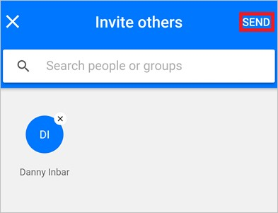

1. Tap **DONE** on the page that indicates the button sharing operation completed successfully.

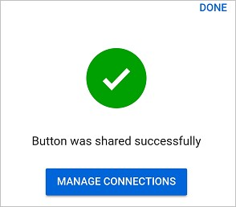

## Require users to use their own connections

**NOTE**

When you share a button, you can allow persons with whom you've shared the button to use all connections that your button uses. You can also require them to use their own connections. If you allow others to use your connections, they can't access the credentials in your connection, or reuse them in any other flow.

Follow these steps to require persons with whom you've shared your buttons to use their own connections.

1. Select **MANAGE CONNECTIONS** on the screen that's displayed immediately after you share a button.
2. Select **EDIT** on the button you want to manage.
3. Select **Provided by user** or your email address.

Your choice indicates whose connections must be used in the shared button.

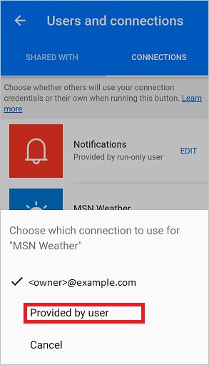

You can view or change your choice any time. To do so, select the **Flows** tab > the flow you shared > **Users and connections** > the **CONNECTIONS** tab > **EDIT** on the button you want to manage.

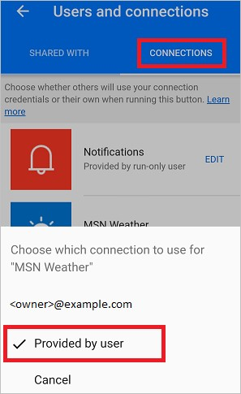

## View the list of button users

You can view all groups or users with whom a button is shared by following these steps from the **Buttons** tab:

1. Tap the small icon next to the button in which you're interested.
2. On the **Button users** page, view all groups or users with whom the button is shared.

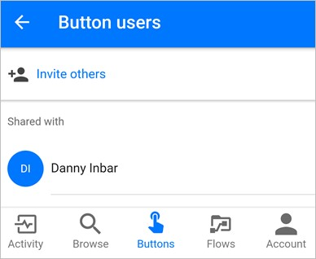

## Stop sharing a button

You can stop sharing a button by following these steps from the **Buttons** tab:

1. Tap the small icon next to the button you no longer want to share.
2. On the **Button users** page, tap the user or group with whom you want to stop sharing the button.

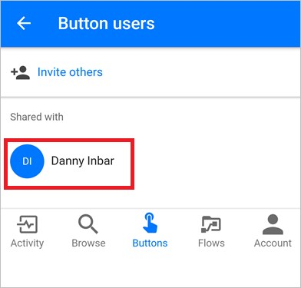

1. Tap **Remove user** when the user's page is displayed.

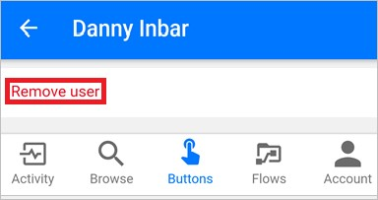

1. Wait for the remove operation to complete. Notice the **Button users** list refreshes, and the user or group you removed is no longer listed.

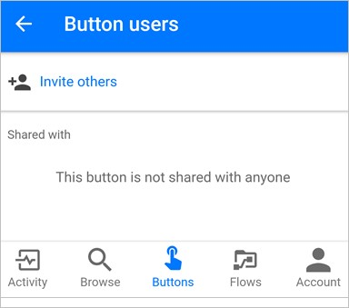

## Monitor the run history

All run history, including the runs initiated by a person with whom a button is shared, appear only on the **Activity** tab of the button creator's Microsoft Flow mobile app.

## Use shared buttons

Before you can run a button that someone has shared with you, you must add it to your **Buttons** tab from the **Add buttons** page.

1. Tap **GET MORE** (or the **New buttons are available** banner if it appears) on the **Buttons** tab.

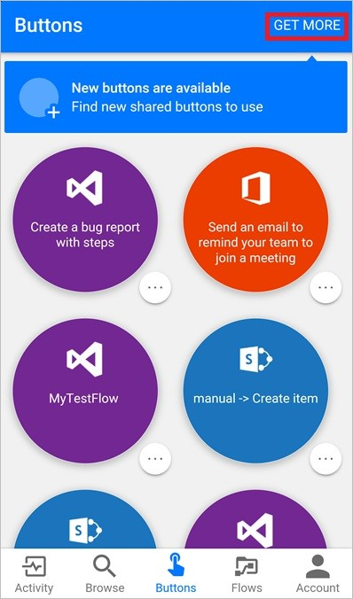

1. Tap the button you want to use.

The tapped button is immediately added to the **Buttons** tab of the Microsoft Flow app. You can then use the button from the **Buttons** tab, just like any other button that's listed there.

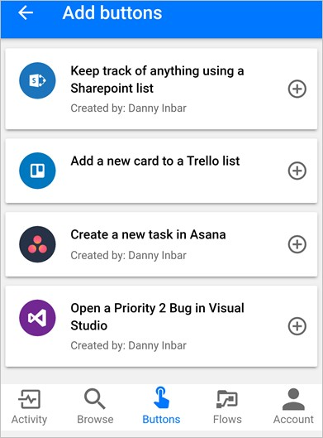

## Re-share a button

You can share a link to a button that's been shared with you.

1. Select **...** next to the button you want to share.
2. Select **Share button link**.

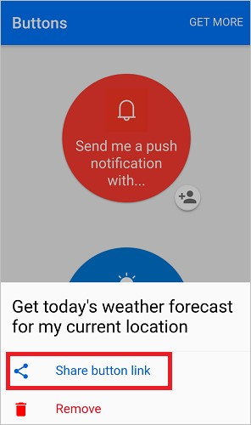

1. Select the app that you'd like to use to share the button, and then follow the steps to send the button to the person with whom you want to share.

## Stop using a shared button

If you no longer want to use a button that was shared with you, remove it from the **Buttons** tab by taking these steps:

1. On the **Buttons** tab, tap **...** next to the button you no longer want to use.

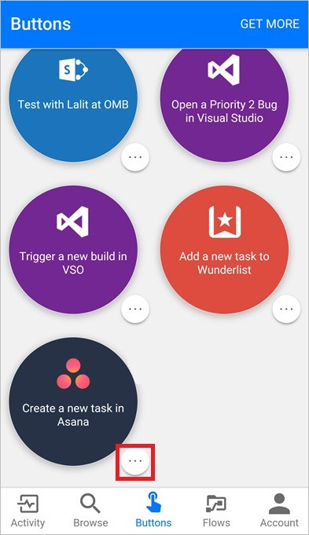

1. Tap **Remove** from the menu that appears.

That's it. The button no longer appears on the **Buttons** tab of the Microsoft Flow app.

**NOTE**

After you remove a shared button, you can add it back by selecting **GET MORE** from the **Buttons** tab.

# Monitor activity in Microsoft Flow from your phone

11/3/2017 • 2 min to read • [Edit Online](https://github.com/MicrosoftDocs/flow-docs-pr/blob/live/flow-docs/mobile-monitor-activity.md)

View a summary of how many times each flow succeeded or failed today, yesterday, and previous days. Explore details about each run, such as when it ran, how long each step took and, if it failed, why.

**Prerequisites**

Install the Microsoft Flow mobile app for [Android](https://aka.ms/flowmobiledocsandroid), [iOS](https://aka.ms/flowmobiledocsios), or [Windows Phone](https://aka.ms/flowmobilewindows) on a supported device. The graphics in this topic reflect the iPhone version of the app, but the graphics on Android and Windows Phone are similar. If you don't already have a flow, create one on [the website for Microsoft Flow](https://flow.microsoft.com/). For easier testing, use one that you can trigger yourself instead of waiting for an external event.

The flow in this tutorial runs when you receive mail from a specific address:

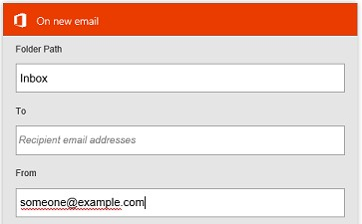

You could configure such a flow with your personal email address for testing and a different address (for example, your manager's) when the flow is ready for real use.

When the flow runs, it sends a custom push notification, with this syntax, to your phone:

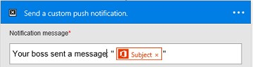

**Note:** You can also manage your flows from the mobile app.

## Display a summary of activity

1. If your flow hasn't run before, trigger a run to generate data.

It might take some time for the data to appear in the app.

1. Open the mobile app, which shows the **Activity** tab by default.

This tab organizes data by day, with today's data at the top.

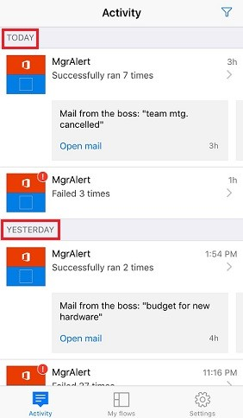

Each entry shows the name of a flow with icons that correspond to its trigger events and actions.

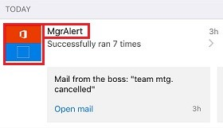

If at least one run of a flow has succeeded in a day, an entry shows the number of successes and the time when it succeeded most recently. A different entry shows similar information if a flow has failed.

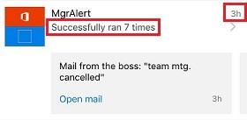

If a flow sends a push notification, the text of the most recent notification appears at the bottom of the entry for successful runs.

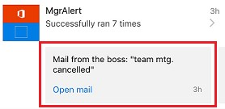

1. If multiple push notifications were sent in a day, swipe left on the notification to view notifications from up to three previous runs. If more than four notifications were sent in a day, swipe left until **See more** appears, and then tap it to view a list of all notifications.

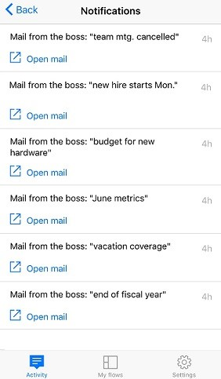

1. Tap **Back** to return to the activity summary.
2. To filter the activity summary, tap the icon in the upper-right corner.

You can show all entries, only the failure entries, or only the entries that include push notifications.

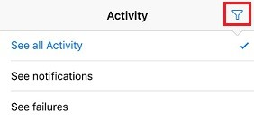

## Show details of a run

1. In the activity summary, tap an entry to show details for the most recent run.

Each event and action appears with an icon that indicates whether the event or action succeeded or failed. If it succeeded, the amount of time it took (in seconds) also appears.

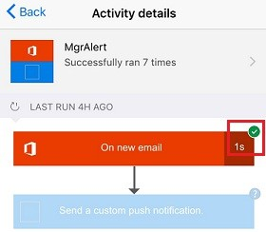

1. At the bottom of the screen, tap **See previous runs** to list all runs of the flow, and then tap a run to show its details.

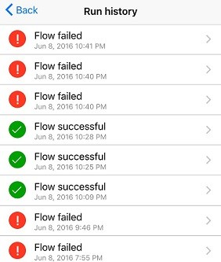

# Manage flows in Microsoft Flow from your phone

11/3/2017 • 1 min to read • [Edit Online](https://github.com/MicrosoftDocs/flow-docs-pr/blob/live/flow-docs/mobile-manage-flows.md)

View a list of all flows that you created and, for each flow, view its events and actions, enable or disable it, and explore its run history.

**Prerequisites**

Install the Microsoft Flow mobile app for [Android](https://aka.ms/flowmobiledocsandroid), [iOS](https://aka.ms/flowmobiledocsios), or [Windows Phone](https://aka.ms/flowmobilewindows) on a supported device. The graphics in this topic reflect the iPhone version of the app, but the graphics on Android and Windows Phone look similar.

If you don't already have a flow, create one on [the website for Microsoft Flow](https://flow.microsoft.com/). For easier testing, use one that you can trigger yourself instead of waiting for an external event.

The flow in this tutorial runs when you receive mail from a specific address:



You could configure such a flow with your personal email address for testing and a different address (for example, your manager's) when the flow is ready for real use.

When the flow runs, it sends a custom push notification, with this syntax, to your phone:



**Note**: You can also monitor flow activity from the mobile app.

## Manage a flow

1. Open the mobile app, and then tap **My flows** at the bottom of the screen to list all your flows.

Each entry shows the name of the flow, icons for its events and actions, the time when it ran most recently, and an icon that indicates whether the most recent run succeeded.

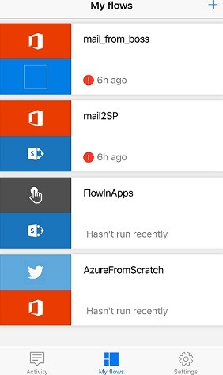

1. Tap a flow to show options for managing it.

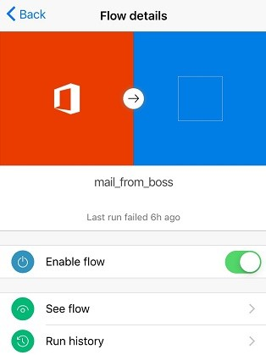

1. Tap the **Enable flow** toggle to enable or disable the flow.
2. Tap **See flow** to show the events and actions for that flow, tap each event or an action to expand it, and then tap **Back**.

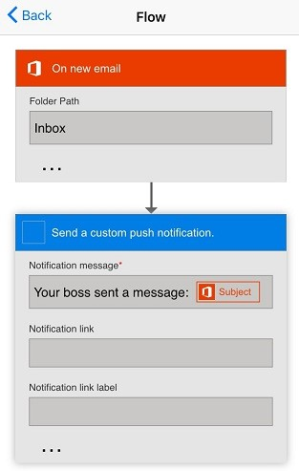

1. Tap **Run history** to show the flow's successes, failures, or both.



1. Tap a run to show whether each event and action succeeded and, if so, how much time (in seconds) it took.

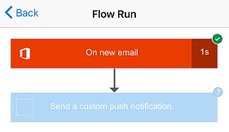

# Run your flows by pressing a Flic smart button (Preview)

11/3/2017 • 4 min to read • [Edit Online](https://github.com/MicrosoftDocs/flow-docs-pr/blob/live/flow-docs/flic-button-flows.md)

Trigger your flows by pressing a physical button, known as a Flic, from Shortcut Labs. For example, press a Flic to track your working hours, block your calendar, count visitors at an event, or save geographical locations.

**IMPORTANT**

Configure all Flic properties by using Flic's mobile app for [Android](https://play.google.com/store/apps/details?id=io.flic.app) or [iOS](https://itunes.apple.com/us/app/flic-app/id977593793?ls=1&mt=8) before you create your flow.

## Prerequisites

To use Flics with Microsoft Flow, you must have:

Access to [Microsoft Flow](https://flow.microsoft.com/).

Downloaded Flic's [Android](https://play.google.com/store/apps/details?id=io.flic.app) or [iOS](https://itunes.apple.com/us/app/flic-app/id977593793?ls=1&mt=8) mobile app, and used it to pair one or more Flics.

## Configure Flic properties

Use Flic's mobile app to program the Flic's events. The events are:

click (one quick press) double-click (two quick presses) hold (one long press)

This screenshot shows a sample of what your Flic configuration process might be like:

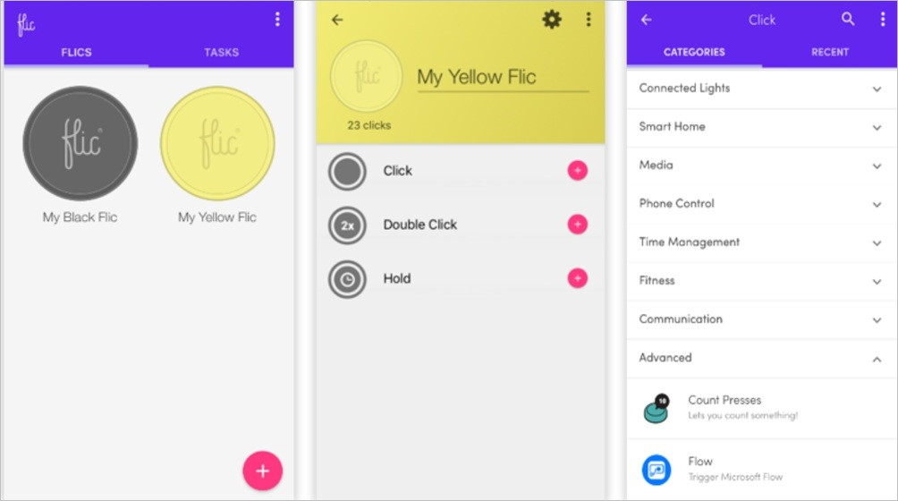

After you've linked a Flic event to Microsoft Flow, you can then select that Flic as a trigger for your flows. You select triggers later in this walkthrough.

## Create a flow that's triggered by a Flic

In this walkthrough, we use a Flic to run a flow that records the time a consultant spends at each client. The consultant presses the Flic once upon arrival, and then presses it again, just before departure from the client. Each press of the Flic starts a run of the flow to which it's connected. The flow saves the current time in Google Sheets, and then sends an email notification. The email contains details about the flow run.

Note: Be sure you've used the Flic mobile app to pair, and configure at least one **click** action to trigger Microsoft Flow. In this screenshot, I've configured the **click** action to trigger Microsoft Flow. Later in this walkthrough we configure our flow to trigger when the Flic is pressed once (clicked).

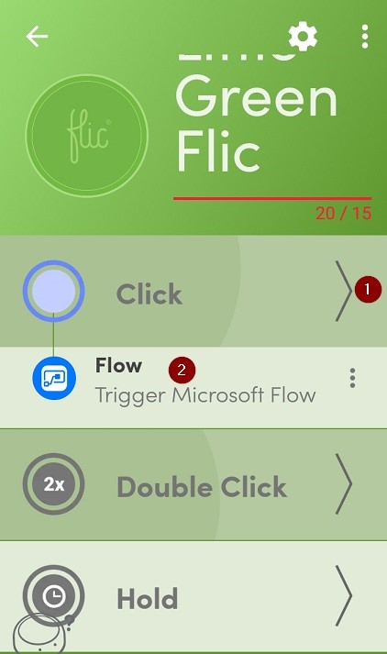

Let's get started creating our flow.

### Start with a template

1. Sign into [Microsoft Flow](https://flow.microsoft.com/).

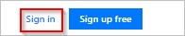

1. Enter **flic** into the search box, and then select the search icon.

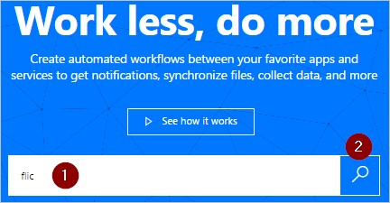

1. Select the **Track your working hours with Flic smart button** template.

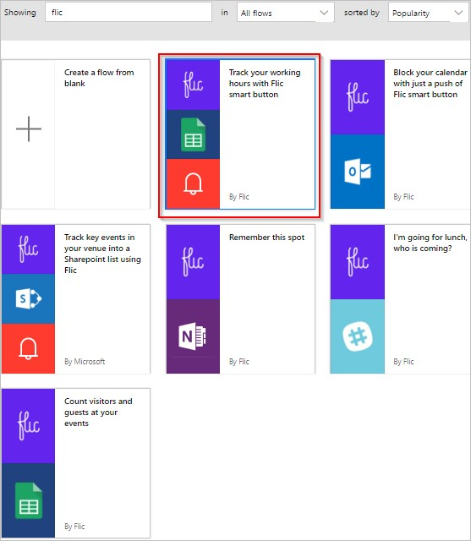

### Create a spreadsheet in Google Sheets

1. Review the template's details and note that this template requires a spreadsheet in Google Sheets.

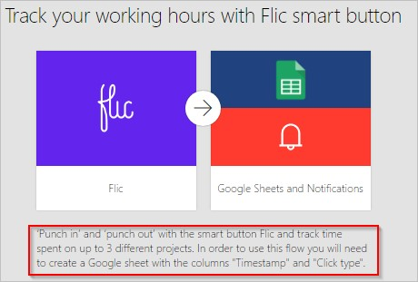

1. In Google Sheets, create a spreadsheet that contains a sheet with columns named **ClickType** and **TimeStamp**.

Tip: You name columns in Google Sheets by entering the column name at the top of the column. So, your sheet should appear like this screenshot:

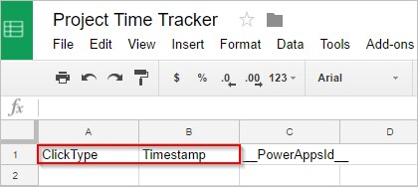

Note: You use this sheet later in this walkthrough.

### Add the Flic trigger to your flow

1. Sign in to the template's services, and then select **Continue**.

**Continue** is enabled after you sign into all required services for the template.

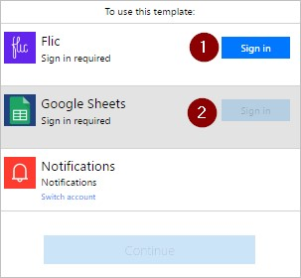

1. Enter **flic** into the search box, and then select the **Flic - When a Flic is pressed** trigger.

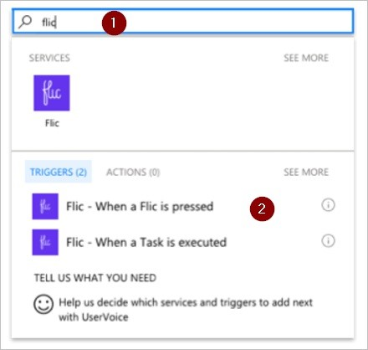

1. Select the Flic you want to use from the **Flic button** list on the **Flic - When a Flic is pressed** card.
2. Select **click** from the **Events** list to indicate that you want to trigger the flow when the Flic is pressed once.

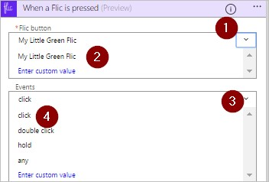

Optionally, you can select **any** to indicate that each Flic event (click, double-click, or hold) triggers the flow.

**Double-click** indicates that the flow triggers when the Flic is quickly pressed two times. **Hold** indicates that a long press on the Flic triggers the flow.

You're free to create other flows and trigger them using the other events in the **Events** list. For example, you can use the **double-click** event to record the time you leave a client.

### Configure the sheet

On the **Insert row** card:

1. Select the spreadsheet you created earlier from the **File** list.
2. Select the sheet from the **Worksheet** list.

Note: Two additional boxes appear on the **Insert row** card after you select the sheet. These boxes represent the two columns in the sheet you created earlier.

1. Select the **ClickType** box, and then select the **Click type** token.
2. Select the **Timestamp** box, and then select the **Click time** token.

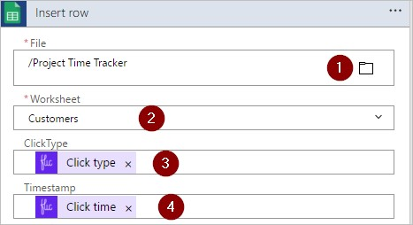

### Confirm the email settings are correct

1. Confirm the **Send me an email notification** card looks like this screenshot.

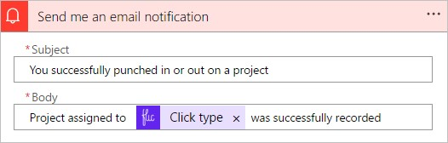

### Save your flow and test it

1. Give your flow a name, and then save it.



If you've followed along, pressing the Flic once triggers the flow. The flow then records the click type and the current time in the sheet and then sends an email to you.

1. Press your Flic once.
2. Open your worksheet in Google Sheets. You should see the **ClickType** and the **Timestamp** columns populated with the "click" and the time, respectively.

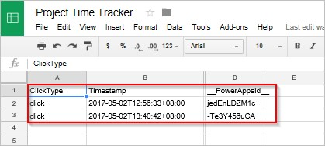

1. You can also see the results of the run from the Microsoft Flow website or from the Microsoft Flow mobile app. Here's a screenshot of my test run.

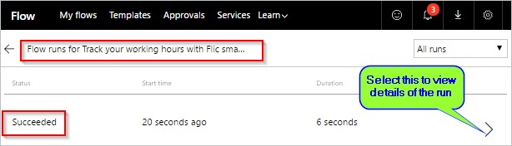

1. Here's what the body of the notification email that I received from the run of the flow looks like.

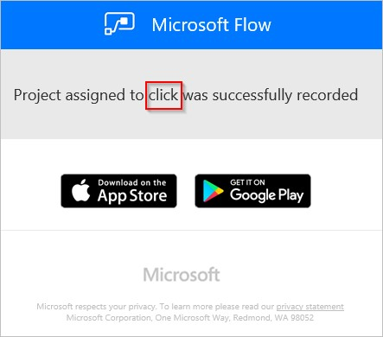

For extra credit, consider extending the flow to automatically record your location (latitude and longitude) when the Flic is pressed.

## More information

Share button flows.

Learn to use button trigger tokens to send current data when your button flows are executed.

Install the Microsoft Flow mobile app for [Android](https://aka.ms/flowmobiledocsandroid), [iOS](https://aka.ms/flowmobiledocsios), or [Windows Phone](https://aka.ms/flowmobilewindows).

# Run your flows with physical buttons (bttns) from The Button Corporation (Preview)

11/3/2017 • 3 min to read • [Edit Online](https://github.com/MicrosoftDocs/flow-docs-pr/blob/live/flow-docs/bttn-button-flows.md)

Trigger your flows by pressing a bttn (a physical button made by [The Button Corporation](https://my.bt.tn/)). For example, you can press a bttn that triggers a flow to perform these tasks:

contacts your helpdesk with location information sends an email to your team blocks your calendar reorders supplies

**IMPORTANT**

You must [register](https://my.bt.tn/) your bttn before you can use it in a flow.

**TIP**

Configure all bttn properties such as name, location, and email address on the [bttn website](https://my.bt.tn/) before you create your flow.

You can also trigger a flow by using a Flic physical button.

## Prerequisites

Access to [Microsoft Flow](https://flow.microsoft.com/).

At least one [registered bttn](https://my.bt.tn/).

## Create a flow that's triggered from a bttn

In this walkthrough, we use a helpdesk template to create a flow that you can trigger with a single press of a [bttn](https://my.bt.tn/). When the flow runs, it generates a support request and then sends it to the helpdesk. The support request provides the helpdesk with the location of the room where help is needed. This walkthrough demonstrates how to create this flow from a template, but you can use the blank template, which gives you full control over all aspects of your flow.

You can use any of these templates to quickly create flows for your bttn and connect to Zendesk, Google, and SharePoint, among others:

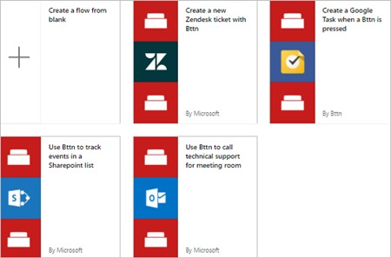

Tip: For the purposes of this walkthrough, give your bttn a name that represents a conference room in a typical office building.

The settings for your bttn should resemble this example (from the bttn website):

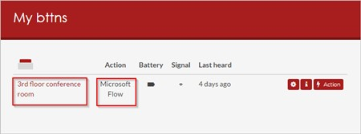

Now that you've registered and configured your bttn, let's get started creating our flow.

### Sign in and select a template

1. Sign into [Microsoft Flow](https://flow.microsoft.com/).

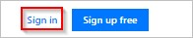

[Note: As an alternative, you can create flows in the Microsoft Flow mobile app for Android, iOS, or Windows Phone.](https://aka.ms/flowmobilewindows)

1. Enter **bttn** into the search box, and then select the search icon.

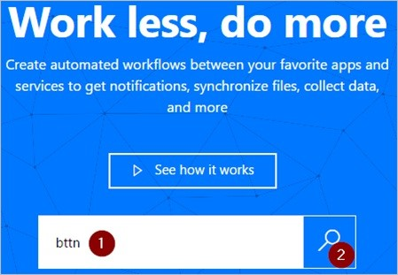

After you select the search icon, all templates that you can use with bttns appear.

1. Select the **Use Bttn to call technical support for meeting room** template.

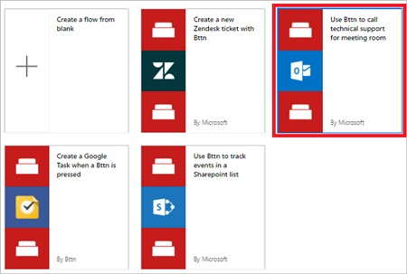

### Authorize Microsoft Flow to connect to your bttn

1. If prompted, sign into the bttn and the Office 365 Outlook services, which will enable the **Continue** button.

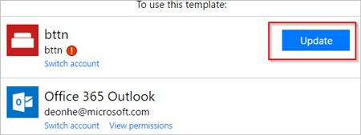

1. When you sign into the bttn service, authorize Microsoft Flow to use your bttns.

**Important**: If you don't authorize Microsoft Flow to use your bttns, you can't see or connect to them from Microsoft Flow.

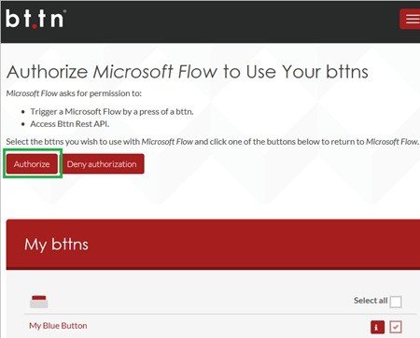

1. After you sign into both services, select **Continue**.

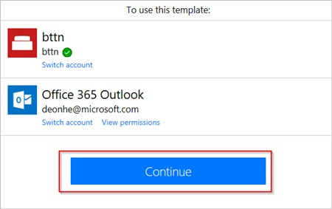

### Select the bttn that triggers the flow

1. In the **When a bttn is pressed** card, open the list of bttn IDs, and then select the bttn that you want to use.

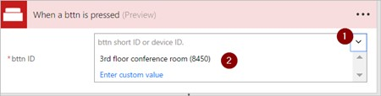

Your flow should now resemble this example.

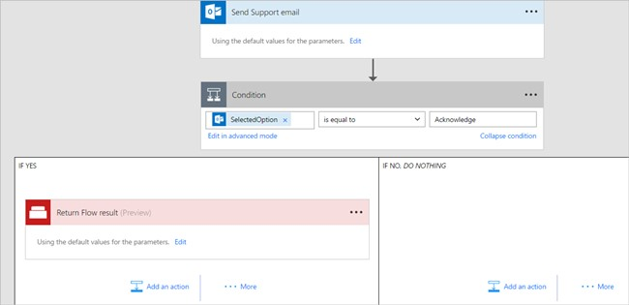

1. Give your flow a name, and then select **Create flow** to save it.



## Test your flow and confirm results

1. Press the button on your bttn.
2. View your flow's run history to confirm that it ran successfully.

You can check run history on the Microsoft Flow website or on your mobile device.

Note: The run status is set to **running** until someone selects **Acknowledge** in the support-request email.

1. You can also confirm that the email was sent to the support team.

If you've followed along, the support email looks similar to this example:

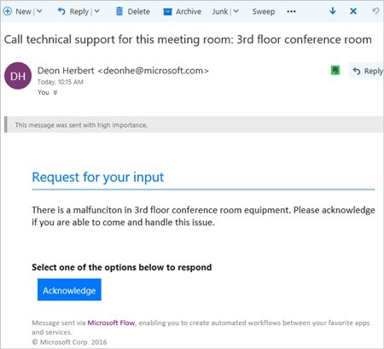

## Troubleshooting

If your flow wasn't triggered, sign into The Button Corporation's site and confirm whether the button activity (presses) are being recorded.

You can also drill into the run activity on the Microsoft Flow site and check for error messages.

## More information

Share button flows.

Learn to use button trigger tokens to send current data when your button flows run.

[Install the Microsoft Flow app for Android](https://aka.ms/flowmobiledocsandroid).

[Install the Microsoft Flow app for iOS](https://aka.ms/flowmobiledocsios).

# Manage connections in Microsoft Flow

11/3/2017 • 2 min to read • [Edit Online](https://github.com/MicrosoftDocs/flow-docs-pr/blob/live/flow-docs/add-manage-connections.md)

If you create a connection in Microsoft Flow, you can easily access your data while building a flow. Microsoft Flow includes commonly used connections, including SharePoint, SQL Server, Office 365, OneDrive for Business, Salesforce, Excel, Dropbox, Twitter, and more. Connections are shared with PowerApps, so when you create a connection in one product, the connection shows up in the other.

For example, you can use a connection to perform these tasks:

Update a SharePoint list.

Get data from an Excel file in your OneDrive for Business or Dropbox account. Send email in Office 365. Send a tweet.

You can create a connection in multiple scenarios, such as these:

Creating a flow from a template

Creating a flow from blank or updating an existing flow

Creating a connection in the [Microsoft Flow website](https://flow.microsoft.com/) directly

This topic shows you how to manage connections in the [Microsoft Flow website](https://flow.microsoft.com/).

## Add a connection

1. In the [Microsoft Flow website](https://flow.microsoft.com/), sign in with your work or organization account.
2. Near the upper-right corner, select the gear icon, and then select **Connections**.

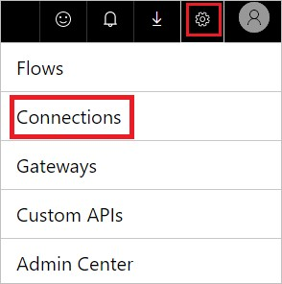

1. Select **Create connection**.
2. In the list of **Available connections**, select the connection that you want to set up, such as SharePoint.
3. Select the **Create connection** button, and then enter your credentials to set up the connection.

When the connection is set up, it's listed in **My connections**.

## Connect to your data through an on-premises data gateway

As of this writing, SQL Server and SharePoint Server support the on-premises data gateway. To create a connection that uses a gateway:

1. Follow the steps earlier in this topic to add a connection.
2. In the list of **Available connections**, select **SQL Server**, and then select the **Connect via on-premise data gateway** check box.

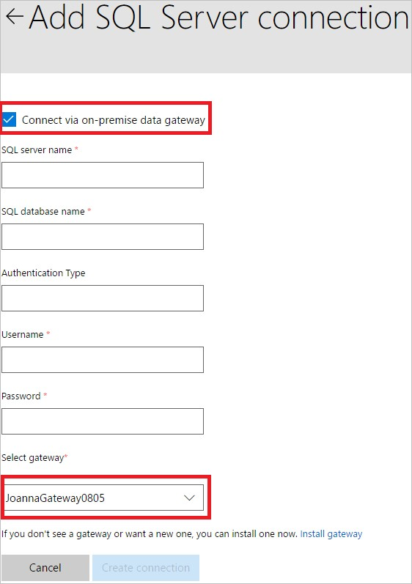

**IMPORTANT**

Microsoft SharePoint data gateways support HTTP traffic but not HTTPS traffic.

1. Provide the connection's credentials, and then select the gateway that you want to use.

For more information, see Manage gateways and Understand gateways.

When the connection is set up, it's listed in **My connections**.

## Delete a connection

1. Go to the **My connections** page, and then select the trash-can icon for the connection you want to delete.

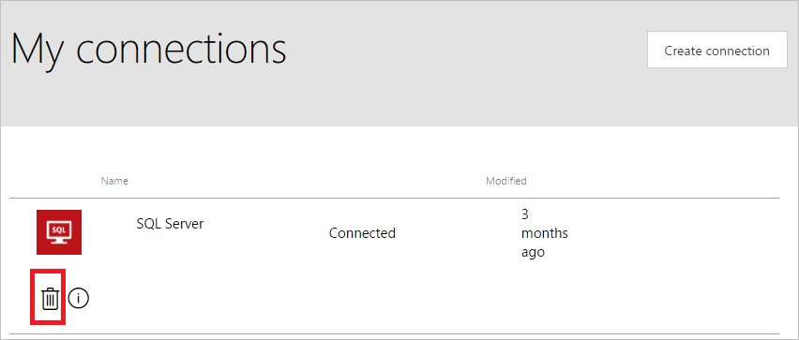

1. Select **OK** to confirm that you would like to delete the connection.

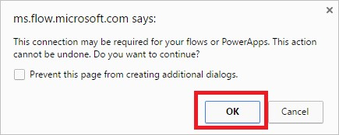

When you delete a connection, it's removed from both PowerApps and Microsoft Flow.

## Update a connection

You can update a connection that isn't working because your account details or your password changed.

1. On the **My connections** page, select the **Verify password** link for the connection that you want to update.

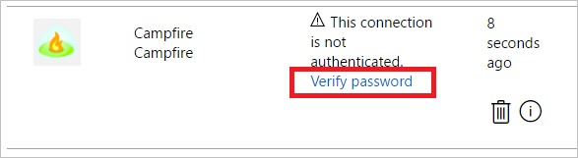

1. When prompted, update your connection with new credentials.

When you update a connection, it's updated for both PowerApps and Microsoft Flow.

## Troubleshoot a connection

Depending on your organization's policies, you might need to use the same account for signing in to Microsoft Flow and creating a connection to SharePoint, Office 365 or OneDrive for Business.

For example, you might sign in to Microsoft Flow with *yourname@outlook.com* but be blocked when you try to connect to SharePoint with *yourname@contoso.com*. You can instead sign in to Microsoft Flow with *yourname@contoso.com* and you'll be able to connect to SharePoint.

# Manage an on-premises data gateway in Microsoft Flow

11/3/2017 • 1 min to read • [Edit Online](https://github.com/MicrosoftDocs/flow-docs-pr/blob/live/flow-docs/gateway-manage.md)

Install and manage an on-premises data gateway to securely integrate a variety of cloud-based apps with your onpremises data and apps through Microsoft Flow.

With a gateway, you can connect to on-premises data over these connections:

SharePoint

SQL Server

Oracle

Informix

Filesystem DB2

**IMPORTANT**

Microsoft SharePoint data gateways support HTTP traffic, but not HTTPS traffic.

## Prerequisites

The user name and password that you used to sign up for Microsoft Flow. Administrative permissions on a gateway.

You have these permissions by default for each gateway that you install, and an administrator of another gateway can grant you these permissions for that gateway.

A license that supports gateways. For more information, see the “Connectivity” section of the [pricing page](https://flow.microsoft.com/pricing/). You can create a gateway and an on-premises connection only in your default environment.

## View your gateways

In the upper-right corner of the [Microsoft Flow website](https://flow.microsoft.com/), click or tap the gear icon, and then click or tap **Gateways**.

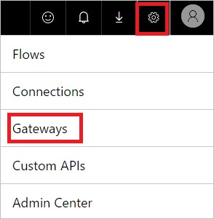

**Note**: If you created or were given access to a gateway in PowerApps, that gateway appears in the **My gateways** list in Microsoft Flow.

## Install a gateway

1. Download the [gateway-installation wizard](https://go.microsoft.com/fwlink/?LinkID=820580&clcid=0x409).

You can also download this wizard by clicking or tapping the gear icon in the upper-right corner of the [Microsoft Flow website](https://flow.microsoft.com/), clicking or tapping **Gateways**, and then clicking or tapping **Create gateway**.

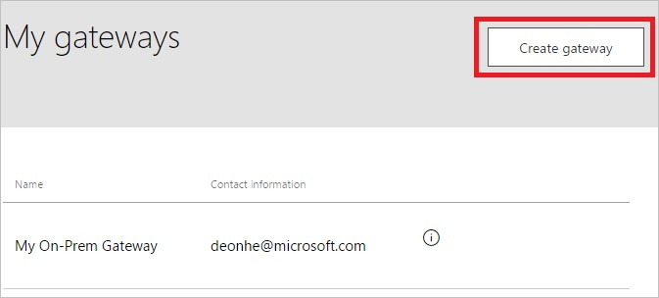

1. Run the wizard, providing the same credentials with which you signed into Microsoft Flow.

After you register and configure your gateway successfully, it shows up in the **My gateways** list in Microsoft Flow.

For more information, see Understand gateways.

# Understand on-premises data gateways for Microsoft Flow

11/3/2017 • 8 min to read • [Edit Online](https://github.com/MicrosoftDocs/flow-docs-pr/blob/live/flow-docs/gateway-reference.md)

Use the on-premises data gateway with Microsoft Flow to establish secure connections to your on-premises data sources such as Microsoft SQL Server.

## Installation and configuration

**Prerequisites** Minimum:

[.NET Framework 4.5](https://www.microsoft.com/download/details.aspx?id=30653)

64-bit version of Windows 7 or Windows Server 2008 R2 (or later)

Recommended:

8 Core CPU

8 GB Memory

64-bit version of Windows Server 2012 R2 (or later) Related considerations:

You can't install a gateway on a domain controller.

You shouldn't install a gateway on a computer, such a laptop, that may be turned off, asleep, or not connected to the Internet.

Gateway performance might suffer over a wireless network.

## Install a gateway

**IMPORTANT**

Microsoft SharePoint data gateways now support both HTTP and HTTPS traffic.

1. [Download the installer](https://go.microsoft.com/fwlink/?LinkID=820931), and then run it.



1. On the first screen of the installation wizard, select **Next** to acknowledge the reminder about installing a gateway on a laptop.

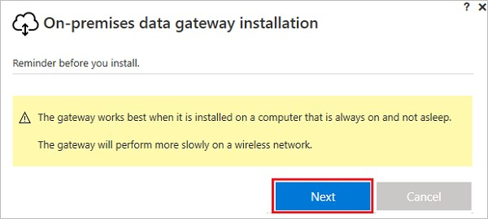

1. Select the installation location.
2. Accept the terms of use and the privacy statement.
3. Select **Install**.

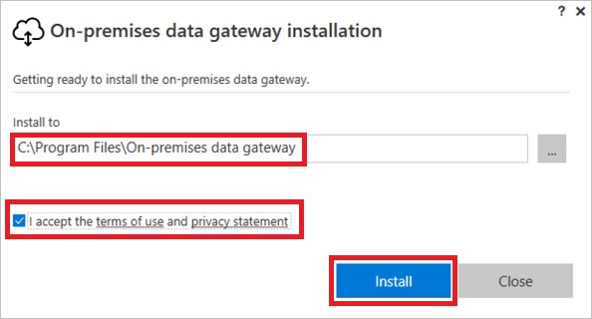

1. In the **User Account Control** dialog boxes, select **Yes** to continue.
2. On the **On-premises data gateway** screen, enter the email address for the account you will use to sign into the gateway, select **Sign in**, and then complete the sign in process.

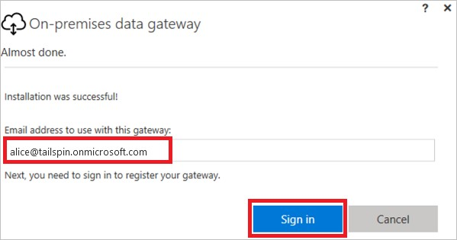

## Register new gateway or take over existing gateway

1. Select either **Register a new gateway on this computer** or **Migrate, restore, or takeover an existing gateway**, and then select **Next**.

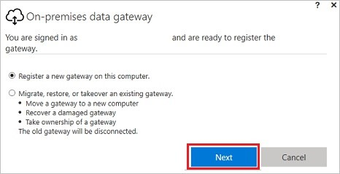

1. To configure a new gateway, enter a name in the **New on-premises data gateway name** box, enter a recovery key in the **Recovery key** box, enter the same recovery key into the **Confirm recovery key** box. Select **Configure**, and then select **Close**.

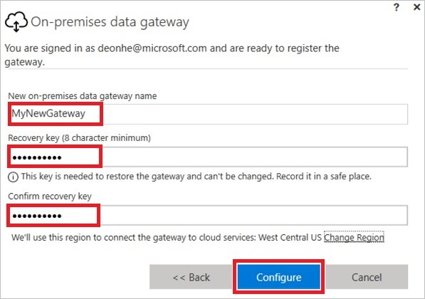

1. Specify a recovery key that contains at least eight characters, and keep it in a safe place. You'll need this key if you want to migrate, restore, or take over its gateway.
2. To migrate, restore, or take over an existing gateway, provide the name of the gateway and its recovery key, select **Configure**, and then follow any additional prompts.

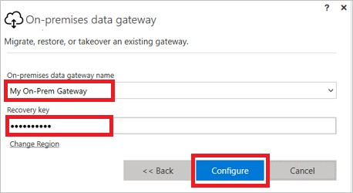

## Restart the gateway

The gateway runs as a Windows service and, as with any other Windows service, you can start and stop it in multiple ways. For example, you can open a command prompt with elevated permissions on the machine where the gateway is running, and then run either of these commands:

To stop the service, run this command:

net stop PBIEgwService

To start the service, run this command:

net start PBIEgwService

## Configure a firewall or proxy

For information about how to provide proxy information for your gateway, see [Configure proxy settings](https://powerbi.microsoft.com/documentation/powerbi-gateway-proxy/).

You can verify whether your firewall, or proxy, may be blocking connections by running the following command from a PowerShell prompt. This command tests connectivity to the Azure Service Bus. This command only tests network connectivity and doesn't impact the cloud server service or the gateway. It helps to determine whether your machine has connectivity to the Internet.

Test-NetConnection -ComputerName watchdog.servicebus.windows.net -Port 9350

The results should look like the output below. If **TcpTestSucceeded** is not *true*, you may be blocked by a firewall.

ComputerName : watchdog.servicebus.windows.net

RemoteAddress : 70.37.104.240

RemotePort : 5672

InterfaceAlias : vEthernet (Broadcom NetXtreme Gigabit Ethernet - Virtual Switch)

SourceAddress : 10.120.60.105

PingSucceeded : False

PingReplyDetails (RTT) : 0 ms

TcpTestSucceeded : True

If you want to be exhaustive, substitute the **ComputerName** and **Port** values with those listed under **Configure ports** later in this topic.

The firewall may also be blocking the connections that the Azure Service Bus makes to the Azure data centers. If that's the case, you'll want to whitelist (unblock) all of the [IP addresses](https://www.microsoft.com/download/details.aspx?id=41653) for your region for those data centers.

## Configure ports

The gateway creates an outbound connection to Azure Service Bus. It communicates on outbound ports: TCP 443 (default), 5671, 5672, 9350 thru 9354. The gateway doesn't require inbound ports.

Learn more about [hybrid solutions](https://azure.microsoft.com/documentation/articles/service-bus-fundamentals-hybrid-solutions/).

|  |  |  |
| --- | --- | --- |
| **DOMAIN NAMES** | **OUTBOUND PORTS** | **DESCRIPTION** |
| *.analysis.windows.net | 443 | HTTPS |
| *.login.windows.net | 443 | HTTPS |
| *.servicebus.windows.net | 5671-5672 | Advanced Message Queuing Protocol (AMQP) |
| **DOMAIN NAMES** | **OUTBOUND PORTS** | **DESCRIPTION** |
| *.servicebus.windows.net | 443, 9350-9354 | Listeners on Service Bus Relay over TCP (requires 443 for Access Control token acquisition) |
| *.frontend.clouddatahub.net | 443 | HTTPS |
| *.core.windows.net | 443 | HTTPS |
| login.microsoftonline.com | 443 | HTTPS |
| *.msftncsi.com | 443 | Used to test internet connectivity if the gateway is unreachable. |

[If you need to white list IP addresses instead of the domains, you can download and use the Microsoft Azure Datacenter IP ranges list. In some cases, the Azure Service Bus connections will be made with IP address inste](https://www.microsoft.com/download/details.aspx?id=41653)ad of the fully qualified domain names.

## Sign-in account

Users will sign in with either a work or school account. This is your organization account. If you signed up for an Office 365 offering and didn’t supply your work email, it may look like nancy@contoso.onmicrosoft.com. Your account, within a cloud service, is stored within a tenant in Azure Active Directory (AAD). In most cases, your AAD account’s UPN will match the email address.

## Windows Service account

The on-premises data gateway is configured to use *NT SERVICE\PBIEgwService* for the Windows service logon credentials. By default, it has the right of Log on as a service. This is in the context of the machine on which you're installing the gateway.

This isn't the account used to connect to on-premises data sources or the work or school account with which you sign into cloud services.

## Frequently asked questions

### General questions

**Question:** What data sources does the gateway support? **Answer:**

SQL Server

SharePoint

Oracle

Informix

Filesystem

DB2

**Question:** Do I need a gateway for data sources in the cloud, such as SQL Azure? **Answer:** No. A gateway connects to on-premises data sources only.

**Question:** What is the actual Windows service called? **Answer:** In Services, the gateway is called **Power BI Enterprise Gateway Service**.

**Question:** Are there any inbound connections to the gateway from the cloud? **Answer:** No. The gateway uses outbound connections to Azure Service Bus.

**Question:** What if I block outbound connections? What do I need to open? **Answer:** See the ports and hosts that the gateway uses.

**Question:** Does the gateway have to be installed on the same machine as the data source? **Answer:** No. The gateway will connect to the data source using the connection information that was provided. Think of the gateway as a client application in this sense. It will just need to be able to connect to the server name that was provided.

**Question:** What is the latency for running queries to a data source from the gateway? What is the best architecture? **Answer:** To reduce network latency, install the gateway as close to the data source as possible. If you can install the gateway on the actual data source, it will minimize the latency introduced. Consider the data centers as well. For example, if your service is using the West US data center and you have SQL Server hosted in an Azure VM, you'll want to have the Azure VM in West US as well. This will minimize latency and avoid egress charges on the Azure VM.

**Question:** Are there any requirements for network bandwidth? **Answer:** It is recommended to have good throughput for your network connection. Every environment is different, and the amount of data being sent will affect the results. Using ExpressRoute could help guarantee a level of throughput between on-premises and the Azure data centers.

You can use the third-party tool [Azure Speed Test app](http://azurespeedtest.azurewebsites.net/) to determine your throughput.

**Question:** Can the gateway Windows service run with an Azure Active Directory account? **Answer:** No. The Windows service must have a valid Windows account. By default, it will run with the Service SID, *NT SERVICE\PBIEgwService*.

**Question:** How are results sent to the cloud? **Answer:** Results are sent using Azure Service Bus. For more information, see how it works.

**Question:** Where are my credentials stored? **Answer:** The credentials that you enter for a data source are encrypted and stored in the gateway cloud service. The credentials are decrypted at the gateway on-premises.

### High availability/disaster recovery

**Question:** Are there any plans for enabling high availability scenarios with the gateway? **Answer:** This is on the roadmap, but we don’t have a timeline yet.

**Question:** What options are available for disaster recovery? **Answer:** You can use the recovery key to restore or move a gateway.

**Question:** What is the benefit of the recovery key? **Answer:** It provides a way to migrate or recover your gateway settings.

### Troubleshooting questions

**Question:** Where are the gateway logs? **Answer:** See Tools later in this topic.

**Question:** How can I see what queries are being sent to the on-premises data source? **Answer:** You can enable query tracing, which will include the queries being sent. Remember to change it back to the original value when done troubleshooting. Leaving query tracing enabled will cause the logs to be larger.

You can also look at tools that your data source has for tracing queries. For example, you can use Extended Events or SQL Profiler for SQL Server and Analysis Services.

## How the gateway works

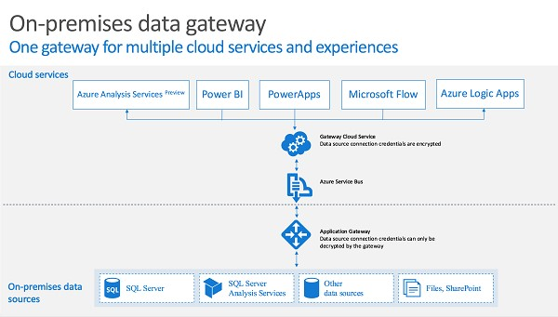

When a user interacts with an element that's connected to an on-premises data source:

1. The cloud service creates a query, along with the encrypted credentials for the data source, and sends the query to the queue for the gateway to process.
2. The gateway cloud service analyzes the query and pushes the request to the [Azure Service Bus](https://azure.microsoft.com/documentation/services/service-bus/).
3. The on-premises data gateway polls the Azure Service Bus for pending requests.
4. The gateway gets the query, decrypts the credentials, and connects to the data source(s) with those credentials.
5. The gateway sends the query to the data source for execution.
6. The results are sent from the data source back to the gateway and then onto the cloud service. The service then uses the results.

## Troubleshooting

### Update to the latest version

Many issues can surface when the gateway version is out of date. Ensure you're on the latest version. If you haven't updated the gateway recently, consider installing the latest version and see if you can reproduce the issue.

**Error: Failed to add user to group. (-2147463168 PBIEgwService Performance Log Users )**

You may receive this error if you're trying to install the gateway on a domain controller, which isn't supported. You'll need to install the gateway on a machine that isn't a domain controller.

## Tools

### Collecting logs from the gateway configurator

You can collect several logs for the gateway. Always start with the logs!

1. Installer logs

%localappdata%\Temp\On-premises_data_gateway_*.log

1. Configuration logs

%localappdata%\Microsoft\on-premises data gateway\GatewayConfigurator*.log

1. Enterprise gateway service logs

C:\Users\PBIEgwService\AppData\Local\Microsoft\on-premises data gateway\Gateway*.log

1. Event logs

The **On-premises data gateway service** event logs are present under **Applications and Services Logs**.

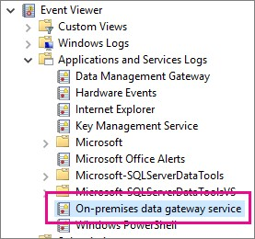

### Fiddler Trace

[Fiddler](http://www.telerik.com/fiddler) is a free tool from Telerik that monitors HTTP traffic. You can see the back and forth with the Power BI service from the client machine. This may show errors and other related information.

# Microsoft Flow for enterprise developers

11/3/2017 • 1 min to read • [Edit Online](https://github.com/MicrosoftDocs/flow-docs-pr/blob/live/flow-docs/dev-enterprise-intro.md)

As an enterprise developer, empower your organization to build robust tailored solutions on Microsoft Flow. Use custom connectors that connect to your data and web services; embed apps in your organization's websites; and work with data in the Common Data Service.

## Build custom connectors

Develop custom connectors to connect to your organization's data and web services through Microsoft Flow. Learn more

Build Azure Functions

Craft Azure Functions to extend apps with custom server-side logic. [Learn more](https://powerapps.microsoft.com/blog/using-azure-functions-in-powerapps/)

## Embed apps

Embed Microsoft Flow directly into your website experiences to create integrated solutions, surfacing workflows or processes where people in your organization already do their work. Learn more

# Register and use custom connectors in Microsoft Flow

11/3/2017 • 7 min to read • [Edit Online](https://github.com/MicrosoftDocs/flow-docs-pr/blob/live/flow-docs/register-custom-api.md)

Microsoft Flow enables you to build workflows with no code. But in some cases, you need to extend Microsoft Flow capabilites, and web services are a natual fit for this. Your flow can connect to a service, perform operations, and get data back. When you have a web service you want to connect to with Microsoft Flow, you register the service as a custom connector. This process enables Microsoft Flow to understand the characteristics of your web API, including the authentication that it requires, the operations that it supports, and the parameters and outputs for each of those operations.

In this topic, we'll look at the steps required to register and use a custom connector, and we'll use the Azure Cognitive Services [Text Analytics API](https://www.microsoft.com/cognitive-services/text-analytics-api). This API identifies the language, sentiment, and key phrases in text that you pass to it.

## Prerequisites

A [Microsoft Flow account](https://flow.microsoft.com/).

An OpenAPI 2.0 (formerly known as Swagger) file in JSON format, a URL to an OpenAPI definition, or a Postman Collection for your API. If you don't have any of these, we'll provide guidance for you. An image to use as an icon for your custom connector (optional).

## Steps in the custom connector process

The custom connector process has several steps, which we describe briefly below. This article assumes you already have a RESTful API with some type of authenticated access, so we'll focus on steps 3-6 in the rest of the article. For an example of steps 1 and 2, see Create a custom Web API for Microsoft Flow.

1. **Build a RESTful API** in the language and platform of your choice. For Microsoft technologies, we recommend one of the following (but you can use any platform):

Azure Functions

Azure Web Apps

Azure API Apps

1. **Secure your API** using one of the following authentication mechanisms. You can allow unauthenticated access to your connectors, but we don't recommend it.

Azure Active Directory. For more information, see Use Azure Active Directory with a custom connector in Microsoft Flow.

OAuth 2.0 for specific services like Dropbox, Facebook, and SalesForce

Generic OAuth 2.0

API Key

Basic Authentication

1. **Describe your API** in one of two industry-standard ways, so that Microsoft Flow can connect to it.

An OpenAPI file

A Postman Collection

You can also build an OpenAPI file in step 4 as part of the registration process.

1. **Register your custom connector** using a wizard in Microsoft Flow, where you specify an API description, security details, and other information.
2. **Use your custom connector** in an app. Create a connection to the connector in your app, and call any operations that the API provides, just like you call standard connections in Microsoft Flow.
3. **Share your custom connector** like you do other resources in Microsoft Flow. This step is optional, but it often makes sense to share custom connectors across multiple app creators.

## Describe your API

Assuming you have an API with some type of authenticated access, you need a way to describe the API so that Microsoft Flow can connect to it. To do this, you create an OpenAPI file or a Postman Collection – which you can do from *any* REST API endpoint, including:

Publicly available connectors. Some examples include [Spotify](https://developer.spotify.com/), [Uber](https://developer.uber.com/), [Slack](https://api.slack.com/), [Rackspace](http://docs.rackspace.com/), and more. An API that you create and deploy to any cloud hosting provider, including Azure, Amazon Web Services (AWS), Heroku, Google Cloud, and more.

A custom line-of-business API deployed on your network as long as the API is exposed on the public internet.

OpenAPI 2.0 (formerly known as Swagger) and Postman Collections use different formats, but both are language-agnostic machine-readable documents that describe your API's operations and parameters:

You can generate these documents using a variety of tools depending on the language and platform that your API is built on. See the [Text Analytics API documentation](https://westus.dev.cognitive.microsoft.com/docs/services/TextAnalytics.V2.0/export?DocumentFormat=Swagger&ApiName=Azure) for an example of an OpenAPI file.

If you don't already have an OpenAPI file for your API and don't want to create one, you can still easily create a custom connector by using a Postman Collection. See Create a Postman Collection for more information. Microsoft Flow ultimately uses OpenAPI behind the scenes, so a Postman Collection is parsed and translated into an OpenAPI definition file.

**Note**: Your file size must be less than 1MB.

### Getting started with OpenAPI and Postman

If you're new to OpenAPI, see [Getting Started with OpenAPI](http://swagger.io/getting-started/) on the swagger.io site.

If you're new to Postman, install the [Postman app](https://www.getpostman.com/apps) from their site.

[If your API is built with Azure API Apps or Azure Functions, see Exporting an Azure hosted API to Microsoft Flow and Microsoft Flow for more information.](https://docs.microsoft.com/azure/app-service/app-service-export-api-to-powerapps-and-flow)

## Register your custom connector

You will now use the OpenAPI file or Postman Collection to register your custom connector in Microsoft Flow.

1. In [flow.microsoft.com](https://flow.microsoft.com/), in the top bar, select the gear to open the settings menu. Select the **Custom Connectors** option.

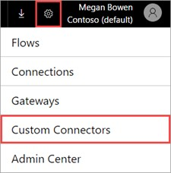

1. Select **Create custom connector**.

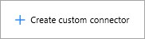

1. In the **General** tab, choose how you want to create the custom connector.

Upload OpenAPI

Paste OpenAPI URL

Upload a Postman Collection V1

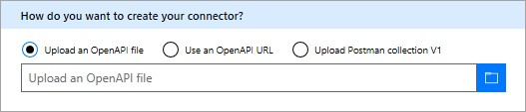

Upload an icon for your custom connector. Description, Host, and Base URL fields are typically autopopulated with the information from the OpenAPI file. If they are not auto-populated, you can add information to those fields. Select **Continue**.

1. In the **Security** tab, enter any authentication properties.

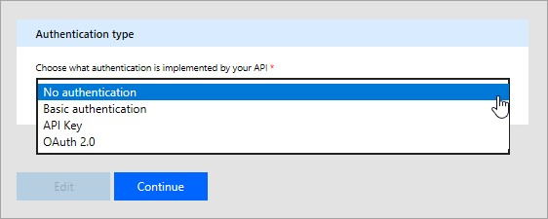

The authentication type is auto-populated based on what is defined in your OpenAPI

securityDefinitions

object. Below is an OAuth2.0 example.

"securityDefinitions": {

"AAD": {

"type": "oauth2",

"flow": "accessCode",

"authorizationUrl": "https://login.windows.net/common/oauth2/authorize",

"tokenUrl": "https://login.windows.net/common/oauth2/token"

"scopes": {}

}

},

|  |
| --- |
| securityDefintions |

If the OpenAPI file does not use the object, then no additional values are needed. When using a Postman Collection, authentication type is auto-populated only when using supported authentication types, such as OAuth 2.0 or Basic.

For an example of setting up Azure Active Directory (AAD) authenthication, see Create a custom Web API for Microsoft Flow.

5. In the **Definitions** tab, all the operations defined in your OpenAPI file or Postman Collection, along with request and response values, are auto-populated. If all your required operations are defined, you can go to step 6 in the registration process without making changes on this screen.

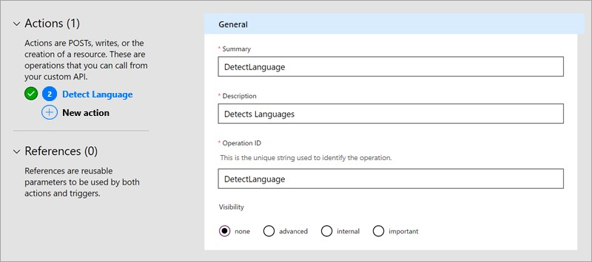

If you want to edit existing actions or add new actions to your custom connector, continue reading below.

1. If you want to add a new action that was not already in your OpenAPI file or Postman Collection, select **New action** in the left pane and fill in the **General** section with the name, description, and visibility of your operation.
2. In the **Request** section, select **Import from sample** on the top right. In the form on the right, paste in a sample request. Sample requests are usually available in the API documentation, where you can [get information to fill out the **Verb**, **Request URL**, **Headers**, and **Body** fields. See the Text Analytics API documentation for an example.](https://westus.dev.cognitive.microsoft.com/docs/services/TextAnalytics.V2.0/operations/56f30ceeeda5650db055a3c6)

|  |  |
| --- | --- |
| **IMPORTANT**   |  | | --- | | Content-type |   Make sure you remove the header from actions, as this will be automatically added by Microsoft Flow. Authentication headers that have been defined in the **Security** section should also be removed from actions and triggers. |

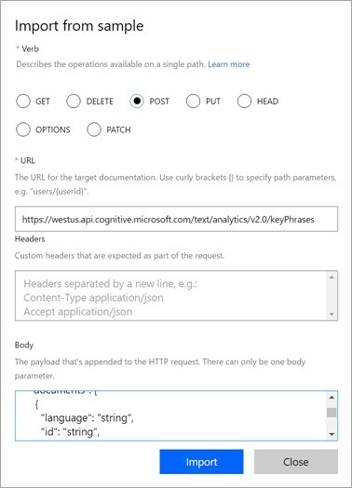

1. Select **Import** to complete the request definition. Define the response in a similar way.
2. Once you have all your operations defined, select **Create** to create your custom connector.
3. Once you have created your custom connector, go to the **Test** tab to test the operations defined in the API. Choose a connection, and provide input parameters to test an operation.

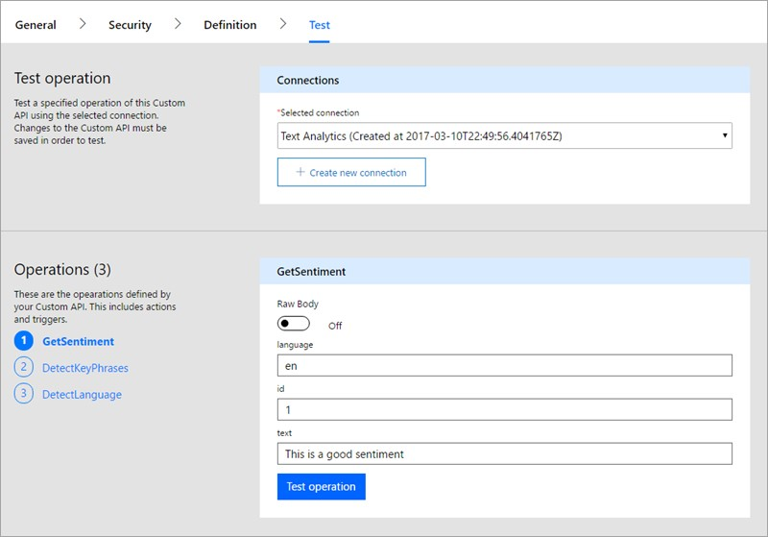

If the call is successful, you get a valid response.

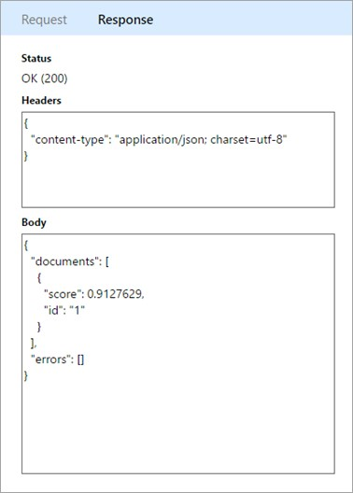

### Quota and throttling

See the [Microsoft Flow Pricing](https://flow.microsoft.com/pricing/) page for details about custom connector creation quotas. Custom connectors that are shared with you don't count against this quota.

For each connection created on a custom connector, users can make up to 500 requests per minute.

## Share your custom connector

Now that you have a custom connector, you can share it with other users in your organization. Keep in mind that when you share an custom connector, others might start to depend on it, and deleting a custom connector deletes all the connections to the connector. If you want to provide a connector for users outside your organization, see Overview of certifying custom connectors in Microsoft Flow.

1. In [flow.microsoft.com](https://flow.microsoft.com/), in the top bar, select the gear to open the settings menu. Select the **Custom connectors** option.



1. Select the ellipsis (**. . .**) button for your connector, then select **View properties**.

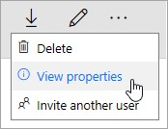

1. Select **Share**, and then enter the users or groups to whom you want to grant access to your connector.

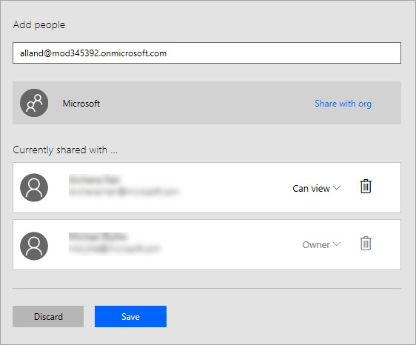

1. Select **Save**.

## Next steps

Learn how to create a Postman Collection Learn about custom OpenAPI extensions.

Use an ASP.NET Web API.

Register an Azure Resource Manager API.

# Describe a custom connector with Postman

11/3/2017 • 1 min to read • [Edit Online](https://github.com/MicrosoftDocs/flow-docs-pr/blob/live/flow-docs/postman-collection.md)

[Postman](https://www.getpostman.com/) is a tool for making your API development faster and easier. This tutorial demonstrates how to create a Postman collection, which you can then use to easily create custom connectors in Microsoft Flow.

## Prerequisites

Install the [Postman app](https://www.getpostman.com/apps).

## Create a Postman Collection

Let's build a Postman Collection for the Azure Cognitive Services [Text Analytics API](https://www.microsoft.com/cognitive-services/text-analytics-api). This API identifies the language, sentiment, and key phrases in text that you pass to it.

1. The first step in creating a Postman Collection is to create a request. When creating the request, you can set the HTTP verb, the request URL, query or path parameters, headers, and the body. For more information, see [Sending Requests](https://www.getpostman.com/docs/requests) in the Postman documentation. For the Detect Language API endpoint, set the values as follows:

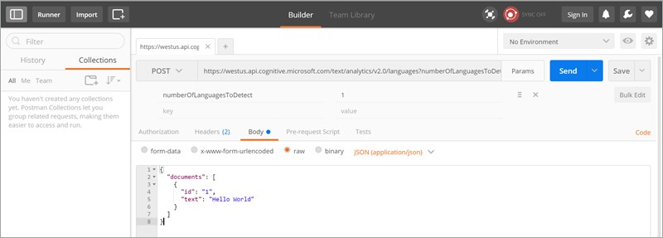

Details of parameters and values used:

|  |  |
| --- | --- |
| **PARAMETER** | **VALUE** |
| Verb | POST |
| Request URL | [https://westus.api.cognitive.microsoft.com/text/analytics/v](https://westus.api.cognitive.microsoft.com/text/analytics/v2.0/languages)  [2.0/languages](https://westus.api.cognitive.microsoft.com/text/analytics/v2.0/languages) |
| Params | numberOfLanguagesToDetect |
| Authorization | “No Auth” |
| Headers | Ocp-Apim-Subscription-Key = Content-Type = application/json |
| **PARAMETER** | **VALUE** |
| Body | |  | | --- | | {  "documents": [ {  "id": "1",  "text": "Hello World"  }  ] } | |

1. Click **Send** to make the request and get the response back.
2. Click **Save** to save the request into a Postman Collection.

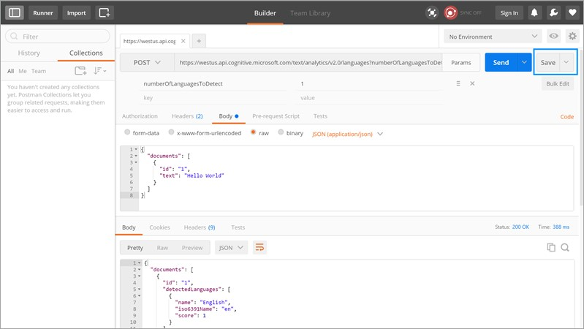

1. Provide a **Request name** and **Request description** in the **Save Request** dialog box. You will use these values in your custom connector.

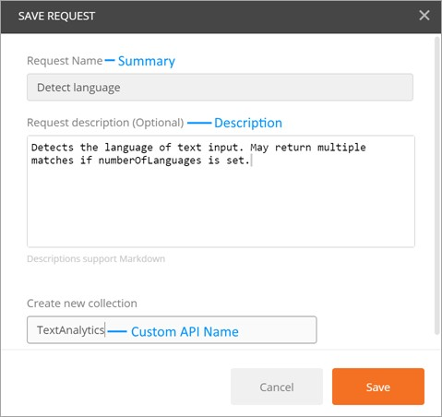

You can also save the response to the request. Custom connectors currently only support a single response per request. If you save multiple responses per request, only the first one is used.

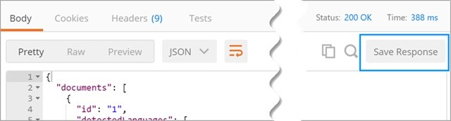

1. Continue building your Postman Collection by creating and saving other requests and responses.
2. Once you have completed building the Postman Collection for all your requests and responses, export the collection.

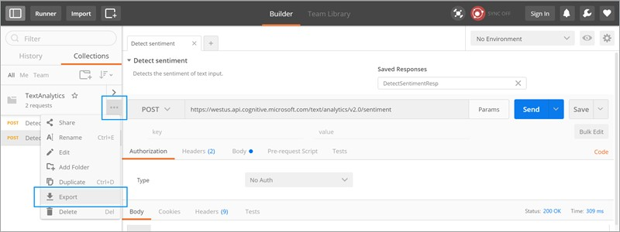

1. Choose **Collection v1** as the export format.

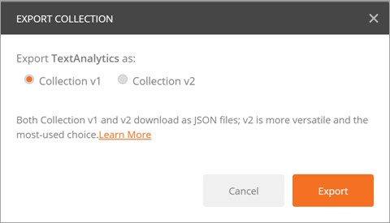

You can now use this Postman collection to create a custom connector in Microsoft Flow.

|  |  |  |
| --- | --- | --- |
| **IMPORTANT**   |  | | --- | | Content-type |   When creating a custom connector from a Postman collection, be sure to remove the header from actions and triggers, as this will be automatically added by Microsoft Flow. Authentication headers (for example,   |  | | --- | | Ocp-Apim-Subscription-Key |   ) should be defined in the **Security** section and must be removed from actions and triggers. |

For more information, see Register and use custom connectors in Microsoft Flow.

# OpenAPI extensions for custom connectors in Microsoft Flow

11/3/2017 • 4 min to read • [Edit Online](https://github.com/MicrosoftDocs/flow-docs-pr/blob/live/flow-docs/customapi-how-to-swagger.md)

## Introduction

To create custom connectors for Microsoft Flow, Azure Logic Apps, or Microsoft PowerApps, you must provide an OpenAPI definition file, which is a language-agnostic machine-readable document that describes your API's operations and parameters. Along with OpenAPI's out-of-the-box functionality, you can also include these OpenAPI extensions when you create custom connectors for Logic Apps and Flow:

|  |  |  |
| --- | --- | --- |
|  | |  | | --- | | summary | |
| |  | | --- | | x-ms-summary | |
| |  | | --- | | description | |
| |  | | --- | | x-ms-visibility | |
| |  | | --- | | x-ms-dynamic-values | |
| |  | | --- | | x-ms-dynamic-schema | |

Here are more details about these extensions:

## summary

Specifies the title for the action (operation).

Applies to: Operations

|  |
| --- |
| summary |

Recommended: Use *sentence case* for .

Example: "When an event is added to calendar" or "Send an email"

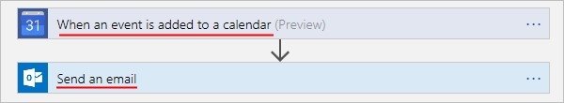

"actions" {

"Send_an_email": {

/// Other action properties here... "summary": "Send an email",

/// Other action properties here...

} },

## x-ms-summary

Specifies the title for an entity.

Applies to: Parameters, Response Schema

|  |
| --- |
| x-ms-summary |

Recommended: Use *title case* for .

Example: "Calendar ID", "Subject", "Event Description", and so on

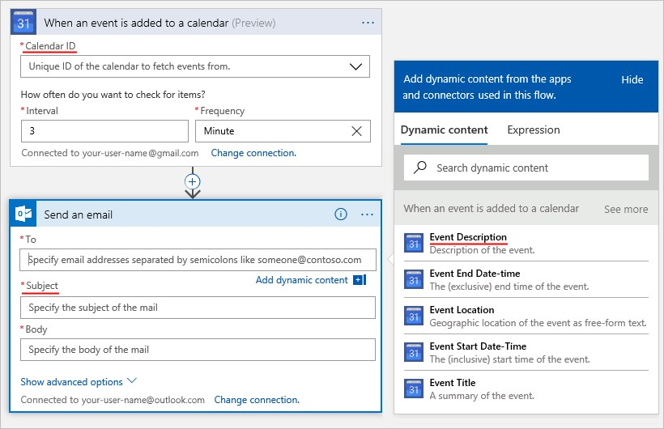

"actions" {

"Send_an_email": {

/// Other action properties here...

"parameters": [

{

/// Other parameters here...

"x-ms-summary": "Subject", /// Other parameters here...

}

]

} },

## description

Specifies a verbose explanation about the operation's functionality or an entity's format and function.

Applies to: Operations, Parameters, Response Schema

|  |
| --- |
| description |

Recommended: Use *sentence case* for .

Example: "This operation triggers when a new event is added to the calendar", "Specify the subject of the mail.", and so on

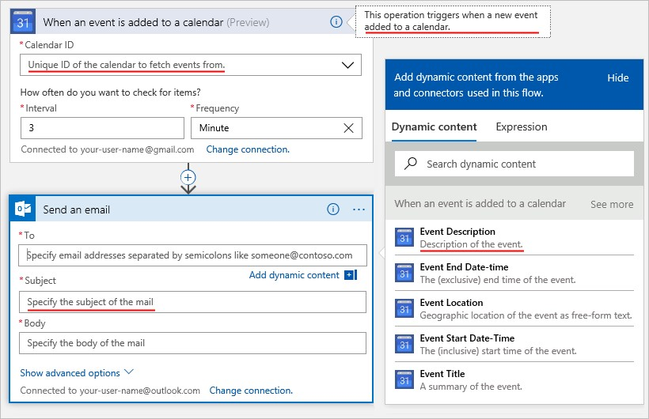

|  |
| --- |
| "actions" {  "Send_an_email": {  "description": "Specify the subject of the mail",  /// Other action properties here... }  }, |

## x-ms-visibility

Specifies the user-facing visibility for an entity.

|  |  |  |  |  |
| --- | --- | --- | --- | --- |
| important | , | advanced | , and | internal |

Possible values:

Applies to: Operations, Parameters, Schemas

|  |
| --- |
| important |

|  |
| --- |
| advanced |

|  |
| --- |
| internal |

operations and parameters are always shown to the user first. operations and parameters are hidden under an additional menu. operations and parameters are hidden from the user.

|  |  |  |  |
| --- | --- | --- | --- |
| **NOTE**   |  |  |  | | --- | --- | --- | | internal | and | required |   For parameters that are , you **must** provide default values for these parameters. |

|  |
| --- |
| advanced |

Example: The **See more** menu and **Show advanced options** menu are hiding operations and parameters.

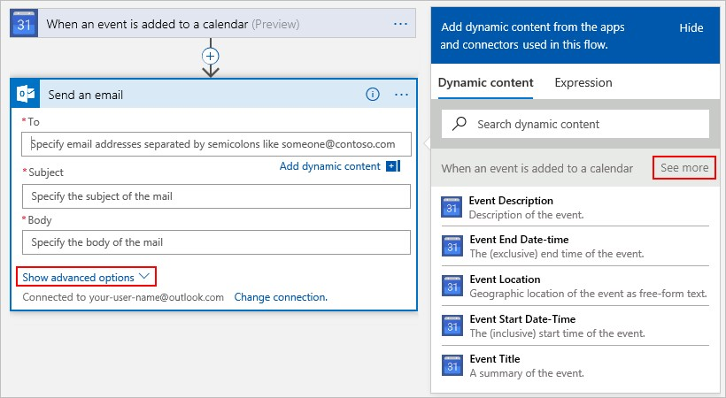

|  |
| --- |
| "actions" {  "Send_an_email": {  /// Other action properties here...  "parameters:": [  {  "name": "Subject",  "type": "string",  "description": "Specify the subject of the mail",  "x-ms-summary": "Subject",  "x-ms-visibility": "important", /// Other parameter properties here }  ]  /// Other action properties here... }  }, |

## x-ms-dynamic-values

Shows a populated list for the user so they can select input parameters for an operation. Applies to: Parameters

|  |
| --- |
| [x-ms-dynamic-values](https://procsi.blob.core.windows.net/blog-images/sampleDynamicSwagger.json) |

[How to use: Add the object to the parameter's definition. For example, see this OpenAPI sample.](https://procsi.blob.core.windows.net/blog-images/sampleDynamicSwagger.json)

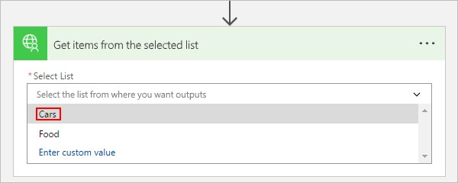

### Properties for x-ms-dynamic-values

|  |  |  |
| --- | --- | --- |
| **NAME** | **REQUIRED OR OPTIONAL** | **DESCRIPTION** |
| **operationID** | Required | The operation to call for populating the list. |
| **value-path** | Required | A path string in the object inside   |  |  | | --- | --- | | value-collection | that refers to the | | parameter value. If | value-collection |   isn't specified, the response is evaluated as an array. |
| **value-title** | Optional | |  | | --- | | value-collection |   A path string in the object inside that refers to the  value's description. If   |  | | --- | | value-collection |   isn't specified, the  response is evaluated as an array. |
| **value-collection** | Optional | A path string that evaluates to an array of objects in the response payload |
| **parameters** | Optional | An object whose properties specify the input parameters required to invoke a dynamic-values operation |

|  |
| --- |
| x-ms-dynamic-values |

Here's an example that shows the properties in :

"x-ms-dynamic-values": {

"operationId": "PopulateDropdown",

"value-path": "name",

"value-title": "properties/displayName",

"value-collection": "value",

"parameters": {

"staticParameter": "{value}",

"dynamicParameter": {

"parameter": "{value-to-pass-to-dynamicParameter}" }

}

}

## Example: All the OpenAPI extensions up to this point

|  |
| --- |
| "/api/lists/{listID-dynamic}": {  "get": {  "description": "Get items from a single list - uses dynamic values and outputs dynamic schema",  "summary": "Gets items from the selected list",  "operationID": "GetListItems",  "parameters": [  {  "name": "listID-dynamic",  "type": "string",  "in": "path",  "description": "Select the list from where you want outputs", "required": true,  "x-ms-summary": "Select List",  "x-ms-dynamic-values": {  "operationID": "GetLists",  "value-path": "id", "value-title": "name"  }  }  ]  }  } |

## x-ms-dynamic-schema

Indicates that the schema for the current parameter or response is dynamic. This object can invoke an operation that's defined by the value of this field, dynamically discover the schema, and display the appropriate UI for collecting user inputs or show available fields.

Applies to: Parameters, Response

|  |
| --- |
| x-ms-dynamic-schema |

How to use: Add the object to a request parameter or response body definition. For an example, see this [OpenAPI sample](https://procsi.blob.core.windows.net/blog-images/sampleDynamicSwagger.json).

This example shows how the input form changes, based on the item that the user selects from the drop-down list:

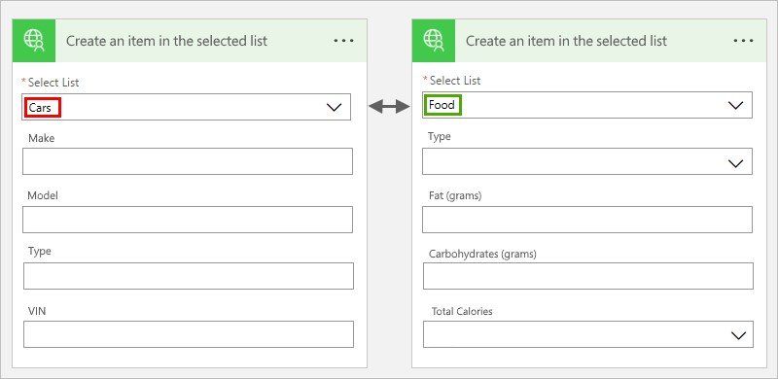

And this example shows how the outputs change, based on the item that the user selects from the drop-down list. In this version, the user selects "Cars":

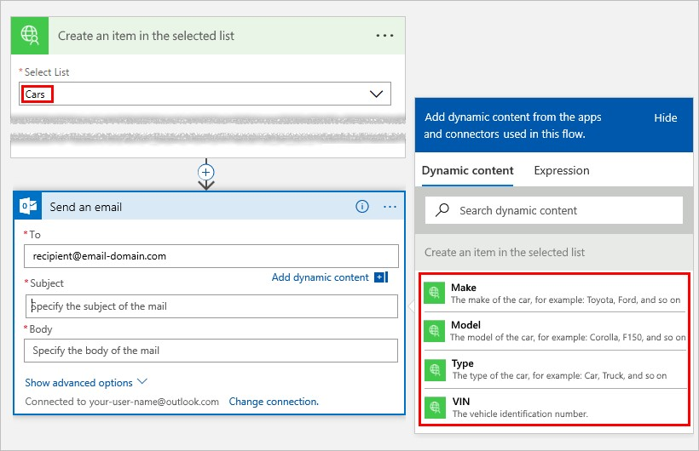

In this version, the user selects "Food":

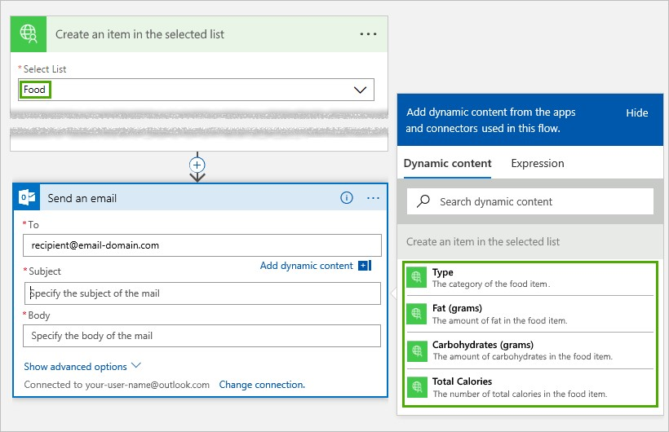

### Properties for x-ms-dynamic-schema

|  |  |  |
| --- | --- | --- |
| **NAME** | **REQUIRED OR OPTIONAL** | **DESCRIPTION** |
| **operationID** | Required | The operation to call for fetching the schema |
| **NAME** | **REQUIRED OR OPTIONAL** | **DESCRIPTION** |
| **parameters** | Required | An object whose properties specify the input parameters required to invoke a dynamic-schema operation |
| **value-path** | Optional | A path string that refers to the property that has the schema.  If not specified, the response is assumed to contain the schema in the root object's properties. |
|  |  |  |

Here's an example for a dynamic parameter:

{

"name": "dynamicListSchema",

"in": "body",

"description": "Dynamic schema for items in the selected list",

"schema": {

"type": "object",

"x-ms-dynamic-schema": {

"operationID": "GetListSchema",

"parameters": {

"listID": {

"parameter": "listID-dynamic"

}

},

"value-path": "items"

}

}

}

Here's an example for a dynamic response:

"DynamicResponseGetListSchema": {

"type": "object",

"x-ms-dynamic-schema": {

"operationID": "GetListSchema",

"parameters": {

"listID": {

"parameter": "listID-dynamic"

}

},

"value-path": "items"

}

}

## Next steps

Register a custom connector.

Use an ASP.NET Web API.

Register an Azure Resource Manager API.

# Use Azure Active Directory with a custom connector in Microsoft Flow

11/3/2017 • 3 min to read • [Edit Online](https://github.com/MicrosoftDocs/flow-docs-pr/blob/live/flow-docs/customapi-azure-resource-manager-tutorial.md)

Azure Resource Manager (ARM) enables you to manage the components of a solution on Azure - components like databases, virtual machines, and web apps. This tutorial demonstrates how to enable authentication in Azure Active Directory, register one of the ARM APIs as a custom connector, and then connect to it in Microsoft Flow. This would be useful if you want to manage Azure resources as part of a flow. For more information about ARM, see [Azure Resource Manager Overview](https://docs.microsoft.com/azure/azure-resource-manager/resource-group-overview).

## Prerequisites

An [Azure subscription](https://azure.microsoft.com/free/).

A [Microsoft Flow account](https://flow.microsoft.com/).

The [sample OpenAPI file](https://pwrappssamples.blob.core.windows.net/samples/AzureResourceManager.json) used in this tutorial.

## Enable authentication in Azure Active Directory

First, we need to create an Azure Active Directory (AAD) application that will perform the authentication when calling the ARM API endpoint.

1. Sign in to the [Azure portal](https://portal.azure.com/). If you have more than one Azure Active Directory tenant, make sure you're logged into the correct directory by looking at your username in the upper-right corner.

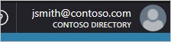

1. On the left-hand menu, click **More services**. In the **Filter** textbox, type **Azure Active Directory**, and then click **Azure Active Directory**.

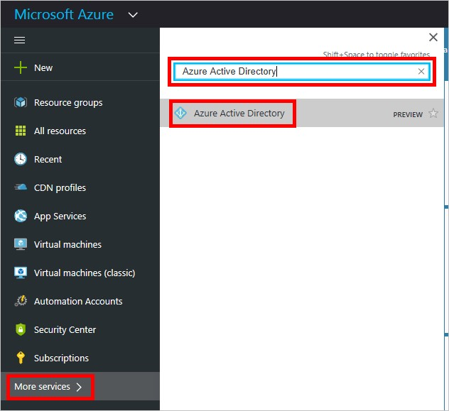

The Azure Active Directory blade opens.

1. In the menu on the Azure Active Directory blade, click **App registrations**.

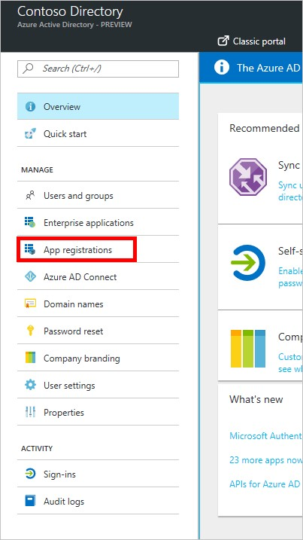

1. In the list of registered applications, click **Add**.

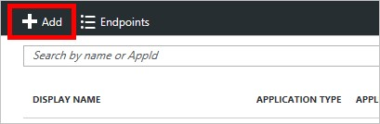

|  |
| --- |
| https://login.windows.net |

1. Type a name for your application, leave **Web app / API** selected, and then for **Sign-on URL** type . Click **Create**.

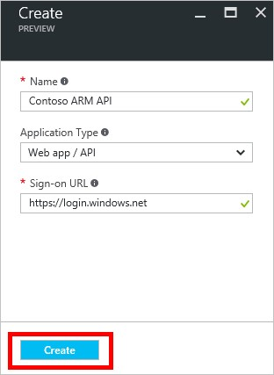

1. Click the new application in the list.

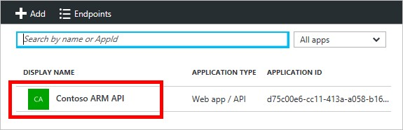

The Registered app blade opens. Make a note of the **Application ID**. We'll need it later.

1. The Settings blade should have opened, as well. If it didn't, click the **Settings** button.

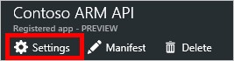

|  |
| --- |
| https://msmanaged-na.consent.azure-apim.net/redirect |

1. In the Settings blade, click **Reply URLs**. In the list of URLs, add and click **Save**.

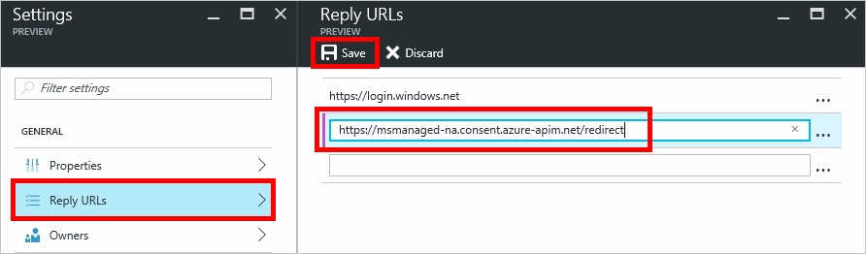

1. Back on the Settings blade, click **Required permissions**. On the Required permissions blade, click **Add**.

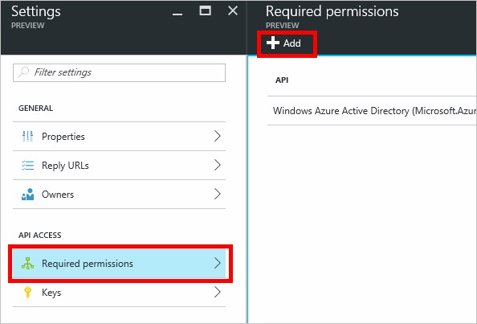

The Add API access blade opens.

1. Click **Select an API**. In the blade that opens, click the option for the Azure Service Management API and click **Select**.

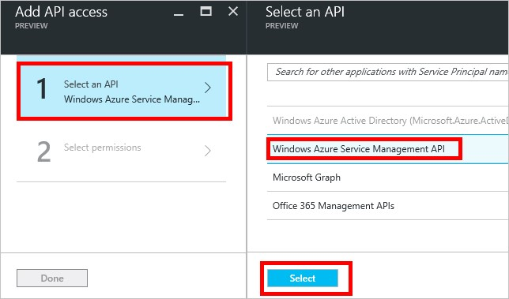

1. Click **Select permissions**. Under *Delegated permissions*, click **Access Azure Service Management as organization users**, and then click **Select**.

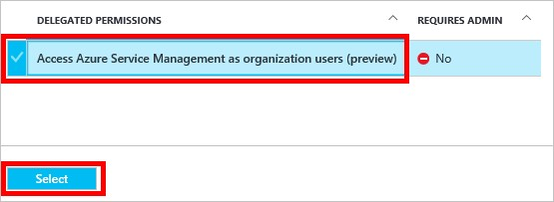

1. On the Add API access blade, click **Done**.
2. Back on the Settings blade, click **Keys**. In the Keys blade, type a description for your key, select an expiration period, and then click **Save**. Your new key will be displayed. Make note of the key value, as we will need that later, too. You may now close the Azure portal.

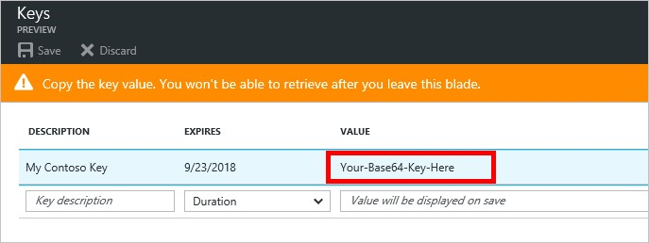

## Add the connection in Microsoft Flow

Now that the AAD application is configured, let's add the custom connector.

1. In the [Microsoft Flow web app](https://flow.microsoft.com/), click the **Settings** button at the upper right of the page (it looks like a gear). Then click **custom connectors**.



1. Click **Create custom connector**.

You will be prompted for the properties of your API.

|  |  |
| --- | --- |
| **PROPERTY** | **DESCRIPTION** |
| Name | At the top of the page, click **Untitled** and give your flow a name. |
| OpenAPI file | Browse to the [sample ARM OpenAPI file](https://pwrappssamples.blob.core.windows.net/samples/AzureResourceManager.json). |
| Upload API icon | Cick **Upload icon** to select an image file for the icon. Any PNG or JPG image less than 1 MB in size will work. |
| Description | Type a description of your custom connector (optional). |

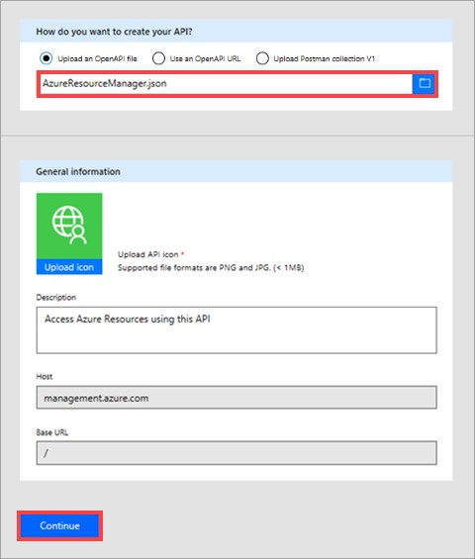

Select **Continue**.

1. On the next screen, because the OpenAPI file uses our AAD application for authentication, we need to give Flow some information about our application. Under **Client id**, type the AAD **Application ID** you noted earlier. For client secret, use the **key**. And finally, for **Resource URL**, type

|  |
| --- |
| https://management.core.windows.net/ |

.

**IMPORTANT**

Be sure to include the Resource URL exactly as written above, including the trailing slash.

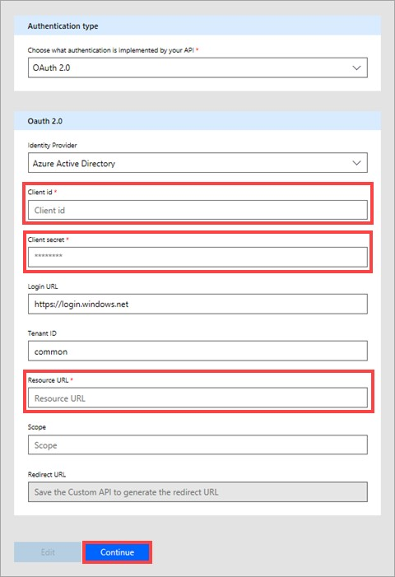

After entering security information, click the check mark (✓) next to the flow name at the top of the page to create the custom connector.

1. Your custom connector is now displayed under **custom connectors**.



1. Now that the custom connector is registered, you must create a connection to the custom connector so it can be used in your apps and flows. Click the **+** to the right of the name of your custom connector and then complete complete the sign-on screen.

**NOTE**

The sample OpenAPI does not define the full set of ARM operations and currently only contains the [List all subscriptions](https://msdn.microsoft.com/library/azure/dn790531.aspx) operation. You can edit this OpenAPI or create another OpenAPI file using the [online OpenAPI editor](http://editor.swagger.io/).

This process can be used to access any RESTful API authenticated using AAD.

## Next steps

For more detailed information about how to create a flow, see Start to build with Microsoft Flow.

To ask questions or make comments about custom connectors, [join our community](https://aka.ms/flow-community).

# Build a custom connector for a Web API in Microsoft Flow

11/3/2017 • 4 min to read • [Edit Online](https://github.com/MicrosoftDocs/flow-docs-pr/blob/live/flow-docs/customapi-web-api-tutorial.md)

This tutorial shows you how to start bulding an ASP.NET Web API, host it on Azure Web Apps, enable Azure Active Directory authentication, and then register the ASP.NET Web API in Microsoft Flow. After the API is registered, you can connect to it and call it from your flow.

## Prerequisites

An [Azure subscription](https://azure.microsoft.com/free/).

A [PowerApps account](https://powerapps.microsoft.com/).

[Visual Studio](https://www.visualstudio.com/vs/) 2013 or higher.

## Create an ASP.NET Web API and deploy it to Azure

1. In Visual Studio, click **File** > **New Project** to create a new C# ASP.NET web application.

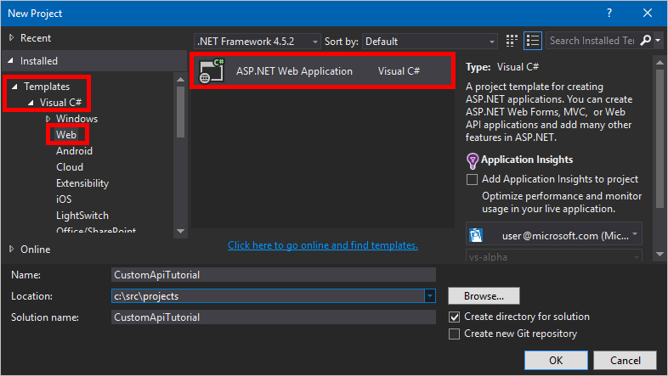

1. Select the **Web API** template. Leave **Host in the cloud** checked. Click **Change Authentication**.

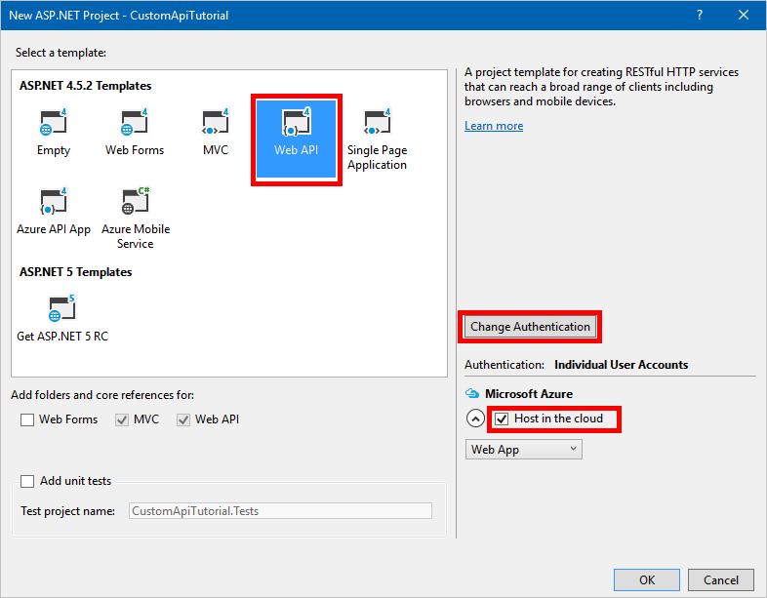

1. Select **No Authentication**, and then click **OK**.

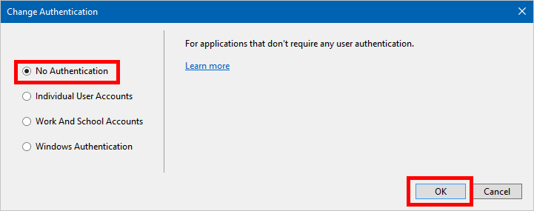

1. Click **OK** on the **New ASP.NET Project** dialog. The Configure Microsoft Azure Web App dialog appears. 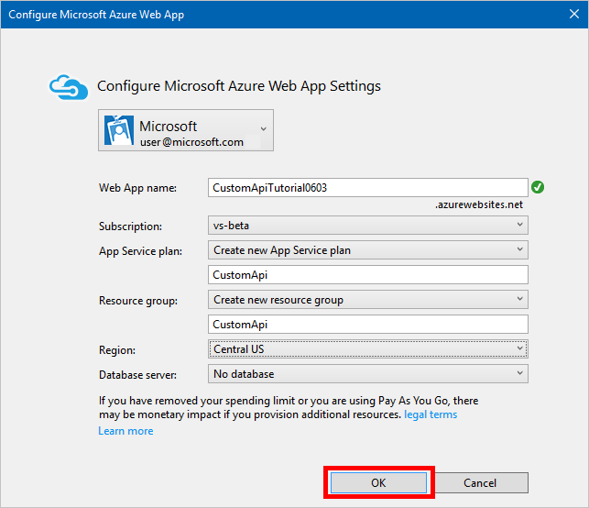]

Select your Azure account, type a **Web App name** (or leave the default), and select your Azure

**Subscription**. Select or create an **App Service plan** (a collection of Web Apps within your subscription). Select or create a **Resource group** (a grouping of Azure resources within your subscription). Select the region where the Web App should be deployed. If required for your Web API, select or create an Azure **Database server**. Finally, click **OK**.

1. Create your Web API.

**NOTE**

If you don't already have code ready for a Web API, try the tutorial [Getting Started with ASP.NET Web API 2 (C#)](https://www.asp.net/web-api/overview/getting-started-with-aspnet-web-api/tutorial-your-first-web-api).

1. To connect our Web API to PowerApps, we'll need a [Swagger](http://swagger.io/) file that describes its operations. You could write an OpenAPI of our own using the [online editor](http://editor.swagger.io/), but for this tutorial, you'll use an open-source tool named [Swashbuckle](https://github.com/domaindrivendev/Swashbuckle/blob/master/README.md). Install the Swashbuckle Nuget package in your Visual Studio project by clicking **Tools**

|  |
| --- |
| Install-Package Swashbuckle |

> **NuGet Package Manager** > **Package Manager Console**, and then, in the Package Manager Console, type the command .

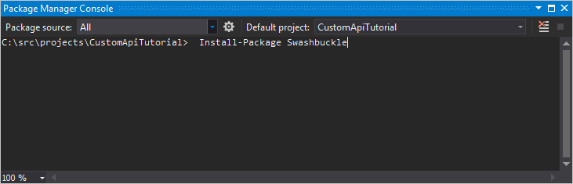

|  |  |  |
| --- | --- | --- |
| **TIP**  When you run your Web API application after installing Swashbuckle, an OpenAPI file will now be generated at the   |  | | --- | | http://<your root URL>/swagger/docs/v1 |   URL . A generated user interface is also available at   |  | | --- | | http://<your root URL>/swagger |   . |

1. When your Web API is ready, publish it to Azure. To publish from Visual Studio, right-click on the web project in Solution Explorer, click **Publish...**, and then follow the prompts in the Publish dialog.

|  |
| --- |
| https://<azure-webapp-url>/swagger/docs/v1 |

1. Retrieve the OpenAPI JSON by navigating to . Save the content as a JSON file. Depending on your browser, you may need to copy and paste the text into an empty text file.

|  |  |  |  |  |
| --- | --- | --- | --- | --- |
| **IMPORTANT**  An OpenAPI document with duplicate operation IDs is invalid. If you are using the sample C# template, the   |  |  |  | | --- | --- | --- | | Values_Get | is repeated twice. You can correct this by changing one instance to | Value_Get |   operation ID and republishing.   |  | | --- | | // |   You can also download a [sample OpenAPI](https://pwrappssamples.blob.core.windows.net/samples/webAPI.json) from this tutorial. Be sure to remove the comments (starting with ) before using it. |

## Set up Azure Active Directory authentication

You will now create two Azure Active Directory (AAD) applications in Azure. For an example of how to do this, see the Azure Resource Manager tutorial.

**IMPORTANT**

Both apps must be in the same directory.

### First AAD application: Securing the Web API

The first AAD application is used to secure the Web API. Name it **webAPI**. Follow the above linked tutorial steps (just the section titled "Enable authentication in Azure Active Directory") with the following values:

|  |
| --- |
| https://login.windows.net |

|  |
| --- |
| https://<your-root-url>/.auth/login/aad/callback |

Sign-on URL:

Reply URL:

There is no need for a client key.

There is no need to delegate any permissions.

**Important!** Note the application ID. You will need it later.

### Second AAD application: Securing the custom connector and delegated access

The second AAD application is used to secure the custom connector registration and acquire delegated access to the Web API protected by the first application. Name this one **webAPI-customAPI** .

|  |
| --- |
| https://login.windows.net |

|  |
| --- |
| https://msmanaged-na.consent.azure-apim.net/redirect |

Sign-on URL:

Reply URL:

Add permissions to have delegated access to Web API.

You need the application ID of this application later as well, so note it.

Generate a client key and store is somewhere safe. We need this key later.

## Add authentication to your Azure Web App

1. Sign in to the [Azure portal](https://portal.azure.com/) and then find your Web App that you deployed in the first section.
2. Click **Settings**, and then select **Authentication / Authorization**.
3. Turn on **App Service Authentication** and then select **Azure Active Directory**. On the next blade, select **Express**.
4. Click **Select Existing AD App**, and select the **webAPI** AAD application you created earlier.

You should now be able to use AAD to authenticate your web application.

## Add the custom connector to Microsoft Flow

|  |
| --- |
| securityDefintions |

1. Modify your OpenAPI to add the object and AAD authentication used for the Web App. The section of your OpenAPI with the **host** property should look like this:

|  |
| --- |
| // File header should be above here...  "host": "<your-root-url>",  "schemes": [  "https" //Make sure this is https! ],  "securityDefinitions": {  "AAD": {  "type": "oauth2",  "flow": "accessCode",  "authorizationUrl": "https://login.windows.net/common/oauth2/authorize",  "tokenUrl" : "https://login.windows.net/common/oauth2/token",  "scopes": {}  }  },  // The rest of the OpenAPI follows... |

1. Browse to [Microsoft Flow](https://flow.powerapps.com/), and add a custom connector as described in Register and use custom connectors in Microsoft Flow.
2. Once you have uploaded your OpenAPI, the wizard auto-detects that you are using AAD authentication for your Web API.
3. Configure the AAD authentication for the custom connector.

|  |
| --- |
| https://login.windows.net |

**Client ID**: *Client ID of webAPI-CustomAPI* **Secret**: *Client key of webAPI-CustomAPI* **Login URL**:

**ResourceUri**: *Client ID of webAPI*

1. Click **Create** and creating a connection to the custom connector.

Next Steps

Walk through the Azure Resource Manager custom connector tutorial.

# Use webhooks with Microsoft Flow

11/3/2017 • 7 min to read • [Edit Online](https://github.com/MicrosoftDocs/flow-docs-pr/blob/live/flow-docs/customapi-webhooks.md)

[Webhooks](http://www.webhooks.org/) are simple HTTP callbacks used to provide event notifications. Microsoft Flow allows you to use webhooks to trigger flows. This tutorial demonstrates how to create a flow triggered by a webhook.

**NOTE**

We will use GitHub as an example of a service that can send notifications via webhooks, but the techniques demonstrated here can be extended to any service that uses webhooks.

## Prerequisites

To complete the tutorial, you will need:

Basic understanding of [webhooks](http://www.webhooks.org/).

Basic understanding of the [OpenAPI Specification](http://swagger.io/specification/) (Swagger).

A [GitHub](https://www.github.com/) account.

The [sample OpenAPI JSON file](https://pwrappssamples.blob.core.windows.net/samples/githubWebhookSample.json) for this tutorial.

Alternatively you can also use the triggers UI to define webhook triggers, in case you don’t want to hand write the OpenAPI file.

## The OpenAPI file

Webhooks are implemented in Microsoft Flow as a type of custom connector, so we'll need to provide an OpenAPI JSON file to define the shape of our webhook. The OpenAPI contains three definitions critical to making the webhook work:

1. Creating the webhook
2. Defining the incoming hook request from the API (in this case, GitHub)
3. Deleting the webhook

### Creating the webhook

|  |
| --- |
| /repos/{owner}/{repo}/hooks |

The webhook is created on the GitHub side by an HTTP POST to . Microsoft Flow will

|  |
| --- |
| post |

need to post to this URL when a new flow is created using the trigger defined in the OpenAPI, or whenever the trigger is modified. In the sample below, the property contains the schema of the request that will be posted to GitHub.

|  |
| --- |
| "/repos/{owner}/{repo}/hooks": {  "x-ms-notification-content": {  "description": "Details for Webhook",  "schema": {  "$ref": "#/definitions/WebhookPushResponse"  }  },  "post": {  "description": "Creates a Github webhook", "summary": "Triggers when a PUSH event occurs",  "operationId": "webhook-trigger",  "x-ms-trigger": "single",  "parameters": [  {  "name": "owner",  "in": "path",  "description": "Name of the owner of targetted repository", "required": true, "type": "string"  },  {  "name": "repo",  "in": "path",  "description": "Name of the repository",  "required": true, "type": "string"  },  {  "name": "Request body of webhook",  "in": "body",  "description": "This is the request body of the Webhook",  "schema": {  "$ref": "#/definitions/WebhookRequestBody" }  }  ],  "responses": {  "201": {  "description": "Created",  "schema": {  "$ref": "#/definitions/WebhookCreationResponse"  }  }  }  }  }, |
| **IMPORTANT**   |  | | --- | | "x-ms-trigger": "single" |   The property is a schema extension that tells Microsoft Flow to display this webhook in the list of available triggers in the flow designer, so be sure to include it. |

### Defining the incoming hook request from the API

|  |
| --- |
| x-ms-notification-content |

The shape of the incoming hook request (the notification from GitHub to Microsoft Flow) is defined in the custom property, as shown in the sample above. It doesn't need to contain the entire contents

of the request, just the portions you want to use in your flows.

### Deleting the webhook

It's very important to include a definition in the OpenAPI that tells Microsoft Flow how to delete the webhook. Microsoft Flow will try to delete the webhook every time you update the trigger in your flow, or when you delete your flow.

|  |
| --- |
| "/repos/{owner}/{repo}/hooks/{hook_Id}": {  "delete": {  "description": "Deletes a Github webhook",  "operationId": "DeleteTrigger",  "parameters": [  {  "name": "owner",  "in": "path",  "description": "Name of the owner of targetted repository",  "required": true, "type": "string"  },  {  "name": "repo",  "in": "path",  "description": "Name of the repository",  "required": true, "type": "string"  },  {  "name": "hook_Id",  "in": "path",  "description": "ID of the Hook being deleted",  "required": true, "type": "string"  }  ]  }  }, |
| **IMPORTANT**   |  | | --- | | Location |  |  | | --- | | Location |  |  | | --- | | Location |   In order for Microsoft Flow to be able to delete a webhook, the API **must** include a HTTP header in the 201 response at the time the webhook is created. The header should contain the path to the webhook that will be used with the HTTP DELETE. For example, the included with GitHub's response follows this format:   |  | | --- | | https://api.github.com/repos/<user name>/<repo name>/hooks/<hook ID> |   . |

## Authentication

The API sending the webhook request to Microsoft Flow will usually have some form of authentication, and GitHub is no exception. Several types of authentication are supported. For this tutorial, we'll use GitHub's personal access tokens.

1. Navigate to [GitHub](https://www.github.com/) and sign in if you haven't already.
2. In the upper right, click your **profile picture**, and then, in the menu, click **Settings**.

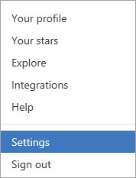

1. In the menu on the left, under **Developer settings**, click **Personal access tokens**.

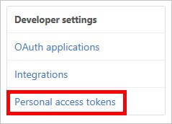

1. Click the **Generate new token** button.

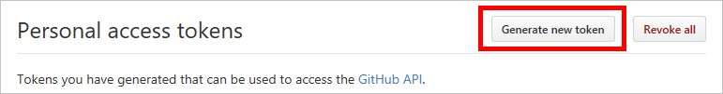

1. In the **Token description** box, enter a description.
2. Select the **admin:repo_hook** checkbox.

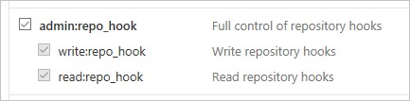

1. Click the **Generate token** button.
2. Make note of your new token.

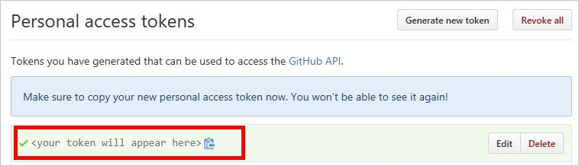

**IMPORTANT**

You won't be able to access this token again. You should copy and paste it somewhere like Notepad to use later in the tutorial.

## Adding the webhook to Microsoft Flow

Now we've got everything we need to add the webhook to Microsoft Flow as a custom connector.

1. Navigate to the [Microsoft Flow web portal](https://flow.microsoft.com/) and sign in if you haven't already.
2. Click the **settings** icon, and then click **Custom Connectors**.



1. Click the **Create custom connector** button.
2. Click the file folder icon in the **Import OpenAPI** box and then select the sample OpenAPI file.
3. Click **Upload icon** in the **General information** section and then select an image file to use as an icon.
4. Click **Continue**.

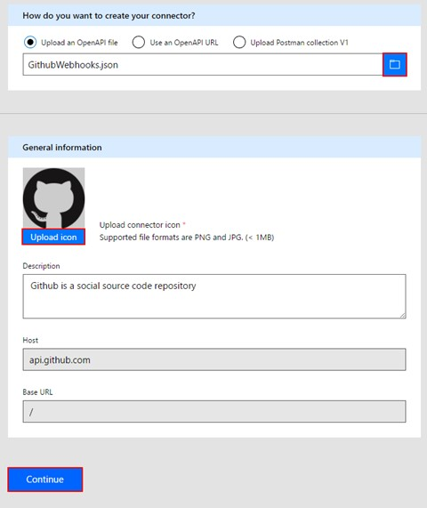

1. On the next screen, we'll configure security settings. Under **Authentication type**, select **Basic authentication**.
2. In the **Basic authentication** section, for the label fields, enter the text **User name** and **Password**. Note that these are only labels that will be displayed when the trigger is used in a flow.

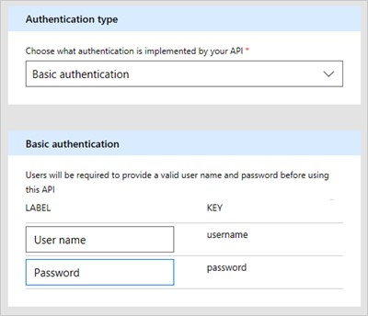

1. At the top of the page, give your flow a name and click **Create connector**.



The new custom connector should now appear in the list on the custom connectors page.

## Creating webhook triggers from the UI

1. After uploading / creating your baseline OpenAPI file, navigate to the **Definition** tab of the custom connector wizard.
2. In the left hand pane, click **+ New trigger**, and fill out the description of your trigger. In this example, we are creating a trigger that fires when a pull request is made to a repository.

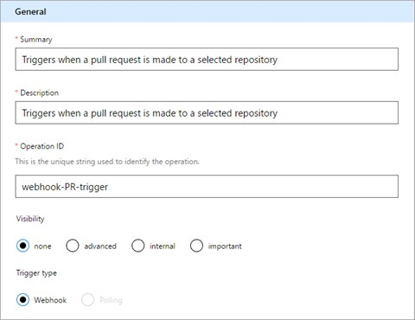

1. Next, define the request to create the webhook trigger. You can do this by importing a sample *create webhook trigger* request. See the [Github API reference](https://developer.github.com/v3/repos/hooks/#create-a-hook) for creating a webhook.

|  |
| --- |
| content-type |

1. Microsoft Flow automatically adds standard and security headers, so we don’t need to define those while importing from a sample.

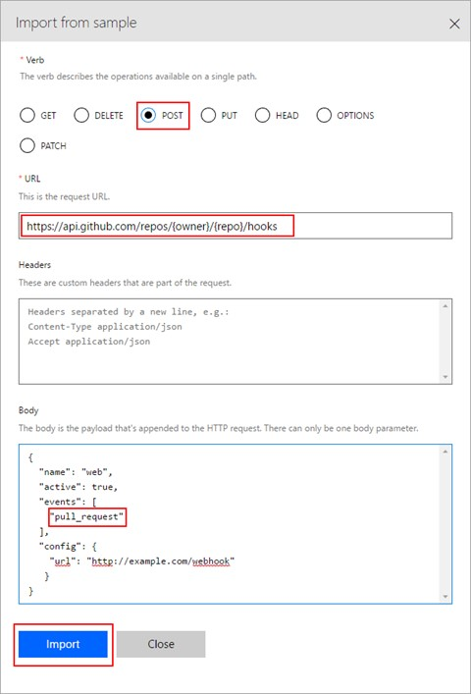

1. After importing the create webhook request, next we will define the webhook response by importing from a sample response. See the [Github API reference](https://developer.github.com/v3/activity/events/types/#pullrequestevent) for a pull request event.

**Note**: You don’t have to paste in the full response. Only the fields that you need should be defined. For this example, we are extracting only the PR url and information of the user who made the PR.

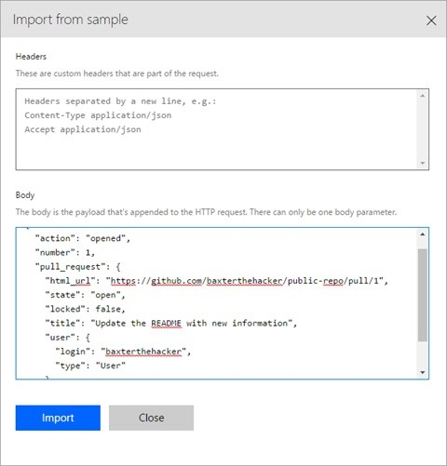

|  |
| --- |
| config |

1. The final step is to select a parameter in the webhook creation request, in the value of which Microsoft Flow should populate a callback URL for Github to populate. For us this is the url property in the object.

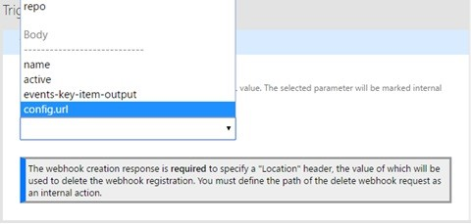

## Using the webhook as a trigger

Now that we've got everything configured, we can use the webhook in a flow. Let's create a flow that will send a push notification to the Microsoft Flow mobile app whenever our GitHub repo receives a git push.

1. In the [Microsoft Flow web portal](https://flow.microsoft.com/), at the top of the page, click **My flows**.
2. Click **Create from blank**.
3. In the designer for Microsoft Flow, search for the custom connector we registered earlier.

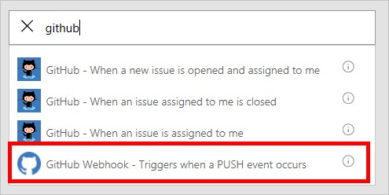

Click on the item in the list to use it as a trigger.

1. Since this is the first time we've used this custom connector, we have to connect to it. For **Connection name**, enter a descriptive name. For **User name**, use your GitHub username. For **Password**, use the **personal access token** you created earlier.

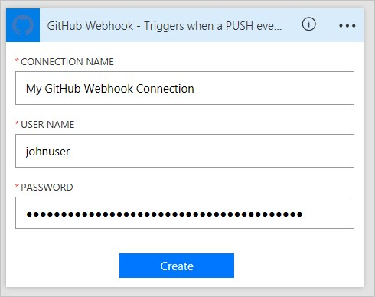

Click **Create**.

1. Now we need to give Microsoft Flow information about the repo we want to monitor. You might recognize the fields from the **WebhookRequestBody** object in the OpenAPI file. For **owner** and **repo**, enter the owner and repo name of a GitHub repo you want to monitor.

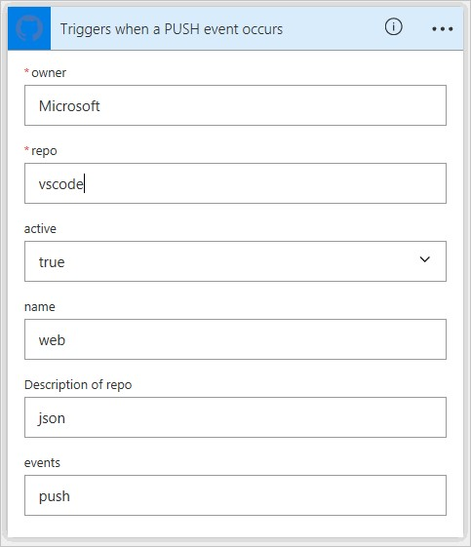

**IMPORTANT**

In this example, I'm using the repository for [Visual Studio Code](https://code.visualstudio.com/). You should use a repo that your account has rights to. The easiest way to do this would be to use your own repo.

1. Click **+ New step**, and then click **Add an action**.
2. Search for and select the **Push notification** action.

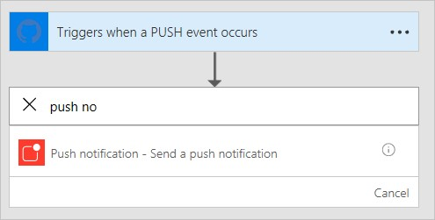

1. Enter some text in the the **Text** field. Note that the **WebhookPushResponse** object in the OpenAPI file defines the list of parameters you can use.

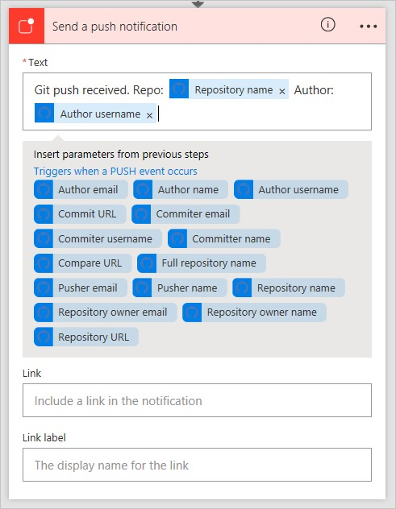

1. At the top of the page, give the flow a name and click **Create flow**.



## Verification and troubleshooting

To verify everything is set up correctly, click **My flows**, and then click the **information icon** next to the new flow to view the run history. You should already see at least one "Succeeded" run from the webhook creation. This indicates that the webhook was created successfully on the GitHub side. If the run failed, you can drill into the run details to see why it failed. If the failure was due to a "404 Not Found" response, it's likely your GitHub account doesn't have the correct permissions to create a webhook on the repo you used.

## Summary

If everything is correctly configured, you will now receive push notifications in the Microsoft Flow mobile app whenever a git push occurs on the GitHub repository you selected. Using the process above, you can use any webhook-capable service as a trigger in your flows.

## Next steps

Register a custom connector.

Use an ASP.NET Web API.

Register an Azure Resource Manager API.

Microsoft Flow for ISVs and Microsoft partners

11/3/2017 • 1 min to read • [Edit Online](https://github.com/MicrosoftDocs/flow-docs-pr/blob/live/flow-docs/dev-isv-partner-intro.md)

As a Microsoft partner or ISV, you can accelerate customer adoption by extending your products to integrate with your customers' data and business processes. Build connectors that enable your customers to connect to your products through Microsoft Flow. You can generate new leads for your business by building apps and publishing them to AppSource for new customers to test-drive.

## Build an API connector

Bring your product into the Microsoft cloud by building a connector that enables Microsoft Flow to talk to your service. Learn more

## Publish templates

Once you have a connector, you should publish templates that demonstrate how to use your service. These templates will serve as examples that users can use to learn and then extend to their own unique workflows. Learn more

## Embed the flow experience in your website or app

Next, you can embed Microsoft Flow from within your app to enable deep, in-context integration between your app and all the other services that Microsoft Flow supports. For example, you can:

Browse all of the templates that relate to your service and let users select a template Manage the flows that users have related to your app

Follow this tutorial for more information about how to embed Microsoft Flow within an app.

## List your solution on AppSource

Generate new leads for your business by building an app and publishing it to AppSource for new customers to testdrive. Learn more

API connector overview (Microsoft Flow)

11/3/2017 • 1 min to read • [Edit Online](https://github.com/MicrosoftDocs/flow-docs-pr/blob/live/flow-docs/api-connector-overview.md)

An **API connector** is an OpenAPI (Swagger) based wrapper around a REST API that allows the underlying service to talk to [Microsoft Flow](https://flow.microsoft.com/), [PowerApps](https://powerapps.microsoft.com/), and [Logic Apps](https://docs.microsoft.com/azure/logic-apps/). It provides a way for users to connect their accounts and leverage a set of pre-built **triggers** and **actions** to build their apps and workflows.

As an **Independent software vendor (ISV)** or **SaaS service owner**, you can build connectors to enable a wide range of business and productivity scenarios for your users. A connector helps you to go beyond a definite set of integrations, and increase the reach, discoverability, and usage of your service.

## Requirements

To build and submit a connector, your service must meet the following requirements:

Business user scenario that fits well with Microsoft Flow, PowerApps, and Logic Apps Publicly available service with stable REST APIs

## Build your connector

The first step to building an API Connector is to build a fully functional custom connector. A custom connector operates exactly like an API connector, but it is limited in availability to its author and specific users within the author's tenant.

The process to build a connector involves multiple steps:

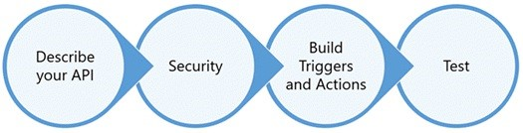

Learn more about how to develop an API connector.

## Submit for certification

After you've built a connector, you submit it for certification. As part of our third party certification process, Microsoft reviews the connector before publishing.

This process validates the functionality of your connector in Microsoft Flow and PowerApps, and checks for technical and content compliance.

Learn more about the process to submit your connector for certification and publishing.

## Get support

For onboarding and development support, please email condevhelp@microsoft.com. This account is actively monitored and managed. Developer queries and incidents will quickly find their way to the appropriate team.

Develop an API connector (Microsoft Flow)

11/3/2017 • 1 min to read • [Edit Online](https://github.com/MicrosoftDocs/flow-docs-pr/blob/live/flow-docs/api-connector-dev.md)

Building a connector involves multiple steps. To get started - in [Microsoft Flow](https://flow.microsoft.com/), click or tap the **Settings** button (the gear icon) at the upper right of the page. Then click or tap **Custom Connectors**.



## Describe your API

API connectors are described using the [OpenAPI standard](https://swagger.io/) for defining the interface of an HTTP API. You can start building with an existing OpenAPI file, or you can import a [Postman Collection](https://www.getpostman.com/docs/collections), which auto-generates the OpenAPI file for you.

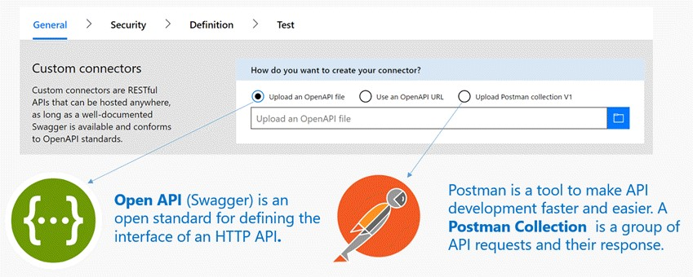

If you start from either of these API descriptions, the metadata fields in the wizard are auto-populated. You can edit these at any time.

## Build security

Pick the authentication type supported by your service, and provide additional details to enable identity to flow appropriately between your service and any clients.

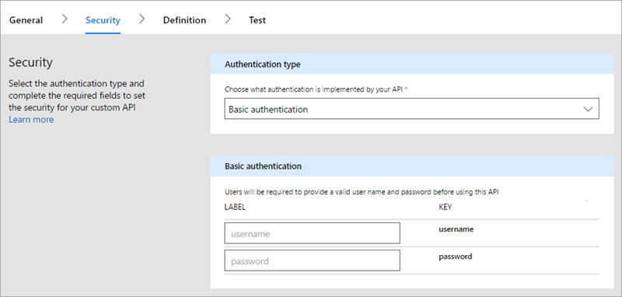

Learn more about the connector security.

## Build triggers and actions

1. To build the triggers and actions for your connector, switch to the **Definition** tab.

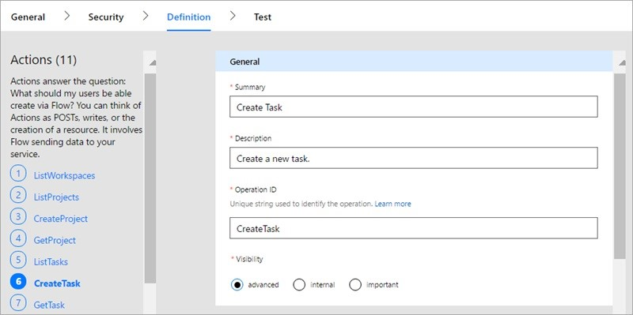

1. Using the wizard, you can add new operations or edit the schema and response for existing ones. The **General** properties for each operation enable you to control the end-user experience for your connector. Learn more about the different types of operations using the links below:

Triggers (not visible in PowerApps)

Actions

[To implement advanced functionality for Microsoft Flow, refer to OpenAPI extensions for API connectors.](https://flow.microsoft.com/documentation/customapi-how-to-swagger/)

1. Finally, click or tap **Create connector** to register the API connector.

For additional features not available in the wizard, please contact condevhelp@microsoft.com.

## Test the connector

Prior to submission, test your API connector in one or more ways:

Using the API connector [Testing wizard](https://flow.microsoft.com/blog/new-updates-custom-api/), you can call each operation to verify its functionality and the response schema.

In the designer for Microsoft Flow, you can visually build flows using your API connector. This method of testing gives you visibility into the user interface functionality and features of your connector.

In the PowerApps Studio, you can call each operation using the formula bar, and bind the response to controls on your screen.

This topic provides an overview; for more information, see Register and use a custom connector.

# Submit your connectors for Microsoft certification

11/3/2017 • 2 min to read • [Edit Online](https://github.com/MicrosoftDocs/flow-docs-pr/blob/live/flow-docs/api-connector-submission.md)

To make custom connectors publicly available for all users in Microsoft Flow, Azure Logic Apps and Microsoft PowerApps, submit your connector to Microsoft for review, validation, and approval for publishing.

## Certification criteria

|  |  |  |
| --- | --- | --- |
| **CAPABILITY** | **DETAILS** | **REQUIRED OR RECOMMENDED** |
| Software-as-a-Service (SaaS) app | Meets a user scenario that fits well with Logic Apps, Flow, and PowerApps. | Required |
| Authentication Type | Your API must support OAuth2, API Key, or Basic Authentication. | Required |
| Support | You must provide a support contact so that customers can get help. | Required |
| Availability and uptime | Your app has at least 99.9% uptime. | Recommended |
|  |  |  |

Also, if you're not a Microsoft partner or Independent Software Vendor (ISV), and you want to certify and publicly release a connector, you must either own the underlying service or present explicit rights to use the API.

To be certified, your connector is reviewed in two phases:

1. Functionality Validation

The custom connector is evaluated for:

Invalid swagger or JSON errors in the Definition section of the custom connector wizard

Runtime and schema validation errors in the Testing section of the wizard

Consequently, each operation is thoroughly tested in Flow, Logic Apps and PowerApps for any clientside errors.

1. Content Validation

A well written connector uses friendly names and descriptions for each entity. We evaluate your swagger to ensure that each operation, input parameter and response attribute contains:

[Summary](https://docs.microsoft.com/azure/logic-apps/custom-connector-openapi-extensions#summary)

[Description](https://docs.microsoft.com/azure/logic-apps/custom-connector-openapi-extensions#description)

[Visibility information](https://docs.microsoft.com/azure/logic-apps/custom-connector-openapi-extensions#visibility)

## Nominate and submit your connector to Microsoft for certification

To apply for certification, follow these steps:

1. **Nominate**
   1. [Submit your nomination](https://go.microsoft.com/fwlink/?linkid=848754).
   2. Sign the mutual Non-Disclosure Agreement and Partner Agreement that you receive. Microsoft requires these signed contracts before proceeding. We can then check whether your connector meets the certification criteria.
   3. If your connector is approved, Microsoft notifies you with instructions for onboarding.
2. **Review**
   1. Send this information to your nomination contact for review:

The OpenAPI file that describes your API

The icon file (.png or .jpg) that represents your connector. (Your icon should have a ~160 pixel logo inside a 230 pixel square. A white logo on a colored background is preferred.)

Your icon's brand color in hexadecimal format, which should match the colored background in the icon file

A test account for validation

A support contact

* 1. If we need more information, we will contact you.

1. **Publish**

After we validate your connector's functionality and content, we stage the connector for deployment across all products and regions. Typically, it takes up to 3 weeks for the certification and deployment process.

By default, all connectors are published as "premium." If you built your app with Azure, you can apply for listing your connector as a "standard" connector that's available to all users with Office 365 Enterprise plans. For more details, ask your nomination contact.

# API connector FAQ (Microsoft Flow)

11/3/2017 • 1 min to read • [Edit Online](https://github.com/MicrosoftDocs/flow-docs-pr/blob/live/flow-docs/api-connector-faq.md)

## Requirements

**Q:** Can I build a connector without REST APIs?

**A:** No, to build a connector, you must support stable HTTP REST APIs for your service.

**Q:** What tools can I use to create a connector?

**A:** Azure has capabilities and services that you can use for exposing any service as an API, such as Azure App Service for hosting, API Management, and more.

**Q:** What authentication types are supported?

**A:** You can use these supported authentication standards:

[OAuth 2.0](https://oauth.net/2/), including [Azure Active Directory](https://azure.microsoft.com/develop/identity/) or specific services, such as Dropbox, GitHub, and SalesForce

Generic OAuth 2.0

[Basic authentication](https://swagger.io/docs/specification/authentication/basic-authentication/)

[API Key](https://swagger.io/docs/specification/authentication/api-keys/)

## Triggers

**Q:** Can I build triggers without webhooks?

**A:** No, custom connectors for Azure Logic Apps and Microsoft Flow support only webhook-based triggers. If you want to request other patterns for implementation, contact condevhelp@microsoft.com with more details about your API.

## Certification

**Q**: I'm not a Microsoft partner or Independent Software Vendor (ISV). Can I still create connectors? **A**: Yes, you can register these connectors for internal use in your organization, but if you want to certify and publicly release a connector, you must either own the underlying service or present explicit rights to use the API.

## Other

**Q:** My APIs use a dynamic host. How do I implement them with OpenAPI?

**A:** Custom connectors don't support dynamic hosts. Instead, use a static host for development and testing purposes. If you want to certify your connector, ask your Microsoft contact about dynamic implementation.

**Q:** Do you support Postman Collection V2?

**A:** No, only Postman Collection V1 is currently supported.

**Q:** Do you support OpenAPI 3.0?

**A:** No, only OpenAPI 2.0 is currently supported.

# Integrate Microsoft Flow with websites and apps

11/3/2017 • 4 min to read • [Edit Online](https://github.com/MicrosoftDocs/flow-docs-pr/blob/live/flow-docs/embed-flow-dev.md)

Embed Microsoft Flow right into your app or website to give users a simple way to automate their personal or professional tasks.

To create flows, users will need either a **Microsoft Account** or a work or school account in **Azure Active Directory**. Microsoft Flow doesn't support, for example, a whitelabel solution that supports whatever identity your system uses (unless it already uses Microsoft Accounts or AAD).

## Prerequisites

Build a custom connector that connects your service to Microsoft Flow. Create and publish one or more templates that use your API.

## Show templates for your scenarios

To start, add this code to show the flow templates directly in your website:

<iframe src="https://flow.microsoft.com/{locale}/widgets/templates/?q={search term} &pagesize={number of templates}&destination={destination}"></iframe>

**Note**: We added a line break so the code displays better on the page.

|  |  |
| --- | --- |
| **PARAMETER** | **DESCRIPTION** |
| locale | |  | | --- | | en-us |  |  | | --- | | de-de |   The four-letter language and region code for the template view. For example, represents American English, and represents German. |
| search term | |  | | --- | | wunderlist |   The search term for the templates that you want to show in the view. For example, search to show templates for Wunderlist. |
| number of templates | The number of templates that you want to show in the view. |
| destination | The page that opens when users click the template. Specify to show the details about the template, or specify   |  |  | | --- | --- | | details | | | new |  |   to open the Microsoft Flow designer. |
| parameters.{name} | Additional context to pass into the flow. |

|  |
| --- |
| new |

If the destination parameter is , Microsoft Flow opens when users click a template, and they can create a flow in the designer. See the next section if you want to have the full experience work from inside of the app.

### Passing additional parameters to the flow

If the user is in a certain context in your website or app, you might want to pass that context to the flow. For example, a user might open a template for *Notify me when an item is added to a list* while looking at a certain list in Wunderlist. By following these steps, you can pass in the list ID as a *parameter* to the flow:

1. Define the parameter in the flow template before you publish it. A parameter looks like

|  |
| --- |
| @{parameters('parameter_name')} |

.

|  |
| --- |
| &parameters.listName={the name of the list} |

1. Pass the parameter in the iframe src. For example, add if you have a parameter called **listName**.

### Full sample

To show the top four templates about Wunderlist in German and to start the user with **myCoolList**:

<iframe src="https://flow.microsoft.com/de-de/widgets/templates/?q=wunderlist

&pagesize=4&destination=details&parameters.listName=myCoolList"></iframe>

## Embed the management of flows

Use the authenticated Flow SDK to allow users to create and manage flows directly from your website or app (instead of navigating to the Microsoft Flow portal). You'll need to sign the user in to Microsoft Account or Azure Active Directory to use the authenticated SDK.

**NOTE**

All users who use Microsoft Flow in your application will be Microsoft Flow users. There is no way to hide the Microsoft Flow branding.

### Include the JavaScript for the authenticated SDK

Include the SDK in your HTML code by following this example. You may also download, minify, and package the SDK with your product.

<script src="https://flow.microsoft.com/content/msflowsdk-1.1.js" async defer></script>

**Create a container to contain the view** Add an HTML div:

<div id="flowDiv" class="flowContainer"></div>

We recommend that you style this container so that it appears with appropriate dimensions in your experience:

<head>

<style>

.flowContainer iframe { width: 400px; height: 1000px; border: none; overflow: hidden;

}

</style>

</head>

Note that the iframe won't render properly below 320 pixels in width and won't fill content above 1200 pixels in width. Any height should work.

### Authentication against the SDK

For listing flows that the user has already authored and also to create flows from templates, provide an authToken from AAD.

|  |
| --- |
| <script>  window.msFlowSdkLoaded = function() { var sdk = new MsFlowSdk({  hostName:'https:/flow.microsoft.com'  });  var widget = sdk.renderWidget('flows', { container: 'flowDiv'  environmentId: '[environmentId]' // find environment id from browser URL when you // click on 'my flows'  //ex:  https://flow.microsoft.com/manage/environments/[environmentId]/flows  });  widget.callbacks.GET_ACCESS_TOKEN = function(requestParam, widgetDoneCallback)  {  var authCallback = function(token) { widgetDoneCallback(null, {  token: token // Get AAD access token from your backend system  });  };  } }  </script> |

|  |
| --- |
| environmentId |

You can find the by making the following api call, which returns the list of environments user has access to:

GET https://management.azure.com/providers/Microsoft.ProcessSimple/environments ?api-version=2016-11-01

|  |
| --- |
| properties.isDefault=true |

This returns a JSON response with list of environments, from which you can pick any environment. You can look for the default user enviroment by checking the property .

|  |
| --- |
| requestParam |

In this example, is defined as:

export interface IRpcRequestParam { callInfo: IRpcCallInfo, data?: any; }

|  |
| --- |
| widgetDoneCallback |

Next, the is a callback function that needs to be called once the host has the token. This is done because token acquisition is likely an async process. The parameters that need to be passed in when calling this

|  |
| --- |
| (errorResult: any, successResult: any) |

|  |
| --- |
| GetAccessToken |

function are . The successResult will depend on the callback type. For the type is:

export interface IGetAccessTokenResult { token: string;

}

# Let customers test drive your flows on AppSource

11/3/2017 • 1 min to read • [Edit Online](https://github.com/MicrosoftDocs/flow-docs-pr/blob/live/flow-docs/dev-appsource-test-drive.md)

Do you want to show off how your app integrates with Microsoft Flow? We now Test Drive solutions on

[AppSource.com](https://appsource.microsoft.com/) as a way for you to share Microsoft Flow integration with customers, and generate leads for your business.

What is a Test Drive solution?

A Test Drive solution enables your customers to try out a real app without installing any applications. Customers just sign into AppSource.com using their Azure Active Directory (AAD) account and run the app in a web browser. Without Test Drive, customers can only read about your app or watch a video that describes it. With Test Drive, customers get a better idea of what your solution is and what functionality your app has. And they have the experience of actually using the app. Customers won't be able to look under the hood to see how your app is built, so your intellectual property is protected. We collect and share lead information with you to help you grow your business.

How do I build a Test Drive solution?

Building an app for a Test Drive solution is just like building any app, but you need to use a data source that the user can be granted access to as a read-only user. Using a data source that's already set up will mean there is zero friction for them to try it out. The full solution that you ultimately distribute to customers will include writable data, but read-only data works well for a Test Drive solution.

## **Embed flow into your product**

Once you have a data source that you can grant the user read-only access to, you can embed Microsoft Flow into your application. Read more about embedding here. You will likely want to use the search functionality to highlight templates that are unique to your application. For example, if your application creates data in Dynamics 365, you can highlight a Dynamics 365 template that pulls data and then sends an email to the user.

How do I list my Test Drive solution on AppSource.com?

Now that your app is ready, it's time to publish it to AppSource.com. In order to start this process, please complete the [application form](https://flow.microsoft.com/partners/get-listed/) on flow.microsoft.com. Once you apply you will receive an email with instructions on how to submit your app to be published on AppSource.com.

# Flow in your organization Q&A

11/3/2017 • 9 min to read • [Edit Online](https://github.com/MicrosoftDocs/flow-docs-pr/blob/live/flow-docs/organization-q-and-a.md)

This topic describes how users in your organization can use Flow, and how you can control the Flow service.

## Signing up for Flow

**What is Microsoft Flow?**

Microsoft Flow is a public cloud service to help individuals and teams to set up automated workflows between their favorite apps and services to synchronize, get notifications, collect data, and more.

**How do people sign up for Flow?**

There are two possible ways for individuals to sign up for Flow through the web portal:

**Option 1**

Anyone can sign up by going to [flow.microsoft.com](https://flow.microsoft.com/), selecting **Sign up free**, and then completing the sign-up process for Flow through [portal.office.com](https://portal.office.com/Start?sku=flow_free) or [signup.live.com](https://signup.live.com/).

**Option 2**

Anyone can sign up by going to [flow.microsoft.com](https://flow.microsoft.com/), selecting **Sign in**, signing in with their work, school or personal email, and accepting the Flow terms of use.

When a user in your organization signs up for Flow with Option 2, that user will be assigned a Microsoft Flow Free license automatically.

Sign up for Flow includes more details.

**Can I block another person from signing up for Flow?**

Microsoft Flow is a fully public cloud service, and everyone in the world can sign up and use it to automate their day-to-day tasks. To use Microsoft Flow there is no requirements that users have or use an Office 365 account. Because of this, there’s no mechanism at this time for you to block another person from using Flow (as everyone in the world can, irrespective of their email address).

However, if a person signs up for Microsoft Flow, and you choose to not support them inside of your organization, they can in no way incur costs to your company. When an individual signs up for Microsoft Flow, the relationship is between that individual and Microsoft, which is like many other cloud services from Microsoft such as Bing, Wunderlist, OneDrive, or Outlook.com. An individual's use of Microsoft Flow does not in any way imply that the service is provided by your organization.

Finally, if your company wishes to restrict the use of organizational-only data inside of Microsoft Flow, that is possible through Data loss prevention (DLP) policies.

**How can people gain access to the paid features of Microsoft Flow?**

Individuals can gain access to the paid features of Microsoft Flow in three different ways:

1. They can individually sign up for a Flow Plan 1 or Flow Plan 2 trial 90 days for free
2. You can assign a Flow license to them within the Office 365 admin portal.
3. The user has been assigned an Office 365 and Dynamics 365 plans that includes access to the Flow service. See the [Flow pricing page](https://flow.microsoft.com/pricing/) for the list of Office 365 and Dynamics 365 plans that include Flow capabilities.

**Can I block another person from using the paid features of Flow?**

Any individual can try out the paid features of Microsoft Flow for 90 days, and incur no costs. However, you can fully manage the assignment of the perpetual paid licenses inside of your organization through the Office 365 admin portal.

As with the free offerings, if an individual chooses to sign up for the trial that is a direct relationship between the individual and Microsoft, not necessarily endorsed by your company.

## Administration of Flow

**Why has the Flow icon appeared in the Office 365 app launcher?**

As announced in August, Microsoft Flow is now a fundamental part of the Office 365 suite. Three months after this announcement Microsoft Flow was enabled as a service as a part of all existing Office 365 SKU's. As users everywhere in the world can now use Microsoft Flow, it has appeared in the app launcher for them.

See the following section if you'd like to remove the Flow tile from the app launcher by default.

**How do I remove Microsoft Flow from the app launcher for my organization?**

If a user was assigned a Flow Plan 1 or Flow Plan 2 license then you can take the following steps to remove the Flow license for that user, which will remove the Flow icon from the app launcher:

1. Go to the [Office 365 Admin Portal](https://portal.microsoftonline.com/).
2. In the left navigation bar, select **Users**, and then select **Active Users**.
3. Find the user you want to remove the license for, and then select their name.
4. On the user details pane, in the **Product licenses** section select **Edit**.
5. Find the license called **Microsoft Flow Plan 1** or **Microsoft Flow Plan 2**, set the toggle to **Off** and then select **Save**.

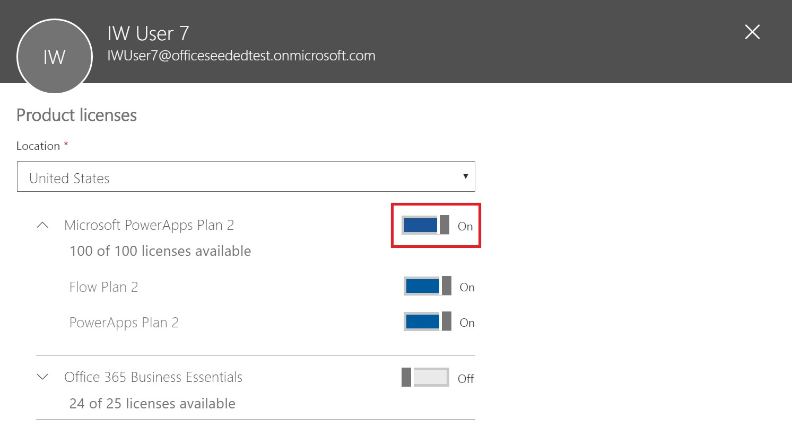

If a user has access to Flow through their Office 365 and Dynamics 365 plan license, then you can disable their access to the additional features included in this plan by taking the following steps:

1. Go to the [Office 365 Admin Portal](https://portal.microsoftonline.com/).
2. In the left navigation bar, select **Users**, and then select **Active Users**.
3. Find the user you want to remove access for, and then select their name.
4. On the user details pane, in the **Product licenses** section select **Edit**.
5. Expand the user's Office 365 or Dynamics 365 license, disable access to the service called **Flow for Office 365** or **Flow for Dynamics 365** and then select **Save**.

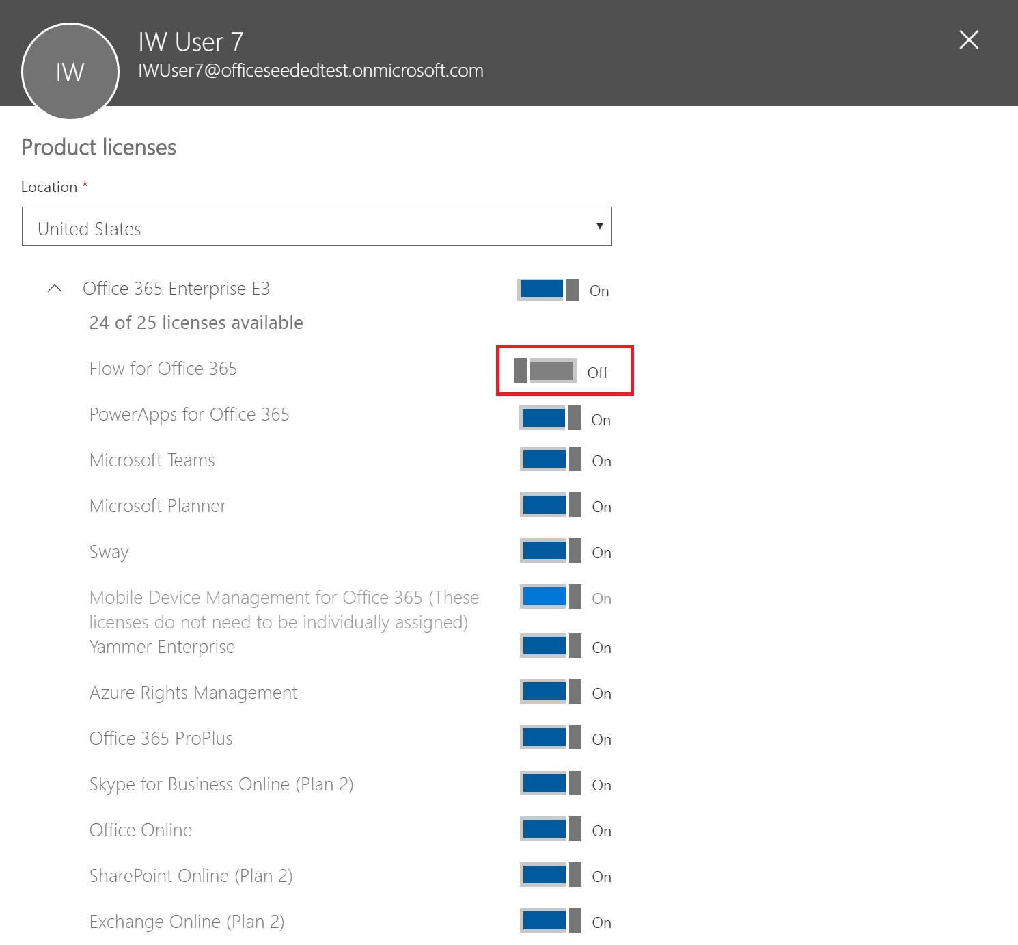

[Bulk removal of licenses is also possible through PowerShell. See Remove licenses from user accounts with Office 365 PowerShell for a detailed example. Finally, further guidance about bulk removal of services within a license](https://technet.microsoft.com/library/dn771774.aspx) can be found at [Disable access to services with Office 365 PowerShell](https://technet.microsoft.com/library/dn771769.aspx).

Removing of the Flow license or service for a user in your organization will result in the removal of the Flow icon from the following locations for that user:

1. [Office.com](https://office.com/)

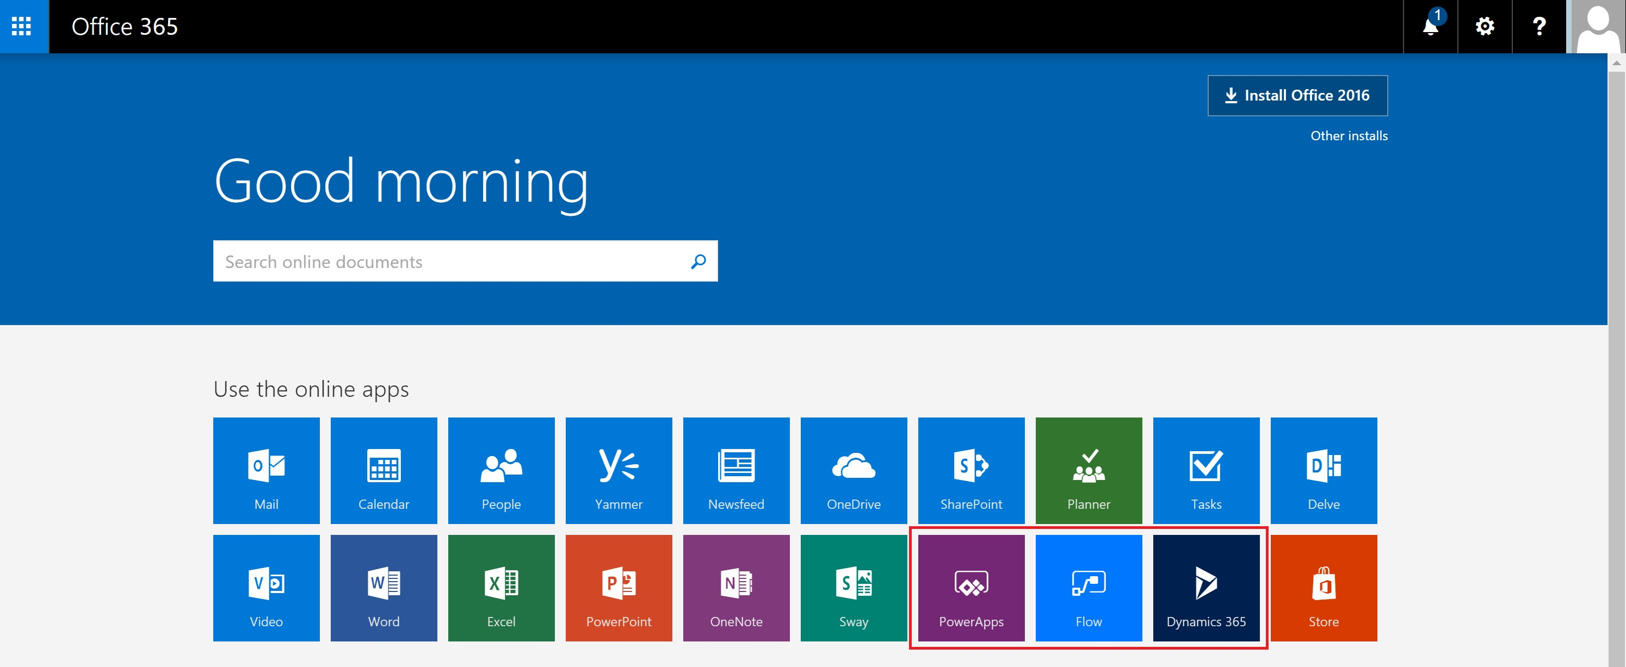

1. Office 365 App Launcher

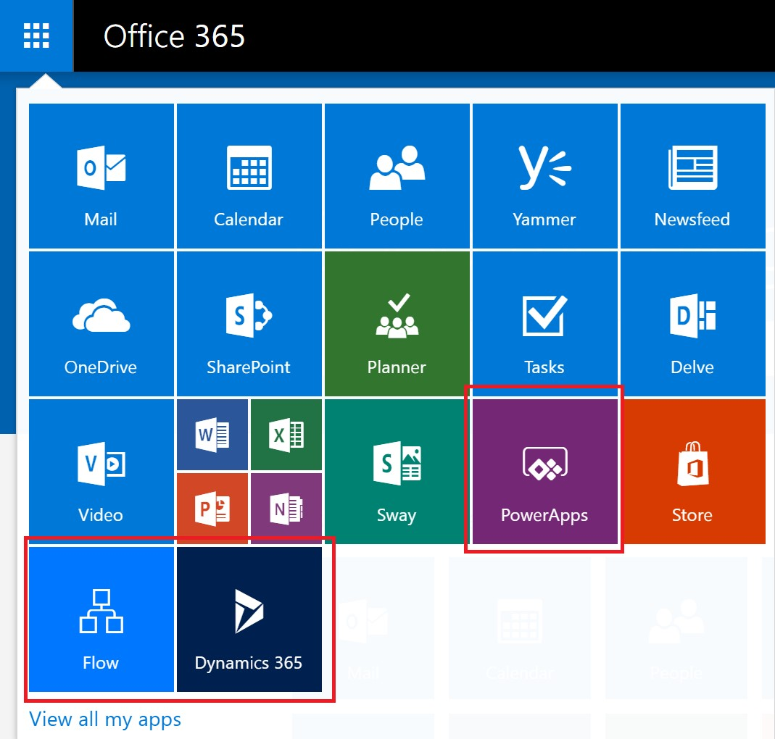

Note that this will only remove the Flow tile by default. A user may still choose to use Microsoft Flow as an individual.

**Why did 10,000 licenses for Microsoft Flow show up in my Office 365 tenant?**

Any person can try out Microsoft Flow Plan 1 or 2 for 90 days, and these trial licenses represent the available capacity for new Flow users in your tenant. There is no charge for these licenses. Specifically, there are two possible reasons why you may see a capacity 10,000 (trial) licenses for Flow showing up in the Office 365 admin portal:

1. If at least one user in your tenant participated in the Flow public preview that spanned from April 2016 to

October 2016 then you will see 10,000 licenses labeled as "Microsoft PowerApps and Logic flows"

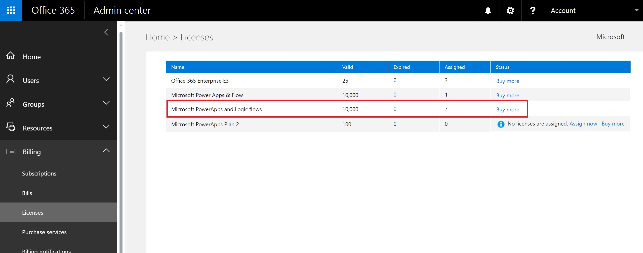

1. If at least one user in your tenant has signed-up for a Flow Plan 2 trial by going through trial signup **Option 1** outlined in the How do users sign up for PowerApps section then you will see 10,000 licenses labeled "Microsoft Power Apps & Flow"

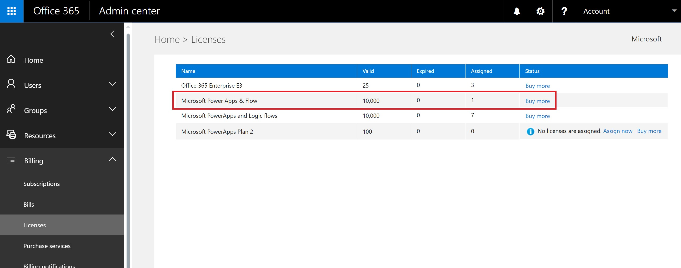

You can choose to assign additional licenses to users yourself through the Office 365 admin portal, but please note that these are trial licenses for Microsoft Flow Plan 2 and they will expire after 90 days of being assigned to a user.

**Is this free? Will I be charged for these licenses?**

No user can incur any cost to your organization without your express consent, so neither free nor trial licenses can cause any charges to your organization. Moreover, they also do not use any quotas, such as run quotas.

**I removed the Microsoft Flow Free license and users can still access Flow?**

The Microsoft Flow Free license is included only for tracking purposes. As covered in the first section, it is not possible to prevent another person from using Microsoft Flow for individual purposes. Thus, the presence of a Microsoft Flow Free license does not actually grant or remove any capabilities.

**Why can't I see all Flow licenses in the Office 365 Admin portal?**

Users can use Microsoft Flow either as individuals or as a part of their organization. Licenses at the organization level will always be visible in the Office 365 portal. However, if a user signs up for a trial as an individual then that is not managed by their Office 365 admin and will not show up in the portal.

**How does an individual find out what plan they are on?**

Anyone can see the plan they have by visiting the Flow pricing page at <https://flow.microsoft.com/pricing>. The plan or trial they are currently on will be shown there.

**Will Microsoft Flow sign up impact the identities in my organization?**

If your organization already has an existing Office 365 environment and all users in your organization have Office 365 accounts, then identity management is not impacted.

If your organization already has an existing Office 365 environment but not all users in your organization have Office 365 accounts, then we create a user in the tenant and assign licenses based on the user’s work or school email address. This means that the number of users you are managing at any particular time will grow as users in your organization sign up for the service.

If your organization does not have an Office 365 environment connected to your email domain, there is no change in how you manage identity. Users will be added to a new, cloud-only user directory, and you will have the option to take over as the tenant admin and manage them.

**A new tenant was created by Microsoft Flow, how do I manage this?**

If a new tenant was created by Microsoft Flow, then you can claim and manage that tenant using the following steps:

1. Join the tenant by signing up for Flow using an email address domain that matches the tenant domain you want to manage. For example, if Microsoft created the contoso.com tenant, then join the tenant with an email address ending with @contoso.com.
2. Claim admin control by verifying domain ownership: once you are in the tenant, you can promote yourself to the admin role by verifying domain ownership. To do so, follow these steps:
   1. Go to [https://portal.office.com](https://portal.office.com/Start?sku=flow_free).
   2. Select the app launcher icon in the upper-left and choose Admin.
   3. Read the instructions on the **Become the admin** page, and then choose **Yes, I want to be the admin**.

**NOTE**: If this option doesn’t appear, an Office 365 administrator is already in place.

**If I have multiple domains, can I control the Office 365 tenant that users are added to?** If you do nothing, a tenant is created for each user email domain and subdomain.

If you want all users to be in the same tenant regardless of their email address extensions:

Create a target tenant ahead of time or use an existing tenant. Add all the existing domains and subdomains that you want consolidated within that tenant. Then all the users with email addresses ending in those domains and subdomains automatically join the target tenant when they sign up.

**IMPORTANT**: There is no supported automated mechanism to move users across tenants once they have been [created. To learn about adding domains to a single Office 365 tenant, see Add your users and domain to Office 365.](https://support.office.com/article/Add-your-users-and-domain-to-Office-365-ffdb2216-330d-4d73-832b-3e31bcb5b2a7)

**How can I restrict my users' ability to access my organization's business data?**

Microsoft Flow allows you to create data zones for business and non-business data, as shown below. Once these data loss prevention policies are implemented, users are prevented from designing or running Flow that combine business and non-business data. For more details, See Data loss prevention (DLP) policies.

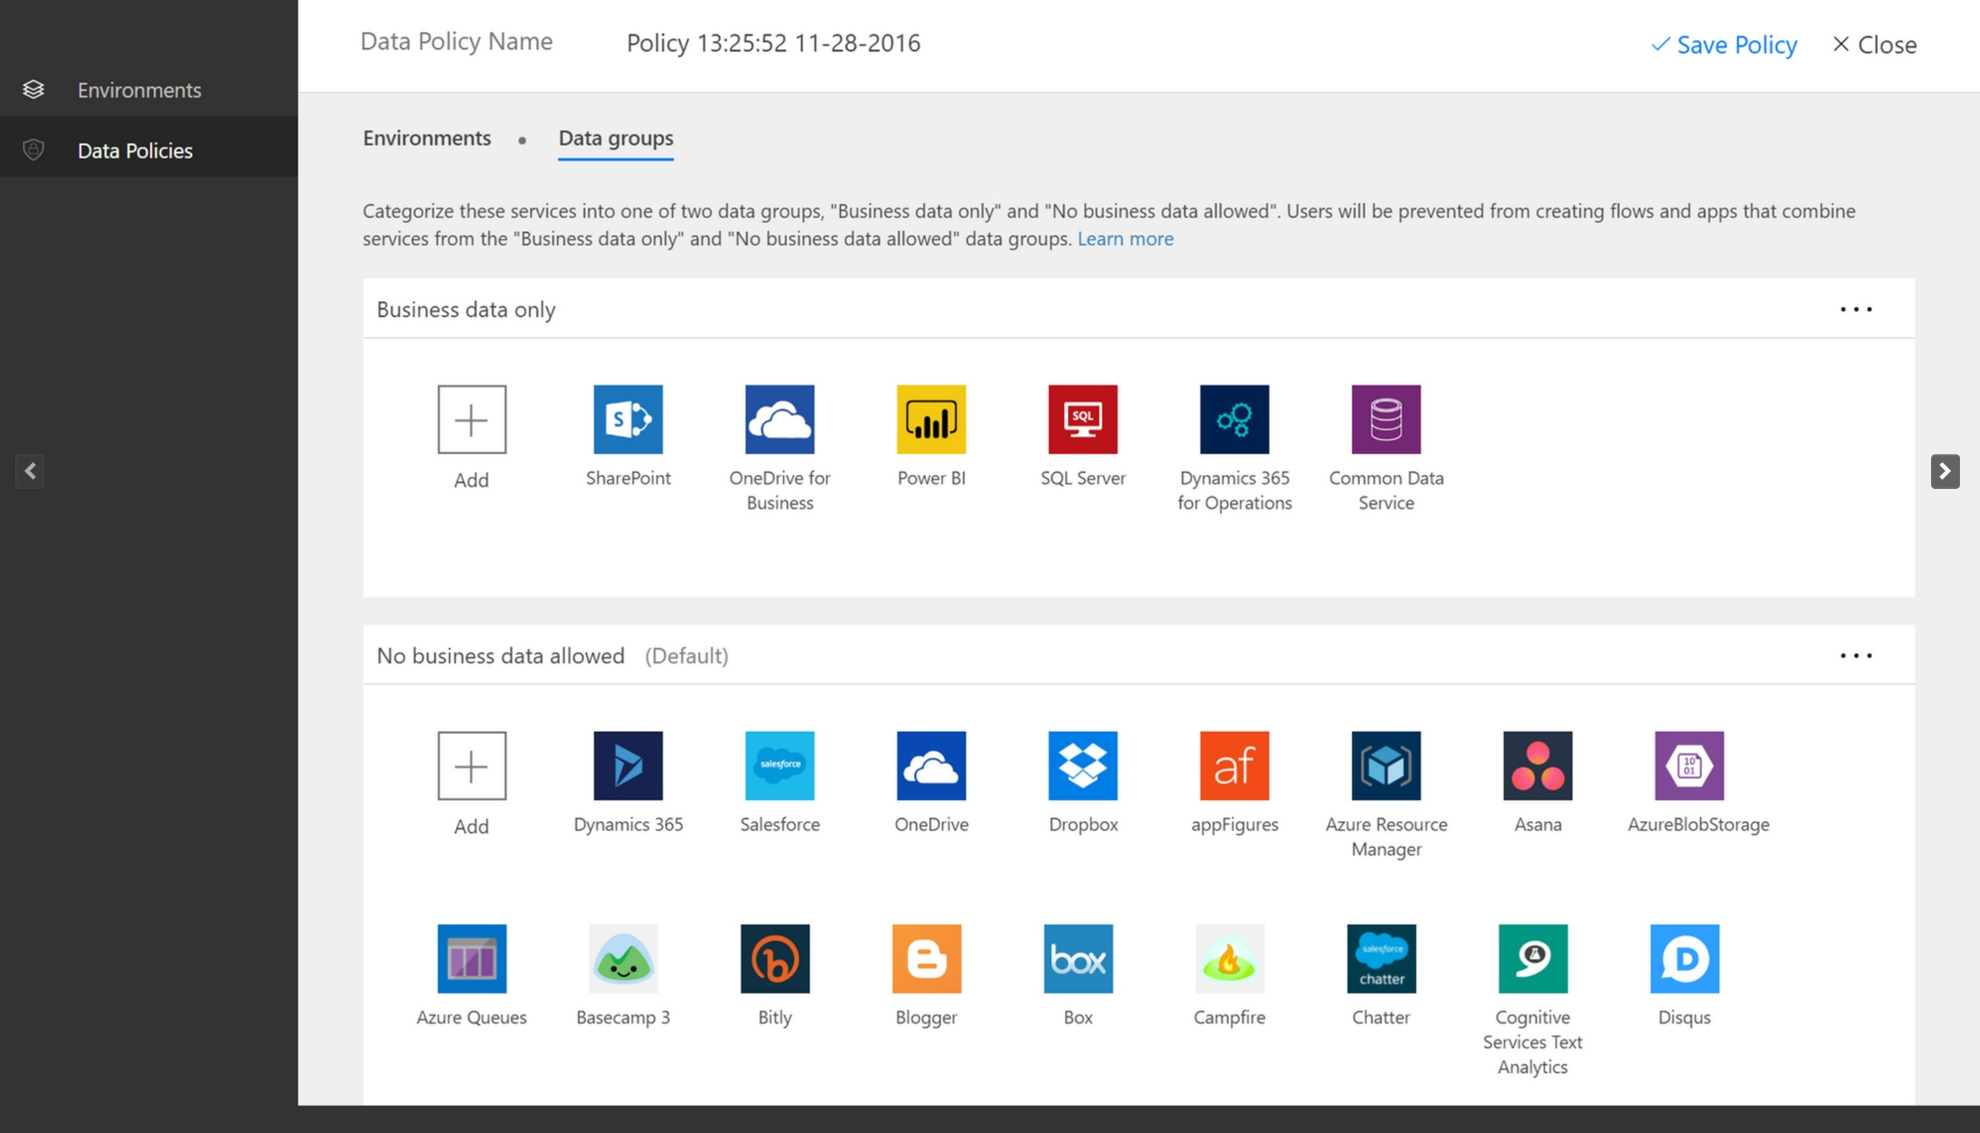

# Billing and metering questions

11/30/2017 • 2 min to read • [Edit Online](https://github.com/MicrosoftDocs/flow-docs-pr/blob/live/flow-docs/billing-questions.md)

This article answers frequently asked questions regarding billing and metering in Microsoft Flow.

Where can I find out what pricing plans are available?

See the [pricing page](https://flow.microsoft.com/pricing/).

Where can I find out what my plan is?

See the [pricing page](https://flow.microsoft.com/pricing/).

How do I switch plans?

In the top navigation menu, select **Learn** > **Pricing**, and then select the plan to which you want to switch.

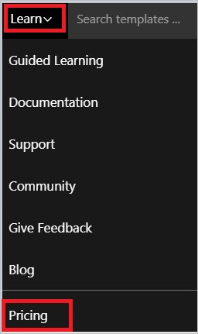

How do I know how much I've used?

If you're on a free plan or a trial plan, click or tap the gear icon in the top navigation bar to show your current usage against your plan.

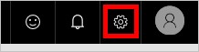

If you're on a paid plan, runs are pooled across all users in your organization. We're working on features to expose available quota and usage across an organization.

What happens if my usage exceeds the limits?

Microsoft Flow throttles your flow runs.

Where can I find more information regarding the usage limits?

On the [pricing page](https://flow.microsoft.com/pricing/), see the **FAQ** section.

What happens if I try to execute runs too frequently?

Your plan determines how often your flows run. For example, your flows may run every 15 minutes if you're on the free plan. If a flow is triggered less than 15 minutes after its last run, it's queued until 15 minutes have elapsed.

What counts as a run?

Whenever a flow is triggered, whether by an automatic trigger or by manually starting it, this is considered a run. Checks for new data don't count as runs.

Are there differences between Microsoft Accounts and work or school accounts for billing?

Yes. If you sign in with a Microsoft Account (such as an account that ends with @outlook.com or @gmail.com), you can use only the free plan. To take advantage of the features in the paid plan, sign in with a work or school email address.

I'm trying to upgrade, but I'm told my account isn't eligible.

To upgrade, use a work or school account, or create an [Office 365 trial account](https://powerbi.microsoft.com/documentation/powerbi-admin-signing-up-for-power-bi-with-a-new-office-365-trial/).

Why did I run out of runs when my flow only ran a few times?

Certain flows may run more frequently than you expect. For example, you might create a flow that sends you a push notification whenever your manager sends you an email. That flow must run every time you get an email (from anyone) because the flow must check whether the email came from your manager. This action counts as a run.

You can work around this issue by putting all the filtering you need into the trigger. In the push notification example, expand the **Advanced Options** menu, and then provide your manager's email address in the **From** field.

## Other limits and caveats

Each account may have as many as:

50 flows.

15 Custom Connectors.

20 connections per API and 100 connections total.

You can install a gateway only in the default environment.

Certain external connectors, such as Twitter, implement connection throttling to control quality of service. Your flows fail when throttling is in effect. If your flows are failing, review the details of the run that failed in the flow's run history.

# The Admin Center

11/3/2017 • 1 min to read • [Edit Online](https://github.com/MicrosoftDocs/flow-docs-pr/blob/live/flow-docs/admin-center-introduction.md)

The admin center is the central location where tenant admins and environment admins manage an organization’s data policies and environments. Any changes you make in the admin center are immediately available to users within the organization.

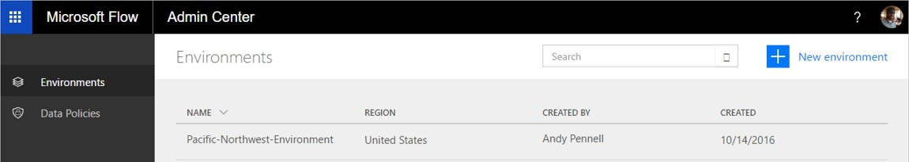

## Access the Admin center

Browse to [https://admin.flow.microsoft.com](https://admin.flow.microsoft.com/) to access the Microsoft Flow admin center.

Environments

Learn more about using environments to manage users, permissions and roles.

## Data policies

Learn more about using data policies to create rules that manage how business data is shared between services in flows.

## Next steps

Learn more about environments

Learn more about Microsoft Flow

# Using environments within Microsoft Flow

11/30/2017 • 5 min to read • [Edit Online](https://github.com/MicrosoftDocs/flow-docs-pr/blob/live/flow-docs/environments-overview-admin.md)

## Benefits

Environments provide the following benefits:

**Data locality**: Environments can be created in different regions and they're bound to that geographic location. When you create a flow in an environment, that flow is routed to all datacenters in that geographic location. This also provides a performance benefit.

If your users are in Europe, create and use the environment in the Europe region. If your users are in the United States, create and use the environment in the U.S.

**IMPORTANT**

If you delete the environment, then all flows within that environment are also deleted. This applies to any items you create in that environment, including connections, gateways, PowerApps, and more.

**Data loss prevention**: As an Administrator, you don't want flows that get data from an internal location (such as *OneDrive for Business* or a SharePoint list that contains salary information), and then post that data publicly (such as to *Twitter*). Use data loss prevention to control which services can share data within your Microsoft Flow deployment.

For example, you can add the *SharePoint* and *OneDrive for Business* services to a business data only policy. Any flows created in this environment can use *SharePoint* and *OneDrive for Business* services. However, they won't be able to share data with other services that aren't included in the business data only policy.

**NOTE**

Data loss prevention is available with some license skus, including the P2 license.

**Isolation boundary for all resources**: Any flows, gateways, connections, custom connectors, and so on reside in a specific environment. They don't exist in any other environments.

**Common Data Service**: Here are your options if you want to create a flow that inserts data into a service:

Insert data into an Excel file, and store the Excel file in a cloud storage account, such as OneDrive.

Create a SQL Database, and then store your data in it. Use the Common Data Service to store your data.

Every environment can have a maximum of one database for your flows in the Common Data Service. Access to the Common Data Service depends on the license you've purchased; the Common Data Service isn't included with the Free license.

## Limitations

Although environments provide many benefits, they also introduce new limitations. The fact that environments are an isolation boundary means that you can never have resources that reference resources *across* environments. For example, you may not create a custom connector in one environment and then create a flow that uses that custom connector in a different environment.

## Use the default environment

The **Default** environment is shared by all users and any user can create flows in the **Default** environment.

**TIP**

If you're a Preview user, all existing flows reside in the default environment. A *Preview user* is someone who was using Microsoft Flow before its release to General Availability (GA).

## The admin center

Administrators use the admin center to create and manage environments. Here are the two ways to open the admin center:

### Option 1: Select Settings

1. Sign in to [flow.microsoft.com](https://flow.microsoft.com/).
2. Select the Settings gear, and choose **Admin Center** from the list:

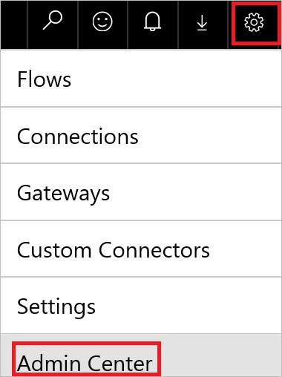

1. The administrator center opens.

**Option 2: Open admin.flow.microsoft.com**

Go to [admin.flow.microsoft.com](https://admin.flow.microsoft.com/), and sign-in with your work account.

## Create an environment

1. In the [Microsoft Flow admin center](https://admin.flow.microsoft.com/), select **Environments**. You'll see all existing environments:

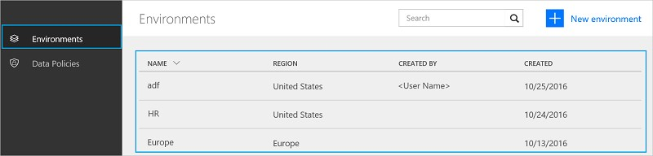

1. Select **New environment** and then provide the required information:

|  |  |
| --- | --- |
| **PROPERTY** | **DESCRIPTION** |
| Environment Name | Enter the name of your environment, such as   |  |  |  | | --- | --- | --- | | Human Resources | , or | Europe flows |   . |
| Region | Choose the location to host your environment. For the best performance, use a region closest to your users. |

1. Select **Create environment**.

You can now add users to the environment.

## Manage your existing environments

1. In the [Microsoft Flow admin center](https://admin.flow.microsoft.com/), select **Environments**:

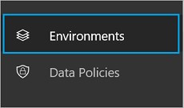

1. Select an environment to open its properties.
2. Use the **Details** tab to view additional information about an environment, including who created the environment, its geographic location, and more:

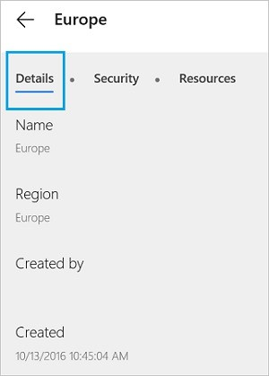

1. Select **Security**.

In **Environment roles**, there're two options: **Environment Admin** and **Environment Maker**:

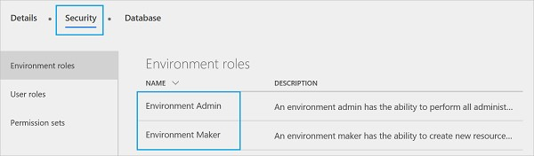

A **Maker** can create new resources such as flows, data connections, and gateways in an environment.

**NOTE**

A user doesn't need to be a **Maker** to *edit* resources in an environment. Each Maker determines who can edit her or his resources by granting permissions to users who aren't environment Makers.

An **Admin** can create data loss prevention policies and perform other administrative tasks, such as create environments, add users to environments, and assign admin/maker privileges.

* 1. Select the **Environment Maker** role, and then select **Users**:

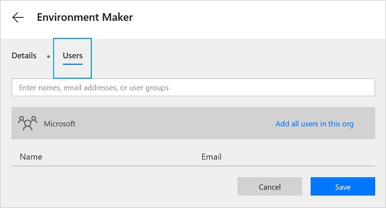

* 1. Enter a name, email address, or user group that you'd like to give the **Maker** role. c. Select **Save**.

1. Within **Security**, select **User Roles**:

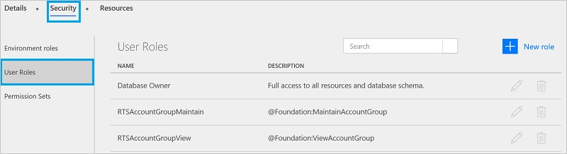

Any existing roles are listed, including the options to edit or delete the role.

Select **New role** to create a new role.

1. Within **Security**, select **Permission Sets**:

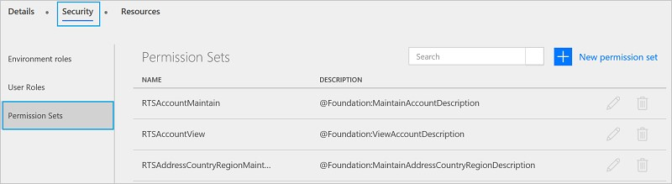

You'll see all existing permission sets and options to edit or delete roles.

Select **New permission set** to create a new permission set.

1. In **Database**, create a database to store your data. This database is part of the Common Data Service.

## Frequently asked questions

**Can I move a flow between environments?**

No, flows cannot be moved between environments. Recreate the flow in the different environment.

**Which license includes the Common Data Service?**

Only Microsoft PowerApps Plan 2 includes rights to create databases with the Common Data Service. However, all paid plans (Microsoft Flow plans 1 and 2, and Microsoft PowerApps plans 1 and 2) have the rights to use the Common Data Service.

Choose a plan that's right for you by visiting the [Microsoft Flow pricing](https://flow.microsoft.com/pricing/) page.

See the Billing questions document for answers to frequently asked questions about billing.

**Can the Common Data Service be used outside of an environment?**

No. The Common Data Service requires an environment. Read more about it.

**What regions include Microsoft Flow?**

Microsoft Flow supports most regions that Office 365 supports, see the regions overview for more details.

**What's needed to create my own custom environment?**

All users with the Microsoft Flow Plan 2 license can create their own environments. All Microsoft Flow users can use environments created by Plan 2 administrators, but they cannot create their own environments.

# Data loss prevention (DLP) policies

11/3/2017 • 5 min to read • [Edit Online](https://github.com/MicrosoftDocs/flow-docs-pr/blob/live/flow-docs/prevent-data-loss.md)

What is a data loss prevention policy?

An organization's data is critical to its success. Its data needs to be readily available for decision-making but it needs to be protected so that it isn't shared with audiences that should not have access to it. To protect this data, Microsoft Flow (Flow) provides you with the ability to create and enforce policies that define which consumer services/connectors specific business data can be shared with. These policies that define how data can be shared are referred to as data loss prevention (DLP) policies.

Why create a DLP policy?

You would create DLP policy to clearly define which consumer services business data may be shared with. For example, an organization that uses Flow may not want its business data that's stored in SharePoint to be automatically published to its Twitter feed. To prevent this, you can create a DLP policy that blocks SharePoint data from being used as the source for tweets.

## Benefits of a DLP policy

Ensures that data is managed in a uniform manner across the organization

Prevents important business data from being accidentally published to services such as social media sites.

## Managing DLP policies

**Prerequisites**

In order to create, edit, or delete DLP policies, the following items are required:

Either environment admin or tenant admin permissions. You can learn more about permissions in the environments topic. A Flow P2 license.

## Create a DLP policy

**Prerequisites**

In order to create a DLP policy, you must have permissions to at least one environment.

Follow these steps to create a DLP policy that prevents data that is stored in your company’s SharePoint from being published to Twitter:

1. While on the Data Policies tab, select the **New policy** link:



1. Enter the name of the DLP policy as *Secure Data Access for Contoso* in the **Data Policy Name** label at the top of the page that opens:



1. Select the environment on the **Applies to** tab.

**Note:** As an environment admin, you can create policies that apply to only a single environment. As a tenant admin, you can create a policy that applies to all environments, one or more selected environments, or all environments except a selected set:

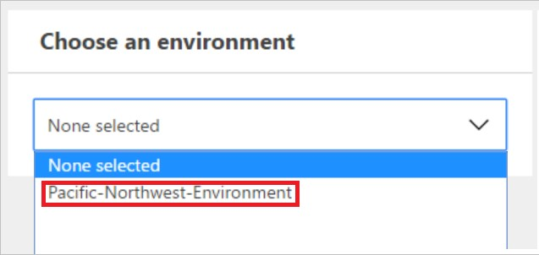

1. Select the **Data groups** tab:

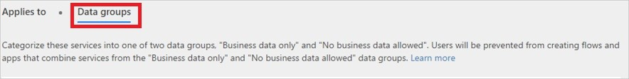

1. Select the **+ Add** link located inside the **Business data only** group box:

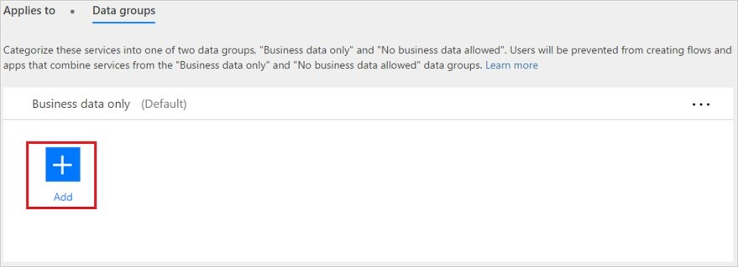

1. Select the **SharePoint** and **Salesforce** services from the **Add services** page:

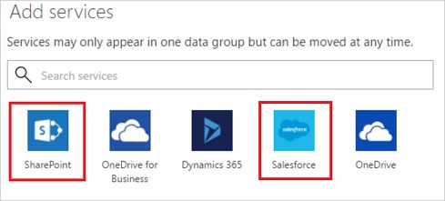

1. Select the **Add services** button to add the services that are allowed to share business data:

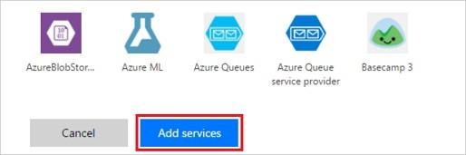

1. Select **Save Policy**:

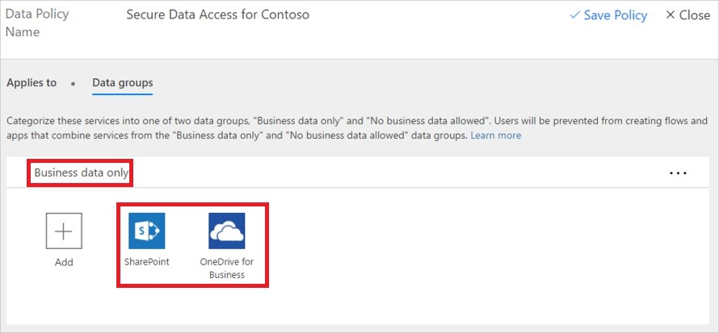

1. After a few moments, your new DLP policy will be displayed in the data loss prevention policies list:

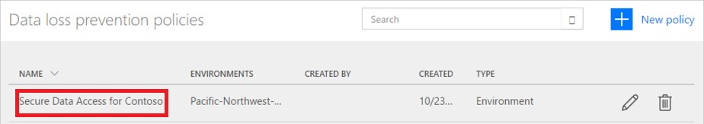

1. **Optional** Send an email or other communication to your team, alerting them that a new DLP policy is now available.

Congratulations, you have now created a DLP policy that allows app to share data between SharePoint and Saleforce and blocks the sharing of data with any other services.

**Note**: Adding a service to one data group automatically removes it from the other data group. For example, if Twitter is currently located in the **business data only** data group, and you don't want to allow business data to be shared with Twitter, simply add the Twitter service to the **no business data allowed** data group. This will remove Twitter from the business data only data group.

## Data sharing violations

Assuming you have created the DLP policy outlined above, if a user creates a flow that shares data between Salesforce (which is in the **business data only** data group) and Twitter (which is in the **no business data allowed** data group), the user will be informed that the flow is **suspended** due to a conflict with the data loss prevention policy you created.

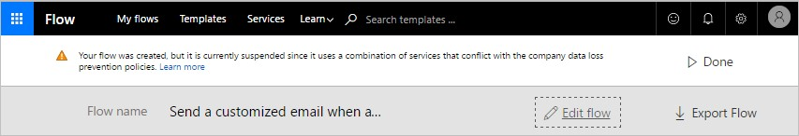

If your users contact you about suspended flows, here a few things to consider:

1. In this example, if there is a valid business reason to share business data between SharePoint and Twitter, you can edit the the DLP policy.
2. Ask the user to edit the flow to comply with the DLP policy.
3. Ask the user to leave the flow in the suspended state until a decision is made regarding the sharing of data between these two entities.

## Find a DLP policy

### Admins

Admins can use the search feature from the Admin center to find specific DLP policies.

**NOTE** Admins should publish all DLP policies so that users in the organization are aware of the policies prior to creating flows.

### Makers

If you don't have admin permissions and you wish to learn more about the DLP policies in your organization, contact your administrator. You can also learn more from the maker environments topic **NOTE** Only admins can edit or delete DLP policies.

## Edit a DLP policy

1. Launch the Admin center by browsing to [https://admin.flow.microsoft.com](https://admin.flow.microsoft.com/).
2. In the Admin center that launches, select the **Data polices** link on the left side.

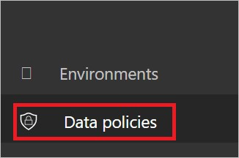

1. Search the list of existing DLP policies and select the edit button next to the policy you intend to edit:

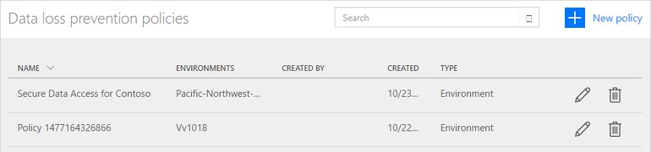

1. Make the changes you wish to make. You can modify the environment or the services in the data groups, for example.
2. Select **Save Policy** to save your changes:



Your policy has now been updated. You can confirm that the changes have been made to your policy by finding it in the data loss prevention policies list and reviewing its properties.

**Note** DLP policies created by tenant admins can be viewed by environment admins but cannot be edited by environment admins.

## Delete a DLP policy

1. Launch the Admin center by browsing to [https://admin.flow.microsoft.com](https://admin.flow.microsoft.com/).
2. In the Admin center that launches, select the **Data polices** link on the left side.



1. Search the list of existing DLP policies and select the delete button next to the policy you intend to delete:

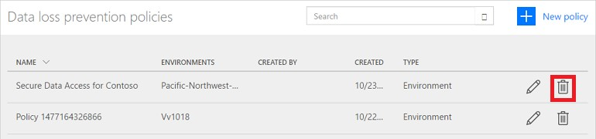

1. Confirm that you really want to delete the policy by selecting the **Delete** button:

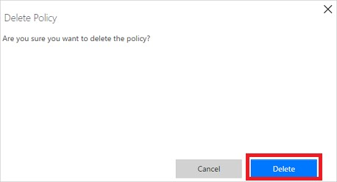

Your policy has now been deleted. You can confirm that the policy is no longer listed in the data loss prevention policies list by selecting the **Data Policies** link on the left and reviewing the list of policies.

## DLP policy permissions

Only tenant and environment admins can create and modify DLP policies. Learn more about permissions in the environments topic.

## Next steps

Learn more about environments

Learn more about Microsoft Flow

Learn more about the admin center

# Learn all about data groups

11/3/2017 • 3 min to read • [Edit Online](https://github.com/MicrosoftDocs/flow-docs-pr/blob/live/flow-docs/introduction-to-data-groups.md)

What is a data group?

Data groups are a simple way to categorize services within a data loss prevention (DLP) policy. The two data groups available are the **Business data only** group and the **No business data allowed** group. Organizations are free to determine which services are placed into a particular data group. A good way to categorize services is to place them in groups, based on the impact to the organization. By default, all services are placed into the **No business data allowed** data group. You manage the services in a data group when you create or modify the properties of a DLP policy from the admin center.

## How data is shared between data groups

Data cannot be shared among services located in different groups. For example, if you place SharePoint and Salesforce in the **Business data only** group and you place Facebook and Twitter in the **No business data allowed** group, you cannot create a flow that moves data between SharePoint and Facebook. While data cannot be shared among services in different groups, you can share data among the services within a specific group. So, going back to the earlier example, since SharePoint and Salesforce were placed in the same data group, flows that your end users create can share data between SharePoint and Salesforce. Similarly, end users can create flows and PowerApps that share data between Facebook and Twitter. The key point is that services in a specific group can share data, while services in different groups cannot share data.

Additionally, one data group must be designated as the *default* group. Initially, the **No business data allowed** group is the *default* group and all services are in the data group. An administrator can change the default data group to the **business data only** data group. **Note** any new services that are added to flow will be placed in the designated *default* group. For this reason, we recommend you keep the **No business data allowed** as the default group and manually add services into the **Business data only** group after your organization has evaluated the impact of allowing business data to be shared with the new service.

## Add services to a data group

In this walk-through, we'll add SharePoint and Salesforce to the **business data only** data group of a data loss prevention (DLP) policy.

1. Select the **+ Add** link located inside the **Business data only** group box of a DLP policy:

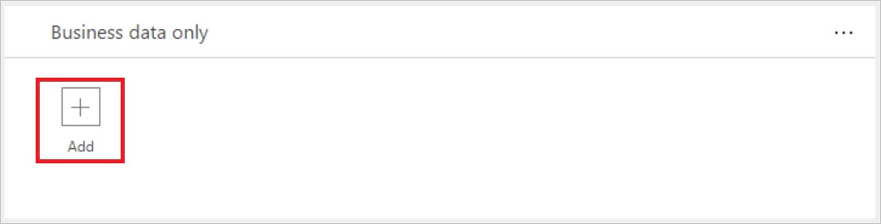

1. Select SharePoint and Salesforce then select **Add services** to add both to the business data only group:

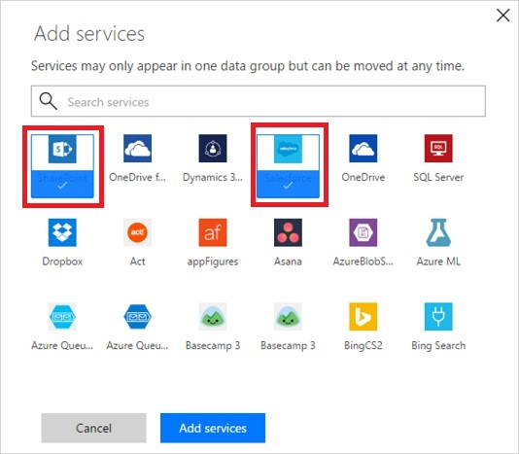

1. Select **Save Policy** from the menu at the top:



1. Notice that both SharePoint and Salesforce are now in the business data only group:

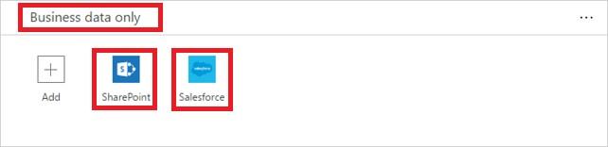

In this walk-through, you've added SharePoint and Salesforce to the **business data only** data group of a DLP policy. If a person who is part of the DLP policy's environment creates an app that shares data between SharePoint or Salesforce and any service in the **No business data allowed** data group, the app will not be allowed to run.

## Remove services from a data group

Since all services must be in one of the available data groups, to remove a service from a specific group, simply add the service to another group then save the policy.

## Change the default data group

In this walk-through, we will change the default data group from the **no business data allowed** data group to the **business data only** data group.

**Important** any new services that are added to flow will be placed in the designated *default* group. For this reason, we recommend you keep the **No business data allowed** as the default group and manually add services into the **Business data only** group.

1. Select the **...** located at the top right corner of the data group you wish to designate as the default data group:



1. Select **Set as default group**:

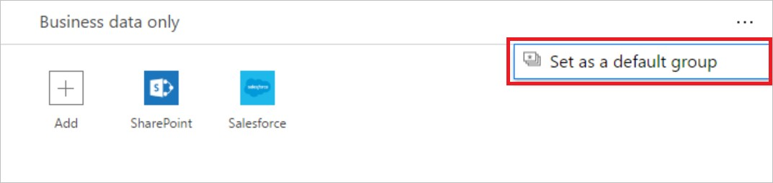

1. Select **Save Policy** from the menu at the top:



1. Notice the data group is now designated as the default data group:

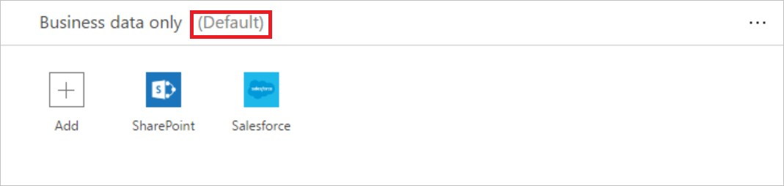

## Next steps

Learn more about data loss prevention (DLP) policies

Learn more about environments

# FAQ for regions in Microsoft Flow

11/3/2017 • 1 min to read • [Edit Online](https://github.com/MicrosoftDocs/flow-docs-pr/blob/live/flow-docs/regions-overview.md)

This document provides a list of frequently asked questions about Microsoft Flow.

How do I find out where my flow is deployed?

Your flow is deployed in the [region](https://azure.microsoft.com/regions/) that hosts the environment. For example, if your environment is created in the Europe region, your flow is deployed in Europe data centers.

Administrators can identify the region if they sign in to the Microsoft Flow [admin center](https://admin.flow.microsoft.com/). The **Environments** tab lists all existing environments and their regions.

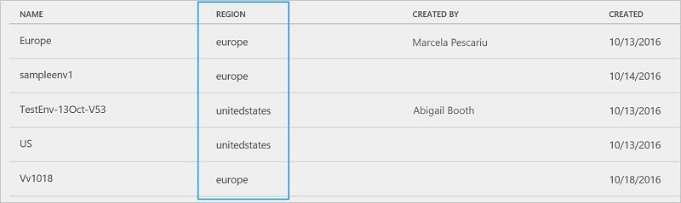

What regions are available?

United States

Europe

Asia

Australia

India

Japan

Canada

What features are specific to a given region?

Environments can be created in different regions and are bound to that geographic location. When you create a flow in an environment, that flow is deployed in data centers in that geographic location. This applies to any items you create in that environment, including the common data model, flows, connections, gateways, apps, and custom connectors.

For optimal performance, create your environment in the region that's closest to your users. For example, if your users are in Europe, create your environments in the Europe region. If your users are in the United States, create your environments in the United States region.

## Gateways

Gateways are:

Not available in the India region.

Supported in the default environment only, not in custom environments.

Is Microsoft Flow available in national clouds?

No, Microsoft Flow isn't available in national clouds. Support for national clouds is planned for 2018.

What outbound IP addresses are used in each region?

See Limits and configuration.

Limits and configuration in Microsoft Flow

11/3/2017 • 2 min to read • [Edit Online](https://github.com/MicrosoftDocs/flow-docs-pr/blob/live/flow-docs/limits-and-config.md)

This topic contains information about the current limits and configuration details for flows.

## Request limits

These are limits for a single outgoing request.

### Timeout

|  |  |
| --- | --- |
| **NAME** | **LIMIT** |
| Request Timeout | 120 Seconds |

### Message size

|  |  |  |
| --- | --- | --- |
| **NAME** | **LIMIT** | **NOTES** |
| Message size | 100 MB | Not all APIs support the full 100MB. |
| Expression evaluation limit | 131,072 characters | |  |  |  |  |  | | --- | --- | --- | --- | --- | | @concat() | , | @base64() | , | string |   can't exceed this limit. |

### Retry policy

|  |  |
| --- | --- |
| **NAME** | **LIMIT** |
| Retry attempts | 4 |

## Run duration and retention

These are the limits for a single flow run.

|  |  |  |
| --- | --- | --- |
| **NAME** | **LIMIT** | **NOTES** |
| Run duration | 30 days | Includes workflows with pending steps like approvals. After 30 days the pending steps will Time Out. |
| Storage retention | 30 days | This is from the run start time. |
| Min recurrence interval | 1 minute |  |
| Max recurrence interval | 500 days |  |

## Looping and debatching limits

These are limits for a single flow run.

|  |  |  |
| --- | --- | --- |
| **NAME** | **LIMIT** | **NOTES** |
| ForEach items | 5,000 | You can use the filter action to filter larger arrays as needed. |
| Until iterations | 5,000 |  |
| SplitOn items | 5,000 |  |
| ForEach Parallelism | 1 |  |

## Definition limits

These are limits for a single flow.

|  |  |  |
| --- | --- | --- |
| **NAME** | **LIMIT** | **NOTES** |
| Actions per workflow | 250 | You can add nested workflows to extend this as needed. |
| Allowed action nesting depth | 5 | You can add nested workflows to extend this as needed. |
| Max characters per expression | 8,192 |  |
| |  |  |  | | --- | --- | --- | | action | / | trigger |   name limit | 80 |  |
| |  | | --- | | description |   length limit | 256 |  |

SharePoint limits

There are [limitations](https://powerapps.microsoft.com/tutorials/connection-sharepoint-online/) on how you can use Microsoft SharePoint with Microsoft Flow and PowerApps.

## IP address configuration

The IP address from which Microsoft Flow requests are sent depends on the region where the environment that contains the flow is located. We don't currently publish FQDNs available for flow scenarios.

### Logic App Service

Calls made from a flow go directly through the Azure Logic App service. Some examples of these calls include HTTP or HTTP + OpenAPI. These calls come from the following IP addresses:

|  |  |
| --- | --- |
| **REGION** | **OUTBOUND IP** |
| Asia | 168.63.200.173, 13.75.89.159, 23.97.68.172, 13.75.94.173,  40.83.127.19, 52.175.33.254, 52.163.93.214, 52.187.65.81,  52.187.65.155, 13.76.133.155, 52.163.228.93, 52.163.230.166 |
| Australia | 13.75.153.66, 104.210.89.222, 104.210.89.244, 13.75.149.4,  104.210.91.55, 104.210.90.241, 13.73.115.153, 40.115.78.70,  40.115.78.237, 13.73.114.207, 13.77.3.139, 13.70.159.205 |
| **REGION** | **OUTBOUND IP** |
| Canada | 52.233.29.92, 52.228.39.241, 52.228.39.244, 52.232.128.155,  52.229.120.45, 52.229.126.25 |
| Europe | 13.79.173.49, 52.169.218.253, 52.169.220.174, 40.113.12.95,  52.178.165.215, 52.178.166.21, 13.95.155.53, 52.174.54.218,  52.174.49.6, 40.68.222.65, 40.68.209.23, 13.95.147.65 |
| India | 52.172.157.194, 52.172.184.192, 52.172.191.194,  52.172.154.168, 52.172.186.159, 52.172.185.79, 52.172.9.47,  52.172.49.43, 52.172.51.140, 52.172.50.24, 52.172.55.231, 52.172.52.0 |
| Japan | 13.71.146.140, 13.78.84.187, 13.78.62.130, 13.71.158.3,  13.73.4.207, 13.71.158.120, 40.74.140.173, 40.74.81.13,  40.74.85.215, 40.74.140.4, 104.214.137.243, 138.91.26.45 |
| United States | 137.135.106.54, 40.117.99.79, 40.117.100.228, 13.92.98.111,  40.121.91.41, 40.114.82.191, 52.160.90.237, 138.91.188.137,  13.91.252.184, 52.160.92.112, 40.118.244.241, 40.118.241.243 |

### Services

Calls made from an API connected through a flow (for example, the SQL API or the SharePoint API) will come from the IP address specified below:

|  |  |
| --- | --- |
| **REGION** | **OUTBOUND IP** |
| Asia | 52.163.91.227, 52.163.89.40, 52.163.89.65, 52.163.95.29, 13.75.89.9, 13.75.91.198, 13.75.92.202, 13.75.92.124 |
| Australia | 13.77.7.172, 13.70.191.49, 13.70.189.7, 13.70.187.251,  13.70.82.210, 13.73.203.158, 13.73.207.42, 13.73.205.35 |
| Canada | 52.233.30.222, 52.233.30.148, 52.233.30.199, 52.233.29.254,  52.232.130.205, 52.229.126.118, 52.229.126.28, 52.229.123.56 |
| Europe | 52.166.241.149, 52.166.244.232, 52.166.245.173,  52.166.243.169, 40.69.45.126, 40.69.45.11, 40.69.45.93, 40.69.42.254 |
| India | 52.172.54.172, 52.172.55.107, 52.172.55.84, 52.172.51.70,  52.172.158.185, 52.172.159.100, 52.172.158.2, 52.172.155.245 |
| Japan | 104.214.137.186, 104.214.139.29, 104.214.140.23,  104.214.138.174, 13.78.85.193, 13.78.84.73, 13.78.85.200, 13.78.86.229 |
| United States | 104.43.232.28, 104.43.232.242, 104.43.235.249,  104.43.234.211, 52.160.93.247, 52.160.91.66, 52.160.92.131,  52.160.95.100, 40.117.101.91, 40.117.98.246,  40.117.101.120, 40.117.100.191 |
| **REGION** | **OUTBOUND IP** |
| United States (Early Access) | 52.161.26.191, 52.161.27.42, 52.161.29.40, 52.161.26.33,  13.66.213.240, 13.66.214.51, 13.66.210.166, 13.66.213.29 |

For example, if you must whitelist IP addresses for your Azure SQL database, you should use these addresses.

# Release notes

11/20/2017 • 28 min to read • [Edit Online](https://github.com/MicrosoftDocs/flow-docs-pr/blob/live/flow-docs/release-notes.md)

## Top questions

1. My flow failed. How do I fix it?
   1. Identify the failure. Start by going to the notifications icon at the top of the web portal, or selecting the **Activity** tab in the mobile app. You should see your flow there, and you can select it.
   2. You are now looking at the flow details. Find the step with the red exclamation icon, and you should see the error message for your flow there.
   3. Depending on the error message, you should be able to **Edit** the flow and fix it. Read more about how to fix common flow failures.
2. How do I use an advanced condition or an expression?

Read about adding conditions.

If you want multiple cases in a flow, click or tap **Add condition** from inside of an existing condition.

Create an advanced expression by referencing [a function in Logic Apps](https://docs.microsoft.com/rest/api/logic/definition-language).

1. How does licensing work with Office 365?

If you're an Office 365 user, you get full access through the Microsoft Flow for Office 365 plan. For more information, see the [pricing plans for Microsoft Flow](https://flow.microsoft.com/pricing/) .

If you're an administrator, see information about licensing for Microsoft Flow, including with Office 365.

## Known issues and resolutions

1. SharePoint lists on My Sites and that aren't of type *Custom List* aren't supported. To work around this issue, create a custom list on a standard SharePoint site.
2. Flows can't write to Taxonomy fields in SharePoint lists. We recommend using a simple string field until this is corrected.
3. File triggers won't fire for files being added inside of nested folders inside the folder you select.

## What's new

### Release 2017-11-09

**OneDrive for Business integration** - There's [now a flow button inside of OneDrive for Business](https://flow.microsoft.com/blog/microsoft-flow-integration-in-one-drive-for-business-and-new-connector-actions/) that can create or trigger flows on selected files or folders.

**Planner triggers** - Start flows when a new task is created, when a task is assigned to you or when one is completed.

**SharePoint attachments** - Work with attachments on SharePoint list items: list, download, add or delete attachments.

**Flow management connector** - Create flows that automate the management of other flows in your environment (for example, add permissions to flows automatically).

**Four new connectors** - Added Azure Custom Vision Service, D&B Optimizer, Enadoc, and Derdak SIGNL4. **More connector actions** - Run SQL queries, get faster email triggers, use any method with HTTP with Azure AD, and more.

[Read more and ask questions](https://flow.microsoft.com/blog/planner-triggers-connector-improvements/) about this release.

### Release 2017-11-02

**Audit Logging** - Microsoft Flow audit events are now available in Office 365 Security & Compliance Center for all tenants.

**Flow widget fixes** - Fixed an issue in the Flow mobile app that caused buttons to not load in the widget.

[Read more and ask questions](https://flow.microsoft.com/blog/security-and-compliance-center/) about this release.

### Release 2017-10-19

**Nested apply to each** - You can add apply to each actions, filter and select in other apply to each containers.

**Date Time actions** - New actions for getting local times, adding, subtracting or formatting times. **Four new connectors** - Added Content Moderator, Docparser, Microsoft Kaizala and Pitney Bowes Data Validation.

**Improved connection experience** - Notifications in the Flow portal when a connection is broken and richer connection details.

**On-the-go collection** - A new template collection for [on-the-go workers](https://flow.microsoft.com/collections/onthego/).

**Email address button inputs** - Collect email addresses from users when they run buttons.

**File button inputs** - Get uploaded files, such as photos, from users when they run buttons.

**First run and auto sign-in** - Improved first run experiences on the mobile app, including automatic sign-in. **Faster Microsoft Forms triggers** - Forms will trigger flows much more quickly than before (previously once an hour).

**Button inputs across sessions** - Buttons triggered on your mobile phone will remember previous inputs. **Mobile activity feed** - Improved activity feed to include more detailed run summaries and troubleshooting details.

[Read more and ask questions](https://flow.microsoft.com/blog/nested-apply-to-each/) about this release.

### Release 2017-10-03

**All must approve** - Require an approval request sent to more than one person to have everyone who received the request to approve it.

**New OneDrive for Business actions** - Generate PDFs for files stored on OneDrive for Business and four other new actions.

**Apache Impala connector** - Apache Impala (incubating) is the open source, native analytic database for Apache Hadoop.

**Add flow descriptions** - Give your flows descriptions so when you share them so your co-workers can see a summary of the flow does.

[Read more and ask questions](https://flow.microsoft.com/blog/all-must-approve-and-onedrive/) about this release.

### Release 2017-09-25 - Q3 Update for Microsoft Flow

**Deeper SharePoint integration in First Release** - There are new "in-the-box" send for review flows and a Flow panel for collecting inputs when you run a flow for first release tenants.

**Dynamics 365 for Customer Engagement** - Flow is now integrated in the UI for Dynamics 365 for Customer Engagement.

**Microsoft Trust Center** - Flow is listed in the Microsoft Trust center, showing certifications like HIPAA, ISO and SOC.

**Usage analytics** - Every flow has an embedded Power BI dashboard with basic usage analytics.

**Audit Logging in First Release** - All flow management events are logged in the Office 365 Security and Compliance center for first release tenants.

**Six new connectors** - Added LinkedIn, Office 365 Groups, Skype for Business, Adobe Sign, Bizzy, and Azure Log Analytics Data Collection.

**SQL triggers** - Run flows when a new row is added or a row is updated in a SQL table.

**On-prem custom connectors** - Custom connectors can now use the On-premises Data gateway to connect to internal endpoints on your network.

[Read more and ask questions](https://flow.microsoft.com/blog/q3-2017-update/) about this release.

### Release 2017-09-21

**Download Flow History** - Download the run history of a Flow as a CSV file to open in Excel.

**Advanced recurrence** - Build recurring schedules to trigger your flows, for example, only trigger on weekdays.

**IntelliSense** - When typing in expressions, IntelliSense will provide suggestions for parameters.

**Four new connectors** - Added connectors for Azure AD HTTP services, Amazon Redshift, Azure Event Grid Publish and FlowForma.

**Sharing links** - A new action to generate sharable links for OneDrive files or Azure Storage Blobs.

[Read more and ask questions](https://flow.microsoft.com/blog/download-history-recurrence/) about this release.

### Release 2017-08-25

**Document properties and more for SharePoint** - [Read and set SharePoint document library properties](https://flow.microsoft.com/blog/support-for-sharepoint-document-library-properties/), and use additional fields like links to the SharePoint item.

**Flow collections** - Flow collections are a set of template collections organized by role or by vertical. **Button resharing** - When you share buttons with your co-workers they can reshare them with other people too.

**Collect lists from buttons** - Define dropdowns of options for users to choose from when they tap the button.

**Seven new connectors** - AWeber, Azure Log Analytics, Azure Tables, DocFusion365, Azure Event Grid, Azure Event Hubs, and StaffHub.

**Improvements to Slack and MySQL** - Create or join channels in Slack, and you can write to MySQL databases.

[Read more and ask questions](https://flow.microsoft.com/blog/button-updates-seven-connectors/) about this release.

### Release 2017-08-02

[**Write to Person, Choice and Lookup fields** - SharePoint's Create item and Update item now support the ability to set Person, Choice, and Lookup fields.](https://flow.microsoft.com/blog/setting-sharepoint-s-person-choice-and-lookup-fields/)

**More action settings** - Now there's more control over how triggers and actions run, including configuring retry policies and pagination.

**Four new connectors** - You can now use Azure File Storage, Elastic Forms, Plivo, and Video Indexer.

[Read more and ask questions](https://flow.microsoft.com/blog/four-connector-action-settings/) about this release.

### Release 2017-07-27 - Q2 Update for Microsoft Flow

**Import and export** - Export and import flow solutions across environments or from test to production.

**Use expressions in actions** - Enter expressions in any action and get inline help with how to use them. **Grow up to Azure Logic Apps** - Save your flows as Azure Logic App resource that can be deployed through Visual Studio or the Azure portal.

**Admin visibility** - Download Microsoft Flow usage in your tenant to understand exactly where and how flows are being used.

**Flows in Dynamics 365** - Use flows inside of Dynamics 365 for Operations & Financials, Business Edition. **Find scenarios more easily** - Browse everything that connector can do and then use any trigger as a jumpingoff point for building flows.

[Read more and ask questions](https://flow.microsoft.com/blog/q2-2017-update/) about this release.

### Release 2017-07-13

**Improved template publishing** - Publish any flow you create, along with its categories, to the public gallery.

**Get events on your Outlook Calendar** - A new action to return all events between two times on your

calendar.

**New mobile functionality** - Run flows on demand and resubmit failed runs in the mobile app.

**Dynamic dropdowns in Custom connectors** - Build dynamic dropdowns, polling triggers and test your custom connectors.

[Read more and ask questions](https://flow.microsoft.com/blog/publishing-and-custom-connectors/) about this release.

### Release 2017-06-28

**Update your language settings** - You can customize both the Language and Region that Microsoft Flow uses through the Settings menu.

**Five new connectors** - Added support for Adobe Creative Cloud, Bing Maps, Bing Search, JotForm and Freshservice.

**Configure timeouts** - Change the time long-running actions, such as approvals, run before they "timeout" and the flow continues.

**Include comments in Outlook for approvals** - When you receive an approval request you can provide comments without ever leaving Outlook.

**Custom connector brand colors** - You can now enter a color for your Custom Connectors that will be used for the backgrounds.

**Save As for team flows** - Make copies of any flows, including Team flows

**Delete flow information** - When you delete a flow, you'll be shown the list of all pending runs for that flow. **Filtering on the Connectors page** - Search for the connectors you want on the Connectors page, and filter by type of connector.

[Read more and ask questions](https://flow.microsoft.com/blog/language-settings-3-connectors/) about this release.

### Release 2017-06-19

You can now view the status of all of the pending approval requests you have sent. Additionally, you can browse and act on all your pending approvals directly from your mobile device.

[Read more and ask questions](https://flow.microsoft.com/blog/sent-requests-flow-mobile/) about this release.

### Release 2017-06-15

**Content conversion** - A new connector that can convert HTML content to plain text, useful for handling HTML formatted emails.

**Three new database connectors** - Added read-only support for MySQL, PostgreSQL and Teradata. These connectors connect via the On-premises data gateway.

**Three other connectors** - Connect to Azure Application Insights, Calendly and Teamwork Projects.

**Better visualization for error handling** - Steps that run after errors are now shown with red dotted arrows so you can easily identify them.

**Run details pane** - When a flow fails there is now a new right-hand pane that contains some helpful steps for how to correct your flow.

[Read more and ask questions](https://flow.microsoft.com/blog/seven-connectors-and-html/) about this release.

### Release 2017-06-04

[**GA for Windows Phone** - The Microsoft Flow mobile app has been released to General Availability for Windows Phone.](https://flow.microsoft.com/blog/announcing-flow-windows-phone-app/)

**Emails on flow failures** - Get notified via email when you have a flow that fails. These failure emails will only be sent out once a week, and can be turned on or off by the user.

**Select action for tables** - Use the new Select action to change the set of columns that will be included in tables. **Microsoft Forms connector** - Microsoft Forms is a new part of Office 365 Education that allows teachers and students to create custom quizzes quickly and easily, surveys, questionnaires, registrations and more.

**Office 365 Enterprise K1 plan** - PowerApps and Microsoft Flow are now included with the Office 365 Enterprise K1 plan with certain quotas.

**HTTP headers are easier** - Just like the Select action you can provide a header name and header value by just filling out the text boxes on the action.

[Read more and ask questions](https://flow.microsoft.com/blog/microsoft-forms-tables-flow-failures/) about this release.

### Release 2017-05-23

**Microsoft Teams connector** - [Microsoft Teams](https://flow.microsoft.com/blog/introducing-the-microsoft-teams-connector-for-flow/) is a chat-based workspace in Office 365 that brings together people, conversations and content – along with the tools that teams need, so they can easily collaborate to achieve more.

**Widgets on iOS and Android** - Microsoft Flow widgets are button shortcuts that provide you an easier and faster way for button triggering straight from your home screen.

**Create "error handling" steps** - Define one or more steps to run after an action fails. For example, get a notification immediately if your flow fails to create a record in Dynamics 365.

**Integer and float variables** - Initialize and increment or decrement counters inside of a flow run to count how many times a certain set of logic runs.

**Flow details page** - When you select a flow in your **My flows** list, you'll see a page with details about that flow, such as who has access and the run history.

**Flow run quotas for admins** - Administrators can now monitor flow run usage across an organization against the common company run quota and get a quota breakdown to understand what licenses contribute to their quota.

**HTTP request trigger improvements** - Use different HTTP methods, and add path segments for the Request trigger.

**Two partner connectors** - Microsoft Flow can now connect to Parserr, an email-parsing service, and Cognito Forms, an online-forms service.

[Read more and ask questions](https://flow.microsoft.com/blog/error-handling/) about this release.

### Release 2017-05-12

**SharePoint Document Libraries integration** - You can select any file in a document library and kick off a flow, for example to send it to your manager for approval, [and much more](https://flow.microsoft.com/blog/flow-in-spo-document-libraries/).

**Microsoft Planner connector** - Microsoft Planner lets you easily bring together teams, tasks, documents, and conversations for better results.

**Admin view of licenses** - Administrators can see all of the Microsoft Flow and PowerApps licenses (both trial and paid) in the Microsoft Flow Admin Center.

**PowerApps Community Plan** - The PowerApps Community plan is a free plan for individuals to explore, learn, and build skills for PowerApps, Microsoft Flow, and Common Data Service.

[Read more and ask questions](https://flow.microsoft.com/blog/planner-community-and-licenses/) about this release.

### Release 2017-05-09

**Azure AD connector** - There is a new connector for performing administrator actions from Microsoft Flow, including creating users or adding them to groups.

**Office 365 Outlook improvements** - Flows can now be triggered by Shared Mailboxes and send mail to a Shared Mailbox. They can also set or read automatic replies.

**Available in Canada** - You can now create your flows in Canada.

**Create custom API webhooks** - Custom connector developers can now add triggers to their custom APIs with webhooks.

**Manage flow owners in the admin center** - Environment administrators can manage flow owners in the Microsoft Flow admin center.

**Connector documentation reference** - We now have a [full connector reference on docs.microsoft.com](https://docs.microsoft.com/Connectors/).

**Two partner services** - Two new partner services were released: Nexmo and Paylocity.

[Read more and ask questions](https://flow.microsoft.com/blog/canada-mailboxes-aad) about this release.

### Release 2017-04-27

**Build flows with parallel steps** - Create flows with parallel execution: meaning you can have two or more steps that run at exactly the same time.

**Five new services supported** - Five new services: Approvals, Benchmark Email, Capsule CRM, LiveChat, and Outlook Customer Manager.

**Monitor retries for actions** - Microsoft Flow will retry when there are failures with services. Now see how many automatic retries occurred and the details of what happened.

[Read more and ask questions](https://flow.microsoft.com/blog/parallel-actions/) about this release.

### Release 2017-04-17 - Q1 Update for Microsoft Flow

**Modern approval experiences** - Create workflows where approvers can approve securely from inside the Microsoft Flow mobile app or the unified approvals center on the Microsoft Flow website.

**Team flows general availability** - Multiple people can own and manage a flow together with team flows, which are now generally available.

**Build connectors for Microsoft Flow** - Anyone can submit their own Microsoft Flow connector for free for the rest of the world to use.

**A "diet" designer** - For certain templates, a new version of the designer presents just the fields that are required to create a flow, which simplifies the experience.

[Read more and ask questions](https://flow.microsoft.com/blog/q1-2017-update/) about this release.

### Release 2017-04-11

**New actions to build tables and lists** - New Create HTML Table, Create CSV Table and Join actions that can process lists of items (instead of the previous Apply-to-each only).

**Insert steps anywhere** - You can now insert a new step anywhere in the workflow without needing to dragand-drop.

**Four new services** - Flow now supports 10 to 8 Scheduling, Act!, Inoreader and the Computer Vision API. With the Computer Vision API you can process images to get the text content (known as OCR), or automatically tag images based on their content.

[Read more and ask questions](https://flow.microsoft.com/blog/html-tables-csvs-computer-vision/) about this release.

### Release 2017-04-03

**Windows Phone Beta** - The Windows Phone App beta program is available to get a preview of the app on your Windows Phone. [Read more](https://flow.microsoft.com/blog/windows-phone-app-beta-is-now-available/).

**Muhimbi PDF** - You can now convert Microsoft Word files to PDF, add watermarks, merge documents and more with Muhimbi PDF. [Read more](https://flow.microsoft.com/blog/convert-files-using-muhimbi/).

**Trigger flows from physical buttons** - Announcing partnerships with two of the leading products in the physical button space: Flic by Shortcut Labs, and Bttn by The Button Corporation. [Read more](https://flow.microsoft.com/blog/physical-buttons/)

### Release 2017-03-22

**Make a copy of your flow** - You can now make a copy of your flow to work on draft versions or duplicate a flow that you've created in the past.

**Two new services** - Adding support for Toodledo - manage your to-do list by creating and updating tasks, and Zendesk, which provides a customer service and support ticketing platform.

[Read more and ask questions](https://flow.microsoft.com/blog/make-a-copy/) about this release.

### Release 2017-03-15

**Share buttons with co-workers** - You can now share flow buttons with other people, making it easy for any business user to perform quick tasks.

**Trigger buttons from the home screen** - Shortcuts to flow buttons from the home and lock screens of mobile devices make it quicker than ever to trigger a flow.

**Team flows in the Microsoft Flow app** - You can now see the flows that have other owners in the Microsoft Flow app for iOS or Android.

[Read more and ask questions](https://flow.microsoft.com/blog/button-sharing/) about this release.

### Release 2017-03-10

**Improved custom connector experience** - You can now use a Postman collection to create a custom connector, and edit, add, and test actions.

**Two new services** - Added PowerApps Notifications and PivotalTracker support.

[Read more and ask questions](https://flow.microsoft.com/blog/new-updates-custom-api/) about this release.

### Release 2017-02-27

**Trigger your flow buttons** - You can now trigger flow buttons right from the Microsoft Flow website. When looking at your list of flows, simply select the "..." menu and choose the Run now command.

**Five new services** - Added Oracle Database, Intercom, FreshBooks, LeanKit and WebMerge support.

[Read more and ask questions](https://flow.microsoft.com/blog/trigger-flow-buttons-web/) about this release.

### Release 2017-02-21

**View environment flows** - Environment administrators can now view the full list of all the flows inside a given environment, as well as enable, disable or delete flows.

**Two new services** - Added Azure Automation and Basecamp 2 support.

[Read more and ask questions](https://flow.microsoft.com/blog/managing-flow-resources-in-the-admin-center/) about this release.

### Release 2017-02-16

**Five new services** - Added support for Azure Data Lake, Bitbucket (a web based hosting service for projects that use GIT revision control), Eventbrite, Infusionsoft and Pipedrive.

**Custom HTTP authentication** - In the flow designer it's now possible to use authentication with custom HTTP endpoints.

**Parse JSON messages** - You can parse JSON data from the HTTP Request trigger or that's returned from the HTTP action.

**Flow run filtering** - Improved filtering for flow runs, with more specific options including seeing Running flows or Cancelled runs.

[Read more and ask questions](https://flow.microsoft.com/blog/managing-flow-resources-in-the-admin-center/) about this release.

### Release 2017-02-06

**Team flows** - Team flows make it possible for multiple people to own and manage a flow together, and, if someone leaves an organization, the flows they created can continue to run.

**Sharing custom connectors** - custom connectors, like team flows, can be shared and collectively managed inside an organization.

**Gmail and LUIS support** - Connect to Gmail and Azure Cognitive Services' Language Understanding Intelligent Service.

[Read more and ask questions](https://flow.microsoft.com/blog/team-flows/) about this release.

### Release 2017-01-30

**Flow button inputs** - Flow buttons can now receive user inputs at run time, so flow authors can define information that's passed in when the button is tapped.

**Outlook Tasks and HelloSign** - Outlook Tasks service lets you manage tasks, and HelloSign enables secure electronic signatures.

[Read more and ask questions](https://flow.microsoft.com/blog/button-user-inputs/) about this release.

### Release 2017-01-23

**Search by service** - Browse by service when you add a trigger or action to see all the actions for each service.

**Switch case** - Add Switch blocks to have several branches of parallel logic.

**More email actions** - New functionality in the Office 365 Outlook and Outlook.com services to work with flagged mails.

**Five new services** - Connect to Local or Network File Systems, the payment service Stripe, IBM Informix, IBM DB2, and UserVoice.

[Read more and ask questions](https://flow.microsoft.com/blog/search-by-service/) about this release.

### Release 2017-01-14

**Resubmit runs** - If a flow failed and you want to try to fix it and run again, you can resubmit the failed run.

**Cancel runs** - When a flow gets stuck, you can now explicitly cancel the run.

**Two new services** - Added support for GoToTraining and GoToWebinar.

**Mobile links** - You can share templates right from the mobile app, and we've added a quick download link for the apps at the top of the website.

[Read more and ask questions](https://flow.microsoft.com/blog/managing-runs/) about this release.

### Release 2016-12-29

Microsoft Flow now supports DocuSign, to handle eSignatures and Digital Transaction Management; SurveyMonkey, for web-based surveys; and the OneNote note-taking app (business accounts only).

[Read more and ask questions](https://flow.microsoft.com/blog/final-2016-services/) about this release.

### Release 2016-12-20

**Run now** - You can now fire off a recurring trigger on demand - for example, if you have a scheduled report every day, but you need the report to run **now** too.

**Six new services** - Build flows that connect to MSN Weather, Medium, Google Contacts, Buffer, Harvest, and TypeForm.

[Read more and ask questions](https://flow.microsoft.com/blog/run-now-and-six-more-services/) about this release.

### Release 2016-12-14

You can now leverage valuable information when triggering a button flow, such as from where the button was triggered, by whom, at what time, and more.

[Read more and ask questions](https://flow.microsoft.com/blog/button-trigger-tokens/) about this release.

### Release 2016-12-06

**Introducing Guided Learning** - Get started with a sequenced collection of courses that pair videos with documentation to help you understand the extensive and powerful capabilities of Microsoft Flow.

**Two new services** - Flows can now use Freshdesk, a customer support solution, and GoToMeeting, an online meeting tool.

**HTTP Webhook support** - A flow can now be an endpoint for webhooks that will automatically register and unregister itself.

[Read more and ask questions](https://flow.microsoft.com/blog/guided-learning-and-two-services/) about this release.

### Release 2016-11-23

**Power BI alert support in Flow** - Turn insights into action by triggering flows from Power BI data alerts.

**Mobile application improvements** - Added the ability to create flows from blank, in addition to the already existing experience of creation from templates. We also improved performance when viewing flow runs.

**Eight new services** - You can now connect to Azure Resource Manager, Azure Queues, Chatter, Disqus, Azure DocumentDB, Cognitive Services Face API, HipChat, and Wordpress.

[Read more and ask questions](https://flow.microsoft.com/blog/power-bi-and-eight-other-services/) about this release.

### Release 2016-11-15

**Microsoft Flow Partner Program** - Microsoft Flow now has a certified partner program to make connections and take advantage of different company’s talents and experience with Microsoft Flow around the world. **Six new services** - We're also releasing six services this week: Asana, Campfire, EasyRedmine, JIRA, Redmine, and Vimeo.

[Read more and ask questions](https://flow.microsoft.com/blog/partner-program-six-new-services/) about this release.

### Release 2016-10-31 - General Availability

**Pricing and licensing** - Now available in both Free and paid plans, as well as included in Office 365 and Dynamics 365.

**Microsoft Flow Admin Center** - Enterprise-ready with the new Admin Center. In the Admin Center you can manage the environments inside the organization.

**Data loss prevention policies** - Administrators can create data loss prevention policies to control the flow of data between services.

**Android availability** - The Microsoft Flow phone app is now available for both iOS and Android. The app enables you to get notifications, monitor activity, and start flows with the tap of a button.

**New designer experiences** - You can now search over the dynamic content passed from step to step, making it much quicker to reference the data you want to.

[Read more and ask questions](https://flow.microsoft.com/blog/announcing-ga/) about this release.

### Release 2016-10-26

**Button flows** - There are countless operations we wish we could trigger anytime and anywhere. Now, with Button Flows, you can get those done at just a click of a button, from your mobile device.

**Announcing environments** - Environments are distinct spaces to store and manage your organization's flows. Environments are geo-located, which means that the flows, apps and business data that lives within an environment will be in the region where the environment is located.

**Six new services** - Adding support for Bit.ly, Cognitive Services Text Analytics, Dynamics NAV, Dynamics 365 for Financials, Instapaper, and Pinterest.

[Read more and ask questions](https://flow.microsoft.com/blog/environments-for-makers/) about this release.

### Release 2016-10-16

**Custom connectors support more authentication types** - Custom connectors now support API Key authentication and can authenticate against any service that supports the full OAuth 2.0 specification.

**Three new services supported** - We've added support for Basecamp 3, Blogger and PagerDuty.

**Designer improvements** - Improved performance, you can now update and repair your connections right from the "..." menu for every action, and we have added a new step called Terminate that you can use to end a flow's run.

[Read more and ask questions](https://flow.microsoft.com/blog/early-october-updates/) about this release.

### Release 2016-09-25

Flow creation now available from your mobile phones. Browse our rich template gallery, navigate through our services list, or select a template category to drill into. [Read more and ask questions](https://flow.microsoft.com/blog/mobile-creation/) about this release.

### Release 2016-09-22

**Microsoft Graph People Picker** - A new Microsoft Graph people picker is integrated directly into the Microsoft Flow UI to help you choose the right contact or email address.

**Microsoft Dynamics AX support** - From inside your flows you can now take action on your Dynamics AX Online operations data, from creating new records to querying for data.

**Two new services from partners** - Now use appFigures or Insightly from your flows.

[Read more and ask questions](https://flow.microsoft.com/blog/more-september-updates/) about this release.

### Release 2016-09-14

**Embedding in your web site or app** - Developers can now embed Microsoft Flow right into their apps or web sites to give their users a simple way to automate their personal or professional tasks.

**Use a flow as an HTTP endpoint** - Now you can use a flow itself as an HTTP API. There is a trigger called Request inside of flow, and you can choose to respond to the incoming request by adding a Response card. **Todoist support** - Todoist gives you perspective over all your projects, at work and at home.

[Read more and ask questions](https://flow.microsoft.com/blog/extend-web-site-application/) about this release.

### Release 2016-09-01

Microsoft Flow now available for everyone - we initially opened up the preview to only email addresses provided by your work or school, like those used with Office 365 Business or Office 365 Enterprise. Today, we are announcing that the preview is officially available, free to use, for all users, no matter what email you may have. [Read more and ask questions](https://flow.microsoft.com/blog/available-for-everyone/) about this release.

### Release 2016-08-31

**Nested conditionals** - Now you can add a second (or third, etc…) condition inside of another.

**Apply to each** - An apply to each loop makes it possible to control the list that you repeat over.

**Do-until** - A do-until loop allows you to repeat a step until a certain condition is met.

**Filter arrays** - There is a single native filter step that can make sure that every item in the list matches some expression that you define.

**Compose string variables** - You can now compose a string variable.

**Scopes** - Scopes are a simple way to group two or more actions together.

[Read more and ask questions](https://flow.microsoft.com/blog/build-advanced-flows/) about this release.

### Release 2016-08-27

**Comments on steps** - Comments make it easy to annotate each individual action with notes so that you can easily remember what the flow needs

**Smartsheet support** - This week we added support to connect to Smartsheet. Smartsheet is a service that makes it easy to collaborate on sheets in the cloud.

**UI refinements when authoring flows** - We have made the flow name front-and-center and moved the save button to the top of the page for easy access.

[Read more and ask questions](https://flow.microsoft.com/blog/add-comments-smartsheet/) about this release.

### Release 2016-08-18

You can now preview the new SharePoint Online modern lists experience that includes the Microsoft Flow integration. [Read more and ask questions](https://flow.microsoft.com/blog/microsoft-flow-integration-with-sharepoint-modern-lists-preview/) about this release.

### Release 2016-08-13

**Visual Studio Team Services** - With Flow, you can now connect VSTS to a wide variety of services such as

O365 Email, Slack, Trello, and Wunderlist.

**Enhancements to SharePoint** - SharePoint lists support a range of data types from simple objects like Single lines of text and Date and Time to complex objects such as Person or Group, Lookup, and Choice.

**Test O365 Outlook Connections** - Whenever you create a new O365 Outlook connection, we will now test it to make sure you’re ready to use it.

**Boolean Control** - We’ve also added a boolean control to clarify which values you should enter for boolean input fields, such as Has Attachments in the When a new email arrives trigger.

[Read more and ask questions](https://flow.microsoft.com/blog/visual-studio-team-services-enhancements-to-sharepoint-and-o365-outlook-and-boolean-control/) about this release.

### Release 2016-08-08

Public preview of the Microsoft Common Data Service integrated in Microsoft Flow. [Read more and ask questions](https://flow.microsoft.com/blog/flow-and-common-data-model/) about this release.

### Release 2016-08-05

**SharePoint On-Premises** - Just like with SharePoint Online, you can create flows around your SharePoint onpremises lists and doc libraries either using pre-defined templates or by building them from scratch.

**Info-bubbles in the designer** - In order to elaborate on the capabilities of each trigger and action, we’ve added info-bubbles above each step of your flow.

[Read more and ask questions](https://flow.microsoft.com/blog/sharepoint-on-premises-and-info-bubbles-2/) about this release.

### Release 2016-07-15

**Four new services added** - Connect to Google Calendar, Google Tasks, YouTube and SparkPost.

**Rename your actions** - Now, you can tell these different actions apart by renaming them.

**Delay for different periods of time** - You can now select any number of Seconds, Minutes, Hours or Days.

**Easier to use folder browser** - We've simplified the folder browser - now selecting on the left will choose that folder, and selecting on the right will open that folder so you can choose the subfolders inside.

[Read more and ask questions](https://flow.microsoft.com/blog/new-google-services-rename-more/) about this release.

### Release 2016-07-08

On-premises connectivity for Microsoft Flow using the on-premises data gateway. This allows you to establish secured connections to SQL Server and integrate them with your flows. [Read more and ask questions](https://flow.microsoft.com/blog/on-premises-data-gateway/) about this release.

### Release 2016-07-02

**Google Sheets support** - In the past, we have had both the ability to use Excel, as well as Google Drive, but this week we are adding native Google Sheets support.

**Get started more quickly from templates** - We have also made some optimizations to the way you can start from templates. Now, you can select what accounts you want to use for a template right inline on the template page.

**No expiring authorization for SharePoint and Office 365** - Now, Microsoft Flow will automatically renew your access to Azure Active Directory-based services, so all of your flows will continue working across password changes.

[Read more and ask questions](https://flow.microsoft.com/blog/more-june-updates/) about this release.

### Release 2016-06-20

**Introducing the new mobile app for Microsoft Flow** - Today, we are pleased to introduce another major piece of our offering: a mobile app now available for download on iOS (soon also on Android) that gives you the power to manage, track, and explore your automated workflows anytime and anywhere.

**Single sign-on** - We've implemented single sign-on that allows you to authenticate to Microsoft Flow with other Microsoft services like Office 365.

[Read more and ask questions](https://flow.microsoft.com/blog/welcome-to-flow-now-more-mobile/) about this release.

### Release 2016-06-18

**New Mail service** - You can now send emails directly from Microsoft Flow, without needing to connect to your personal or work email accounts inside of Microsoft Flow.

**Notifications in the portal** - Now, you'll see Notifications at the top of the portal whenever something is broken with your flows.

**All Activity in the portal** - You can now see activity across all of your flows by clicking the new Activity tab in the flow website.

[Read more and ask questions](https://flow.microsoft.com/blog/mail-and-all-activity/) about this release.

### Release 2016-05-27

**Browse templates by service** - There is a now a way to see all of the services that we support (without having to log in). From this page you can see a description of each of the services, and check out the templates that we have for that service.

**Create and use your custom connectors** - Just like you can create custom connectors in PowerApps, you can also connect to your own APIs right at flow.microsoft.com:

**Test your flows before finishing** - Whenever you save a flow you can now see the results of the flow run live in the page, if you perform the starting action.

[Read more and ask questions](https://flow.microsoft.com/blog/may-updates-to-microsoft-flow/) about this release.

### Release 2016-05-07

Added two new services: Microsoft Project Online and Mandrill by Mailchimp. [Read more and ask questions](https://flow.microsoft.com/blog/announcing-microsoft-flow-webinars/) about this release.

### Release 2016-04-27 - Public Preview

If you used Logic flows as part of [Microsoft PowerApps](https://powerapps.microsoft.com/), the Microsoft Flow Preview release offers several new features:

You can now browse a gallery of dozens of templates and sort by Popularity, Name, or Date published.

You can publish your own templates into the gallery after you customize a flow.

You can see the history for every check and run of your flow.

When you save a flow, you can watch it in action immediately by just performing the trigger action. We have a [new community](https://go.microsoft.com/fwlink/?LinkID=787467) for you to discuss Flow or [submit your ideas](https://go.microsoft.com/fwlink/?LinkID=787474).

## Next steps

If you have any issues not already covered in these release notes or in the FAQ, please [join our community](https://go.microsoft.com/fwlink/?LinkID=787467) to ask questions, or [contact support](http://go.microsoft.com/fwlink/?LinkID=787479).